- DEEPWAVE Flight Track design
  - GV Flight tracks
We estimate that the GV will make from 20 to 30 flights during its DEEPWAVE deployment from June 5 to July 21, 2014. The DEEPWAVE flight tracks are divided into three science categories. Mountain wave surveys over NZ and Tasmania; Open ocean wave surveys (including Macquarie and Auckland Islands); and Tasman Sea Predictability Flights. These different flight tracks are shown together in a schematic fashion in Fig 5.1.
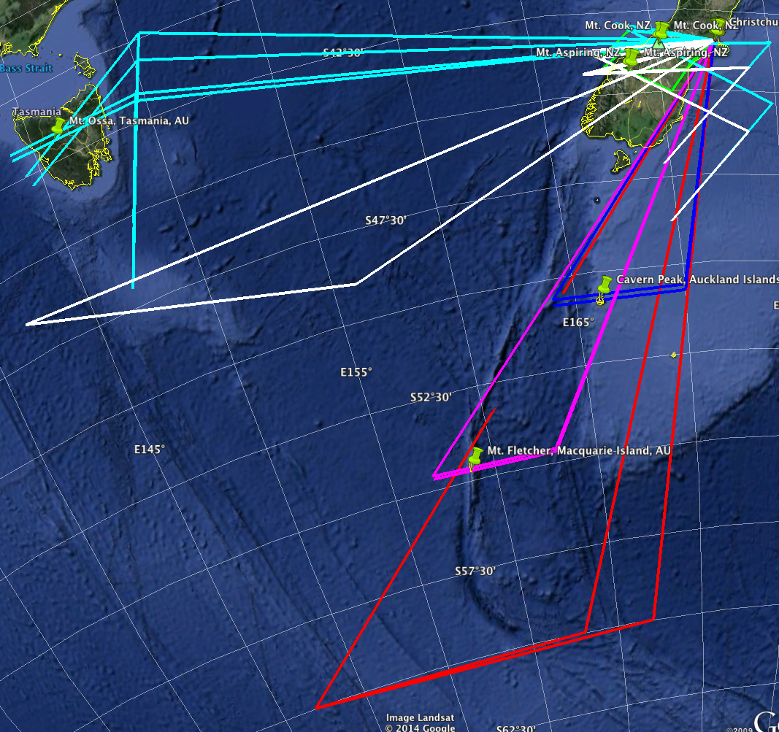
Fig 5.1: A schematic super-position of all the DEEPWAVE flight track types.
There are a few general principles that will apply to all GV flights. In general, the GV will fly at night and above the highest clouds to allow optimum performance of the vertically pointing remote sensing instruments. All three of the new airborne remote sensing systems perform best at night when sunlight is not illuminating the upper atmosphere. Night flights put an additional fatigue stress on aircrews and scientific staff that must be taken into account in mission planning. Night flights put slightly less fatigue stress on crews when the takeoff is just after sunset so that the aircraft can be back on the ground by 1 or 2AM.
Another consideration is that nights with good wave conditions tend to come in episodes lasting two to six days. To adequately observe these episodes requires that the aircraft be able to operate on subsequent nights (i.e. back-to-back flights). EOL has proposed the following strategy to partially accommodate this request. During the middle two weeks of the project, double flight and ground crews will be available allowing full-length (i.e. 9-hour) back-to-back night flights. The PIs should insure that double science crews are available as well. When only a single crew is available, it should be possible to fly shorter 5-hour back-to-back flights. These shorter back-to-back flights could be used for New Zealand mountain wave surveys or for predictability missions. A 5-hour predictability flight over the Tasman Sea would be followed, 24 hours later by a GW survey flight over NZ.
A good target altitude for the GV is 13 km (FL 430). The tropopause altitude over the South Island in June/June is typically 10 to 12km, so the aircraft will usually be in the low stratosphere. We will try to maintain constant altitude on each leg to improve the quality of the data. Most wave survey legs will be longer than 300km to observe gravity waves with long wavelengths. Most wave surveys will be flow in a direction close to the wind vector. For example, if the wind direction is westerly at 270T, the tracks will be flown at 270T and 090T. If the wind direction is WSW, at say 300T, the tracks will be at 300T and 120T. To reverse course the GV can perform a 90-270 turn. When using the airborne lidar to perform a wind profile, an extra 360 degrees can be added to the turn. Dropsondes will be deployed over the sea and at approved points over New Zealand. No dropsondes will be released over Tasmania.
The premise of DEEPWAVE is that with strong westerly winds aloft, wave breaking will be suppressed in the low stratosphere and waves will continue to propagate into the middle atmosphere. Under these conditions, the GV will usually encounter smooth air at FL430. On the other hand, wave induced turbulence is not perfectly predictable. Care must be taken in flight planning and operations to avoid strong turbulence. If weak winds are found at flight level, turbulence might be found also.
From previous mountain wave projects, we know the value of repeat legs (both track and altitude); during flights and between flights.. Repeat legs during flights allow wave time variation to be detected. Repeat legs between flights allow the wave dependence on environmental parameters to be detected. Repeat legs should be flown in exactly the same track (i.e. within 2km or better).
To aid in flight planning, a set of probable flight tracks are discussed here. Table 4.1 below summarizes the types of flight tracks needed to meet the three science objectives. In the Table, Indices 1-3 are mountain wave flights. Indices 4,5 and 7 are open ocean flights for non-orographic gravity waves. Index 6 is the predictability flight. Note that only the Mountain Wave flights (1-3 are on pre-designed flight tracks). All the others will be designed based on the forecasts. If, in mid-project, other flight tracks are needed, they will be added. Table 4.2 provides the latitude/longitude position of mountain reference points for flights over the NZ South Island.
Table 4.1: Proposed flight tracks for the NGV
Index | Location | Style | Transect  Direction | Purpose | Estimated  number | DWS
1a | Mt. Cook | V | 270 | Mt. Wave/Trailing | 2 | 20
1b | Mt Cook | V | 300 | Mt. Wave/Trailing | 3 | 20
2a | Mt Aspiring | V | 270 | Mt. Wave/Trailing | 2 | 20
2b | Mt Aspiring | V | 300 | Mt. Wave/Trailing | 3 | 20
3a | Tasmania | V | 240 | Mt. Wave/Trailing | 1 | 10
3b | Tasmania | V | 270 | Mt. Wave/Trailing | 1 | 10
4 | Auckland Island | Ferry / Transect | 270 | Mt. Wave/Non-Oro | 1 | 10
5 | Macquarie Island | Ferry/ Transect | 270 | Mt. Wave/Non-Oro | 1 | 10
6 | Tasman Sea | Ferry/ Transect | generic | predictability | 5 | 20
7 | Southern Ocean/Tasman Sea | Ferry/ Transect | generic | Non-Oro. | 4 | 20

Table 4.2: Terrain reference points for mountain wave flights ( rounded values of latitude and longitude)
Index | Terrain | Latitude | Longitude
1 | Mt. Cook | 43.5 S | 170.1 E
2 | Mt Aspiring | 44.5 S | 168.5 E
3 | Tasmania (center) | 42.0 S | 146.5 E
4 | Auckland Is. | 50.75 S | 166.1 E
5 | Macquarie Is. | 54.6 S | 158.9 E

- Flight tracks type 1 and 2 are transects over the South Island of New Zealand to observe mountain waves combined with transects to the south of the island to observe “trailing waves”. The combination of the two transects give the total track a V-shape. Four variants are considered. Tracks 1a and 1b both pass over Mt. Cook but at different angles, attempting to orient the transect directly into the wind. Tracks 2a and 2b take a similar approach over Mt Aspiring. The Mt. Aspiring option would be chosen when the southern part of the South Island is experiencing stronger westerly and generating stronger waves than the central region. Generally the legs on Tracks 1 or 2 will be repeated several times to observe time fluctuations of wave properties.
Note that while the northern mountains of the South Island sometimes produce strong mountain waves, we have not designed a flight track to observe them. This is so because waves from the lower latitudes are less likely to reach the polar jet located at 55 degrees south latitude.
- Flight tracks 3 focus on mountain waves from Tasmania. While these wave require a long ferry flight to observe, they are important for the project as they often appear in satellite gravity wave maps. We include two orientations for the transect. Variant 3a cuts across the main Tasmania terrain gradient and would be appropriate when the wind is from the SW. Variant 3b would be preferred in straight westerly flow. Both versions of Track 3 include a V with a transect to the SW to observe high altitude trailing waves. Because of the long ferry flight, the wave transects will probably be repeated no more than once before turning for home.
- Flight Track 4 focuses on waves generated by small Auckland Island in the Southern Ocean. Waves from this island sometimes appear in satellite. Track 4 would be chosen when the forecast predicts strong low level flow over Auckland Island and/or when a general Southern Ocean survey of non-orographic waves is desired.
- Flight Track 5 focuses on waves generated by small Macquarie Island in the Southern Ocean. There is a convenient Australian sounding station there. Track 5 would be chosen when the forecast predicts strong low level flow over Macquarie and/or when a general Southern Ocean survey of non-orographic waves is desired. Because of the long ferry flight, the wave transects will probably be repeated no more than once before turning for home.
- Flight track 6 is a generic flight track used to observe the state of the atmosphere near a “predictability hotspot”. The location of these flights will depend on the forecasted position of these hotspots. While these flights require long ferry legs, they may not be long flights overall. Only one leg through the hotspot is required. They will sometimes be followed by Tracks 1 or 2 the following night.
- Flight track 7 is a generic flight track over the Tasman Sea or Southern Ocean for the purpose of observing non-orographic gravity waves. The location of these flights will depend on the forecasted position of these waves. If strong waves are encountered, a repeat aircraft transect may be attempted, depending on the fuel remaining. We have been alerted to possible radio communications problems on these flights into the high southern latitudes.

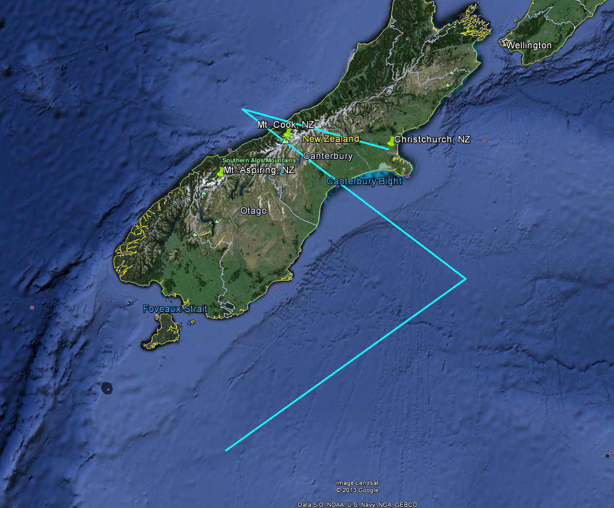
Figure 5.2: Example of Track 1b. Track 1a is rotated from Track 1b so the Mt Cook transect runs EW. Tracks 2a and 2b are similar but shifted SW.
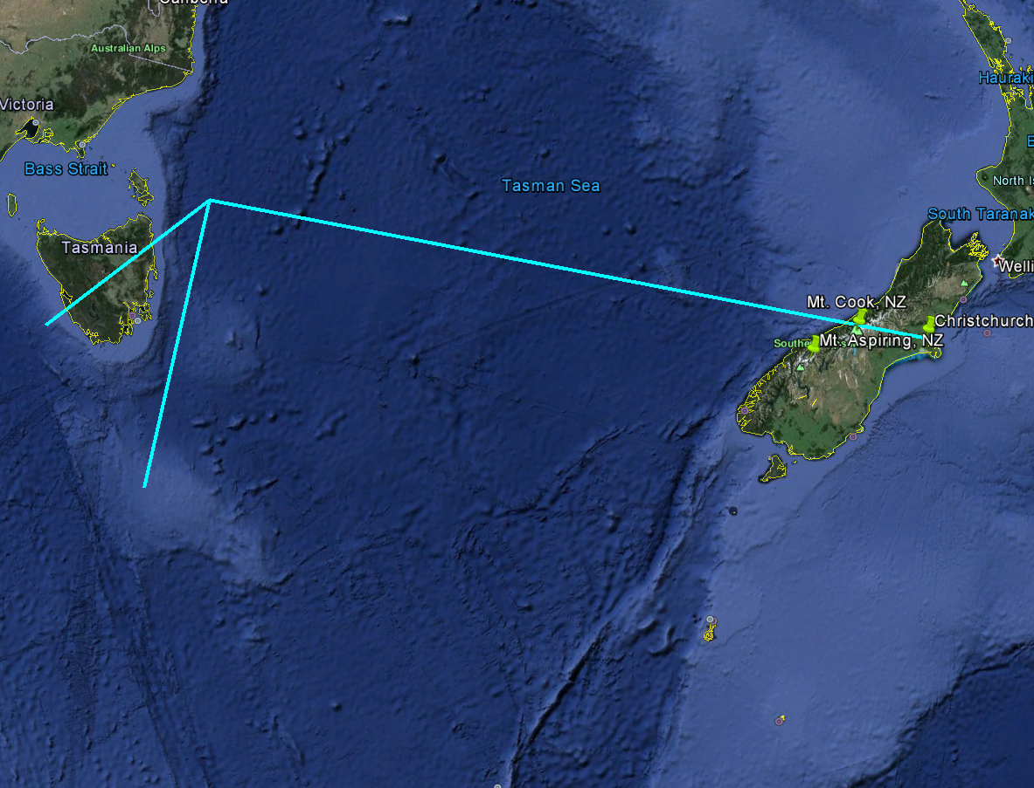
Figure 5.3: Example of Track 3a over Tasmania.
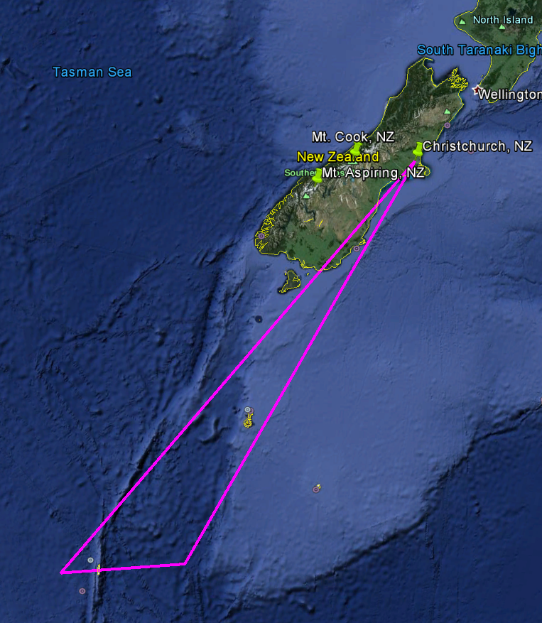
Figure 5.4: Example of Track 5 over Macquarie Island. Track 4 to Auckland Island is similar.
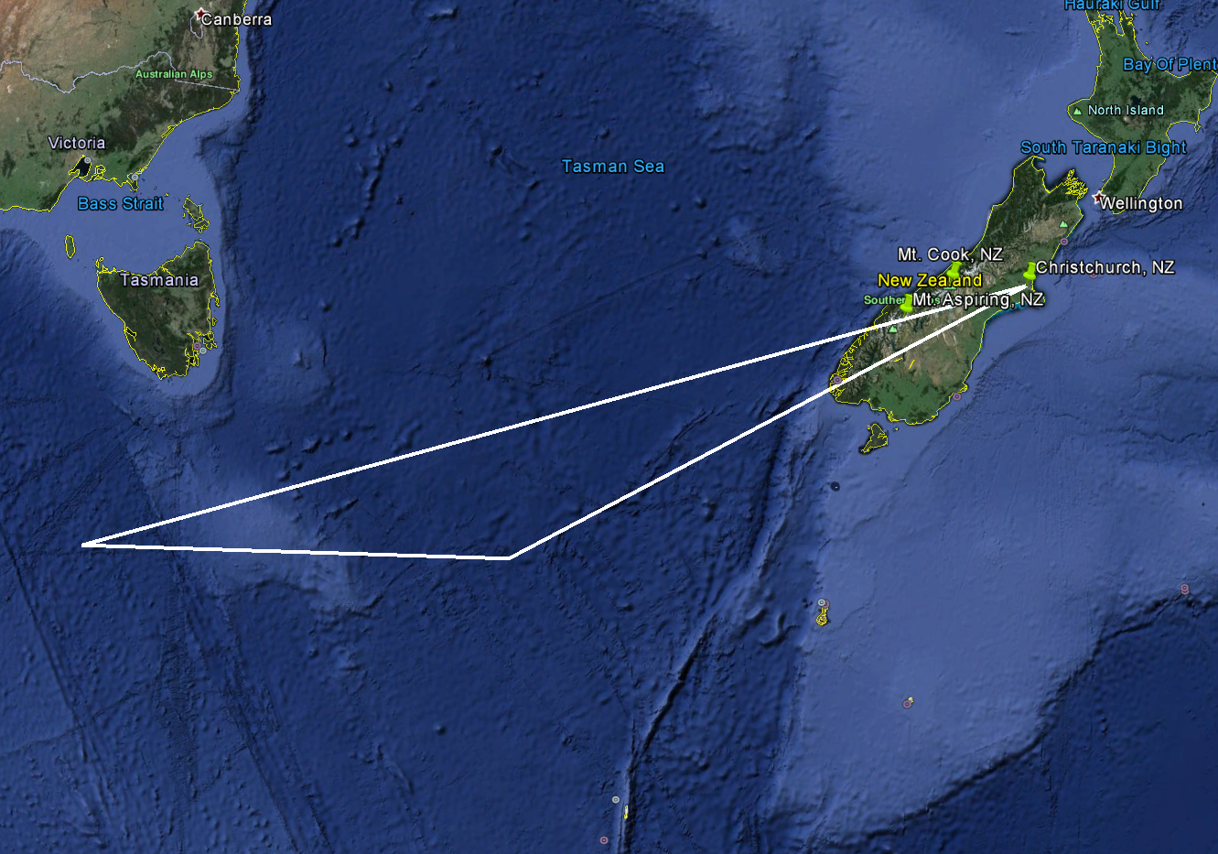

Figure 5.5: Example of Track 6 to sample forecast sensitive regions in the S. Tasman Sea for the predictability objective.
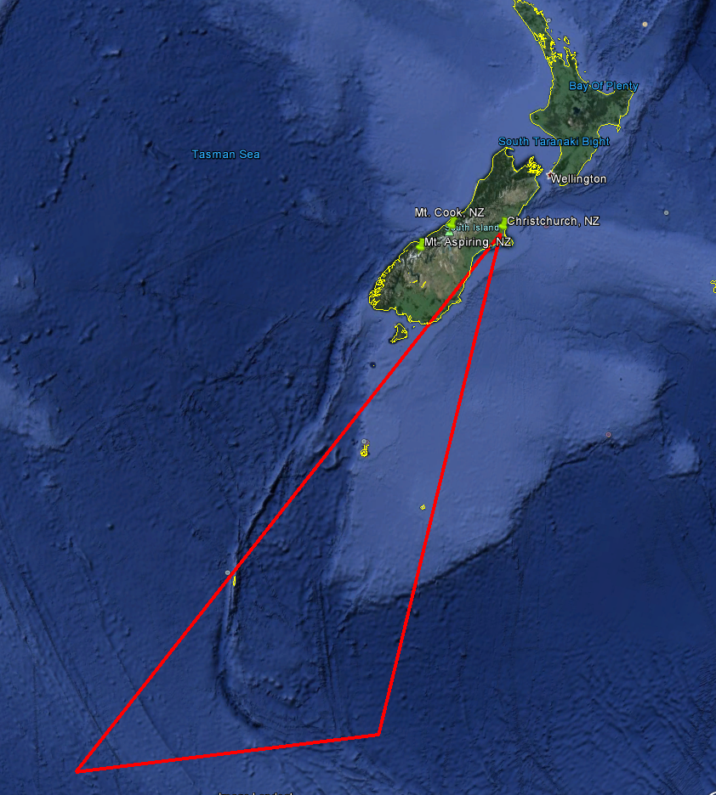
Figure 5.6: Example (Green lines) of the Track 7 searching for non-orographic gravity waves over the Southern Ocean.

  - Falcon flight tracks
The DLR Falcon will probably fly box patterns or repeat transects over the South Island. It does not have the range to participate in the other more distant objectives of DEEPWAVE. On a single flight, the Falcon will probably complete four transects. The cross-island legs may go over our mountain reference points for Mt. Cook and Mt. Aspiring. After refueling, it could do another set of transects. Like the NGV, it is best if the Falcon does its transects along the wind vector. This may allow them to put their wind lidar into a linear scan instead of a conical scan. The Falcon will fly at lower altitudes than the NGV. We estimate that the Falcon will make 15 four-hour flights during its DEEPWAVE deployment from June 29 to July 21.
Two examples of possible Falcon flight tracks are shown in Fig. 5.7. The Falcon flight operations and sampling exclusively in the vicinity of the South Island. It shorter range makes these missions highly effective and also offers the opportunity for 2 flight missions within a single crew duty day.
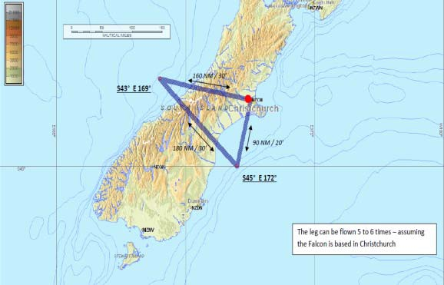

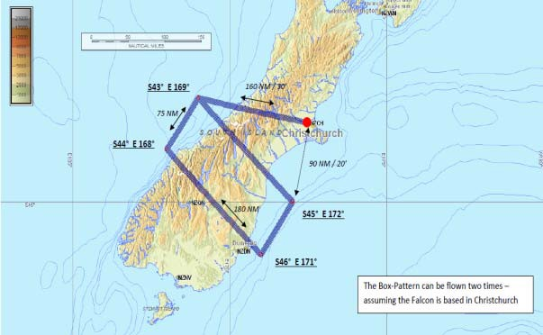
Figure 3.7. Two proposed flight tracks for the DLR Falcon 20 jet aircraft. Cross barrier. Operations base at Christchurch is shown as the red dot. Flight legs can be duplicated multiple times during the flight depending

