- Models and Forecasting
4.1 Models
4.1.1 Operational Global Models
Standard operational global models (GFS, ECMWF, UK Unified Model) will be used in support of DEEPWAVE forecasting activities. The attributes of these operational global models are provided in Table 4.1. It should be noted that the ECMWF IFS model products, supplied by DLR, were used frequently during the DEEPWAVE dry run because of that model’s high top (80 km or 0.01 hPa), and the fact that it is the most skillful medium range forecast model, particularly in the S. Hemisphere. Standard graphical products for the global models are shown in Table 4.2.
4.1.2 Operational and Real-Time Research Mesoscale Models
A number of high-resolution mesoscale models will be run in real time to support DEEPWAVE forecasting. The basic characteristics of these models are summarized in Table 1. Several regional models provide coverage over New Zealand, the Tasman Sea, Tasmania and a portion of the Southern Ocean (COAMPS and NZLAM using 15 and 12 km horizontal grid increments, respectively). High resolution models including WRF (6 km resolution), COSMO (2.8 km resolution), and NZCSM (1.5 km resolution) will focus more on New Zealand and will be particularly useful for planning missions over the S. Island. These mesoscale models are typically run for 36-h to 48-h durations, with the 6-km resolution WRF and the 12-km resolution NZLAM run out to 72 h.
4.1.3 Real-Time Adjoint Model
An adjoint modeling system based on COAMPS will be run at ~35 km horizontal resolution. The adjoint system will provide initial condition sensitivity computed for a 24-h forecast and based on 36-h and 48-h lead times (from two separate runs). Thus, the sensitivity calculations will be valid at 36-h and 48-h times in the future from the two runs to allow sufficient time for the G-V mission to be planned and executed. The metric or response function is based on the winds in a box surrounding the S. Island for the lowest 1 km above the ground at the final forecast time (24 h integration plus the lead time, so the total forecast time is either 60-h or 72-h). These calculations indicate the regions over which the model forecast kinetic energy at the final time (60-h or 72-h) is most sensitive to changes in the initial state (or in this case the lead time at 36 h or 48 h). The goal is to deploy dropswindsondes from the G-V over regions where the sensitivity is the largest, in order to improve the forecasts of the low-level winds impinging on the S. Alps and mountain wave launching.

4.1.4 Real-Time Linear Model
Linear mountain wave models also will be run to support DEEPWAVE mission planning. One possible candidate is a ray tracing model that provides forecasts of the linear response to flow over the South Island. These models could be particularly useful for linear wave forecasts for Auckland and Macquarie Islands, since the topography is relatively low (~700 m).
Table 4.1. Overview of the characteristics of the global and mesoscale models that will be used for forecasting during DEEPWAVE.
Model | Type | Org. | Horizontal Res. | Vertical Levels | Top | Fcst Length | Freq.  /day | Purpose
GFS | Global | NCAR  EOL | 27km | 64 | ~50km | 240 h | 4x | Medium range
IFS | Global | DLR | 16km | 137 | 80km 0.01hPA | 240 h | 4x | Medium range high alt GWs
UM | Global | NIWA | 17km | 70 | 80 km | 144 h | 4x | Medium range high alt GWs
NZLAM | Meso | NIWA | 12km | 70 | 80 km | 72 h | 4x | GWs, meso
NZCSM | Meso | NIWA | 1.5km | 70 | 40 km | 36 h | 4x | Fine scale GWs,
COAMPS | Meso | NRL | 15km | 86 | 60 km | 48h | 2x | GWs, meso
WRF | Meso | Inns. | 6 km | 89 | 35 km | 72h | 2x | GWs, meso
COSMO | Meso | BGS | 2.8 km |  |  | 48h | 2x | Fine scale GWs,
COAMPS Adjoint | Meso | NRL | 35 km | 60 | 30 km | 48h | 4x | Targeting
Ray Tracing | Linear | NRL |  |  |  |  |  | Ray Tracing

4.1.5 Standard DEEPWAVE Model Products
A number of different model products have been identified and summarized in Table 4.2. These products will be typically provided at a temporal frequency of 3 h. Some models (e.g., medium range global) will provide products out to 5 days; the mesoscale models will provide products to 36 h or 48 h. The intention is to standardize the model graphical products (colors, domains, levels, variables) as much as possible to allow for easy intercomparison of output from multiple modeling systems.
Table 4.2. Summary of standard model graphical products for DEEPWAVE.
Variable | Levels | Temporal Frequency | Forecast Length
SLP, 3-h rain fall  hPa, mm | Sea level | Every 3 h | 120 h global  48 h mesoscale
Heights-Winds  Meters, m/s  vectors | 850, 700, 500, 300, 200, 100, 50, 10, 5 mb | Every 3 h | 120 h global  48 h mesoscale
Vertical velocity  m/s | 850, 700, 500, 300, 200, 100, 50, 10, 5 mb | Every 3 h | 120 h global  48 h mesoscale
Divergence  10**3 /s | 850, 700, 500, 300, 200, 100, 50, 10, 5 mb | Every 3 h | 120 h global  48 h mesoscale
Theta, vertical velocity, horizontal winds | Cross barrier sections  - Across S. Island (3 sections)  - Across Tasmania  Section in height coord.  Top at 40 km | Every 3 h | 48 h
Wind speed, potential temperature | Meridional cross section | Every 3 h | 48 h
Vertical flux of wave energy and zonal momentum flux. | 4, 9, 13, 16, 20, 30, 40, 50, 60 km | Every 3 h | 48 h
Targeting products (NRL only) | Vertically integrated energy, sensitivity for 850, 700mb | Every 3-6 h | 24 h sensitivity with various lead times
Profiles of zonal wind speed (or cross mtn) for all targets | Vertical profile – SI NZ (N and S), TAS, AI, MI, several S. Ocean Pts | Every 3-6 h | 120 h Global
Cloud Top | Top in height | Every 3 h | 48 h
Turbulence | Flight Level | Every 3 h | 48 h

4.2 Forecasting and Nowcasting
Weather forecast discussions will occur daily during the DEEPWAVE field campaign. The daily schedules are described in Section 3. There will be a weather discussion during the DEEPWAVE Daily Planning Meeting each afternoon and a pilot weather briefing 2 hours before take-off. Additionally, there will be a morning weather forecast discussion convened prior to the Daily Planning Meeting. Nowcasting will occur on the day of a flight to assess whether conditions have changed from the previous day. By convention, we consider Day 1 to refer to the current day, Day 2 to tomorrow, etc.
There are 5 types of general missions that will be considered during DEEPWAVE for the G-V and Falcon. The forecasters need to assess and summarize the conditions for each of these mission types. The DEEPWAVE missions include:
- Orographic and trailing waves in the vicinity of the S. Island of New Zealand
- Orographic and trailing waves in the vicinity of Tasmania
- Orographic and non-orographic waves in the vicinity of Auckland and/or Macquarie Islands, located to the south of New Zealand.
- Non-orographic waves over the Southern Ocean forced by jet streams, fronts, convection etc.; the source for these waves may not be known prior to the mission.
- Predictability and targeting mission to sample regions of initial condition sensitivity, typically upstream of New Zealand.
Additionally, forecasters will need to consider multiple ground based instruments located at Hokitika (ISS, radiosondes), and radiosonde launch sites at Lauder, Haast, Tasmania, and Macquarie. If conditions are favorable for orographic waves, radiosondes at some of these sites may be launched at a more frequent interval (up to every 3 h) for short (~1-2 day) intensive observing periods (IOPs).
The forecast discussion will consider the following aspects:
- Current synopsis and synoptic-scale discussion
- Synoptic-scale outlook for: i) up to 48 h, ii) days 2-4, iii) extended range
- Airport forecast and alternate airport forecasts (ceiling, wind, precip)
- Gravity wave outlook for the above mission types
  - Consider the launching conditions, moisture, clouds, conditions for deep propagation, AIRS data etc.
  - Time periods of interest: i) up to 48 h, iii) days 2-4
- Predictability: Assess the conditions and targets for Day 2. Sensitive regions are valid at +36h and +48h from the initialization time.
- Turbulence outlook: Provide forecasts of flight level turbulence (up to 36 h, through Day 2) for the most promising targets.
- Mission outlook summary: Summarize the prospects for various mission types through the use of the color-coded Mission Outlook Summary (see Table 4.3).
It may help the forecasters to use standard thresholds, admittedly somewhat arbitrary, that summarize the prospects for gravity waves to be launched by the various orographic barriers. Based on experience from the T-REX field program, the wind speed at crest level can be used as a proxy for the wave launching amplitude. Since DEEPWAVE is concerned with deep propagation of gravity waves, strong winds through the depth of the stratosphere are considered desirable. Given these two conditions, we propose a simple set of criteria to summarize the gravity wave potential for mission types 1-3 as follows:
- At 700 hPa (i.e. 3 to 4 km AMSL)
  - U>20 m s⁻¹, A grade (1.0)
  - U>10 m s⁻¹, B grade (2.0)
  - U<10 m s⁻¹, C grade (3.0)
- At 10 hPa (i.e. ~30 km AMSL)
  - U>20 m s⁻¹, A grade (1.0)
  - U>10 m s⁻¹, B grade (2.0)
  - U<10 m s⁻¹, C grade (3.0)
- Average mountain wave score
  - A grade (1.0-1.9) (green color in Table 4.3)
  - B grade (2.0-2.9) (yellow color in Table 4.3)
  - C grade (>3.0) (red color in Table 4.3)
Inclusion of momentum and energy flux calculations may be another criterion that could be used to delineate the weak and strong gravity wave events.
The predictability type of mission is more difficult to quantify using a few basic criteria. The main attributes that constitute a promising event for the predictability objective include:
- Relatively strong winds impinging on the S. Island orography; at 700 hPa (i.e. 3 to 4 km AMSL)
  - U>20 m s⁻¹, A grade (1.0)
  - U>10 m s⁻¹, B grade (2.0)
  - U<10 m s⁻¹, C grade (3.0)
- Upstream sensitivity targets within the range of the G-V for a 6-h mission. Targets over the central and eastern Tasman Sea are generally accessible. Higher scores should be given to more coherent targets that the aircraft can readily sample.
(qualitative score 1.0 for best targets, 2.0 good, 3.0 relatively poor)

- Magnitude of the sensitivity is average to large. Higher scores should be given to greater sensitivity.
(qualitative score 1.0 for large sensitivity, 2.0 average sensitivity, 3.0 relatively weak sensitivity)

- Average predictability score
  - A grade (1.0-1.9) (green color in Table 4.3)
  - B grade (2.0-2.9) (yellow color in Table 4.3)
  - C grade (>3.0) (red color in Table 4.3)
It is possible to combine a gravity wave mission over Tasmania with a predictability mission, if the targets can be flown over during the G-V ferry legs.
These simple criteria can be used to summarize the forecaster DEEPWAVE mission outlook in a single spreadsheet, shown in Table 4.3. Here the green color indicates an excellent outlook for gravity waves or predictability targets, yellow is good, and red is relatively poor. We anticipate the spreadsheet will be included in the DEEPWAVE EOL catalog. Scores for Southern Ocean flights are qualitative based on the forecaster expectation for gravity waves from the models or based on conceptual models.

Table 4.3. Example spreadsheet summarizing the forecast outlook for various DEEPWAVE mission targets.
Mission | Day 1 | 24h | 30h | 36h | 42h | 48h | Day 3 | Day 4
New Zealand
Tasmania
Auckland & Macquarie
S. Ocean
Predictability

Given the complexity of the forecast process for DEEPWAVE, providing an overall summary will be desirable. An example of such a summary is shown in Table 4.4, which gives highlights of the outlook for each type of DEEPWAVE mission. We anticipate that this summary spreadsheet will be available in the DEEPWAVE EOL catalog.

Table 4.4. Example Turbulence Forecast form. Will be completed daily to assist pilots in flight planning and turbulence avoidance.
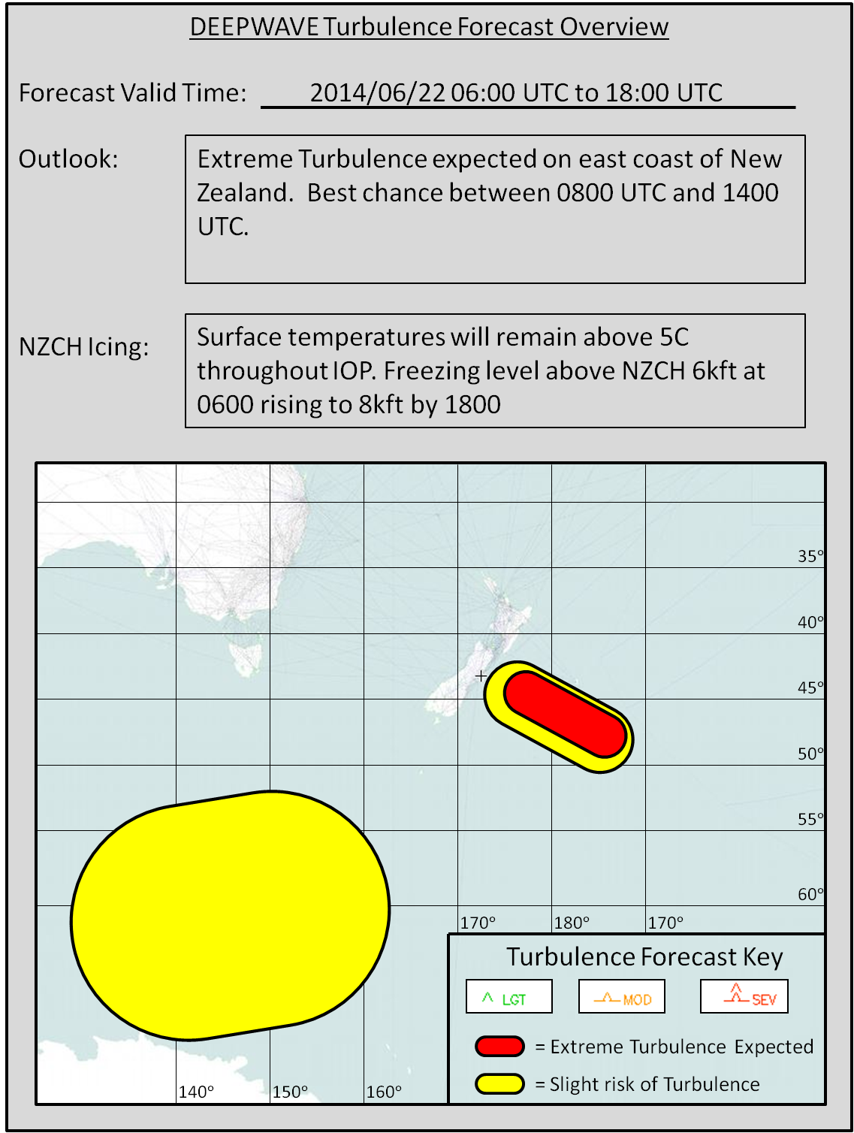
Table 4.5. Example forecaster spreadsheet summarizing the prospects for various DEEPWAVE missions.
Mission | Summary Comments
New Zealand | Strong cross mountain flow on Days 1-2. Trailing waves Days 1-2; Not promising beyond
Tasmania | Weaker GWs than last case, with transient GWs on Day 2. Back to back 9 h flights only possible w/ double crewing beginning at 72h
Auckland Island | Flow is too weak to generate much wave activity through Day 4
Macquarie Island | 20+ m/s NW flow increasing during 0600-1500 UTC on Day 2. Shallow waves indicated from models.
Non-orogr. GWs | ECMWF and COAMPS forecasts are not indicating non-orographic waves through Day 3.
Targeting | Targets upstream of NZ are too widespread, flow is weak on Day 2. Targets upstream of Tasmania are too far for the G-V to reach.

