- Conduct of Operations
  - Project Schedule

An overview of the DEEPWAVE schedule is shown in Fig 3.1. Note that the “Operation” periods vary somewhat for the different facilities. Within the operations period for the Gulfstream V (i.e. 5 June to 21 July), several Intensive Operations Periods (IOP) will be declared by the Science Steering Committee. An IOP is a period of from 12 to 48 hours when aircraft and balloon operations are planned or underway. IOP start and end times are usually declared 24 hours in advance of the start time. Project data sets are usually organized by IOP number.

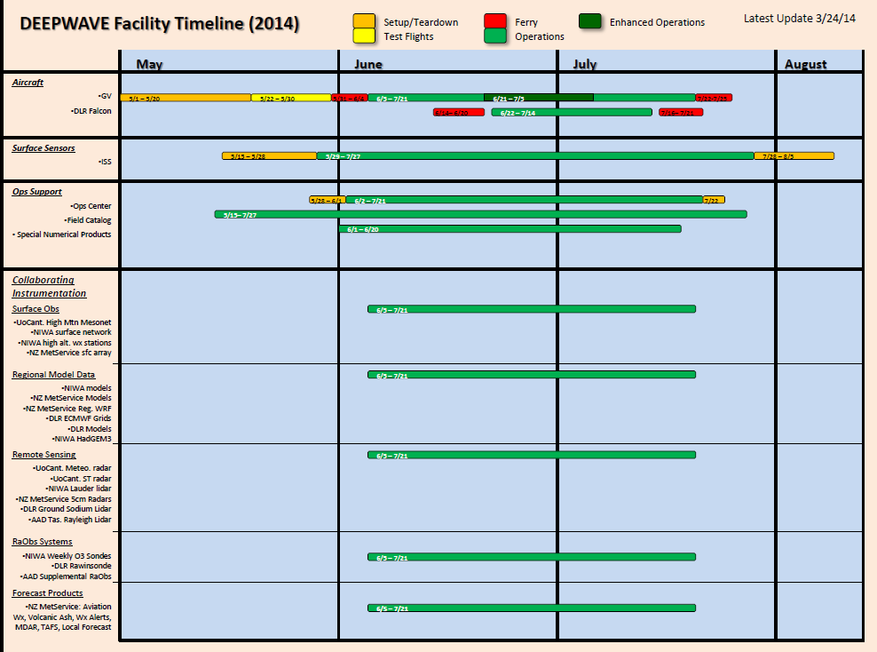
Fig 3.1: DEEPWAVE Facility Timeline
DEEPWAVE field operation preparation will begin in the first week of May. Figure 3.1 shows the schedule for the full suite of DEEPWAVE facilities and instrumentation.
Initial preparations for operations begin with aircraft upload in early May and the set-up of the DEEPWAVE Christchurch Operations Center beginning on 30 May.
The NCAR/NSF GV aircraft instrument upload will occur from 1 to 20 May. GV test flights will last from 5/22 through 5/30. Ferry to New Zealand will begin on 5/31, with the plane arriving in Christchurch on 6/3. Research flight operations will last from 6/5 through 7/21, with an enhanced operations period (pilot double crews) between 6/21 and 7/5. The DLR Falcon will ferry from Germany to Christchurch between 6/22 and 6/27. Research flight operations will last from 6/29 to 7/21, and ferry back to Germany will last from 7/23 to 7/29.
The NCAR/NSF ISS system will begin setup near Hokitika, New Zealand on 5/15. Operations will last from 5/29 to 7/27, and teardown will take place from 7/28 to 8/5.
DEEPWAVE operations support will begin with the Field Catalog becoming operational (i.e. accept operational products) on 5/15, lasting through the project and approximately 2 weeks following the last flight day on ~4 August . The operations center in Christchurch will be set up between 5/30 and 6/2. It will be operational between 6/3 and 7/21, with teardown on 7/22. Numerical products and research model output related to DEEPWAVE operations should all be accessible on the Field Catalog by 6/1, lasting through 8/04.
Collaborating instrumentation from the different research groups in New Zealand and Australia should all be operational by 6/5 – the first potential IOP of the DEEPWAVE project. Instrumentation will run through the duration of the project, ending on 7/21, depending upon specific instrumentation provider schedules.
We have also provided information in Figure 3.2 that provides some very specific details related to the very busy first week of operations in DEEPWAVE.

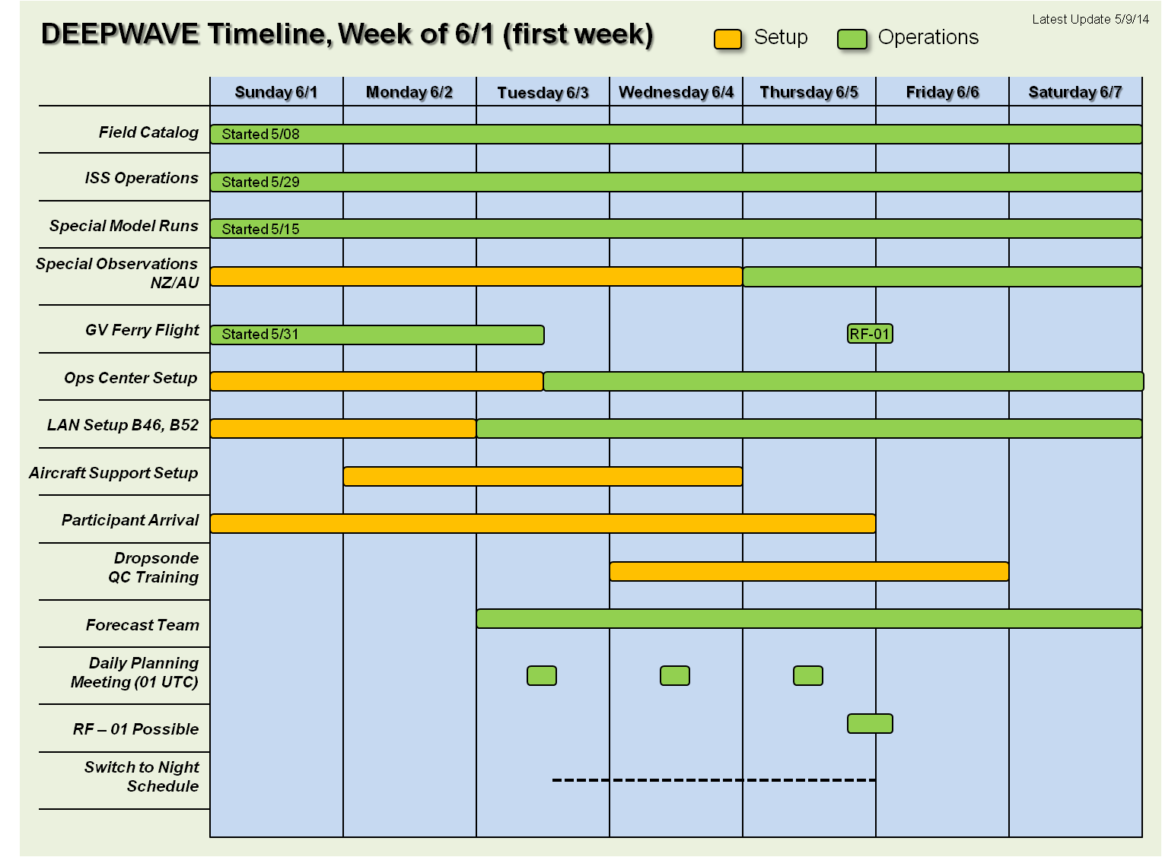
Figure 3.2. DEEPWAVE Time line for the first week of set-up and operations in the 1-7 June 2014 period including set-up and proposed first GV flight day on evening of 5 June.
Some components of the project will be underway and many will be in the process of starting up during the first week of June. The Field Catalog, ISS Operations and special model runs will all be operational on or before 1 June. Setup for Observations from New Zealand and Australia will last through 6/4, becoming operational on 6/5. The NCAR/NSF GV ferry flight will arrive in Christchurch on 6/3. The flight crew will transition into night schedule with the first potential IOP-1 flight on the night of 6/5 – 6/6. The Operations Center setup will fully functional on the afternoon of 6/3. LAN setup in buildings B46 and B52 will conclude by end of day Monday 6/2. Aircraft support setup will begin Monday 6/2 and last through Wednesday 6/4. DEEPWAVE participants will be arriving throughout the week, with most of the staff in place by Thursday 6/5. Dropsonde Quality Control training will take place from Wednesday 6/4 through Friday 6/5 for those students and staff involved in that process. The DEEPWAVE forecast team will begin operation starting with Tuesday’s (6/3) forecast cycle, looking ahead to potential IOPs beginning the night of 6/5. Daily Planning Meetings will begin on Tuesday 6/3. These meetings will take place every day at 1PM New Zealand Local time (01 UTC).

  - Leadership and staff schedule
Due to staff rotation though Christchurch, the job assignments in DEEPWAVE will also rotate. For simplicity, we have chosen to use a weekly rotation. The Science Steering Committee is responsible for declaring IOPs and deploying observing systems, with the limits of expendable resources supported by the funding agencies. Its weekly schedule is given in Table 3.1.

Staffing Table 3.1: Steering Committee Schedule (subject to change)
Week | Dates | Chair | Members
1 | June 2-June 8 | R.Smith | Fritts, Taylor, Reinecke, Uddstrom
2 | June 9-June 15 | Fritts | R.Smith, Doernbrack, Reinecke, Taylor
3 | June 16-June 22 | Doernbrack?  Taylor? | Doyle, R. Smith, Fritts, Taylor, Turner
4 | June 23-June 29 | Fritts? | Fritts, Eckermann, Doernbrack
5 | June 30-July 6 | Doyle? Doernbrack? | Doyle, R. Smith, Reynolds, Schlager, Taylor
6 | July 7-July 13 | Doyle | Doernbrack, R. Smith, Eckermann
7 | July 14- July21 | R. Smith | Uddstrom, Eckermann, Doernbrack

The Forecast Team is responsible for comparing different numerical guidance products and ranking the days ahead with respect to suitability for different mission types. Assignments throughout the deployment period as shown in Table 3.2.

Table 3.2: Forecasting Team Schedule (Subject to Change)
Week | Dates | Lead | Staff
1 | June 2-June 8 | Revell | Reinecke, Kruse, Nugent
2 | June 9-June 15 | Reinecke | Revell, Gisinger, Kruse, Mixa
3 | June 16-June 22 | Turner | Gisinger, Mixa, Reutter,
4 | June 23-June 29 | Gisinger | Kruse, Charnick, Nugent, Wagner,
5 | June 30-July 6 | Watson | Reutter, Wagner, Gisinger
6 | July 7-July 13 | Brandolino ? | Mixa, , Nugent, Wagner, Nugent, Watson
7 | July 14-July 20 | Nugent | Gisinger, Kruse,

The Gulfstream V requires onboard technicians for the vertically pointing remote sensing instruments provided by the principal investigators and listed in Table 3.3.

Table 3.3: Schedule for Gulfstream Lidar and IR Mapper operators
Week | Dates | Lidars | IR Mapper
1 | June 2-June 8 | Williams, Mixa | Pautet
2 | June 9-June 15 | Williams, Mixa | Pautet
3 | June 16-June 22 | Williams | Pautet
4 | June 23-June 29 | Williams, Bossert | Pautet
5 | June 30-July 6 | Williams, Bossert | Pautet
6 | July 7-July 13 | Bossert | Pautet
7 | July 14-20 | Bossert | Pautet
(IR Mapper: Also Taylor or Criddle)
There are several other important positions that require trained and focused staff. The Status Coordinator presents the status of all the DEEPWAVE facilities at the Daily Planning Meeting. The dropsonde quality control coordinator performs a quality control on the deployed dropsondes from the GV AVAPS system and transfers data to the GTS. The Hokitika ISS staff prepares, launches and monitors daily and IOP Balloon launches.
The schedule of staff to support ISS operations in Hokitika assisting the NCAR/EOL In-Situ Sending Facility (ISF) personnel are listed in Table 3.4. Using various delayed data sets, the “Deployment Judge” reviews the efficacy of IOP and aircraft/balloon deployment decisions. This staff position can be off-site.
Table 3.4: Schedule of ISF/ISS Hokitika Staff ( on site with Bill Brown and/or other EOL/ISF personnel)

Week | Dates |  | US/German |  |  | Dates |  |  | NZ Students
1 | June 2-June 8 |  | Azusa Takeishi, Tashiana Osborne |  |  | June 3-15 |  |  | Jordan Miller
2 | June 9-June 15 |  | Tashiana Osborne
3 | June 16-June 22 |  | Christine Tsai, Tashiana Osborne |  |  | June 13- 25 |  |  | David Stevens
4 | June 23-June 29 |  | Philipp Reutter |  |  | June 23-July 4 |  |  | Joe Chen
5 | June 30-July 6 |  | Tyler Mixa |  |  | July 2-14 |  |  | Kate Walsh
6 | July 7-July 13 |  | Chris Kruse |  |  | July 13-23 |  |  | Ben Jolly
7 | July 14-20 |  | Campbell Watson |  |  | July 22-Aug 4 |  |  | Simon Parson

Footnote to Table 3.4--
Institutions: Osborne (St Cloud), Takeishi, Tsai, Nugent, Watson (Yale), Reutter, Wagner (DLR)
Additional staff from the NZ Defence Force: Jamie Halla (June 23-29) and Sally Garrett (June 30- July 6)
Note that dates given in the table are “on-duty” dates. Travel to and from Hokitika should occur on the adjacent days.
Table 3.5: Staff positions in CHC operations center
Week | Dates | Daily Status Report | DWS on GTS | Judge vs AIRS
1 | June 2-June 8 | Kruse | Nugent | Eckermann
2 | June 9-June 15 | Nugent | Kruse | Eckermann
3 | June 16-June 22 | Tsai | Mixa | Eckermann
4 | June 23-June 29 | Mixa | Tsai | Eckermann
5 | June 30-July 6 | Gisinger | ? | Eckermann
6 | July 7-July 13 | Watson | Gisinger | Eckermann
7 | July 14-20 | Nugent | Kruse | Eckermann

  - Utilization of limited resources.

There are four types of limited resources funded by the NSF
- GV flight hours:180 hours
- GV dropsondes: 280
- ISS balloon from Hokitika: 150 (NZ wave surveys only)
- Haast (NIWA) soundings:50 (NZ wave surveys only)
to be shared among the three types of research missions in DEEPWAVE: Mountain wave surveys: NZ and Tasmania; Open ocean wave surveys (including Macquarie and Auckland Islands); and Tasman Sea Predictability Flights. A plan for resource expenditure is given in Table 3.6.
Table 3.6: Limited resources from NSF (estimated number of flights in parentheses)
Resource | Total | MntWaves | Open ocean | Predictability
GV Flight hours | 180 | 100 (11 to17) | 50 (5 to 8) | 30 (3 to 5)
GV DWS | 280 | 156 | 78 | 46
ISS balloons | 150 | 150
Haast balloons | 50 | 50
As the GV resource is computed as a number of flight hours, the number of flights is uncertain. If the average flight duration is 6 hours, we would fly 30 flights. If the average duration is 9 hours, we would fly 20 flights. In either scenario, it will be a challenge to properly utilize all 180 flight hours in the approximately 50 days of the project. It would require a flight every other day to keep pace. The pace of flying will be slowed by mandatory down days, equipment failure, lack of science targets, etc.
The ISS balloons from Hokitika will be utilized as follows. There will be daily launches to provide a climatology of the DEEPWAVE period. The time should match the standard 00UTC schedule (i.e. 1200 NZST) so an actual launch time of 1100NZST is recommended. These daily launches would use about 50 sondes. During IOPs, we will launch at 3-hour intervals to monitor changes in the wind and humidity fields and changes in the waves themselves. If we had 15 South Island flight days (including Falcon flights) we could launch about 6 sondes per IOP. Six sondes will cover a 15 hour period. We should anticipate some lost (or repeat sondes) due to equipment malfunction or human error.
The NIWA sondes from Haast are more limited; 50 in all. If we flew sondes from Haast for 10 IOPs with 5 launches each, we would expend all 50 sondes.
The DLR Falcon will be available for research flights from 29 June to 21 July, 2014. During this period the aircraft can expend about 60 flight hours. The duration of the Falcon is about four hours, so we anticipate about 15 flights. In some cases, two flights can be carried out in one day. All of these flights will be assigned to the study of mountain waves over the South Island.
d. Operations Coordination and Daily Schedule
The DEEPWAVE operations staff described in Section 3b will be organized to conduct operations planning and support as presented in this section. Figure 3.3 provides the daily schedule of planning and support of operations for a single day. The figure shows both UTC and NZ Standard time (LT) on the time bar along the center of the figure.
Figure 3.3 DEEPWAVE Daily Planning Schedule. Timeline is in UTC and NZ local standard time.
There will be a Morning Weather Update briefing at the DEEPWAVE Operations Center (DOC) of interested Science Group members and operations staff at 0800 LT. A member of the forecast team will provide a weather update covering the next operational period during the upcoming evening. Decisions from this meeting are focused are focused on only the same evening’s planned operations. Remote participation via conference call, using conference telephone and web web-based Ready Talk software will be available. The MWU may be cancelled if no operations are anticipated for that same evening. The key results from the Daily Planning Meeting (DPM) should be a set of primary and secondary science objectives that will be considered for the next day flight and ground based operations.
The DEEPWAVE project will have a Daily Planning Meeting 7 days per week to discuss relevant issues, remaining resources and status, science objective status, current weather, synoptic situations and outlook as well as PI science mission proposals. This meeting will involve all available project participants. The Daily Planning Meeting will be convened at 0100 UTC (1300 Local Time [LT] in This time was chosen to allow participation of as many groups as possible across the project. The DPM will be held every day throughout the field season beginning 3 June and concluding 21 July 2014.
There are critical updates and decisions that will come out of each Daily Planning Meeting These items are listed below. All this information will be provided via the DEEPWAVE Field Catalog Reports Section.
Decisions--
- Any updates to the day 0 (this evening) flights and other special observations (cancellation, timing etc.)
- Pre-flight briefing time and location
- Post-flight debriefing
- Science mission proposals (primary and secondary as required)
- Science objectives for the day 1 (next evening) flights and other special observations
- Staffing for next IOP (i.e. science mission director, nowacster, operations director, flight science and facility crews)
- Next Update (e.g. morning weather discussion, time)
Updates—
- Facility Status
- Current operational status (start, end or status in IOP) including observations, science objectives etc.
- Weather forecast summary out through day 2
- Weather forecast outlook spreadsheet
- Operations Plan of the Day
- NOTAMS through CAA (general location 24 hour in advance, with modifications possible the afternoon before mission, more than 2 hours before Take-off)
- Email notification to CAA must be sent more than 2 hours before Take off (Airways NZ email address to be provided)
If an IOP has been scheduled, the following decisions must be made and communicated quickly to the relevant groups. This will be done via the DEEPWAVE Field Catalog http://catalog.eol.ucar.edu/deepwave and possibly email as a backup.
- IOP start date and time. Estimated end of IOP
- Aircraft deployment information (GV and/or Falcon)
  - Takeoff time and mission duration
  - Science objectives and flight tracks
  - Mission scientist and science crew
  - Flight-following ground staff

- Supplemental Rawinsonde launch times
  - Hokitika (NCAR ISS)
  - Haast (NIWA)
  - Lauder (DLR)
  - Hobart (BoM)
  - Macquarie (BoM)

The project will schedule approximately 3 Science Review Meetings to assess the progress on science objectives, preview preliminary data and products collected in the field and consider any modifications to data collection strategies. The tentative schedule of these meetings will be at the end of the second week of data collection, near the 4th week of the project and finally just before the data collection period ends just before 22 July. The date and time of the meetings will be provided to participants at a later date.
e. Logistics and facilities at CHC (USAP offices)
The DEEPWAVE Operations Center and aircraft support will be located at the US Antarctic Program (USAP) Christchurch (CHC) International Airport. Figure 3.4 is an aerial photo of the base with the two buildings that will be occupied by DEEPWAVE aircraft; scientific participants and operations support personnel.
Figure 3.4. Aerial view of US Antarctic Program Facilities on and near Christchurch International Airport. DEEPWAVE hangar and offices labeled as buildings B46 and B52. These buildings are within the airport boundary and require badge identification to enter.
The space we will occupy consists of various offices, storage space and hangar space in Building B46 and B52 of the NSF USAP building complex shown in Figure 3.3. The aircraft will sit on the Christchurch (CHC) aircraft apron adjacent to hangar B46. The Operations Center, forecasting area, scientist offices and related activities are located in B52. NCAR aircraft support staff and instrumentation will reside in office space in B46.
The USAP Office/Storage Building 52 and Hangar 46 are both prewired for Internet. Wired and wireless connections are possible. The buildings are currently supported with 30 Mbps service from New Zealand Telecom. There are already some peripherals available in the hangar and office building. These include a network color and B/W printer, large screen TV, computer interface and computer projector for the main conference room. In addition, EOL will add other network printers and projectors as needed.
Agreement has been reached with the USAP and the CHC Airport Authority that all project participants must wear a picture ID badge while working at the USAP facilities in Christchurch. All participants provided information to EOL and badges have been produced that must be worn and visible while on the USAP premises and adjacent ramp where the GV will be located.

