- DEEPWAVE Observing Systems
  - Research aircraft
The key observing platform in DEEPWAVE is the NSF/NCAR Gulfstream V (Fig 6). Since entering the NCAR fleet in 2005, it has been deployed to many research projects around the globe. In terms of science objectives, the closest prior project to DEEPWAVE was the T-REX project in 2006 where the GV observed mountain waves above the Sierra Nevada Range in California.

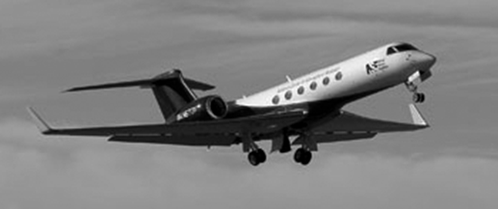

Figure 2.1: The NSF/NCAR Gulfstream V research aircraft

As seen in Fig 7, the unique aspect of GV instrumentation for DEEPWAVE is the three up-looking remote sensors These allow gravity waves to be tracked from the flight level in the lower stratosphere into the stratosphere, mesosphere and lower thermosphere. The GV is also equipped with the AVAPS dropsonde system. More details are provided in Appendices A, B and C.
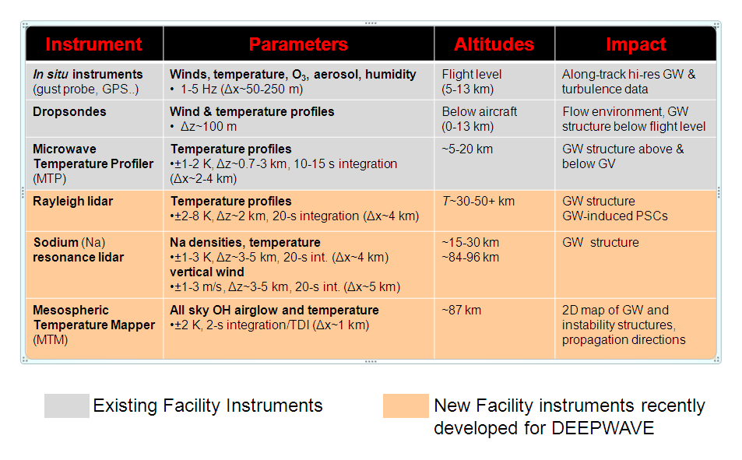
Fig 2.2: The conventional and up-looking remote sensing instruments on the GV for DEEPWAVE

The other research aircraft in DEEPWAVE is the DLR Falcon (Fig 8). This aircraft has been a part of the German DLR fleet for nearly four decades and has flown in dozens of projects around the world. In addition to flight level in situ instruments, it will carry a downlooking Doppler “wind” Lidar for mapping out the wind field in the troposphere.

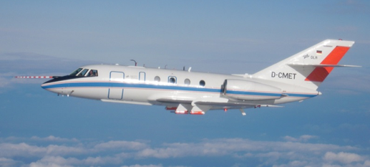

Fig 2.3: The DLR Falcon

  - Upper air stations

Five upper air sites will be active during DEEPWAVE (Fig 9). In Invercargill and Wellington, the NZ Met Service will launch two balloons per day in its normal operational schedule. In Hokitika, the NCAR ISS will use a VHF radar to continuously profile the wind field up to about 5km, while launching balloons daily for at a 3-hourly pace for IOPs. In Haast, NIWA will establish a upper air station to launch balloons during IOPs. Likewise, DLR will launch balloons during IOPs from the NIWA research station at Lauder. In addition to these sites in Fig 9, the Australian Bureau of Meteorology (BOM) will launch sondes both operationally and on demand from Hobart, in Tasmania and Macquarie Island in the southern ocean.

Due to the science objectives of DEEPWAVE, the special sondes from Hokitika, Haast and Lauder will be requested to design their launches to reach at least 20km and to 25 or 30km if possible. High resolution data should be recorded if possible.

Fig 2.4: Approximate locations of the upper air sites for DEEPWAVE: NZMetService operational sites in Invercargill and Wellington, the ISS in Hokitika, the NIWA site in Haast and the DLR launch facility at the NIWA lab in Lauder.

  - Surface based remote sensing observations
Fixed vertically pointing remote sensing instruments will be running at several locations
- Birdling's Flat: - meteor radar (J. Baggaley) - horizontal winds ~80-100 km (auto.)
- Lauder: - AMTM (M. Taylor) - GW OH structure, T(x,y,t) at ~87 km (auto.) ; - Na lidar, (B. Kaifler) - T(z,t) to ~30-100 km, U_{h}(z,t) ~80-100 km, one comp. ; Airglow imager (S. Smith) - GW airglow structures, ~87-95 km, ~300 km (auto.)
- Mt. John: - airglow imager (S. Smith) - GW airglow structures, ~87-95 km, ~300 km (auto.); - FPI (G. Hernandez) ??? (auto.)
- Hobart, TAS – Rayleigh lidar, sondes (other per.);
- Davis, Ant. (68.6ºS, Australia) - Antarctic radars, lidar, airglow (other per.)

  - Satellite Data
Current and future GW-resolving satellite instruments that may be acquiring data during the DEEPWAVE main field phase in 2014.
Table 2.1. Available satellites and their instruments providing data during the DEEPWAVE field phase
Instrument | Satellite | Orbital Inclination | Technique | Launch
AIRS | Aqua | 98.2º | Infrared nadir | 2002
AMSU-A | NOAA-15,16,18, 19 Aqua, MetOp-A | 98.5-99.0º | Microwave nadir | Progressive 1998-2009
IASI | MetOp-A, MetOp-B | 98.7º | Infrared nadir | 2006 (A)  2012 (B)
GPS | FORMOSAT-3 (COSMIC constellation) | 72º | Radio occultation | 2006
MLS | Aura | 98.2º | Microwave limb | 2004
SABER | TIMED | 74.1º | Infrared limb | 2001
ATMS | Suomi NPP | 98.7º | Microwave nadir | 2011
CrIS | Suomi NPP | 98.7º | Infrared nadir | 2011
SSMIS | DMSP F16,F17,F18,F19 | 98.8º | Microwave nadir | Progressive  2006-2014
Aladin | ADM-Aeolus | 97.0º | Doppler Lidar | 2014

