- The DEEPWAVE Project
  - Project Goals
The goals of DEEPWAVE are to observe, understand, model and predict the deep vertical propagation of gravity waves from the troposphere into the stratosphere, mesosphere and lower thermosphere (Fig 1) and the impact of gravity waves on the momentum and energy budget there. Of particular interest are the time-varying roles of migrating frontal cyclones, polar jet structure and solar tides on the gravity waves.

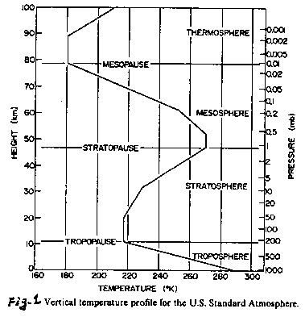
Fig 1.1:Temperature profile from the US Standard Atmosphere. Height and pressure scales are provided.

  - Project Motivation
The science motivation for DEEPWAVE comes from several decades of research advancing knowledge of gravity wave physics, gravity wave observing methods and large scale studies of wave-influenced momentum budgets, overturning circulations and global climate. This literature provides strong evidence for the following motivating ideas:
- Mountains, convection and jet stream accelerations can produce vertically propagating GWs
- These GWs account for primary vertical energy & momentum transport at all levels
- The deposition of wave momentum and energy modifies the large scale overturning circulations in the earth’s atmosphere.
- The important GWs are not resolved by satellite measurements or GCMs
- GCM parameterizations of GWs are known to be seriously deficient
- Improved predictions of GWs will enhance the skill of weather and climate models

  - Why is DEEPWAVE in the winter in New Zealand?
While GWs are generated in every part of the globe and all seasons, the primary occurrence of deep propagation is in association with the polar jets in the stratosphere. The physical reason for this connection between waves and wind is that atmospheric layers with weak westerlies or reversed easterlies cause waves to break and dissipate their energy. A good illustration of this relationship is given in Fig. 2. For southern hemisphere winter, the largest wave-induced temperature variances are seen at pressure levels above 10hPa in the polar jet near 50 degrees south latitude.

Fig 1.2: Zonally averaged temperature variance (colored) in the stratosphere from AIRS for July 2005 (from Gong at al., 2012). Contours (black) show the zonal winds. The three panels show results for two different AIRS look angles and their difference.

The geographical distribution of wave induced temperature variance is shown in Fig 3. The strongest “hotspot” of wave activity is near the Drake Passage. Initial planning for a field project there (SAANGRIA) was translated to New Zealand (DEEPWAVE) in 2012 for operational reasons A zoom of the DEEPWAVE regions in Fig 4 shows intense wave activity over New Zealand and Tasmania.
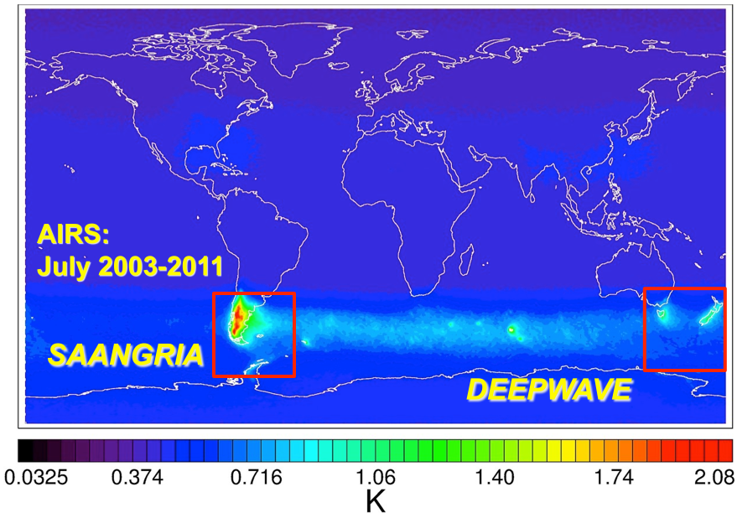

Fig 1.3: AIRS temperature variance at 2 hPa for July. (Courtesy of S. Eckermann)

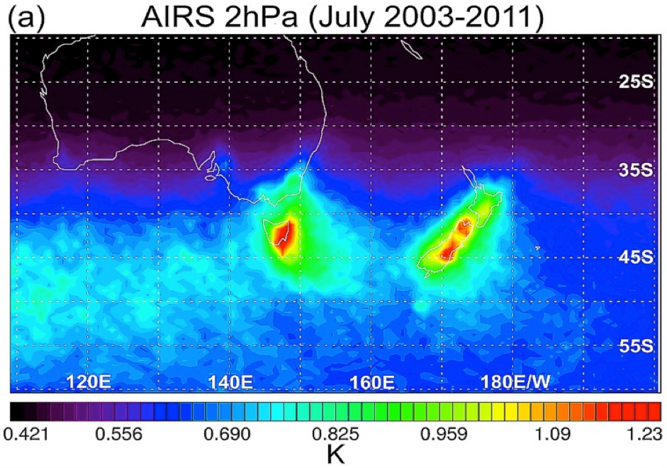

Fig 1.4: AIRS temperature variance at 2hPa for July. (Courtesy of S. Eckermann)

These satellite derived maps of wave activity climatology provide the rationale for a June/July field project based in New Zealand. An indication of the variety of instantaneous wave fields seen from AIRS is shown in Fig 5.

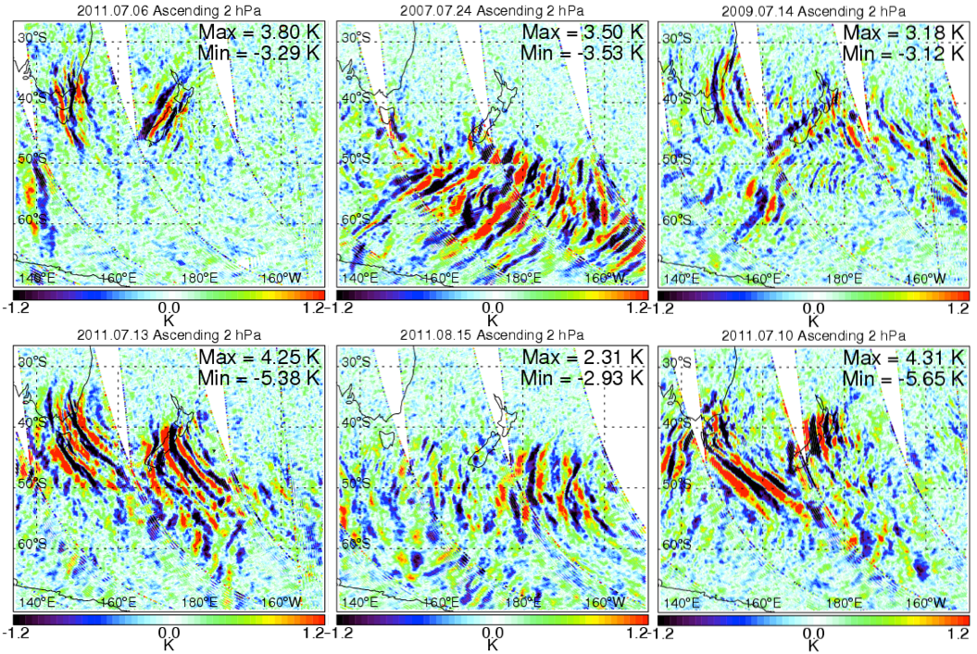
Mountain Waves
Multiple Sources
Non-Orographic GWs

Fig 1.5: Instantaneous temperature anomaly maps from AIRS at 2hPa. (Courtesy of S. Eckermann)

  - Participating institutions and agency support
The DEEPWAVE project is a collaboration between a number of research groups. The initial proposals to Naval Research Laboratory were written by James D. Doyle at NRL at Monterey, CA and Stephen Eckermann at NRL in Washington, DC. The initial proposals to the National Science Foundation were written by David Fritts at GATS in Boulder, CO and Ron Smith at Yale University in New Haven, CT. The final DEEPWAVE proposal to NSF included Mike Taylor from Utah State University. Additional NSF funding was awarded to Steve Smith at Boston Univ. and Brian Billings at St. Cloud State for supplemental observations. A unique aspect of the NSF support is that it involves two sections of the AGS Division; Aeronomy and Physical and Dynamic Meteorology. The lead program manager at NSF was Anne-Marie Schmoltner. The participation of the German DLR in DEEPWAVE was proposed by Markus Rapp and Andreas Dőrnbrack at DLR. The participation of the National Institute of Water and Atmospheric Research in New Zealand was proposed by Michael Uddstrom. The Australian Antarctic Division will also participate in DEEPWAVE with their ground based remote sensing devices.
With support from the NSF, the Earth Observing Lab (EOL) at NCAR is also playing an important role in DEEPWAVE. An addition to providing the Gulfstream V research aircraft and the Integrated Sounding System (ISS), EOL is helping with the operational side of the project and with the data management.

