- Appendices: Details of DEEPWAVE instruments
Appendix A: Flight level instruments on the GV (from Jorgen Jensen)
Thermodynamics:
1x static pressure, connected to fuselage buttons
1x Qc through pitot tube on fuselage
1x CR-2 cryogenic cooled mirror hygrometer
2x cooled mirror hygrometers (OK to about -60C, slow)
1x VCSEL hygrometer, 25 Hz
2x Harco anti-iced temperature, slow
1x Rosemount temperature, fast
Wind:
1x 5-hole radome attack, sidelip and total pressure (Qc through connection to static buttons), 20 Hz.
4D-LAMS (experimental, high-accuracy, no promises) with CMIGITS IRS unit, mounted in a PMS can.
1x anti-iced Rosemount 858 5-hole probe, mounted in a PMS can.
Position:
3x Honeywell IRS.
1x Applanix IRS (experimental, high accuracy, never installed in a stand-alone mode before, no promises, may not be part of the payload/TBD).
1x Novatel GPS, 5 Hz, on GV.
1x Novatel L1/L2 GPS, 1 Hz, on the ground in Christchurch (assuming that we can find a roof-top location).
1x Omnistar XP realtime satellite update to GPS, 0.15 m claimed accuracy (assuming satellite coverage).
1x Garmin GPA, low accuracy.
Omnistar XP will be the primary altitude sensor. The ground GPS station will be run (assuming location, see above), and it provides a backup to the Omnistar input. It is not clear what the accuracy can be obtained for the differential GPS (ground station and GV) due to possible ionospheric differences in conditions west, over and east of the mountains. We will likely only process the dGPS data if the Omnistar XP does not function as expected. There may also be additional NZ ground GPS stations that can be used for dGPS calculation, but this may have a data cost (common for NZ) and further increase the dGPS processing workload.
Aerosol and trace gases:
1x 3760A CN butanol CN counter, 1 Hz.
1x water vapor from VCSEL, 10 Hz.
1x UHSAS aerosols, 60 nm – 1 mu (has had problems, extensive upgrade underway at DMT at present). Note: Either UHSAS or SID-2H can be flown, not both of them.
Cloud:
1x SID-2H, small ice particles and round particles, mounted in a PMS can. Note: Either UHSAS or SID-2H can be flown, not both of them.
1x RICE supercooled LWC sensor
Radiation and video:
1x MTP, mounted in a can.
1x digital video, but not turned on

Appendix B: AVAPS dropsonde system

NCAR Weather instrument

Mini Sonde Technical Note
  - National Center for Atmospheric Research
  - Earth Observing Lab
  - Boulder, Colorado

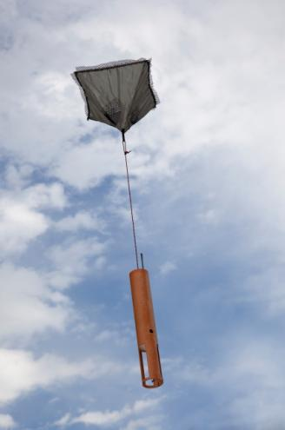

Document Version Control
Version | Date | Author | Change Description
1.0 | 3-15-2012 | Hock | Initial Document
1.1 | 8-15-2012 | Hock | Added new plot, Figure 8

TABLE OF CONTENTS
1 INTRODUCTION 1
1.1 Document Brief 1
1.2 Overview 1
2 Scientific Society Contributions 2
3 Mini Sonde Description 3
3.1 Flight Characteristics 4
3.2 Sonde Reliability 8
3.3 Aircraft Safety 8
APPENDIX 10
A. Document References 10
B. Glossary 10

LIST OF TABLES
Table 1 Mini Sonde Specifications 3
Table 2 Sonde Descent Time 4
Table 3 Mass of Mini Sonde 8

LIST OF FIGURES
Figure 1 NCAR Mini Sonde 1
Figure 2 Hurricane Forecast Improvement due to the use of GPS Sonde Observations from Synoptic Surveillance Missions 1999-204 (see appendix for reference) 2
Figure 3 Mini Sonde Components 4
Figure 4 Mini Sonde Descent Time 5
Figure 5 Sonde descent velocity 5
Figure 6 Horizontal Sonde Distance traveled 48,000 ft to 22,000 ft. 6
Figure 7 Horizontal Sonde Distance traveled 48,000 ft to surface 7
Figure 8 Horizontal Sonde Distance traveled 59,000 ft to surface 7
INTRODUCTION

Document Brief
The NSF/NCAR GV Airborne Vertical Atmospheric Profiling System (AVAPS) is a key atmospheric instrument that measures vertical profiles of ambient temperature, pressure, humidity, wind speed and wind direction. Measurements are taken by a parachuted GPS sonde that is launched from the aircraft and descend to the surface. In-situ data collected from the sonde’s sensors are transmitted back in real time to an onboard aircraft data system via radio link.
The purpose of this document is to provide a technical description and operation of the NCAR Mini Sonde.

Overview
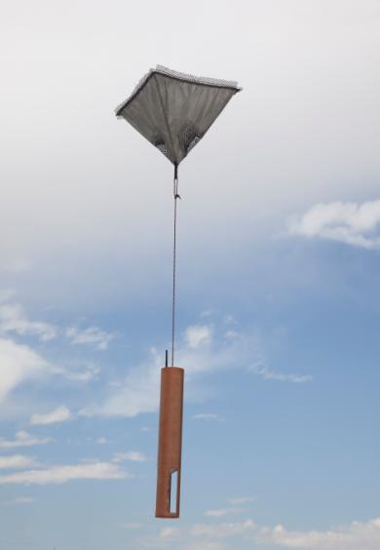
The sonde is a small electronic device which contains atmopsheric sensors: pressure, temperature, humidity and a GPS receiver to dervie winds. The sonde is launched from an aircraft where a parachute is deployed. As the sonde descendes to the earth’s surface it continoulsy measures the state of the atmoshere and telemetries this information to the research aircraft. The aircraft is equiped with dedicated hardware and sofware to process the signal from the sonde in real-time to display and archive the data. Once the sonde has reached the sureface, all data collected during the descent is sent via satellite to atmospheric research centers or the National Hurricane Center or the World Meterological Organization. The mini Sonde and aircraft is the equivalent of a standard radiosonde or weather balloon launched by the National Weater Service launched twice a day from over 100 locations in the U.S.
Figure 1 NCAR Mini Sonde
Atmospheric soundings from dropsondes provide the ability to measure conditions over remote areas such as the oceans, Polar Regions and land masses; they also provide a means to obtain soundings in and around severe weather systems, such as hurricanes. Atmospheric soundings obtained from sondes during hurricane reconnaissance flights have improved the accuracy of forecasts of hurricane landfall by about 20 percent over the decade of the 1990’s (see Figure 5, from James Franklin National Hurricane Center). The use of aircraft released sondes have had a dramatic impact on the forecast track of hurricanes, see figure 2.

The GPS Min Sonde is used by Air Force Hurricane Hunters routinely to provide critical weather information to the National Hurricane Center in Miami, FL. The

Scientific Society Contributions
Sonde are also deployed by many research aircraft worldwide to support atmospheric research to better improve forecasts of high impact weather such as winter storms, west coast extreme rains and hurricanes forecasting. In the past 15 years over 60,000 sondes have been released from aircraft worldwide with the largest percentage dropped by the U.S. Air Force Hurricane Hunters.
Dr. James Franklin, Branch Chief, Hurricane Specialist at the NOAA/NWS/National Hurricane Center says, “The sonde and its predecessors, plays a crucial role in the operations of the National Hurricane Center. These sondes provide us with accurate measurements of the minimum central pressure in a tropical cyclone – a key measure of intensity. They help NHC Hurricane Specialists determine the strength and size of a tropical cyclone’s wind field, which help determine the placement and timing of hurricanes and tropical storm watches and warnings, and provide tropospheric soundings that improve track forecasts models by 10-20%, on average, during the important watch/warning period within 48 hours of hurricane landfall on the United States coastline. The sondes have also been used as ground truth to calibrate other technologies crucial to the Nation’s hurricane warning program. The GPS sonde has become an integral part of NHC’s operations and an essential part of the forecasters’ toolkit.”
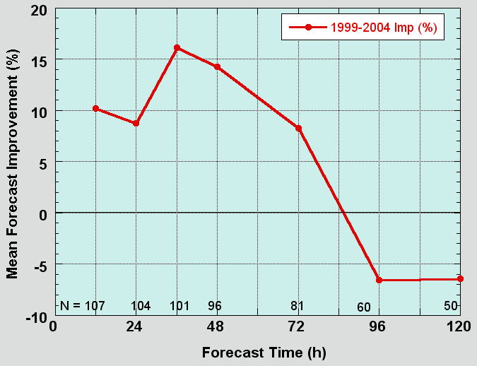
Figure 2 Hurricane Forecast Improvement due to the use of GPS Sonde Observations from Synoptic Surveillance Missions 1999-204 (see appendix for reference)

Mini Sonde Description

The mini Dropsonde is composed of a small electronic circuit board, sensors and a battery housed in a cardboard tube with a parachute. The total weight of the sonde is less than 6 ounces with dimensions of a 1.75” diameter tube 12 inches long. The inner electronic components of the dropsonde consist of precision temperature, pressure and humidity sensors, low powered telemetry transmitter, GPS receiver and a microprocessor. As the sonde descends it continuously measures the atmosphere from the release altitude to the earth’s surface. Measurements are made every half second which provides a precise detailed profile of the atmosphere. The parachute deploys from the top of the sonde within seconds of being released from the aircraft. The parachute is a specially designed for high reliability and a very stable descent. As the sonde descends the GPS receiver tracks the position and velocity of the sondes, this change in motion corresponds to the atmospheric winds. The sensor data, GPS receiver 3D position and 3D velocity along with engineering health of the sonde is all wirelessly sent via radio waves to the aircraft with a low powered transmitter operating in the 400-406 MHz Meteorological band.
The following table summarizes the technical specifications for the AVAPS mini sonde developed by NCAR.
Table 1 Mini Sonde Specifications

Mass | 5.47 oz (5.89 oz with parachute cap)
Length | 11.2” (12 inches with parachute cap)
Diameter | 1.875” (4.6 cm)
Fall Speed @ sea surface | 2165 ft/min (11m/s)
Sensors | Temperature
 | Pressure
 | Humidity
 | Wind speed & Direction
Press, Temp, RH data rate | 0.5 seconds
Wind Data rate | 0.25 seconds
Battery | 3-cell pack (CR-2 camera size cells)
RF Telemetry Band | 400-406 MHz

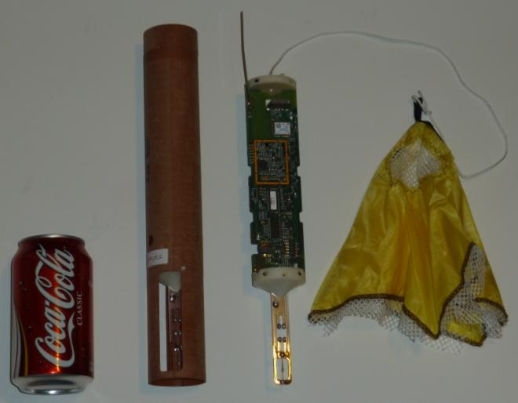
Temperature & Humidity Sensors
Sonde Body
GPS Receiver
Electronics
Parachute
Figure 3 Mini Sonde Components

Flight Characteristics

The as the sondes descend it continually slows as the air pressure density increases. Below in figures 4 and 5 are plots showing the sonde descent time and vertical velocity.

Table 2 Sonde Descent Time

Starting Altitude | Ending Altitude | Descent Time
48,000 ft. | 0 ft (sea surface) | 14.5 min
48,000 ft. | 22,000 ft. | 6.3 min
48,000 ft. | 18,000 ft. | 7.6 min
22,000 ft. | 0 ft (sea surface) | 8.2 min
18,000 ft. | 0 ft (sea surface) | 6.9 min

Figure 4 Mini Sonde Descent Time

Figure 5 Sonde descent velocity

The new NCAR mini sonde has been used on two field programs from the NASA Global Hawk research aircraft. There were a total of 223 sondes release in a variety of weather conditions and various locations throughout the northern hemisphere, Pacific Ocean, Arctic and Gulf of Mexico. Below are two graphs showing the horizontal statistical variation of how far the sonde travels from an altitude of 48,000 feet as it descend to the surface and from 48,000 feet to 22,000 feet in controlled airspace.

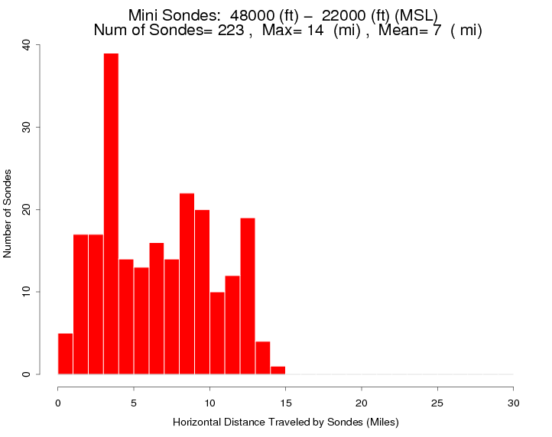
Figure 6 Horizontal Sonde Distance traveled 48,000 ft to 22,000 ft.

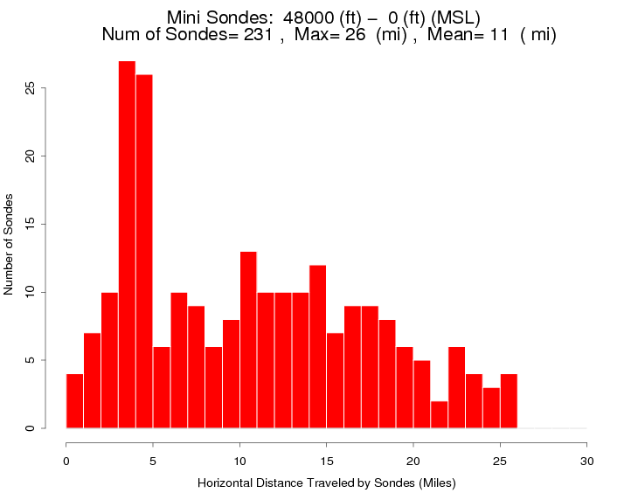
Figure 7 Horizontal Sonde Distance traveled 48,000 ft to surface

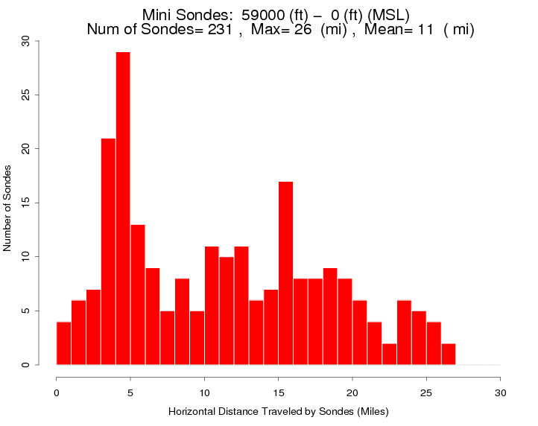
Figure 8 Horizontal Sonde Distance traveled 59,000 ft to surface

Sonde Reliability

The Mine dropsonde is the latest generation of an aircraft released sonde. The current design has been used from NASA’s unmanned aircraft Global Hawk. Over the past two years (WISPAR & HS3 2011) there have been a total of 243 sondes released in the Pacific and Gulf of Mexico, five of the sondes parachutes did not fully deploy. The descent rate of these sondes at the surface was ~5,000 feet/min. The sondes currently have a success rate of 98.4%. Improvements to the design of the sonde and improved testing during manufacturing are currently being implemented to increase the reliability of the sonde.

Aircraft Safety

FAA, Subchapter F, Part 101: Moored Balloons, Kites, Unmanned Rockets and Unmanned Free Balloons (see reference 3.)

The following paragraphs of the FAA regulations apply to radiosondes which are the same weather instrument as the mini sonde.

FAR 101.1 Applicability
(i) Carries a payload package that weighs more than four pounds and has a weight/size ratio of more than 3 oz per square inch on any surface of the package, determined by dividing the total weight in ounces of the payload package by the area in square inches of its smallest surface.

The dropsonde weighs 6.0 oz, the smallest surface area is 2.4 square inches, therefore the weight/size ratio = 6/2.4 = 2.5 oz/in2 which meets the FAR 101.1 criteria.

Table 3 Mass of Mini Sonde

Major Component | Size (in) | Area min  (in² ) | Area max (in² ) | Mass (oz) | Mass Den (oz/in² )  Min Area | Mass Den (oz/in² )  Max Area
GPS Dropsonde | 11.2 L x 1.875 D | 2.76 | 21.0 | 5.3 | 1.92 | 0.25
Case only | 11.2 L x 1.875 D | 2.76 | 21.0 | 3.0 | 1.09 | 0.14
PC Board | 6.85 x 1.75 | - | 12 | 1.1 | 0.09 | 0.40
Battery only | 1.1 x 0.63 x 1.8 | 0.693 | 1.98 | 1.2 | 1.73 | 0.606
Parachute | 7.9 x 7.9 |  | 62.4 | 0.2 |  | 0.003

FAR 101.7 Hazardous Operations
(b) No person operating any moored balloon, kite, unmanned rocket, or unmanned free balloon may allow an object to be dropped there from, if such action creates a hazard to other persons or their property.

Currently there are over 90 U.S. National Weather Service (NWS) launch sites and approximately 800 worldwide for weather balloons. NWS launches radiosondes twice a day everyday from these locations. There are over 75,000 radiosonde balloon launches every year in the US by the National Weather Service. The balloons rise at ~1,000ft/min to an altitude of ~100,000 feet. A radiosonde is typically in the air for 2-3 hours as it ascends and then descends. On ascent the radiosonde would be in controlled airspace from 18,000 ft. to 40,000 ft. for 22 minutes, while a dropsonde is only in the same range for less than 8 minutes.

Radiosonde observations are applied to a broad spectrum of efforts. Data applications include:
- Input for computer-based weather prediction models;
- Local severe storm, aviation, and marine forecasts;
- Weather and climate change research;
- Input for air pollution models;
- Ground truth for satellite data

Dr. Reinhold Busen, Chief Scientist for the DLR Falcon wrote a paper, “The Release of Dropsondes: A Hazard for Commercial Aircraft” (Busen, 2000), prior to the 1999 MAP experiment addressing the question of the probability with which meteorological sondes dropped from aircraft would collide with other aircraft flying at lower levels.

Quoting from the papers Abstract;”Real air traffic data for Germany regarding the total number of aircraft and the fleet composition are used for the calculations. An overall collision probability of about 2.6*10⁻⁶ is estimated for a randomly and uncontrolled dropped sonde to collide with an aircraft, considering peak traffic density. From this probability one collision would statistically be expected out of about 386,000 drops”.

APPENDIX

Document References
The following documents and other sources were used in the process of writing this document.
- Franklin, James,
- Busen, R., (2000), “The release of Dropsondes: A Hazard for Commercial Air Traffic”, Air Traffic Control Quarterly, Vol 8(2) 155-171.
- 14 CFR, Aeronautics and Space, Chapter I Federal Aviation Administration, Department of Transportation, Subchapter F – Air Traffic and General Operating Rules, Part 101 – Moored Balloons, kites, unmanned Rockets and Unmanned Free Balloons.

Glossary
The following terms are used in this document.
Term / Acronym | Definition
GPS | Global Positioning System
GV | Gulfstream G-V aircraft
Mini-GPS dropsonde | Dropsondes used in the Global Hawk in 2011. These are smaller than the previous generation dropsondes.
AVAPS | Airborne Vertical Atmospheric Profiling System aka Dropsonde system

Appendix C: Airborne Remote sensing Provided by the PIs (GV)

New Airborne Scientific Instrumentation
New remote-sensing instruments, on the NGV, the AMTM, Rayleigh lidar, and sodium resonance lidar are designed to work together to characterize and quantify gravity wave structures, propagation, and momentum fluxes from the GV flight level to ~100 km.

NGV Advanced Mesospheric Temperature Mapper (AMTM)
The is a new 2-D imaging system designed specifically to measure gravity wave structure (intensity and temperature) in the infrared OH emission layer in the upper mesosphere (altitude ~87 km) with an unprecedented high spatial (~4 sec integration) and temporal (<0.5 km/pixel) resolution. The AMTM utilizes a proven spectroscopic technique to remotely measure mesospheric gravity wave signatures in the OH (3,1) band airglow emission layer even in the presence of strong moonlight. Due to its high sensitivity and robust design the AMTM is very well suited for quantifying mesospheric gravity waves from the NGV aircraft as part of the Deepwave program.

The AMTM consists of three main parts: a high throughput telecentric optical system, a sensitive InGaAs (320 x256 pixels) infrared array (spectral response ~0.9-1.7 μm), and a computer controlled filter wheel fitted with narrow band (~3 μm) interference filters. The filters sequentially measure selected emission lines in the OH (3,1) band to determine mesospheric temperature and its variability induced by the gravity waves. The AMTM has been designed for operations at the L5 port (which is 18.5° off-zenith) and is mounted vertically on a standard rack to view the night sky through a double glass window (coated for IR transmission) on the GV aircraft. This provides a zenith field of view of ~60° across track and 80° along track with ~0.5 km pixel resolution (corresponding footprint ~80 km x 105 km at 87 km altitude). Figure 2 shows a sketch of the AMTM as mounted on the rack. The system was tested thoroughly during a series of test flights over the USA conducted in February/March 2013. Figure 3 shows photographs of the AMTM system as mounted on the GV for the test flights conducted in 2013 (right), as well as a recently installed IR side looking camera (left). Figure 4 shows example OH (3,1) band intensity and OH rotational temperature maps containing gravity wave structure imaged on the 22nd February test flight. The waves had a horizontal wavelength of ~30 km and were observed over Wyoming progressing with a horizontal phase speed of 44m/s.
Figure 2: Sketch of the AMTM mounted on the GV rack
Figure 1: Cartoon of AMTM mounted in the GV

To augment the AMTM zenith field measurements two additional IR cameras (each with a field of view ~40° horizontal by 30°vertical) have recently (April 2014) been mounted at the low-elevation (25°) viewing ports providing extensive broad-band (0.9-1.7 μm) OH measurements of the gravity wave field sampled by the AMTM at ranges up to ~600 km on either side of the aircraft (Figure 3, left). These combined systems will require an on-board operator for monitoring and control. Figure 5 shows a composite map obtained during ground-testing of the AMTM zenith measurements and a single narrow-field OH imager from Logan, UT, prior to uploading the instrumentation onto the aircraft in May 2014. The complementary nature of the low-elevation intensity data and the zenith AMTM temperature measurements is clearly evident enabling a much larger area of the gravity wave field to be sampled during each flight.
Figure 3: AMTM mounted inside the GV for the test flights of Feb-Mar 2013

Figure 4: OH (3,1) band intensity (left) and temperature (right) maps of the mesopause region recorded during the Feb 22nd, 2013 test flight over Wyoming. Short-period gravity waves propagating towards the ESE direction are visible in both images.

Figure 5: Projection on a map of the OH airglow intensity measured by the zenith-pointing AMTM instrument (top rectangle) and a low-elevation IR camera (large triangle), as observed from Logan, UT, on May 1st, 2014. Note the extensive gravity wave field sampled in this configuration.

Appendix D: Flight level instruments (Falcon)
The Falcon in-situ sensors include basic meteorology and turbulence measurements
(noseboom) and for various trace gases (H2O, O3, CH4, CO, CO2, N2O, SO2). The trace gas intruments include: The QCL (Quantum Cascade Laser Spectrometer) measures N2O and CO. The Picarro cavity ring down spectrometer measures O3, CH4, and CO2. The CIMS (Chemical Ionization Mass Spectrometer) measures SO2. The Waran/CR-2 combination provides H2O measurements with two different systems based on TDL (tunable diode laser hygrometer) and the high performance chilled mirror hygrometer CR-2.
Appendix E: Airborne remote sensing (Falcon); the Wind system

The 2 µm Doppler wind lidar system will sample the disturbed wind field and gravity waves over the S. Alps terrain underneath the Falcon by employing different scan strategies. Generally, the wind profiles are retrieved from LOS measurements of the Doppler lidar by the velocity–azimuth display (VAD) technique. The instrument performs a conical step-and-stare scan around the vertical axis with a nadir angle of 20°. Combined with the movement of the aircraft, this results in a cycloid scan pattern. The horizontal resolution of the wind profiles (5–10 km) is determined by the time needed for one scanner revolution (24 times 1 or 2 s as accumulation time per scan
position, plus 6 s for the scanner motion) and the aircraft velocity (160–240 m/s). The vertical resolution of 100 m is determined by the pulse length of the laser [full width at half maximum (FWHM) = 400 ns (~120 m)] and the nadir angle of 20°. Nadir pointing measurements only without scanning mode will provide vertical winds in a horizontal resolution of ~ 200 m. Additionally, the aerosol backscatter can map out the cloud field over the S. Alps. Cloud mapping is important as clouds may alter the generation of vertically propagating gravity waves. Expected cloud types include lenticular (liquid or ice) clouds, undulating alto-stratus, and sallow convective clouds.

Appendix F: ISS instruments and operations

- 150 total soundings
- Minimum altitude 20km; preferred altitude 30 to 35km
- 50 daily soundings
- 15 South Island flight days (including Falcon days)
  - 6 soundings at 3 hour intervals
  - 90 total soundings

Suite of instruments to make detailed profile of the atmosphere
ISS Components:
- Wind profiler radar
- Radiosondes soundings
- Surface meteorology
- Lab space: integrate measurements, communications
West coast site will continuously monitor on-shore flow
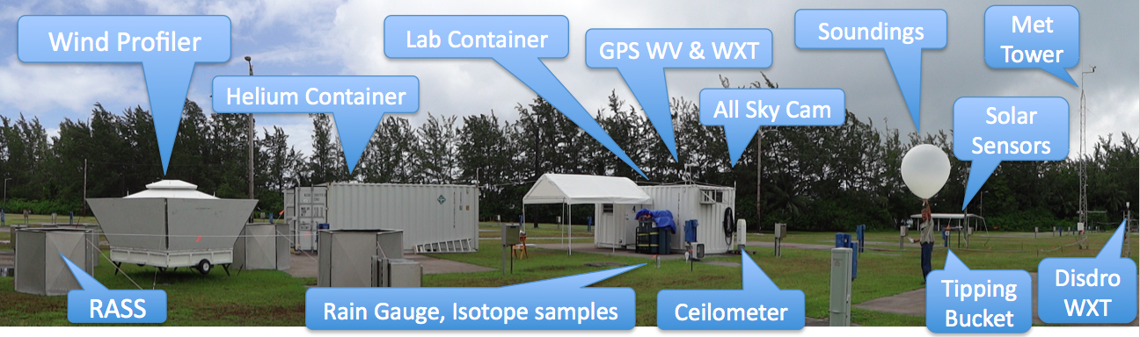
Figure F.1. Typical Deployment of Integrated Sounding System (ISS) as it will be configured in Hokitika, NZ for DEEPWAVE.

Radar Wind Profiler
- Vertically looking radar to measure wind profile
- Can also observe precip and clear-air turb
- 449 MHz (66 cm), 4 kW
- NZ radio frequency allocation approved
- Likely range 200 m up to 4 – 6 km AGL
- Spaced Antenna for rapid wind measurement
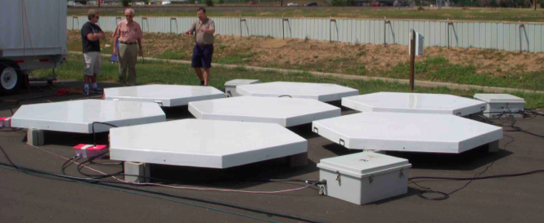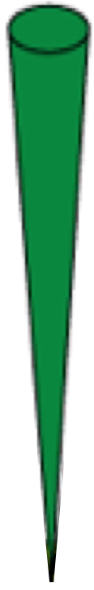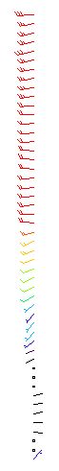
Wind
Figure F.2. The seven spaced antennas making up the new 449 MHz profiler system developed by NCAR/EOL In-situ Sensing Facility (ISF) for deployment in DEEPWAVE. Increased power and multiple antenna configurations will allow for profiles up to 4.6km above ground.

Radiosondes

- Vaisala RS-92 instrument package
measures:
Temp., Humidity, Pressure,
Wind (with GPS)
High resolution (1 sec)
- 150 soundings
- Daily launches
- IOP launches
  - 12-hourly prior to GV flights
  - 3 – 6 hourly during GV flights
  - Episodic launches
- Critical level data to WMO-GTS
- Real-time plots on web
- Mix of staff and students operators
- QC sounding within 6 months

Potential Tracks
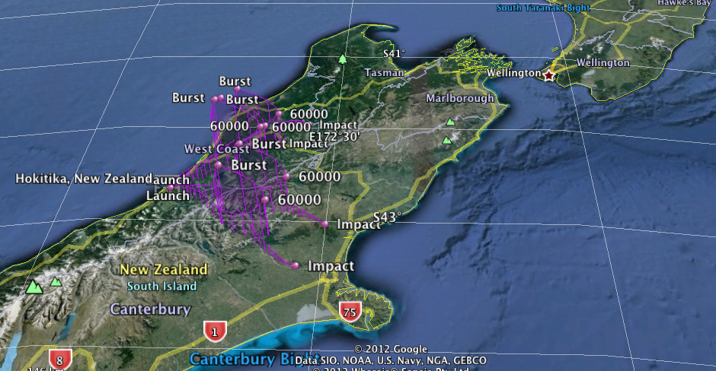
Expecting some radiosondes to go out of range in IOPS
Second receiving station at University of Canterbury
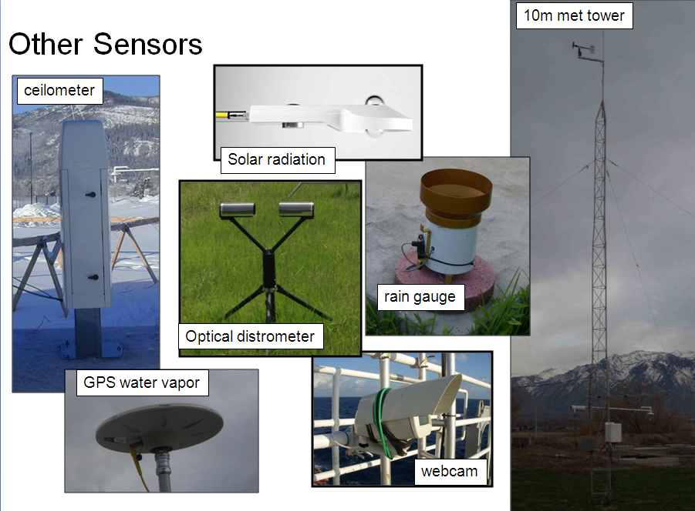

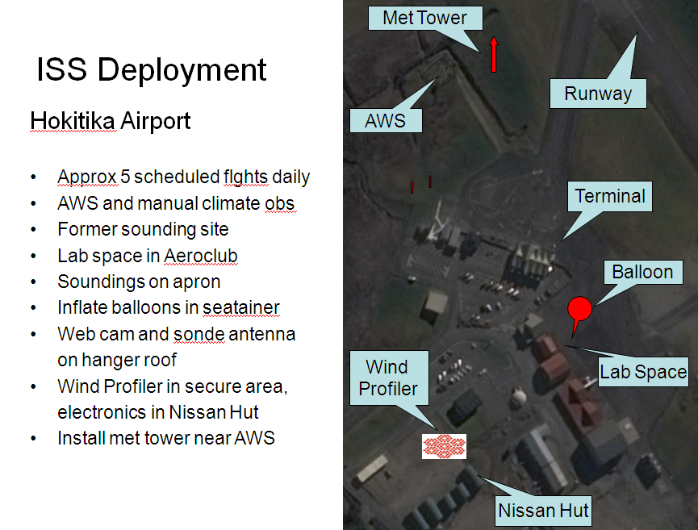
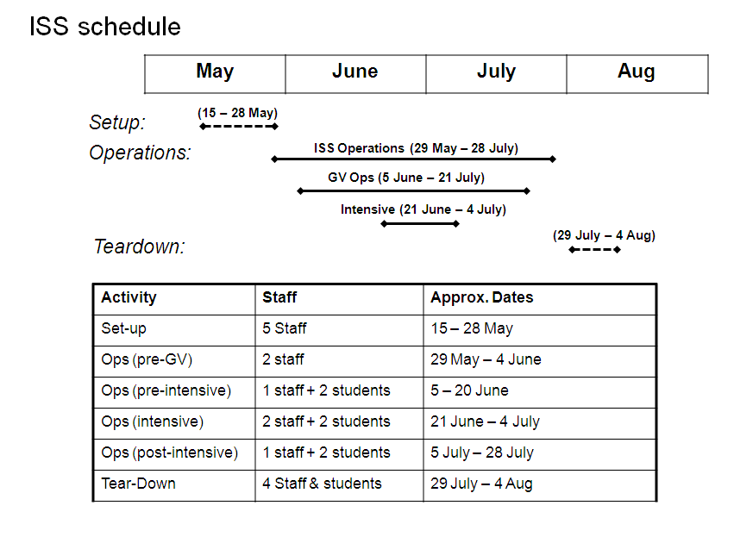
  - Appendix G: Instruments at Lauder

The balloon launching system at Lauder.

(2) radiosonde launches in a period from June 14 – July 20 2014

Purposes:
- determination of wind, temperature and humidity from the surface up to about 30 km altitude
- determination of the tropopause height
- characterization of gravity waves in the troposphere and stratosphere

Different launch techniques will be applied in coordination with the other radiosonde stations deployed during DEEPWAVE-NZ as:
- simultaneous launches of two balloons with different gas fillings
- series of balloon launches every 90 min or 180 min during IOPs

(a) Väisälä radiosonde station of the Ludwig Maximilians University Munich with 80 sondes and 600 g balloons

(b) GRAW radiosonde station of the University of Innsbruck with 20 sondes and 600 g balloons
The Lauder remote sensing instruments

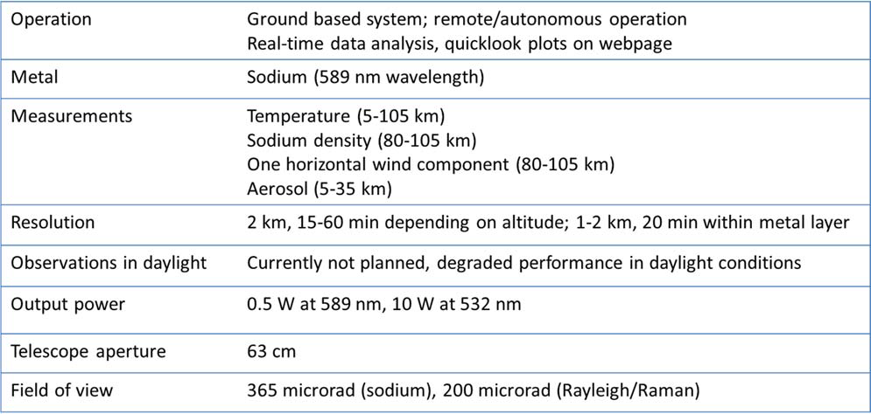

Sodium-Rayleigh-Brillouin-RamanLidar (Na-RBR)

Transmitter
0.5 W at 589 nm(Sodium resonance)
10 W at532nm

100Hz reprate
BandWidth <100 MHZ

Receiver
1 Channelat 589 nm
1Raman channelat 608 nm
2 Channels at 532 nm
1Rayleigh-Brillouinchannel

Appendix H: Haast Upper Air Soundings

Launch Site
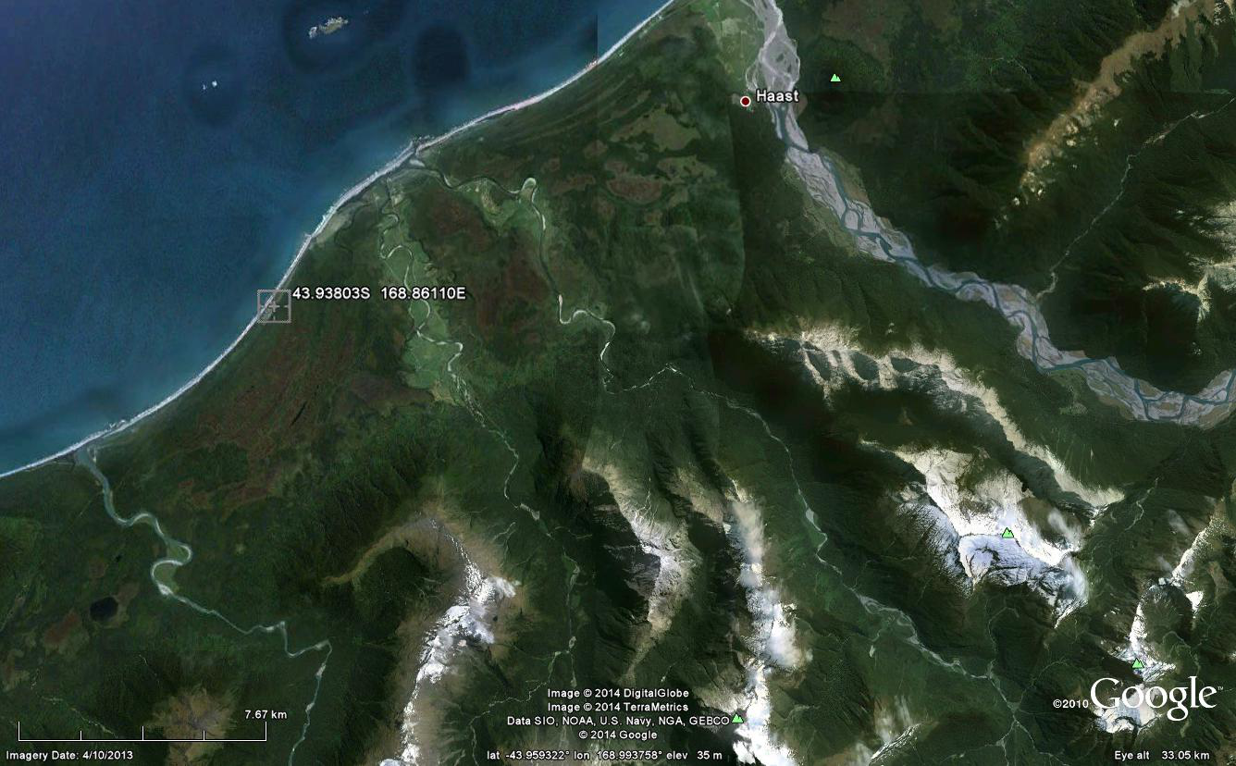All launches will be made from a site at Hannahs Clearing (43.93803S 168.86110E 2m AMSL) near Haast, New Zealand (see Figure 1).

The horizon profile from the launch site (Figure 1) is shown in Error! Reference source not found..Observing 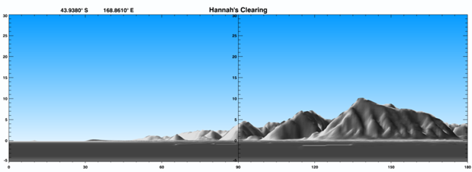
Instruments
Component | Instrument Details
Surface Measurements | NIWA Tier 2 (standard) Automatic Weather Station with a Vaisala WXT sensor providing observations of barometric pressure, humidity, precipitation, temperature, and wind speed and direction at 2.5 m above ground.
Ground station | Vaisala DigiCORA
Radiosonde | Vaisala RS92-SGPD
Balloon | Totex TA600 (600g high-altitude sounding balloon)
Gas | Helium

Data
The DigiCORA will save raw data every two seconds. From these data standard WMO PILOT and TEMP messages will be generated and made available to the GTS after balloon burst, which is expected to be around 2 hours after launch (assuming the balloon reaches ~32 km, and rises at 5 ms⁻¹ as observed for Lauder winter ozonesonde flights). The DigiCORA software will carry out standard quality control / error detection for the data submitted to the GTS. The raw data will be made
available in a suitable format for ingestion into the campaign’s data archive, within 2 months of the completion of the field campaign.

Launch Constraints
A tent-style shelter will be used to provide some protection from high winds during balloon filling operations, and launches should be achievable up to surface wind speeds of the order of 40 – 45 kts.
During declared Intensive Observing Periods, releases will be made at times that are not less than 3 hours apart.

Communication Links
The site does not have terrestrial cellular coverage. Dialup access is available from the accommodation site that the team will use. The TEMP and PILOT messages will be mailed to a GTS gateway (to be determined) for insertion onto the GTS.
Communications with the team will be provided via a satellite phone.

Staffing and Contact Details
The NIWA team will consist of:
Tony Bromley (tony.bromley@niwa.co.nz) and
Sally Gray (sally.gray@niwa.co.nz).
Address:
Waiatoto River Safari
1921 Jackson Bay Road
Hannahs Clearing
Haast 7844 New Zealand
Phone: +64 3 750 0780

Satellite Phone: 00 881 631 429 246

Appendix H: Surface based remote sensing

Sodium-Rayleigh-Brillouin-RamanLidar (Na-RBR)

Transmitter
0.5 W at 589 nm(Sodium resonance)
10 W at532nm

100Hz reprate
BandWidth <100 MHZ

Receiver
1 Channelat 589 nm
1Raman channelat 608 nm
2 Channels at 532 nm
1Rayleigh-Brillouinchannel

-,..,_-, '
Figure 1 Map of South Westland (South Island, New Zealand) indicating the location of Hannahs Clearing (43.93803S 168.86110E) with respect to the town of Haast.

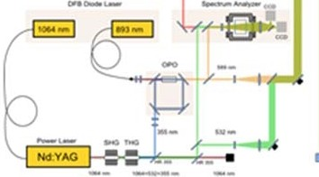

.! • D-

.,.,.,.._.
Appendix I: Australian Radiosondes
The Australian Bureau of Meteorology (BoM) operates routine radiosonde upper air soundings from a variety of sites, including Hobart Airport (42.50ºS 147.30ºE), and Macquarie Island (54.30ºS, 158.57ºE). Early DEEPWAVE science discussions identified the latter two radiosonde sounding stations as highly relevant scientifically to the gravity-wave observing objectives of DEEPWAVE.
Accordingly, the DEEPWAVE science PIs reached out to BoM in 2012-2013 to see whether additional radiosonde soundings from both sites could be accommodated during DEEPWAVE. Discussions took place with:
- David Nottage (Superintendent of Composite Operations, Observations and Engineering Branch, Australian Bureau of Meteorology, D.Nottage@bom.gov.au),
- Dr. Greg Roff (Centre for Australian Weather and Climate Research, g.roff@bom.gov.au),
- Michael Joyce (Manager, Regional Resources Network Operations Section for Obs Sys Strategy & Operations, Australian Bureau of Meteorology, m.joyce@bom.gov.au).
Decisions about additional radiosondes at Macquarie Island needed to be made in 2013, since extra radiosondes for this remote Southern Ocean location have to be committed and shipped up to a year in advance. Initial discussions with David Nottage associated a nominal cost per radiosonde of $US200, based only on the cost of consumables and an initial assumption of labor costs being waived.
These costs necessitated discussions with NSF program managers to cover these costs. Accordingly a $6000 line item cost for Australian radiosonde consumables was provided within the NSF DEEPWAVE science proposal led by Ron Smith and Dave Fritts. This $6000 total cost would assume a maximum number of 30 additional radiosondes from Hobart and Macquarie Island combined over the 2014 DEEPWAVE deployment. It should be noted that BoM, through David Nottage, purchased an additional 100 radiosonde units for 2014, so that more than 30 radiosondes could be used for DEEPWAVE if additional funding for this line item can be procured.
The Hobart radiosonde station is manned 24 hours and its routine soundings occur twice per day at 0000 UTC and 1200 UTC. A 3-hourly launch sequence spanning 24 hours could be facilitated from this location, if local officials are agreeable. Labor costs of these additional soundings will be waived at the Hobart location given that it is already manned around the clock.
The Macquarie Island station also conducts routine radiosonde soundings twice daily at 0000 UTC and 1200 UTC. At the time of writing it remains unclear whether any type of labor overtime cost will be assessed and charged by BoM for additional radiosonde launches from this remote site. We continue to work with Dr. Roff, Mr. Nottage and Mr. Joyce in providing a final official BoM decision on this issue for appropriate budgeting of this DEEPWAVE cost in time for the field deployment.
The procedure for requesting additional Hobart and/or Macquarie Island radiosonde sounding is as follows. The Deepwave Operations Center will send an email to co_srfo@bom.gov.au with the subject heading “DEEPWAVE-NZ” and will list in the body of the email text when the extra launches would be required and from which site. This email will go to the BoM OEB/Composite Operations/Field Operations Center and they would then tasks operators at Hobart and/or Macquarie Island to launch sondes as required.
Current data resolution for Hobart radiosonde soundings is 10s and at Macquarie Island is 2s, although radiosondes from Hobart can be set to 2 s on request (see above). The acquired radiosonde data are saved as meteorological messages (transmitted on the GTS) with binary data files saved within the BoM’s mass data storage system (SAM).
Appendix J: Other Surface based remote sensing
Appendix K: Satellite Data
The table in section 2d lists nadir and limb-viewing remote-sensing instruments on current operational and research satellite platforms with the necessary spatial resolution and radiometric precision to partially resolve gravity wave-induced temperature perturbations in the stratosphere. For DEEPWAVE, our primary focus is on waves resolved in high-resolution nadir imagery, since these sensors resolve deep waves of shorter horizontal wavelengths, which are believed to carry much of the energy and momentum relevant for wave driving of the middle atmospheric circulation. These waves are most relevant to the specific science objectives of DEEPWAVE. By contrast, limb sensors resolve short vertical scale gravity waves of long horizontal wavelength, which are believed to transport comparatively less momentum and energy. The tropospheric nadir channels generally cannot isolate gravity-wave activity since infrared and, to a lesser extent, microwave thermal radiances are contaminated by cloud moisture effects. By contrast, the low humidity levels in the stratosphere lead to clean extraction of gravity wave temperature perturbations in stratospheric radiance channels once large-scale structure is removed.
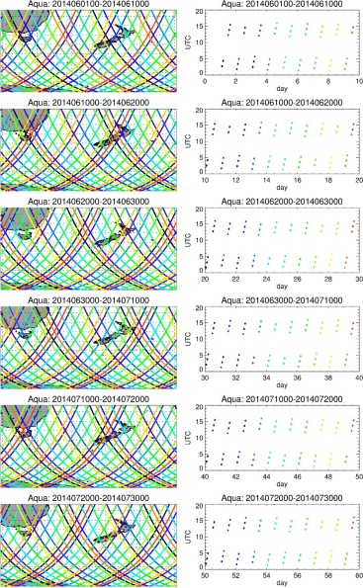
Figure K.1. Geodetic latitudes, longitudes and universal times (UTC) of the predicted Aqua subsatellite points over the DEEPWAVE RAO for the June-July 2014 deployment period. These ephemerides were calculated using two-line element (TLE) data generated on 18 May 2014 [source: NRL Space Science Division, Washington, DC].

Our primary sensor of choice for DEEPWAVE is the Atmospheric Infrared Sounder (AIRS), launched in September 2002 aboard NASA’s Aqua satellite into a 98.2º inclination polar low-Earth orbit (LEO) at an altitude of 705 km and a 1330 LT equatorial crossing time on the ascending node (LTAN). The orbital period is ~98.8 min. These ephemerides allow us to predict well ahead of time the locations and local times of satellite overpasses and swath locations at the ground, for coordinating research flights to acquire common volume measurements with AIRS. This is being provided from a pair of NRL sources:
- an interactive NexSat portal for DEEPWAVE, provided by NRL’s Marine Meteorology Division through a publically accessible web site at http://www.nrlmry.navy.mil/nexsat-bin/nexsat.cgi?BASIN=CONUS&SUB_BASIN=focus_regions&AGE=&REGION=Australia&SECTOR=DEEP_WAVE&PRODUCT=vis_ir_background&SUB_PRODUCT=goes (click on “Pass_Predictor”)
- a series of high-resolution projected ephemerides data for the Aqua and Suomi-NPP provided by the Space Science Division at NRL , plotted in Figure K.1.
AIRS is a hyperspectral infrared cross-track scanning nadir imager whose scan cycle involves 90 separate step-and-stare measurements separated in equal cross-track nadir angle increments between ±49º. The footprint resolution at the ground at the subsatellite point is ~13.5 km in diameter. This scan pattern together with the 7.5 km s⁻¹ satellite velocity sweeps of measurement swaths with a cross-track width at the ground of ~1650 km.
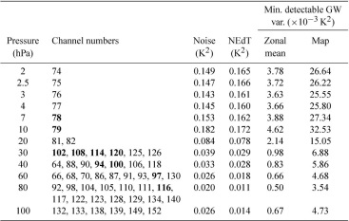
Figure K.2. List on nominal altitudes, averaged AIRS radiance channels, and levels of radiometric noise and noise-equivalent delta temperatures (K2): see Appendix A of Gong et al. (2012) for further information.

Algorithms for the extraction of stratospheric gravity-wave perturbations from AIRS Level 1B stratospheric thermal radiances are described in Eckermann and Wu (2012) and references therein. Briefly, we utilize the hyperspectral (multichannel) properties of AIRS to average radiances from a series of wavelength channels that peak at similar stratospheric altitudes (see Figure K.2), so as to reduce to radiometric noise floors and increase the signal-to-noise thresholds for gravity-wave detection. Large-scale radiance structure is fitted and removed using a two-dimensional circular along-track running average with a diameter of ~600 km. This large-scale radiance structure due to synoptic-scale temperatures and the limb darkening effect is subtracted from the raw radiance data to isolate small-scale radiance residuals due to resolved gravity-wave structure. An additional 3x3 pixel running average is applied to these radiance perturbations to increase the final signal to noise properties of the final gravity-wave radiance signals.
The routine processing of AIRS telemetry into Level 1B swatch radiances takes about 24 hours. For the DEEPWAVE practice field phase in August 2013, we utilized for the first time an additional near-real-time (NRT) Level 1B AIRS radiance product issued by the Goddard Earth Sciences Data and Information Services Center (GES DISC), described by Hearty et al. (2010). The AIRS NRT radiances typically appear in less than 3 hours. During the August 2013 practice field-phase period, we performed a detailed daily intercomparison between waves from the early NRT Level 1B radiances and those derived later from the research-quality Level 1B radiances: see http://catalog.eol.ucar.edu/deepwave_2013/ops. Few discernable differences were evident, and so gravity wave radiance structure derived from AIRS NRT Level 1B radiances will be a central product during the June-July 2014 field deployment, as well as the later research-grade Level 1B radiances. To assure fast in-field access to these radiances, we are also working with operational centers at the Naval Research Laboratory (NRL) in Monterey and the National Institute of Water and Atmospheric Research (NIWA) in New Zealand to provide even faster access to these fields and backup capabilities for processing these radiances as the data become available. In response to requests, we will also generate additional gravity-wave maps in a Mercator projection to allow better integration with EOL’s GIS tool known as Catalog Maps.
AIRS launched in 2002 and could conceivably cease operations at any moment due to temporary or permanent hardware failures. As a result, we are also working to stand up gravity-wave products from additional nadir sensors in time for the 2014 deployment. Our primary focus at the time of writing is infrared radiances from the Cross-track Infrared Sounder (CrIS) on the Suomi-NPP satellite. CrIS is an operational follow-on to AIRS and is a hyperspectral nadir infrared imager with similar scanning and radiometric properties. Timely access to the CriS radiances is more problematic than for AIRS but is being worked on at the time of writing.
Another source of satellite gravity-wave data that we are considering are microwave nadir radiances from the Advanced Microwave Sounding Unit-A sensors on NOAA satellites and Aqua (see Eckermann and Wu 2006; Eckermann et al. 2006 2007). These data are more accessible, with up to 6 different AMSU-A sensors on meteorological satellites, as well as the Advanced Technology Microwave Sounder (ATMS) on Suomi-NPP. The primary drawback with these measurements is that the footprint diameters of these measurements at the ground are around 3 times wider than those from AIRS and CrIS, which degrades the instrument’s ability to resolve small-scale gravity-wave structure. However, large-scale gravity-wave structure is still resolved, and these microwave radiances provide a good validation standard for those acquired from the infrared sounders (see, e.g., Eckermann et al. 2007).
Gravity-wave maps will be generated and delivered to the data catalogue as they are generated. We will also seek to archive the raw radiances at NRL to allow for more detailed postprocessing and scientific analysis of these data for their gravity-wave content after the mission. We also have accurate models of the vertical weighting functions of relevant AIRS and AMSU-A channels to facilitate forward modeling of three-dimensional atmospheric model fields for better comparison with these data for scientific studies, as described by Eckermann et al. (2006, 2007).

REFERENCES
Eckermann, S. D., and D. L. Wu (2006), Imaging gravity waves in lower stratospheric AMSU-A radiances, Part 1: Simple forward model, Atmos. Chem. Phys., 6, 3325-3341.
Eckermann, S. D., and D. L. Wu (2012), Satellite detection of orographic gravity-wave activity in the winter subtropical stratosphere over Australia and Africa, Geophys. Res. Lett., 39, L21807, doi:10.1029/2012GL053791.
Eckermann, S. D., D. L. Wu, J. D. Doyle, J. F. Burris, T. J. McGee, C. A. Hostetler, L. Coy, B. N. Lawrence, A. Stephens, J. P. McCormack, and T. F. Hogan (2006), Imaging gravity waves in lower stratospheric AMSU-A radiances, Part 2: Validation case study, Atmos. Chem. Phys., 6, 3343-3362.
Eckermann, S. D., J. Ma, D. L. Wu, and D. Broutman (2007), A three-dimensional mountain wave imaged in satellite radiance throughout the stratosphere: Evidence of the effects of directional wind shear, Quart. J. Roy. Meteorol. Soc., 133, 1959-1975.
Gong, J., D. L. Wu, and S. D. Eckermann (2012), Gravity wave variances and propagation derived from AIRS radiances, Atmos. Chem. Phys., 12, 1701-1720.
Hearty, T., X.-M. Hua, Y.-I. Won, A. Savtchenko, M. Theobald, B. Vollmer, E. Manning, and E. Olsen (2010), AIRS rear real time (NRT) data products, 9pp, May 10, 2010, available at http://disc.sci.gsfc.nasa.gov/nrt/additional/nrt/documentation/airs-nrt-documentation/nrt-memo.pdf

