University of California, San Diego

Aircraft Aerosol Time-of-Flight Mass Spectrometer (A-ATOFMS)

Hazardous Materials and Equipment Documentation

Date: April 7, 2011

University of California, San Diego
9500 Gilman Dr., M/C 0314
La Jolla, CA 92093-0314

Prepared By:
Kerri Denkenberger
Kaitlyn Suski
University of California, San Diego
(858) 534-7430
ksuski@ucsd.edu
1. Lasers
The A-ATOFMS utilizes three lasers: 2 continuous wave 532 nm diode-pumped solid state lasers (JDS Uniphase) and 1 ultra pulsed Nd:YAG 266 nm laser (Big Sky Laser). Documentation from JDS Uniphase and Big Sky Laser regarding these lasers is shown in the attached Appendix (2.1 and 2.2). Details related specifically to the A-ATOFMS are listed below. The entire A-ATOFMS chamber (including these 3 lasers) is vibration isolated using 4 AEK Technology Barry T-mounts (rated for 80 lb. loads each) in addition to the rack vibration isolation plate.

1.1 Two continuous wave 532 nm diode-pumped solid state lasers, 50 mW output power (JDS Uniphase, CDPS532M-050)
Please see Appendix 2.1 for details regarding these lasers from JDS Uniphase (www.jdsu.com). The lasers are mounted on the outside of the light scattering region of the A-ATOFMS (see attached schematic in Appendix 1.1). The corresponding laser power supplies will be located inside the power distribution box (previously approved by Kurt Zrubek and Mark Lord). The outputs of these lasers point directly into the metal chamber of the A-ATOFMS; there is no stray light.

1.2 One ultra pulsed CFR Nd:YAG 266 nm laser, randomly triggered to fire at up to 50 Hz, ~2.0 mJ output (Big Sky Laser)
According to Big Sky Laser (www.bigskylaser.com), this laser has been qualified to the vibration portion of the Military Standard. The laser is mounted beneath the A-ATOFMS mass spectrometer chamber (see Appendix 1.2). The corresponding laser power supply and cooler (ICE) is a 19” rack model. The output passes through or over 1 aperture and 3 mirrors before entering this mass spectrometer chamber. This entire region is shielded, so there is no stray light. During times of laser alignment, 266 nm laser goggles are worn by individuals looking at the light beam; there is no stray light during this time.

2. Radioactive Materials
2.1 Staticmaster neutralizers (Staticmaster ionizer, 1U400)
The A-ATOFMS has a small custom-made neutralizer positioned directly above the critical orifice shown in Appendix 1.1. Three Amstat Industries, Inc. (www.amstat.com) staticmaster ionizers (1” x 15/16” x 7/32”, ²¹⁰Po, 500 microcuries, Appendix 2.3) are positioned on the side of a small cylinder (6061-T6 Al-alloy) with a volume of ~3.5 inches³. This cylinder is then enclosed in another fully sealed cylinder (6061-T6 Al-alloy) and labeled UN2911. Appropriate radiation safety paperwork has been completed through Joseph Sullivan and David Skydel (UC San Diego radiation safety officers), as well as Milenda Powers (NCAR safety officer).

3. Batteries
3.1 UPS (APC SUA3000RM2U)
The vendor specifications for this APC (www.apc.com) Smart-UPS 3000VA can be found in Appendix 2.4. According to these specifications, the battery is a sealed leakproof Lead-Acid battery with suspended electrolyte. The power cord between the UPS and NCAR power box meets GV wiring specifications (similar to the previously approved A-ATOFMS electrical documentation) and uses aircraft grade plugs (eg. Pass & Seymour 5266-x).

4. Pumps
4.1 Three Turbo V81-M (969-8901)
See the attached vendor specifications (Appendix 2.5) for details regarding the Varian (www.varianinc.com) turbo V81-M pumps. These pumps are located on the dome-top and light scattering region of the A-ATOFMS (Appendix 1.1).

  - One Turbo V301 (969-8823)
See the attached vendor specifications (Appendix 2.6) for details regarding the Varian (www.varianinc.com) turbo V301 pump. This pump is located on the mass spectrometer (Appendix 1.1).

  - One IDP-3 Dry Scroll Vacuum Pump (IDP3B01)
The IDP-3 is an oil free, hermetic, dry scroll vacuum pump with a brushless motor. See the attached vendor specifications (Appendix 2.7) for more details regarding the Varian (www.varianinc.com) IDP-3 pump.

  - One KNF Micro Diaphragm Gas Pump (NMP 850.1.2 KNDC B))
See the attached vendor specifications (Appendix 2.8) for details regarding the KNF (www.knf.com) micro diaphragm gas pump.
Appendix: A-ATOFMS Hazardous Materials and Equipment Documentation

1. A-ATOFMS schematics showing mounting of lasers

1.1 Mounting of JDS Uniphase lasers
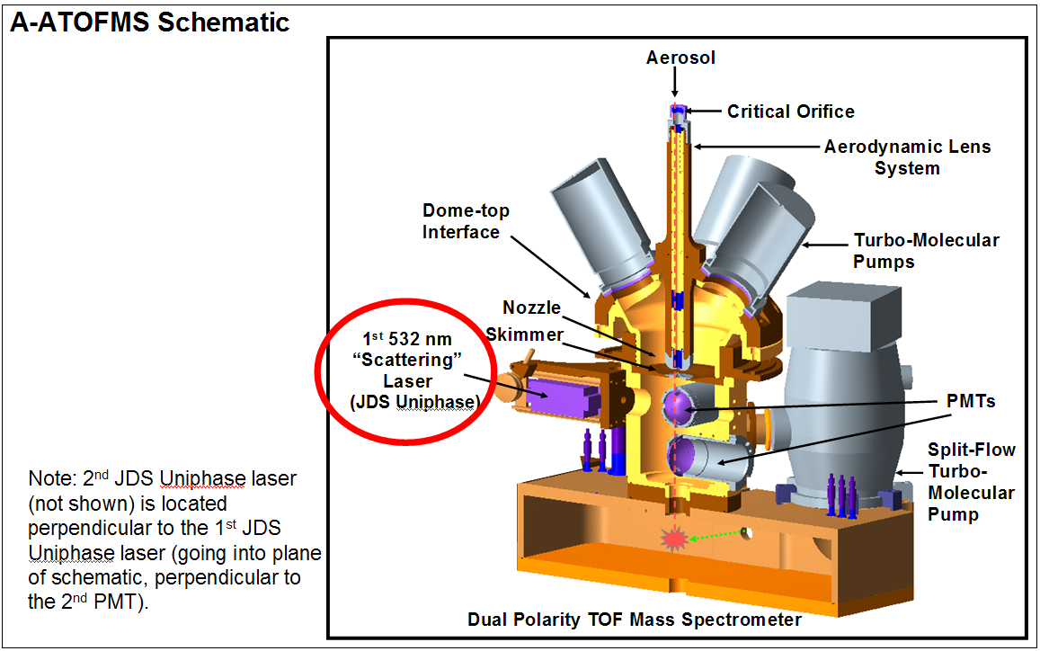

  - Mounting of Big Sky laser
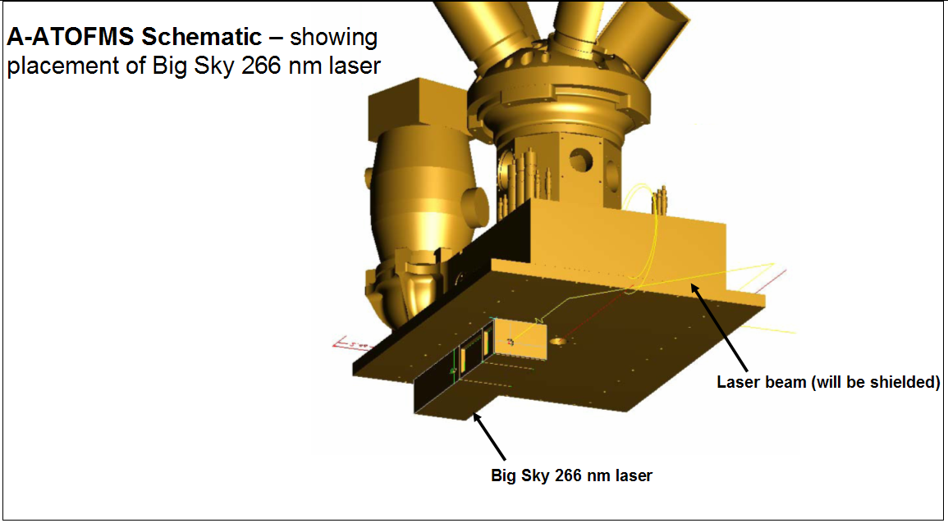

2. Vendor Specification Sheets

2.1 JDS Uniphase (www.jdsu.com) lasers: Continuous wave 532 nm diode-pumped solid state lasers (CDPS532M-050)
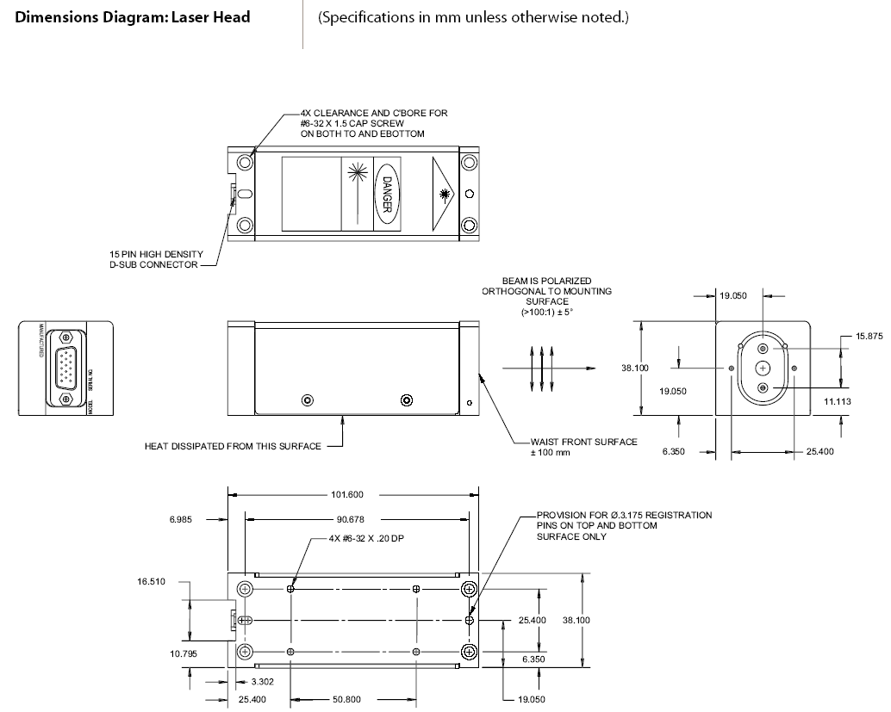

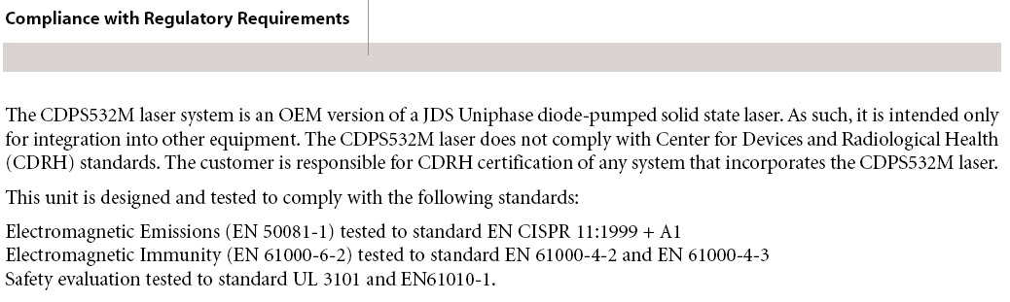

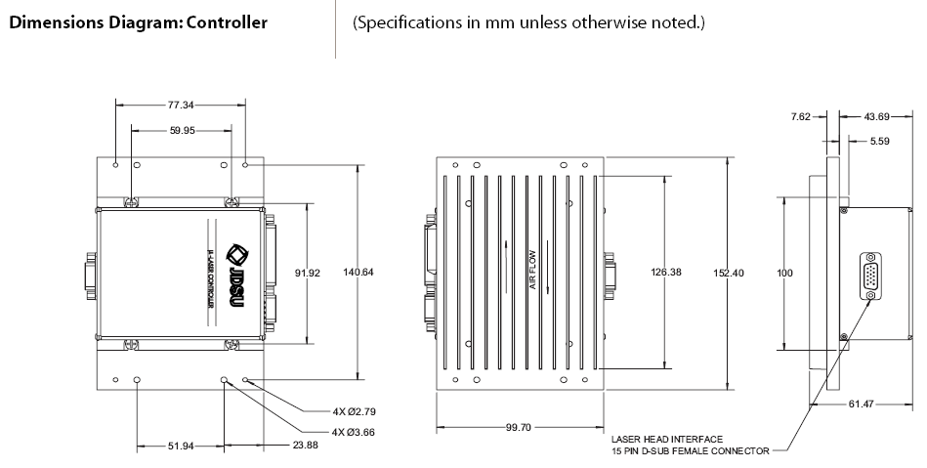

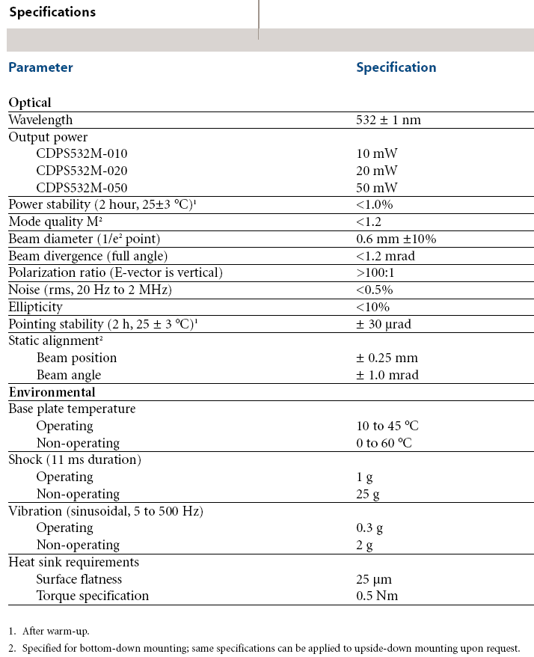

  - Big Sky (www.bigskylaser.com) laser: Ultra pulsed CFR Nd:YAG 266 nm laser (50 Hz)
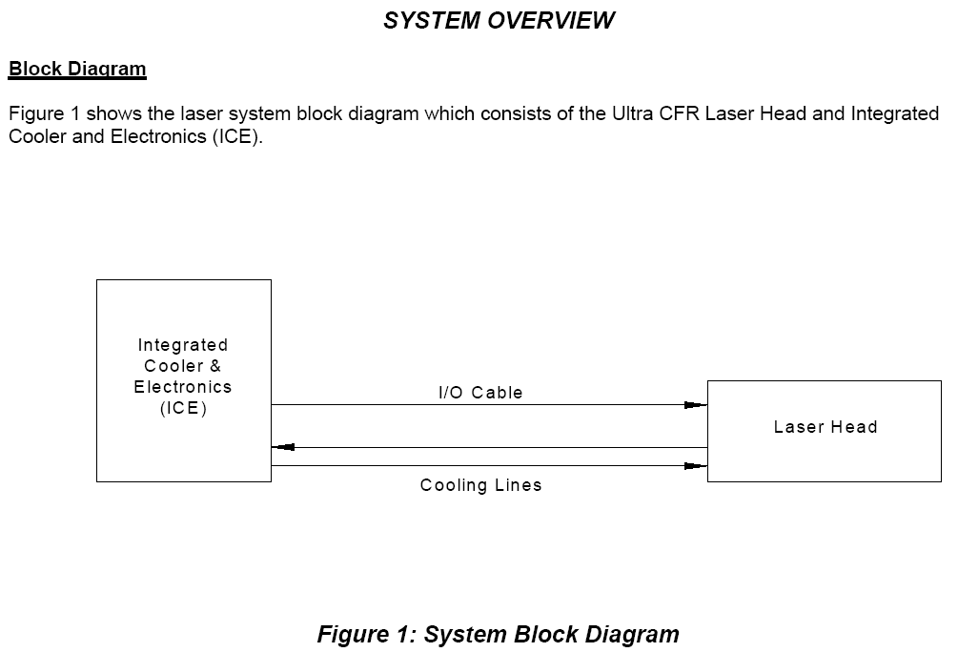

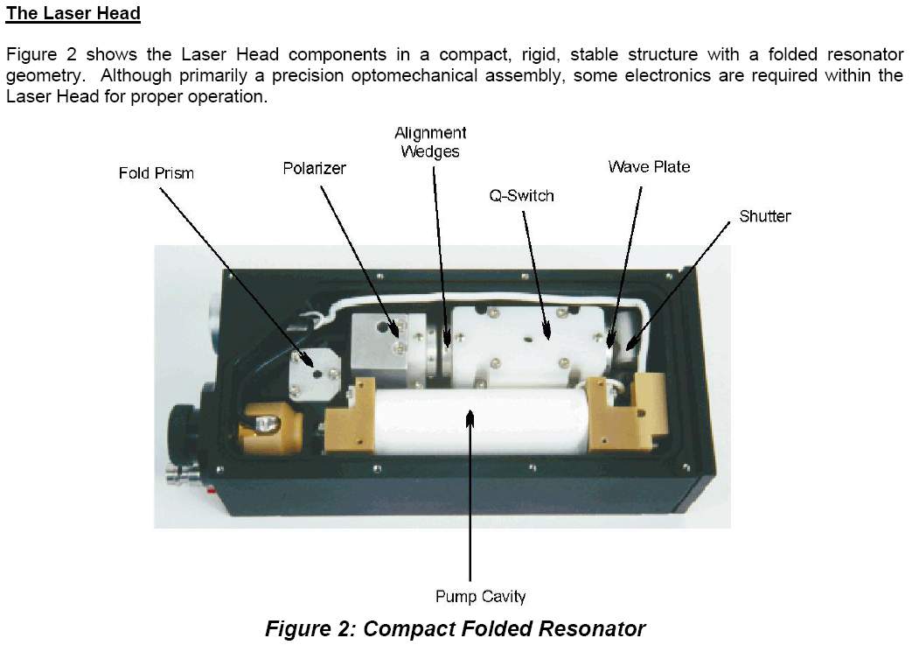
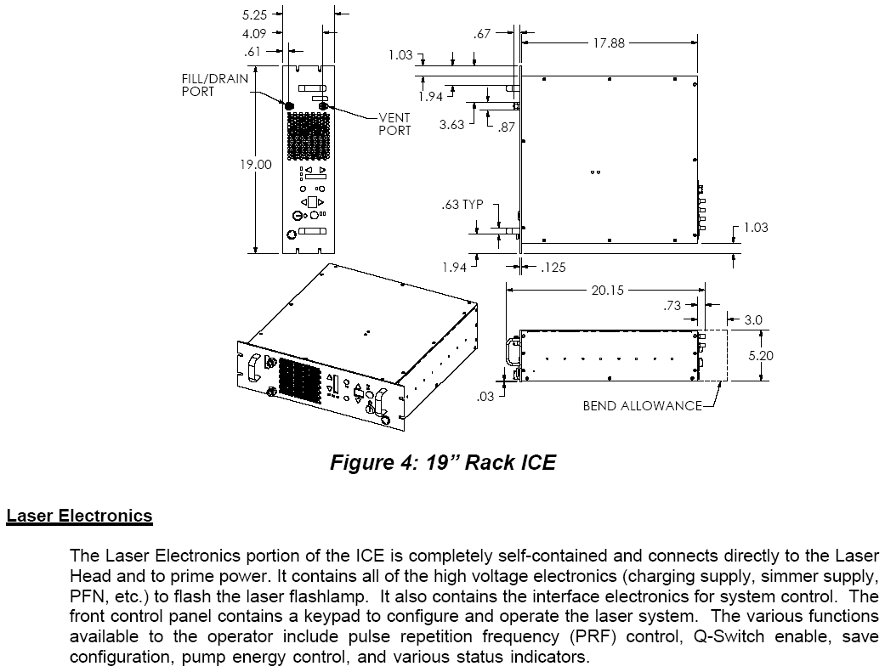

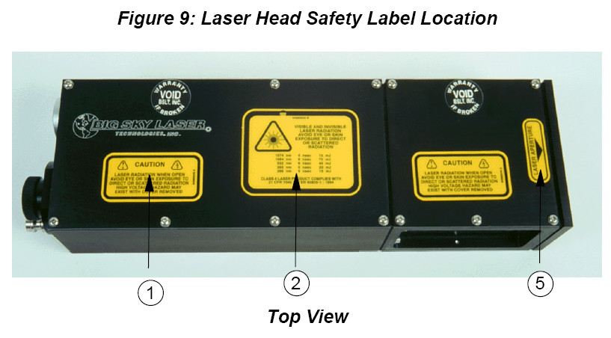
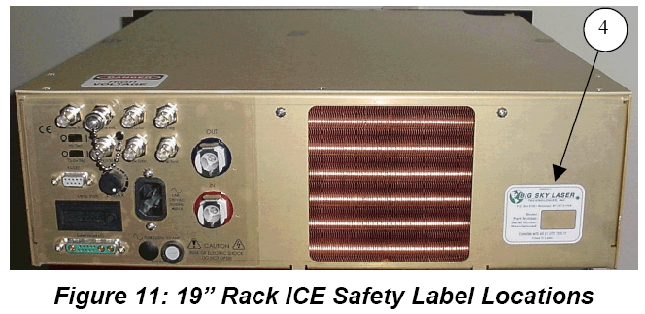

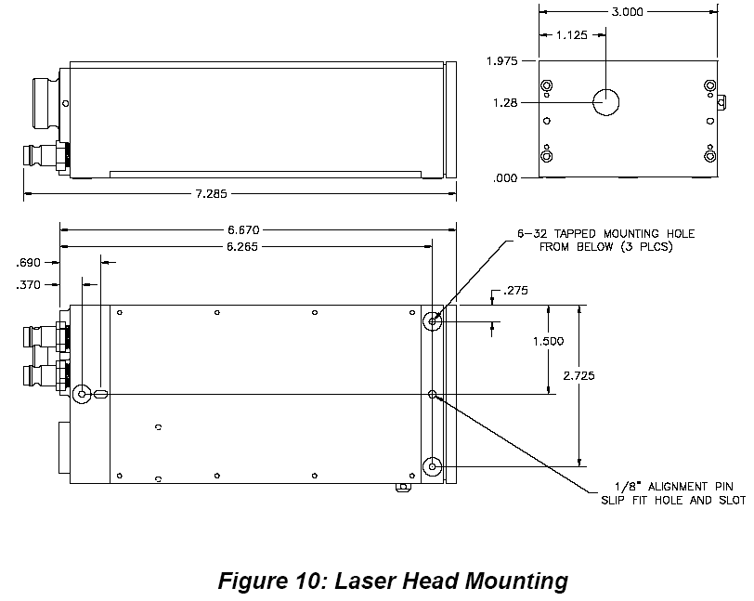

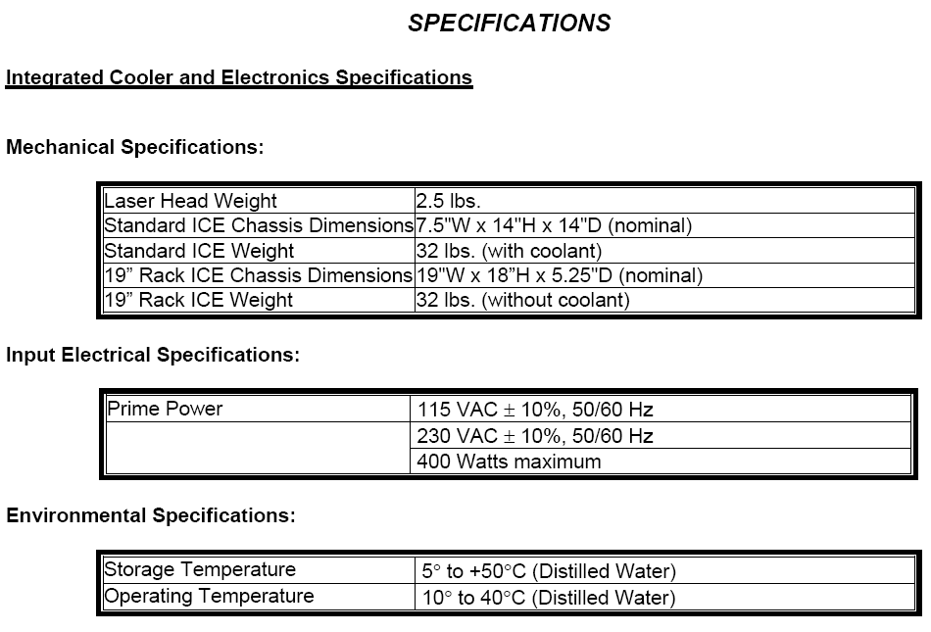
2.3 Staticmaster Ionizer (www.amstat.com)
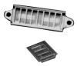

2.4 APC (www.apc.com) Smart-UPS 3000VA USB & Serial RM 2U 120V
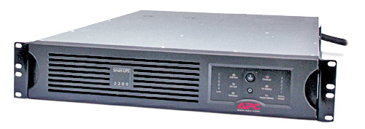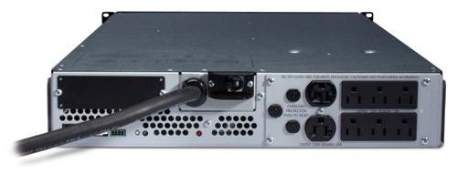
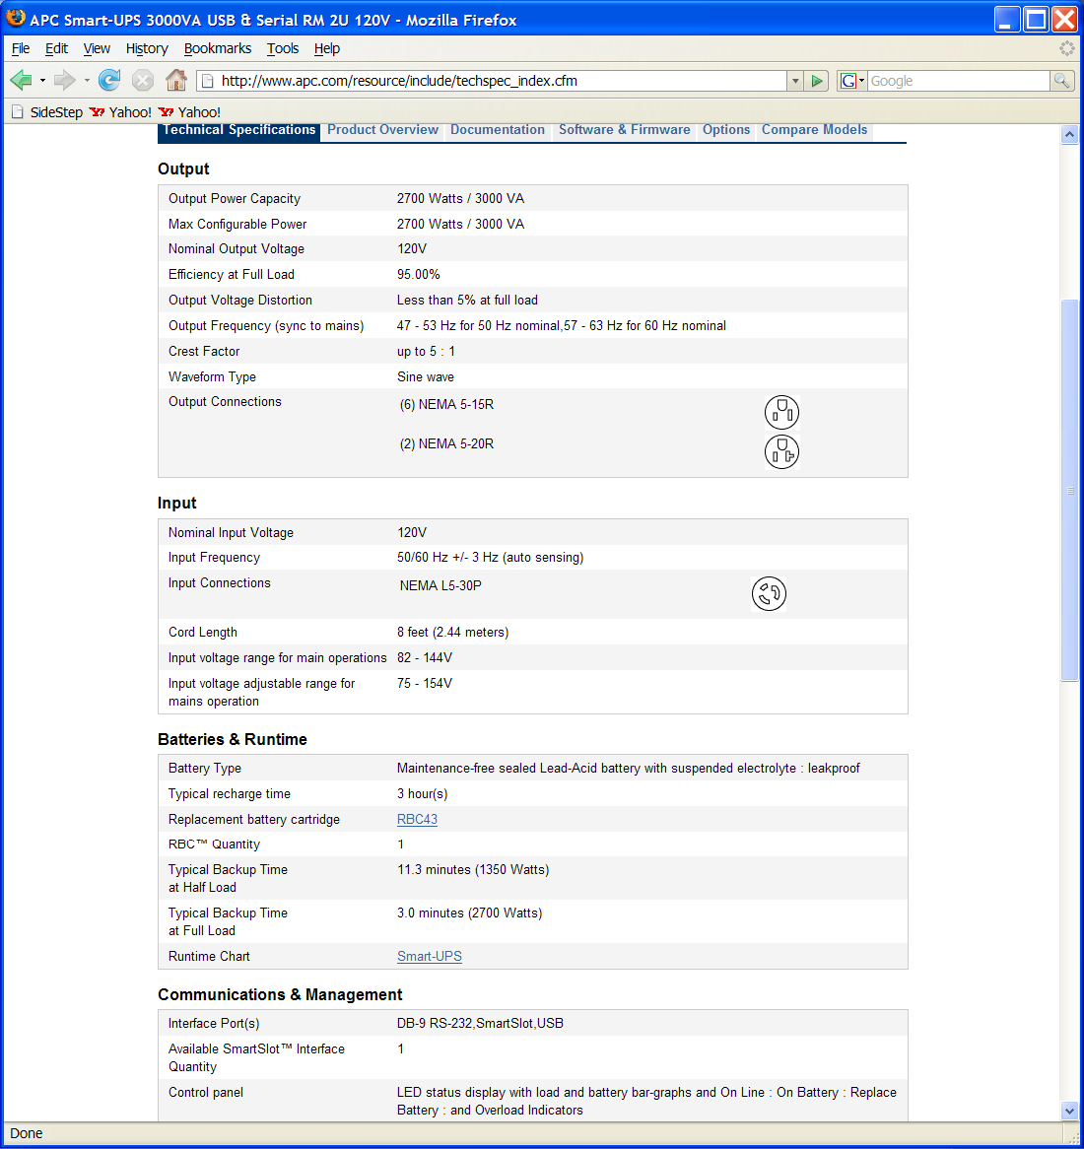

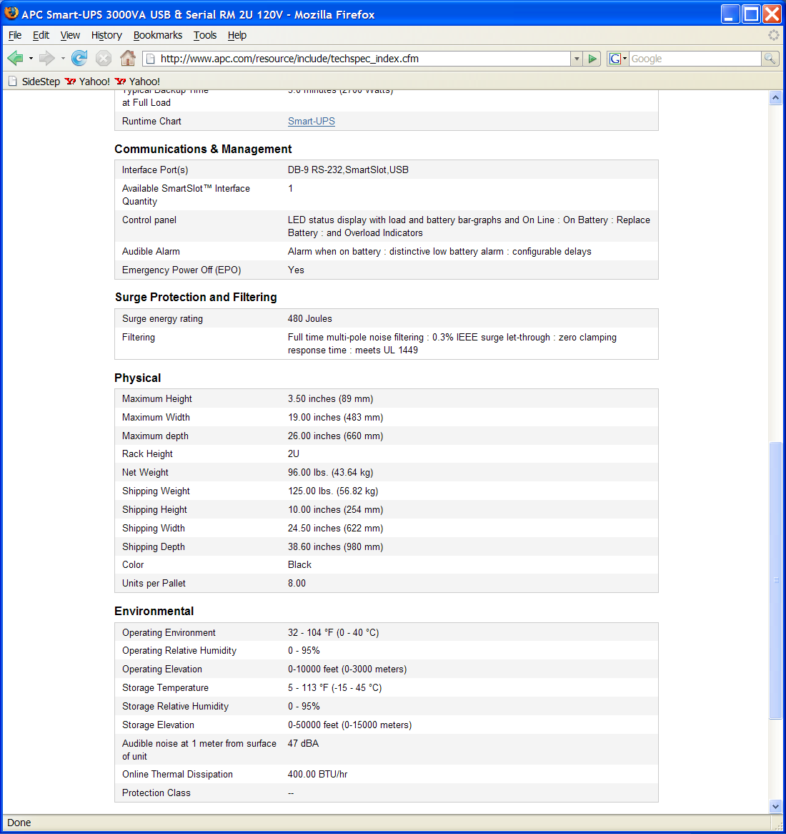

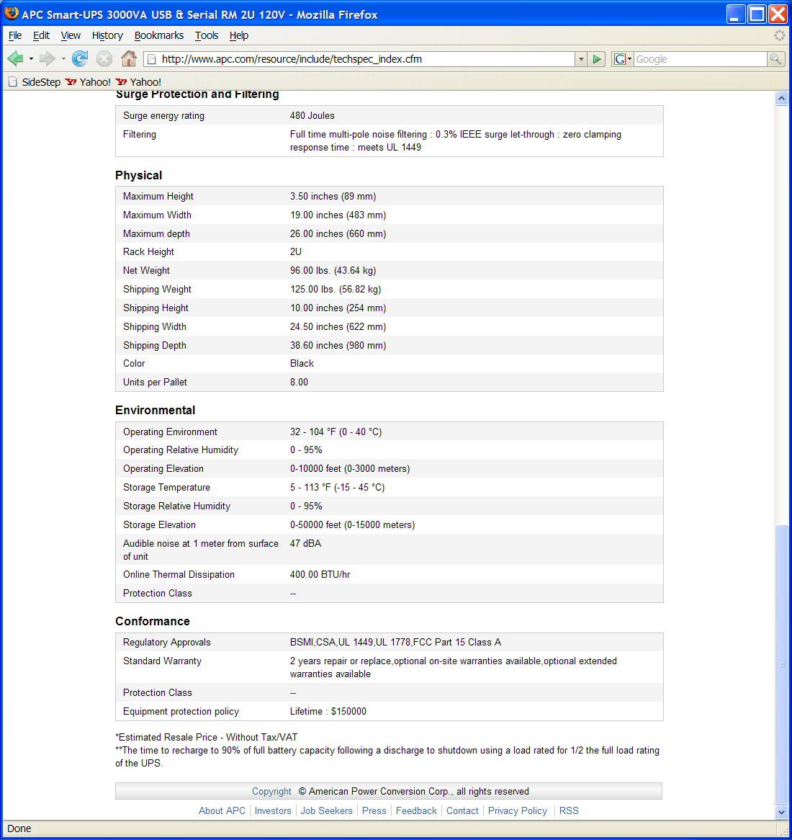
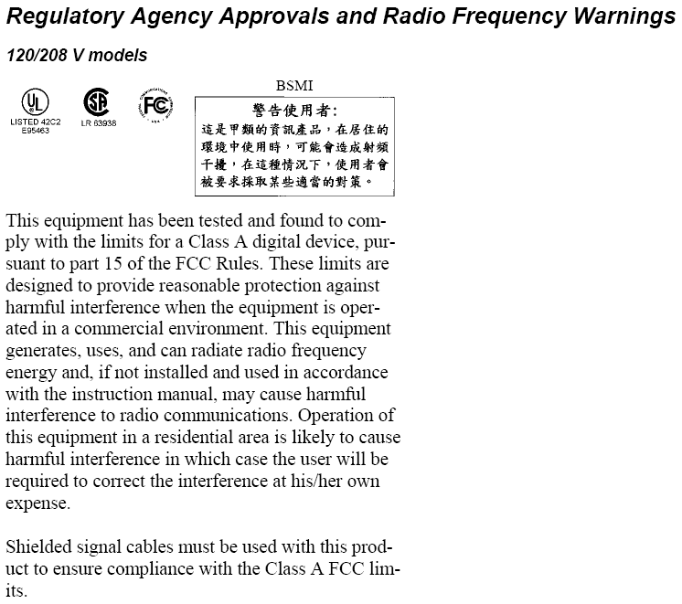

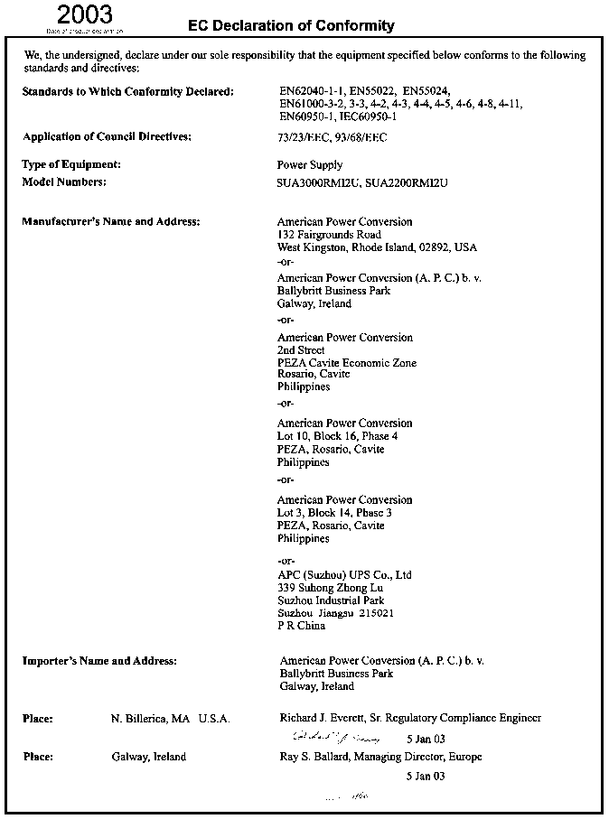

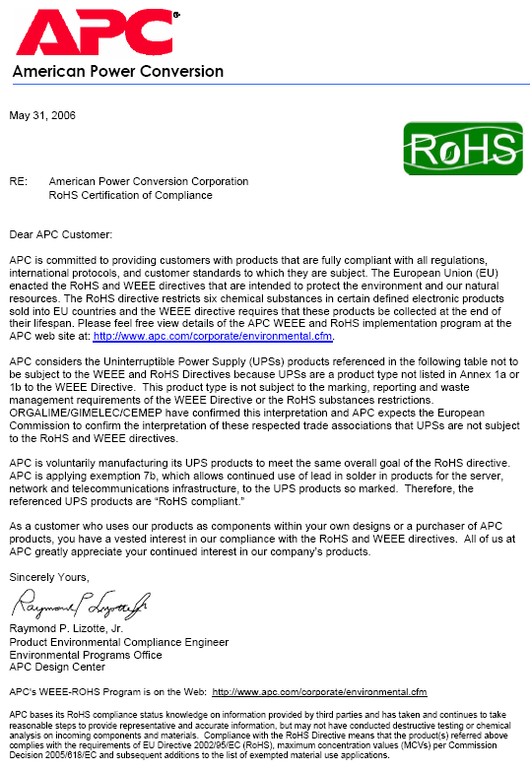
2.5 Varian (www.varianinc.com) Turbo-V81M pump (969-8901) vvv

2.6 Varian (www.varianinc.com) Turbo-V301 pump (969-8823)
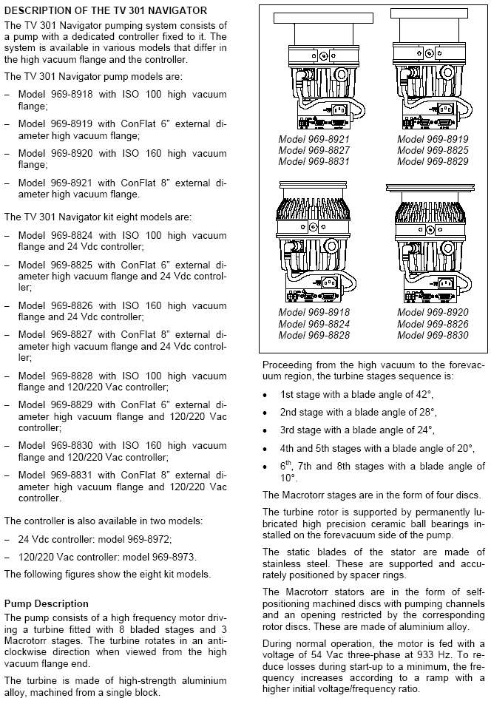

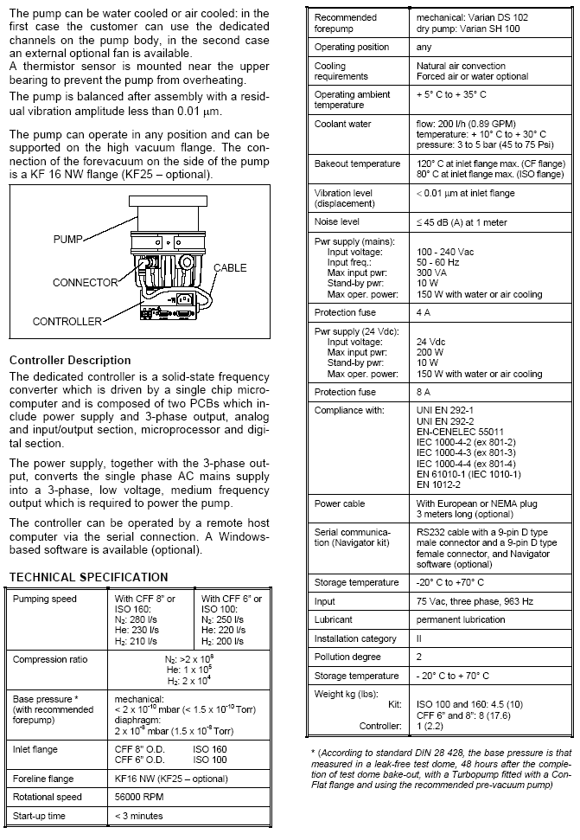
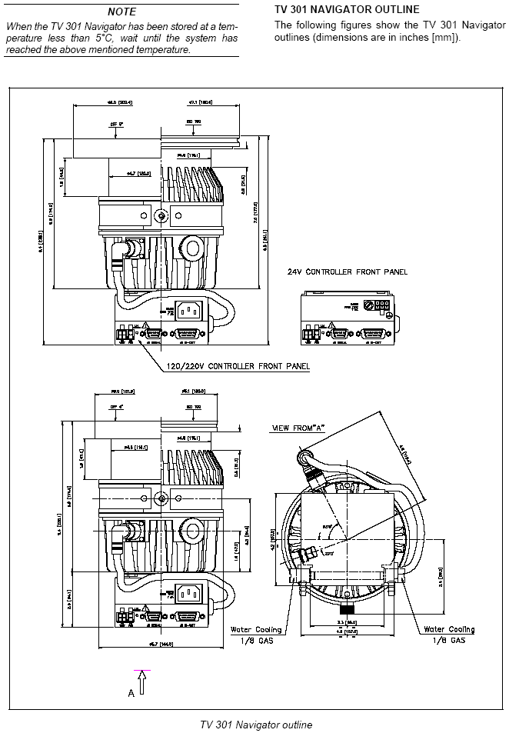

2.7 Varian (www.varianinc.com) (IDP3B01)

2.8 KNF Micro Diaphragm Gas Pump (NMP 850.1.2 KNDC B))

