Applanix GPS/IMU Performance on ARISTO-130
And Related Documentation
(September, October/2015)

Overview:
The Applanix GPS/IMU system which is part of the GISMOS HAIS instrument was flown on the C-130 for the ARISTO project and performed successfully on 4 of the 5 flights. (On RF01 it appeared to be working normally in flight but the data file was not saved before shut down of the system and it was lost.) The 18 variables, including UTC time, were recorded in a binary file and subsequently converted to ascii files and merged into “standard” RAF high-rate netCDF files for comparison to the C-130 Honeywell INS Laseref V variables of similar content. The Applanix variables were recorded at 10 Hz and the system has the capability of recording data up to 200 Hz.
The Applanix system was also flown on the GV during the DEEPWAVE project in New Zealand during June/July 2014. The system operated successfully on 12 of the 26 flights. On the flights when the system was not operating there were problems with GPS reception and the real time software was an older version that was upgraded for ARISTO. Also for ARISTO the original GISMOS PC was replaced with a new laptop. The only DEEPWAVE flight that was fully processed and merged at the high rate was RF15 which was dedicated to inflight calibration maneuvers.
Applanix data were merged into ARISTO netCDF files for comparison with other INS/GPS parameters. The comparisons gave good results in the mean and using spectral analyses with the exception of offsets in some parameters due to the location/orientation of the various systems. The Applanix data were not used to calculate a 3D wind vector as this would require merging into a ADS file or other software developments allowing the data to be synchronized with other “raw” data (e.g., AIDIFR, QC, etc.) and remove any offsets or adjustments that derived to accommodate the Honeywell INSs.
System Configuration and Installation:
For ARISTO the components relating to the Applanix system were removed from the HAIS GISMOS GV rack and installed in a C-130 rack. The rack shelf that contained the Applanix components (without the laptop computer) was modified to be able to be installed in a C-130 or GV rack (see a picture of the installation in the Appendix, figure 7).
The installation consists of a Panasonic CF-52 laptop, running Wndows 7, which was purchased by the RAF specifically for the Applanix, an inertial measurement unit (IMU) – not in the rack, a Vicor power converter (114 VAC, 400/60 Hz to 28 VDC), Applanix control unit (POSAV, Model AV SA V5, 28 VDC). There is a unique shielded cable approximately 5.5 meters long that connects the IMU to the POSAV. The system requires at least one primary GPS antenna input to the POSAV and there is a connector available for a second (auxiliary) GPS input. For ARISTO only one GPS input was used and it was from the research GPS antenna and was split several times before the input. See figure 1.
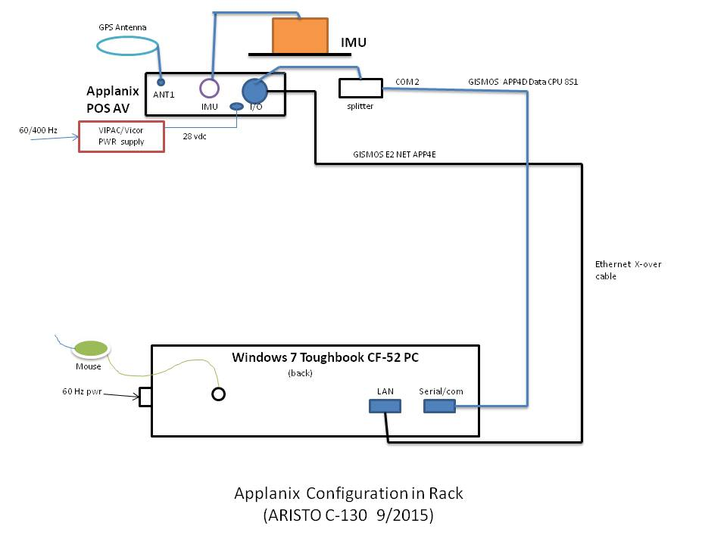
Figure 1: Physical layout on the C-130. PC Toughbook was purchased new for the system and the GPS antenna is the existing RAF C-130 research antenna.

The Applanix POSAV system consists of a “strapdown” IMU using solid state quartz accelerometers and MEMS (micro-electro-mechanical) gyros, and a POSAV computer system (PCS) that has a GPS interface (2), real-time kalman filter software, data storage (solid state disk and PCMCIA card) and I/O ports (RS-232 and ethernet) for the laptop PC GUI and data transfer. Two GPS systems are recommended for the best results in terms of accuracy.
In addition to the configuration shown above, the IMU, which is not mounted in the rack, needs to be mounted on a rigid plate and has been mounted on seat rails on the floor in the C-130 in front of the rack and for the GV, on seat rails in front of the rack. The distances between the GPS antennae being used and the IMU (“lever arms”) must be accurately measured and entered into the POSAV software in the control unit.
All code and documentation are in SVN at: http://svn.eol.ucar.edu/svn/raf/trunk/instruments/Applanix.
The data are archived within the EOL CODIAC system: http://data.eol.ucar.edu/codiac/ under the projects flown, i.e, DEEPWAVE or ARISTO. Users should contact datahelp@eol.ucar.edu for help with access.
In-flight Operation and Data Recording:
The laptop communicates with the POSAV control via a serial communications port and the real time data are recorded on the laptop via an Ethernet port. The data are also recorded internally on the POSAV (PCS) hard drive and there is also the capability to record on a PCMCIA card which must be inserted into the POSAV. For ARISTO the data were recorded on the laptop only.
It is best to start up the Applanix a minimum of 20 minutes before takeoff to insure that the system is operating properly and that the POSAV unit is communicating with the laptop computer. See Appendix B, “Applanix operation onboard C-130 or GV”.
Post Processing:
The POSAV unit combines the IMU and GPS data via a real time kalman filter to provide aircraft parameters: attitudes, position, speeds and accelerations, etc. After a flight the real time data are downloaded and extracted via Applanix proprietary program POSPac MMS v 7.1 (see Appendix C). This software runs on Windows machines and provides many files (27) of flight data including flight notes in text format. The output from one of these files, vnav_fltflnm.out, is a binary file that the RAF converts into ascii via a matlab program developed by Kelly Schick. (The name of the onboard data file is established when the Applanix system is powered up on the aircraft.) The data rates are set by the control program and the RAF has used 10 Hz for ARISTO – rates up to 200 Hz are available. There are 17 variables beginning with GPS time in seconds output to the vnav file. Before running the matlab program, to get UTC time the day of the week starting with Sunday must be entered on line 92 (Sunday =0, Monday =1, etc.) – see instructions for using matlab code.
The ascii file produced by the matlab code can then be merged with a nctCDF file. This has been done using an “R” software program written by Al Cooper (ReadARISTOAppx.R) and it can merge at either the high rate (25 Hz) or 1 second averages. For the high rate merge the Applanix data are linearly interpolated to 25 Hz from 10 Hz and then smoothed using Savitzky-Golay polynomials (3rd order, spanning 7 points).
The processing described is using real time data from the Applanix. This is not to be confused with the more sophisticated post-processing software programs available from Applanix that use the raw variables sampled in real time and applies forward and reverse kalman filtering. A software license must be obtained from Applanix at a cost of ~ $22K.

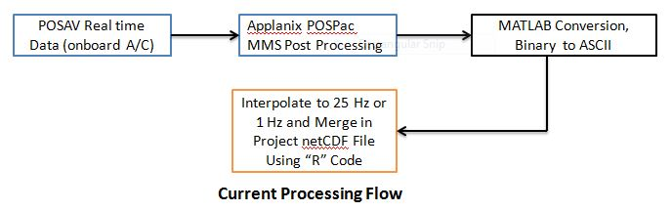
Figure 2: Schematic of data flow from the onboard PCS and ground processing. The POSPac MMS post processing only formats and organizes the real time data and message logs into separate files for viewing or further processing.
Data Analysis and Results:
As mentioned above the Applanix system performed flawlessly on the C-130 ARISTO project. The data file on flight RF01 was lost due to operator inexperience but inflight monitoring indicated that it was working properly. Due to many problems with the system on DEEPWAVE subsequent processing of only one of the 12 partially successful flights was processed and merged – this was RF15 which was dedicated to calibration maneuvers and some results are presented here in addition to ARISTO data. The Applanix data has only been sampled at 10 Hz on these two deployments giving a 5 Hz cutoff for spectral analysis. For comparison with other onboard inertial and GPS systems recorded at higher rates (25Hz), Applanix variables were linearly interpolated to 25 Hz and then smoothed using Savitzky-Golay polynomials and merged onto RAF netCDF files via R code provided by Cooper.

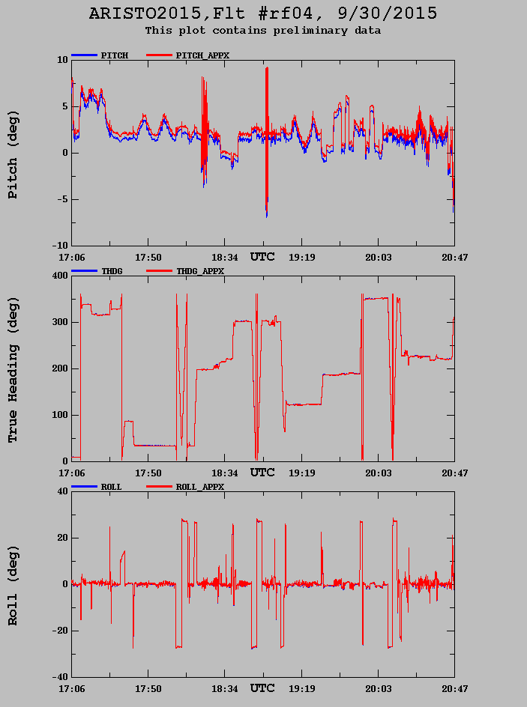
Figure 3: Comparison of pitch, roll and heading from the Applanix and Honeywell inertial systems for ARISTO RF04. The Applanix real time data has a kalman filter applied; the Honeywell Laseref V system has not applied a kalman filter.
While the data from all four of the ARISTO flights where it was recorded have been processed, the data presented here is from RF04. It is representative of all of the four flights and has some maneuvers that are interesting. As mentioned above the Applanix data were sampled at 10 Hz and interpolated to 25 Hz. It is realistic to question whether there are offsets in time as the “standard” C-130 data set and the Applanix data were recorded on separate systems that were not linked but both were using GPS time (corrected to UTC time in the Applanix post-processing). There could also be potential for offset in the interpolation process but none is apparent from either source.
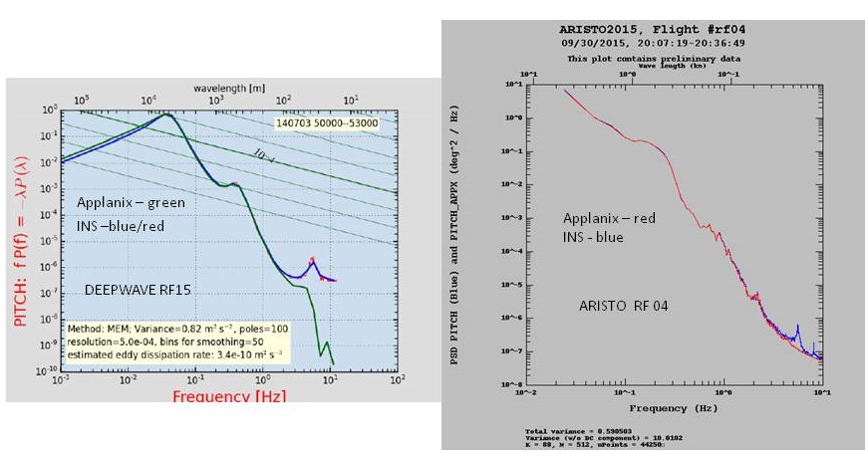
Figure 4: Power spectral density plots from DEEPWAVE (left) and ARSITO (right) comparing the pitch variable from the Honeywell Laseref IV and V inertial systems (INS) and the Applanix. Note the spike in pitch in the INS.
The figures show examples of the aircraft attitudes (pitch, roll and heading). The spectra plots for pitch show a spike around 4 to 5 Hz in the INS but not in the Applanix. This is probably not real as it shows up in the GV and C-130 and could be a result of filtering or noise. In figure 4 the aircraft vertical velocity spectra from the INS on the C-130 the GPS and the Applanix in level flight. The INS and

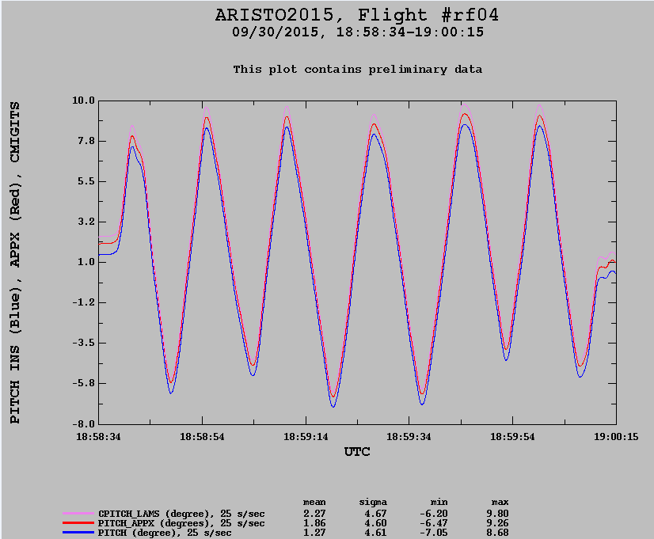
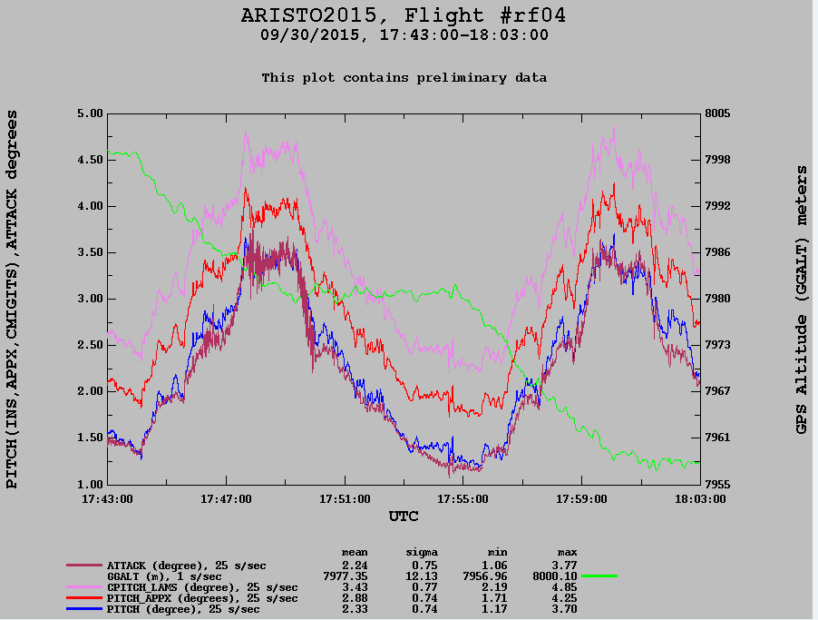
Figure 5: The top plot shows measures of pitch from the INS, the Applanix, and the GPS/IMU in the LAMS pod during a pitch maneuver. The bottom plot shows the same three in straight and (almost) level flight. Altitude on the right. Also the attack from the radome. One would expect it to track the primary INS pitch if the appropriate calibrations and adjustments have been made.
Applanix gives similar results but there is a peak in the INS around 5 Hz which may be due to the peak in the INS pitch spectra.
Figure 5 shows the pitch angle as measured by the Honeywell INS, the Applanix and the Systron Donner SDN 500 GPS/IMU (an updated version of the CMIGITS used in previous LAMS and gust pods) which is in the wing mounted gust pod. The top plot shows the pitch angles in a pitch maneuver and the bottom plot is a period of about 20 minutes where there is a slow step change in altitude of ~ 50 meters. In both of these examples close examination shows that the attitude measurements are very close in their fluctuations and trends but have offsets in the mean that are constant within “noise” limits (e.g. PITCH – PITCH_APPX ~ 0.55, ROLL-ROLL_ APPX ~ 0.04, THDG-THDG_APPX~ 0.32 degrees). The Honeywell systems (INS, Laseref IV, V) have the capabilty of real time kalman fitlering using the avionics GPS, but this is only available on the C-130 and has outputs of position (Lat/Lon) and groundspeed but they are not being used. The SDN 500 uses real time kalman filtering as does the Applanix. The offsets are most likely due to the locations of the various INS systems in the C-130 relative to each other and the primary axes of the aircraft. Presumably calculations to resolve the offsets based on the relative positions and the rotation of the aircraft could be made but have not been done.
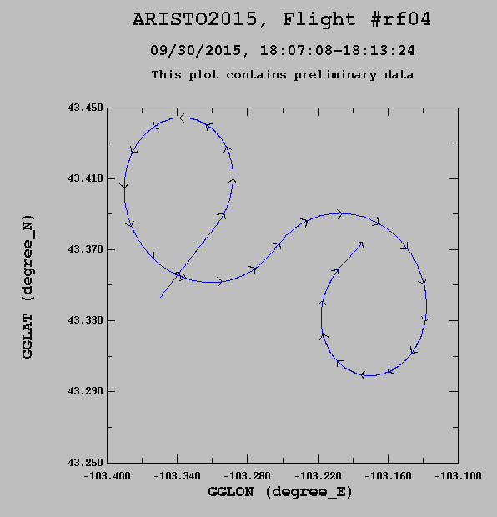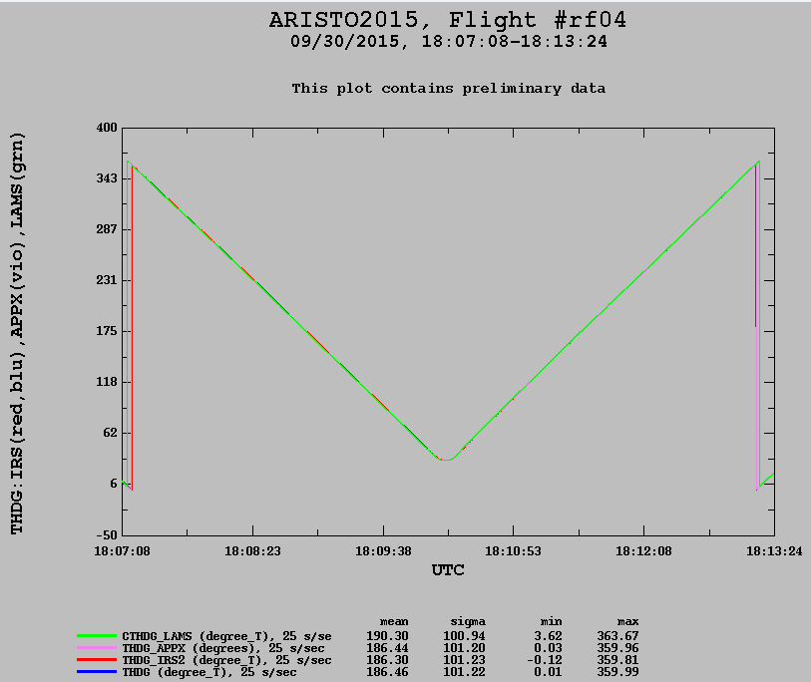
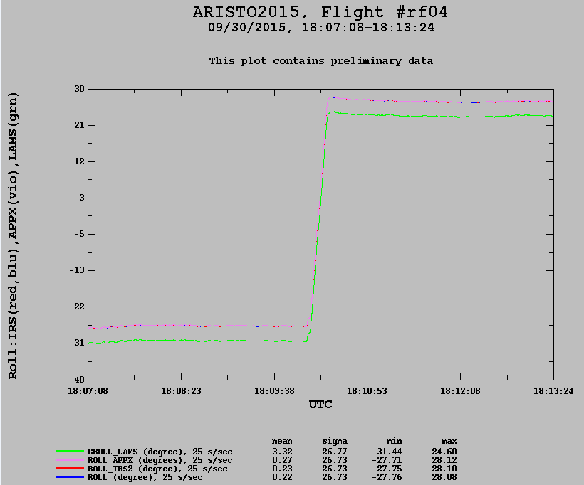
Figure 6: Plots during a 360 degree circle maneuver. Top left shows the C-130 track; top right the true heading (THDG) from five of the inertial/GPS systems and; bottom roll from the five systems.
Figure 6 is showing the roll and heading (THDG) attiudes from the two Honewywell INSs, the Applanix and the SDN500 (CROLL_LAMS) during two 360 degree cirlces in opposite directions. The agreement is very good with, again, the offsets in the mean due to the different locations of the systems in the C-130.

Conclusions and Recommendations: Data from both ARISTO and DEEPWAVE show that the real time Applanix data compare well with the Honeywell IRUs and the GPS systems on the C-130 and GV (For detailed DEEPWAVE analysis see Cooper’s memo, First Look at Applanix Measurements, 8/23/2015.) Comparisons between attitude angles (pitch, roll, yaw) are very good in the mean and for the most part in the 25 Hz interpolated data with the exception of a few “spikes” of unknown origin. There are offsets between these measurements due primarily to the different locations and orientation in the C-130 of the inertial sensors. The offsets differ somewhat between DEEPWAVE (GV) and ARISTO (C-130) and are nearly constant in the C-130 during the entire flight leading to the conclusion that they are due to different locations of the systems in the C-130. This offset is not as apparent in the DEEPWAVE data set possibly because the Applanix was mounted in the same position as when it was part of GISMOS and the location had been surveyed to an uncertainty of a centimeter or less. On the C-130 the location was determined from aircraft structural drawings and the uncertainty is undetermined but on the order of inches.
This report only considers the comparisons of the inertial and inertial/GPS systems and does not address the other measurements that go into the 3D wind calculations , i.e. dynamic and static pressures, attack and sideslip angles, and to a lesser degree temperature. The comparisons shown for ARISTO C-130 show the “INS” measurements PITCH, ROLL, and THDG which are from the primary Honeywell Laseref V SM (there are three on the C-130) which is not using a kalman filter. (The “primary” refers to the inertial data that is used in the wind calculations.) Table 1 shows the accuracy specifications supplied by the manufacturers of the different INS/GPS systems. The Honeywell Laseref V SM (SM=special missions) has improved accuracy over the non-SM due to “hand selected” and calibrated components, otherwise the IV and V have the same specifications.

INS/GPS  Parameter | Honeywell Laseref IV GV | Honeywell Laseref V SM C-130 | Systron-Donner SDN500 | Applanix 510 RTX | Applanix 510  Post-Processed | Applanix 610  Post-Processed
Pitch, Roll Angle deg | 0.050¹ | 0.025 ¹ | 0.057³ | 0.008 ⁴ | 0.005⁴ | 0.0025⁴
True Heading deg | 0.20¹ | 0.05¹ | 0.086³ | 0.040⁴ | 0.008⁴ | 0.0050⁴
Horizontal Velocity m/sec | 1.0¹ | 0.5¹ | 0.41³ | 0.050⁴ | 0.005⁴ | 0.005⁴
Vertical Velocity m/sec | 0.47² | 0.47² | 0.29³ | Not specified | Not specified | Not specified
¹ 1 sigma accuracy by manufacturer ² 2 sigma accuracy by manufacturer ³ 3 sigma error Systron-Donner
⁴ Max RMS error – Absolute Accuracy Specifications, typical performance. From manufacturer.
Table 1: Performance specifications from manufacturers. The SDN500 (replacement for CMIGITS) and the Applanix use kalman filtering in real-time. Applanix has additional post processing software available. RTX refers to real-time.
These specifications indicate that the Applanix systems with kalman post-processing are the superior systems. (The Applanix system currently in use is the 510. The 610 is the latest model available from Applanix.) Due to these small numbers (differences and statistics) it is difficult to resolve differences from the many plots even if one takes into account the offsets owing to location in the aircraft, time offsets between systems, filtering delays in the Honeywell INS, interpolation, etc. A more exhaustive analysis would have to be done and incorporation of the Applanix into the primary processing to have the 3D wind analysis. In the implementation of a kalman filter time phasing between the GPS and inertial components used is critical. In the current nimbus processing the calibrations, time offsets, etc. have been “tuned” or adjusted to the Honeywell INS characteristics and a complimentary filter is used to combine the GPS and INS variables. These adjustments, uncertainties and computations are discussed in detail in the draft NCAR Technical Note “Characterization of Uncertainty in the Measurements of Wind from the NSF/NCAR Gulfstream V Research Aircraft”. While this refers to the GV similar processing code is used for the C 130 with adjustments and tuning made for the Honeywell INS and the other parameters (e.g., radome, static pressure, etc.) used to calculate 3D winds. Recently Al Cooper has been working on developing a Kalman filter using data from the GV and RF15 from DEEPWAVE. This is still a work in progress.
For the future the GV and C-130 would benefit from GPS/INS systems that use kalman filtering to get the optimum aircraft attitudes and position where pitch and true heading are the most critical for the vertical and horizontal wind measurements. The RAF should get the best possible aircraft parameters ( attitudes, position and speed) these GPS/INS systems can provide and then concentrate on the measurements of the wind relative to the aircraft without having to make adjustments to these systems. The Applanix systems are used on many research aircraft including several NASA aircraft, the Wyoming King Air, the UND Citation and the CIRPAS Twin Otter and they are very happy with the results. To get the most accurate data from the Applanix the RAF would need to invest in the post-processing software at a cost of ~ $22 K for the license with a $2K annual support fee.
The advantage of a commercial GPS/INS unit with the associated Kalman filter processing software over an in-house developed package is the access to ongoing software upgrades and support for both software and hardware without having to RAF staff to support a complex software package. Additionally Applanix has a large user base (not limited to the airborne science community), extensive documentation on all aspects of the system and the Applanix post-processing software which can use multiple GPS antennae with L1/L2 , DGPS and does not have the time offsets associated with the Honeywell systems that must be accounted for.
Acknowledgements:
Ta Viet Hung for modifications to the GISMOS configuration and installation in a C-130 rack making the system more compact and compatible with GV and C-130 racks. Ted Russ for SA support in initially bringing up the system after WINDOWS OS updates; Cory Wolf and Ta for in-flight monitoring and data downloads; Kelly Schick and Al Cooper for post-project data processing software support, Don Lenschow for comments on the relevance of variations between INS/GPs systems and Janine Aquino for the archiving of data and documentation from ARISTO and DEEPWAVE.
Appendix A: Installation on C-130 for ARISTO
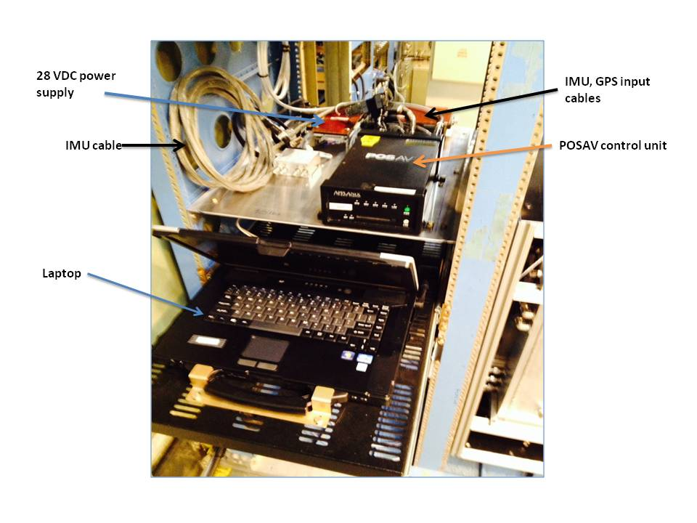
Figure 7: Photograph of the C-130 rack (looking forward) containing the POSAV control unit and the laptop. The GPS/IMU is mounted in front of the rack on a metal plate on the floor at FS 458.
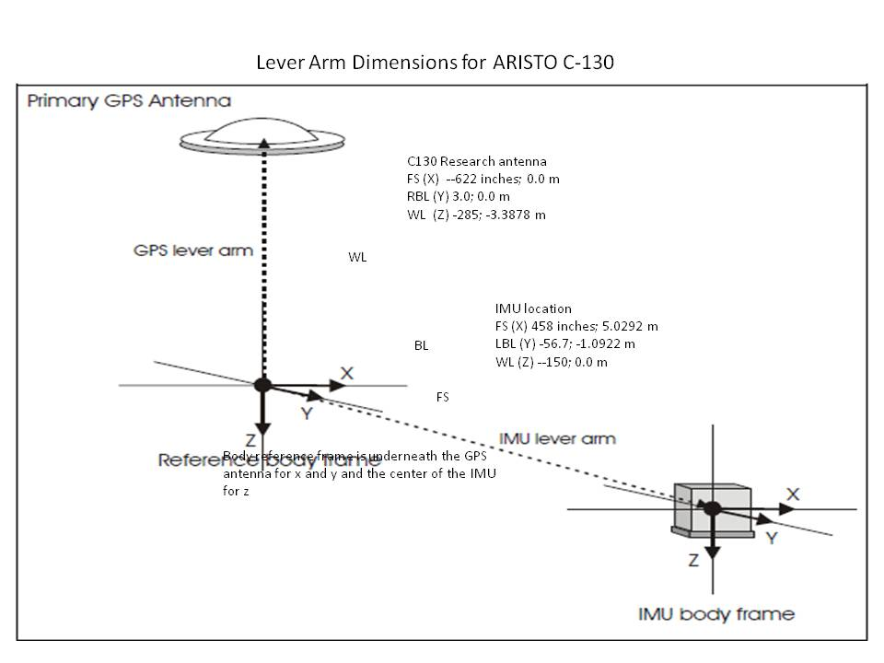
Figure 8: Example of lever arms on C-130 installation. These must be entered into the POSAV control software for a project.

Appendix B: Applanix Operation Onboard C-130 or GV
Applanix Operations Checklist

START-UP
- Power on Applanix at least 20 minutes before flight, if possible.
- Power on Applanix Panasonic laptop PC
- Click POS-AV 5.2 icon (lower left) on PC
- Wait to see address 128.46.118.136 in the window that indicates LAN Ethernet is active
- Click connect (green plug icon at top) - standby icon should turn red (If there is an error “cannot connect”, see network troubleshooting below)
- POSAV error : logging device error => OK (Note: logging should not be started until the C-130 is near door closed and take off)
- Pull-down menu Logging => Ethernet logging => Secondary tab (log file will show “Default2”) => Browse
- Click on folder; type in file name: ARISTOxxxx (the xxxx represents flight type and number, e.g., TF, FF, RF 01, 02, ….)
- Verify that the append button is checked
- Start logging (should be default 10 Hz). POS sec Ethernet logging status window shows that data is logging => then minimize

Monitoring
- Check installation parameters:
Settings => Installation => Lever arms
- Check Reference to IMU Lever arms are what was noted on the diagram
- Check Reference to Primary GPS are
  - okay
Settings => Installation => Tags
Check Time Tag 1 = GPSTime
And also all other time tags are GPS Time
  - okay
(“Accuracy “ displays for Attitude and Velocity can be ignored)
- IMU status: (initially) failure
GPS Status: C/A
Write on log sheet the time when GPS status went to C/A
View => GPS data
Verify we have greater than 8 satellites
- Note on log sheet the time the SNR for all satellites are > 30 for L1 and > 18 for L2
- When Normal operations, IMU status goes from failure to OK,
GPS Status goes from not available to C/A (This normally takes 2 minutes, on a bad day it could take 15 minutes)
- Screen should show green light for Position first, then green light for velocity, then after a long time green light for Attitude, then after an S turn green light for heading
- Disregard accuracy settings.

Shutdown
- Leave POS-AV software running upon landing
- After plane has stopped, continue logging for at least 10 minutes.
- After 10 minutes, stop logging
Logging => Ethernet logging => stop logging
Close POS-AV software
File => exit
Message log has changed, would you like to save it? => yes
=> TF/RFXX_log.txt
=> okay
- Insert the flash drive in front of CPU Note: This and the next two steps can be disregarded and the file can be left on the PC for later processing – see note below. However, it should be verified that the file is in the flight folder (for this example, ARISTO) on the PC.
- Go to the Applanix folder (tab on the left of screen)
- Copy file ARISTOxxxx and xxxx_log.txt to USB drive
- Turn off computer
- Turn off Applanix => press and hold power button on the front until power button starts blinking.
Note: To process the data file after flight use POSPac MMS 7.1. This program is on the laptop. See instruction for POSPAc processing.

Troubleshooting
- If the Applanix POSav unit and the PC are not communicating via the Ethernet crossover cable check settings in the PC. The laptop’s Ethernet adapter (named “Ethernet Crossover”) should have a statically assigned address, a class b subnet mask, and the gateway set, and nothing else.
IP address: 128.46.118.10
Gateway: 128.46.118.1
Subnet: 255.255.0.0
The POSAV 5.2 software is given the address of the instrument to connect to, so when it is started it should maintain the address previously used, if not: at the top of the POSAV window, in the address window next to “connect” button put in 128.46.118.136.

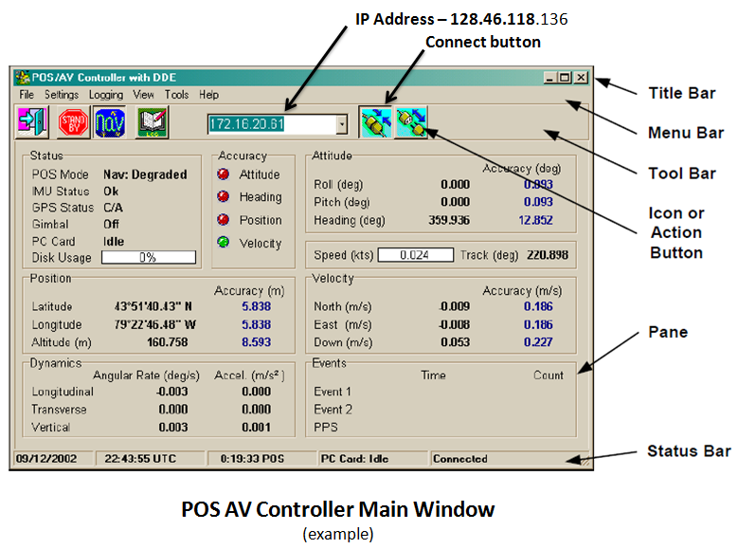
Figure 9: Main Applanix control widow on laptop interface. Tabs on upper left (e.g., File, Settings, etc.) are used to setup and control data logging, view lever arms, messages, etc.

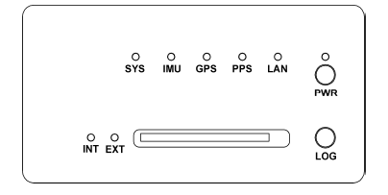
Figure 10: Applanix Controller (PCS) Front Panel Switches and Indicators. The horizontal slot accommodates a PCMCIA card (not used in ARISTO)

Applanix Indicator lights:
(A few minutes after power is turned on)
SYS – GREEN (flash or steady)
IMU – GREEN
GPS – YELLOW (steady)
PPS – GREEN (flash)
LAN – GREEN (flash)
PWR – GREEN (steady)
INT – off or RED
EXT – off or RED

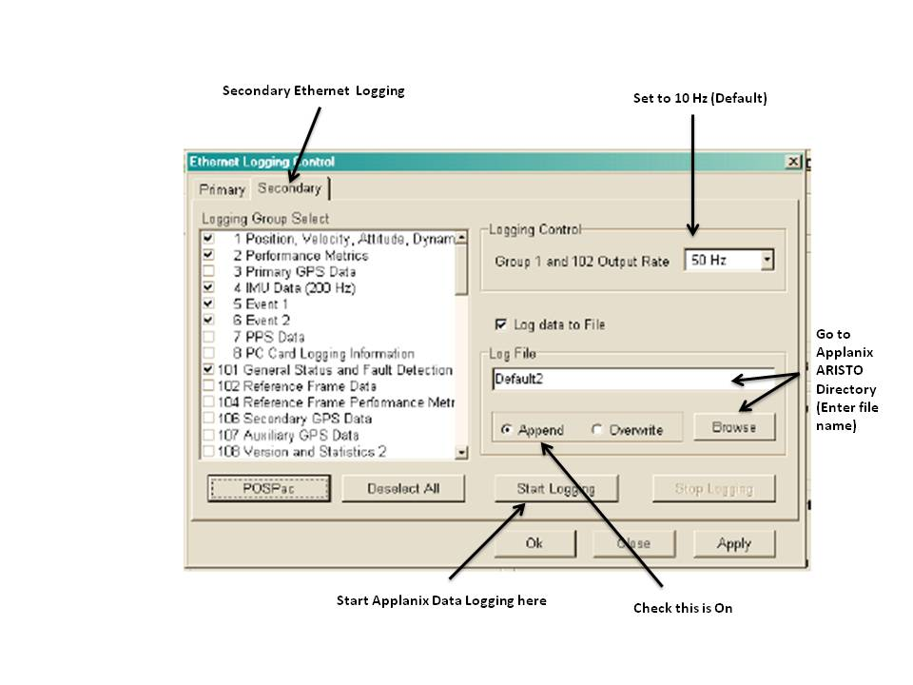
Figure 11: Example of data logging display and setup on laptop.

Appendix C: Extraction of real-time data post-flight using Applanix POSPac software
POSPac processing – extraction of real-time Applanix data using the ARISTO project as an example.
(For use on Applanix laptop but can also be performed on any computer where POSPac MMS V 7.1 has been installed )
(11/2015)
Put Applanix real-time data where accessible – /Applanix/gpsdata for this project
- Start POSPac MMS V 7.1
- File> new project> Blank template > press “OK”
- Project explorer > Mission 1 (on upper left side of window)
- Properties > name; Mission 1
- Get rid of “Mission 1” by clicking it and overwriting with new name (e.g., ARISTOgndtestxx, ARISTOtf01, etc.) > close (click twice)
- File > save project as > navigate (Save in) to Libraries/Documents/ Applanix/Applanix/nav > File name > save (eg., GTXX, TFXX, RFXX) – may want to create a project directory in the future
- Project > import > Select File > (raw flight data should already be in Applanix directory on flash drive or moved to /Applanix on laptop)
- Go to “…” (upper right) – This may not be necessary if proper directory already shows up
- C\Users\setup\Des..\Applanix/gpsdata > Ok
- Highlight Data “ARISTORFxx” (if data are able to be processed they will have file type “Pos Data”)
- Import, (wait) - several other messages will appear and leave before import is complete if the raw data are good
- POS Data extraction – Primary C/A
- IMU data continuity check
- Primary GNSS conversion
- Aux 1 GNSS conversion
- Ephemeris, etc..
- Raw data check-in (comes up automatically) > Receiver tab (This window will only appear if import was successful)
- Receiver>Manufacturer > unkown> (pull down)“Trimble”, Type (pull down) > “BD950”> OK
- Projection Definition (should give Lat, Lon at start of flight) > Ok
- A flight track plot will appear. Use pull down tabs at top to view Reports > Display Plots, performance metrics, etc.
- File > Exit “Save Changes” box will appear > click on yes, and output file will be saved

