National Center for Atmospheric Research

Containment Vessel for a Nitric Oxide (NO) Gas Cylinder and Gas Delivery System

System Description and Components Guidebook

Document No: 677-05-O3C-200-FM

Revision: 7

Date: January 3, 2006

National Center for Atmospheric Research
Atmospheric Chemistry Division
1850 Table Mesa Drive
Boulder, Colorado 80305

Prepared By:

Ilana B. Pollack
Postdoctoral Research Scientist
Atmospheric Odd Nitrogen Group
National Center for Atmospheric Research

Table of Contents

- Introduction
- List of References
- List of Terms and Abbreviations
- NO Containment Vessel System Description
  - Overview
  - Summary of Normal Operating Principle
  - Summary of Safety Measures
  - Possible Failure Modes and Countermeasures
  - Normal Operating Procedure
  - Emergency Safety Procedure
- Complete Description and Design Criteria for all NO Containment System Parts
  - Overview of Information and Definition of Terms
  - Specific Information for all Containment System Items
  - NO Containment Vessel Summary Parts List
- Figures
  - Block/Flow Diagram of NO Containment Vessel’s Interaction with O₃-C Instrument
  - Block/Flow Diagram of NO Gas Delivery Line and Monitors
  - Sketch of NO Gas Delivery System – Inside Containment Vessel
  - Sketch of Electrical Feedthrough and Vent System for Containment Vessel
  - 3-D Model of the Containment Vessel Including all Mechanical Components
Appendix 1: Swagelok and CGA Fitting Spec. Sheets
Appendix 2: Electrical Feedthrough Spec. Sheets
Appendix 3: Pressure Regulator and Flow Restrictor Spec. Sheets
Appendix 4: Solenoid and Flow Controller Spec. Sheets
Appendix 5: NO Monitor Spec. Sheets
Appendix 6: Material Safety Data Sheets for Nitric Oxide (NO)
Appendix 7: Electronic Communications with Gulfstream
- Introduction

A containment vessel has been designed to contain a 0.44 L commercially purchased, stainless steel lecture bottle of nitric oxide (NO) gas (grade >99%) filled to a maximum pressure of 500 psig. The reagent NO is supplied to an ozone chemiluminescence (O₃-C) instrument (see figure 6.1) that will participate in the upcoming T-rex field campaign in Spring of 2006 aboard the NCAR HIAPER Gulfstream V aircraft. The 500 psig lecture bottle of reagent NO will be sufficient for several flights of maximum duration. Since NO is a toxic gas, the small high pressure cylinder, its pressure regulator, and several safety measures are mounted inside a containment vessel that is vented to the outside of the aircraft.

The containment vessel has been carefully designed to completely contain the lecture bottle of NO gas, the pressure regulator, an NO gas delivery line, a vent line to the outside of the aircraft, and several safety measures for monitoring and controlling NO gas flow. The plumbing of the containment vessel has been carefully planned to minimize the number of fittings while still providing more than sufficient safety measures with redundancies and safety margins as well as convenient points of disconnect for the testing and maintenance of individual components. Specific parts and materials have also been carefully selected to minimize the overall size and weight of the containment vessel.

All equipment associated with the O₃-C experiment (including the NO containment vessel) will be used aboard the aircraft only for a specified field campaign and not for general public use. All O₃-C instrumentation and the containment vessel will be removed from the aircraft at the conclusion of the field campaign. This equipment will also be immediately removed should the aircraft be sold or given away.

Only members of the NCAR flight crew or trained observers necessary to complete the scientific mission will be carried aboard the aircraft and allowed to operate scientific equipment. As a regulatory means, the pilots will be documenting the purpose of each crew member flying aboard the aircraft. In addition, at least one trained NCAR data technician will be present in the aircraft cabin during every flight. The main responsibility of the data technician is to oversee all activity in the cabin and to act as the chief liaison between the cabin crew and flight crew. In the event of a breach of the containment vessel, the data technician will immediately initiate the emergency safety procedure outlined in a later section of this document. A notification system consisting of a strobe light and loud audible alarm will be mounted on the top of the equipment rack. A flight manual supplement has been prepared for in-flight reference of the emergency safety procedure.

Personnel training will consist of the routine safety briefing plus additional presentations on specific safety issues by UCAR or RAF staff. All the members of the flight crew must participate in the safety briefing and then sign the safety briefing forms proving that they have done so. Each of the primary investigators or the project manager is required to submit a summary of the relevant safety issues associated with their research equipment. UCAR or RAF staff will then present this information as part of the safety briefing. For the nitric oxide containment vessel, the information presented at the safety briefing will include:
1) Information about nitric oxide gas
2) A summary of the safety features that have been implemented into the containment vessel
3) The emergency safety procedure
4) Information about the flight manual supplement and the binder of Material Safety Data Sheets onboard the aircraft

This document contains a complete description of the normal operating principle of the NO gas delivery system inside the containment vessel, a normal operating procedure for using the containment system with the O₃-C instrument, and an emergency safety procedure. An in depth summary of safety measures including a failure mode analysis is also provided. In addition, detailed information including margins of safety for each component and fitting used in either the construction of the containment vessel or the delivery line is presented in this document along with a summarizing table of the same information for quick and easy reference.
2. List of References
- NSF/NCAR GV Investigator’s Handbook, revision 12/1/2004.
- The American National Standards Institute’s Handbook for Space Systems – Metallic Pressure Vessels, Pressurized Structures, and Pressure Components (S-080-1998).
- Swagelok Product Catalog, supplied by Denver Valve and Fitting.
- F.J. Callahan, Swagelok Tube Fitter’s Manual, 1963.
- Material Safety Data Sheet for Nitric Oxide from Scott Specialty Gases (Lecture bottle vendor), Website: http://www.scottgas.com.
- MIL-HDBK-5, revision J.
- The American Institute of Aeronautics and Astronautics Handbook for Space Systems – Structures, Structural Components, and Structural Assemblies (S-110-2005).
- Electronic Communications with Gulfstream.

3. List of Terms and Abbreviations

Burst Pressure
Used to give evidence of satisfactory workmanship and material quality and/or establish maximum initial flaw sizes for demonstration that the pressurized hardware will not rupture or fracture. The burst pressure here is determined as maximum expected operating pressure multiplied by a factor of safety of 2.0.

Commercial Off The Shelf (COTS)
A purchased product that will be used un-altered from the way it was constructed by the manufacturer.

Cracking Pressure
The upstream pressure at which the first indication of flow occurs for a check (or relief) valve. The cracking pressure is generally reported as the pressure differential (in psig) between the upstream and downstream parts of the valve.

Custom-Built By a 3rd party (CBB3)
An item that is specially designed and built by a contracted service outside of NCAR.

Custom-Built In-House by us (CBIH)
An item that is specially designed and built by the research scientist, the Research Aviation Facility, or one of the machine shops associated with NCAR.

Factor of Safety (FS)
A multiplying factor to be applied to the maximum expected operating pressure for purposes of analytical assessment and/or test verification of adequacy.

Maximum Allowable Working Pressure (MAWP)
The maximum pressure that can be accommodated by a component, fitting, or piece of hardware without disrupting its function.

Maximum Design Pressure (MDP)
Used for design and testing of pressure vessels and related pressure components. The MDP differs from MEOP according to the degree of consideration of “potential credible failure” within a pressure system and the resultant effects on pressure of the vessel during system operation. The MDP would account for the worst case scenario of one or more credible system failures.

Maximum Expected Operating Pressure (MEOP)
The maximum pressure which the pressurized hardware is expected to experience during it service life, in association with its applicable operating environments.

Proof Pressure
Used to give evidence of satisfactory workmanship and material quality and/or establish maximum initial flaw sizes for safe-life demonstration. The proof pressure here is determined as maximum expected operating pressure multiplied by a factor of safety of 1.5.

4. NO Containment Vessel System Description

4.1 Overview

A containment vessel has been designed to fully contain a lecture bottle of nitric oxide (NO) gas (500 psig, 0.44 L), a pressure regulator, an NO gas delivery system, and several safety measures (described in section 4.2) for monitoring and controlling NO gas flow.

The plumbing of the containment vessel has been carefully chosen to minimize the number of fittings while still providing more than sufficient safety measures with redundancies and safety margins as well as convenient points of disconnect for the testing and maintenance of individual components. The following is a specific description of the operating principle of the NO gas delivery system inside the containment vessel.

Figures 6.2 through 6.5 clarify the intent and practicality of implementing select components within the containment vessel. These figures can be found at the end of this document. Figure 6.2 illustrates a block/flow diagram of the entire NO gas delivery line as well as the respective positioning of the NO gas monitors. Figures 6.3 are schematics of all of the components along the NO gas delivery line. Figure 6.4 depicts the components used for the electrical feedthrough and the vent system for the containment vessel. Figure 6.5 (a-g) depicts a three dimensional model of the containment vessel and all of the mechanical components inside. This figure also serves to illustrate how these components will be positioned relative to each other inside the vessel.

Note that all equipment associated with the O₃-C experiment (including the NO containment vessel) will be used aboard the aircraft only for a specified field campaign and not for general public use. All O₃-C instrumentation and the containment vessel will be removed from the aircraft at the conclusion on the field campaign. This equipment will also be immediately removed should the aircraft be sold or given away.

Only members of the NCAR flight crew or trained observers necessary to complete the scientific mission will be carried aboard the aircraft and allowed to operate scientific equipment. As a regulatory means, the pilots will be documenting the purpose of each crew member flying aboard the aircraft.
4.2 Summary of Normal Operating Principle

In this system, high pressure NO gas originates from the lecture bottle inside the containment vessel and passes through a standard CGA180 fitting to a 2-way ON/OFF solenoid valve, which is normally closed. The valve on the lecture bottle must be manually opened in order for gas to flow from the bottle to the CGA fitting. Likewise, the solenoid valve must be specifically controlled open by the data acquisition computer in order for high pressure gas to flow to the rest of the system. The high pressure gas is then directed through a tee positioned directly after the solenoid valve. This has a bellows shut-off valve on one end that is then capped during use under the normal operating procedure. This port of the tee and bellows valve will only be uncapped and used during lab maintenance as a convenient point for connection of a N₂ purge system. After this tee, the high pressure gas line splits. The first pathway sends high pressure gas to an electronic pressure transducer for automated pressure monitoring. The second pathway sends high pressure gas to a check valve which acts to relieve any over pressure of NO gas into the containment vessel above a set cracking pressure of 600 psig. This check valve is a safety measure installed to prevent over pressurization of the high pressure gas cylinder. The third pathway delivers NO gas to a two-stage pressure regulator. The pressure regulator will be set to deliver 30 psig of NO gas to the delivery line to the O₃-C instrument. The double stage feature on the pressure regulator ensures delivery of 30 psig of NO gas to the instrument regardless of ambient pressure effects on the primary stage. From the pressure regulator the line splits in three ways to allow for a low pressure monitor by an electronic transducer, low pressure release into the containment vessel at 50 psig cracking pressure via a second check valve, and for the NO gas delivery line to the instrument. On the NO gas delivery line, there is a flow restrictor and then a bellows valve for manual ON/OFF control of gas flow out of the containment vessel to the instrument. A second, normally closed, 2-way ON/OFF solenoid valve will be positioned just after the bellows valve in order to have automated shutoff of NO gas delivery on the low pressure side of the regulator. The manual bellows valve must be open for NO gas to flow to this 2-way solenoid valve and the remaining sections of the gas delivery line. Both of the 2-way solenoid valves will remain closed during take-off and landing procedures. The solenoid valves will only be activated open when the aircraft reaches an acceptable altitude for commencing ozone chemiluminescence measurements.

4.3 Summary of Safety Measures

Nitric oxide is characterized as a colorless gas with a sharp, sweet odor that can appear to have a brownish color in high concentrations in air due to conversion to NO₂. An exposure limit of 25 ppm (time weighted average) for nitric oxide is consistently recommended by:
- The OSHA General and Construction Industry Permissible Exposure Limit (PEL)
- The American Conference of Governmental and Industrial Hygienists' threshold limit value expressed as a time-weighted average (ACGIH TLV). (This recommendation corresponds to the concentration of a substance to which most workers can be exposed without adverse effects.)
- The National Institute of Occupational Safety and Health recommended exposure limit for an 8- or 10-h time-weighted-average exposure and/or ceiling (NIOSH REL).

The PEL is also significantly greater than the limit of human detection, since the odor threshold for NO gas is 0.3 to 1.0 ppm. This PEL is also 4 times less than the 100 ppm limit for Immediate Danger to Health and Life (IDHL).

Several safety measures have been installed inside the containment vessel and are described in detail here.
- Two NO monitors will be used to detect NO leaks at a concentration of 25 ppm.
  - The monitors can detect NO gas over a 0-100 ppm range at a resolution of 0.5 ppm and at a time response of < 15 seconds. Both monitors are equipped with an 80 db audible alarm, a 0-5 V analog output, and a digital display. The monitors are calibrated in ppm and have an adjustable set point. Both monitors will be set to sound the alarm at concentrations greater than or equal to the above recommended PEL of 25 ppm. The monitors do not have a test button for the audible alarm, however, an icon of a bell is present in the lower left corner of the digital display to signify that the sounding alarm is active.
  - One monitor will be placed near the main entry to the cabin for confidence that no NO gas is present before personnel boards the aircraft prior to each flight. This monitor is primarily used for assurance that no leaks are present when personnel first board the aircraft after a period of non-use.
  - A second monitor will be affixed to the O₃-C equipment rack between the instrument and the containment vessel. The voltage output (0-5 VDC) of this specific monitor will be sampled by the data acquisition computer. The 0-5 V output corresponds to the 0-100 ppm range of the detector. A set point of 25 ppm corresponds to a set point voltage of about 1.25 V. In the case of a leak, the audible alarm on the NO monitor will sound. In addition, the monitor will send a signal above the 1.25 V set point to the computer system. The computer then commands the 2-way solenoid valves to close, thereby stopping high pressure gas flow to the pressure regulator and low pressure gas flow to the NO delivery line to the instrument. The output of this monitor will also be linked to a strobe light and a second, louder audible alarm than the one internal to the monitor. The strobe light (amber colored) and the piezo warbler alarm (95 dB) will be mounted on the top of the equipment rack so that it is clearly visible to all cabin crew members. Should the light and audible alarm on this warning panel be activated by the NO monitor, the data technician or any member of the cabin crew can immediately be in contact with the pilots/flight crew. The strobe light and piezo warbler unit will be equipped with a test button or switch.
- A 2-way solenoid valve has been placed just after the NO lecture bottle for automated control of NO gas shut-off. A secondary 2-way solenoid valve is positioned inside the vessel along the NO gas delivery line on the low pressure side of the regulator.
  - If an NO gas leak is detected by the NO monitor on the rack, both solenoid valves will be automatically closed by the computer, thereby shutting off all NO gas delivery. This automated shut-down supplements the need for an in-flight operator to close the three manual valves should a leak occur. This is especially important if the operator is busy responding to another situation at the time or does not hear the alarm. It also gives the flight crew time to put on any necessary safety equipment.
  - Both solenoid valves are normally closed so that delivery of NO gas to the pressure regulator and the low pressure delivery line to the instrument will be automatically shut-down in the event of a power failure.
  - Automated shut-down due to the normally closed function of the solenoid valves supplement the need for an in-flight operator to close the three manual valves should a leak occur. This is especially important if the operator is busy responding to another situation at the time or does not hear the alarm. It also gives the flight crew time to put on any necessary safety equipment.
  - The solenoid valves also serve as a means of controlling the start-up and shut-down sequences for the experiment. The solenoid valves will be controlled open by the data acquisition computer only when a specific atmospheric pressure is detected outside the aircraft corresponding to a suitable altitude for commencing measurements. This ensures that the solenoids remain closed during takeoff and landing procedures, and eliminates the unpredictability of a timed sequence. For example, when the aircraft lands, or in the case of an unexpected termination of the flight, both solenoid valves will automatically close when the aircraft drops below a specified altitude, thereby shutting down the NO gas delivery system.
  - Since the data acquisition computer will automatically regulate NO gas delivery to the O₃-C instrument throughout the course of the flight, all three manual valves (on the lecture bottle, the regulator, and the bellows valve) will be opened and set prior to takeoff, thereby reducing the need for in-flight operational assistance.
- Viewport windows are also installed for visual confirmation of pressure gauges in addition to the electronic pressure transducers.
- Check valves will be used on both the low and high pressure sides of the regulator (see figure 6.3) to ensure a safe and controlled release of NO gas into the containment vessel should the system become over pressurized. Check (or relief) valves are generally not used for toxic gas systems, however, a controlled release of NO gas into the containment vessel is preferred in this application to an over pressurization of the system.
  - The check valve on the low pressure side of the regulator, which is set at a cracking pressure of 50 psig, protects all of the components from the low side of the regulator through the O₃-C instrument from seeing pressures above 50 psig. An uncontrolled over pressurization of the low pressure delivery line could lead to either damage or rupture of downstream components and/or gas leaks in the system. Using a check valve allows any gas pressurized above 50 psig to be released in a controlled manner inside of the containment vessel. Since the containment vessel is vented overboard during flight, the vessel should never see the maximum expected pressure. Regardless, the containment vessel has been specifically designed to completely contain a release of the entire contents of the lecture bottle. (See section 5.1 for maximum expected pressure calculations for the containment vessel.) Therefore, the check valve provides a specific route for controlled relief of any over pressurized gas into the vented containment vessel rather than into the aircraft cabin.
  - The check valve on the high pressure side of the regulator, which is set at a cracking pressure of 600 psig, protects all of the components from the lecture bottle to the high side of the regulator from seeing pressures above 600 psig. An uncontrolled over pressurization of the high pressure part of the line may lead to either damage or rupture of components (including the lecture bottle) and/or gas leaks in the system. Using a check valve allows any gas pressurized above 600 psig to be released in a controlled manner inside of the containment vessel, which is vented overboard the aircraft. Again, the containment vessel has been specifically designed to completely contain a release of the entire contents of the lecture bottle, even though the vented vessel should never experience the maximum expected pressure of 31 psig. Here, the check valve provides a specific route for controlled relief of any over pressurized gas from the lecture bottle and high pressure components into the vented containment vessel rather than risking a build-up to burst pressures.
- Pressure transducers will also be used for computer controlled monitoring of the high and low pressure sides of the regulator. If either pressure transducer reports a sudden change in pressure to the data acquisition computer, both 2-way solenoid valves will automatically be controlled closed, thereby ceasing all NO gas flow.
- A flow restrictor is placed along the NO gas delivery line to restrict the amount of gas flow to the instrument.
  - Under normal operating conditions, the flow of NO gas is restricted to 10 sccm with an upstream and downstream pressure of 40 psig and 30 psig, respectively.
  - In the case of a leak developing along the delivery line, the maximum flow of NO gas from the leak point will be 40 sccm, where the four-fold increase in flow rate arises from the increase in pressure drop across the flow restrictor from 40 psig to atmosphere. Under this worst case scenario where NO gas is released into the cabin at a flow rate of 40 sccm, assuming perfect mixing of gases, only a small concentration of NO gas (2.3 ppmv) will build up in the cabin. This concentration is 10 times less than the PEL of 25 ppm, which is the limit for an 8-hour period of exposure. (The above calculation uses the cabin air refresh rate for the Gulfstream V aircraft, and is further described in section 4.3.)
- There will also be a manual ¼ turn, shut-off valve on the containment vessel’s vent hose located just at the back plate of the vessel. (see figure 6.5) This shut-off valve allows the containment vessel to be completely sealed during transport on and off of the aircraft. The containment vessel will also be pressure and leak tested in the lab prior to any field campaign by filling the vessel with N₂ gas or ultrapure air up to the proof pressure of 47 psig. This proof pressure is determined by multiplying the maximum expected operating pressure that the containment vessel could ever experience (31 psig) by the proof factor of safety of 1.5. The maximum pressure for the containment vessel is modeled (see Section 5.1 for detailed calculations) assuming a complete release of the contents of the lecture bottle into a non-vented containment vessel.
- A check valve is also placed in the line of the containment vessel’s vent hose. The primary function of the check valve is to prevent exhaust from the aircraft and from other experiments attached to the community exhaust system from back-streaming into the containment vessel. This check valve is set to a cracking pressure of 20 psig and reseals when the upstream pressure inside the vessel drops below 17 psig. This corresponds to a cracking pressure of 32 psia when the containment vessel is installed on the aircraft on the ground (atmospheric pressure of Boulder, CO is ~12 psia). Due to the cracking pressure and reseal conditions of the check valve, the vessel will remain at Boulder atmospheric pressure thought the course of the flight. The atmospheric pressure at ~45,000 ft. is ~2 psia. Only when there is a leak in the containment vessel above 20 psig will the check valve crack allowing NO gas to be exhausted from the containment vessel to the outside of the aircraft. The check valve will reseal when the upstream pressure of the check valve drops below 17 psig, even if at high altitude, thereby leaving the vessel at 19 psia. When the aircraft lands in Boulder the vessel will still be at 19 psia, or 7 psig according to the atmospheric pressure at Boulder. Since the containment vessel is designed to fully contain a complete release of gas into the vessel at the proof pressure of 47 psig, a slight pressurization to 7 psig will not compromise the structure and safety features of the vessel.
- The containment vessel is vented overboard the aircraft. The exhaust hose will be attached to the research community exhaust system for aircraft experiments. A standard sized (NW50) port for attaching vent hoses to the research community exhaust system is located next to each equipment rack. During instrument testing and upload when the aircraft is located on the ground and/or in the hangar, an external vent hose will be set up by Research Aviation Facility technicians in order to direct the research community exhaust away from personnel.
- The containment vessel will also be sufficiently labeled with warning signs as well as stickers showing the correct directions for opening and closing the manual valves.
- A notebook for keeping track of containment vessel usage will also be placed near the vessel. The notebook not only allows us to keep a history of the usage of the vessel, but also allows easy access to pressure logs and prior observations that provide useful information during maintenance operations. The notebook will be securely stowed for most of the flight, especially during take-off and landing procedures.

4.4 Possible Failure Modes and Countermeasures

- Power failure
  - In the case of a power failure all solenoid valves will switch to their normal positions. The 2-way solenoid valves are normally closed, so in the case of a power failure the NO gas supply to the high pressure side of the regulator and to the delivery line would be automatically shut-down.
  - The NO monitors are outfitted with a 9V battery back-up system.
- Pressure regulator failure
  - In the case of a pressure regulator failure, the low pressure check valve positioned just after the regulator would immediately relieve any over pressurized gas, leaving the delivery line pressurized to no more than 50 psig. A maximum design pressure assuming this failure has been accounted for in margin-of-safety pressure analysis for all plumbing components (see Section 5).
  - Additionally, the pressure transducers would report anomalous behavior in pressure to the data acquisition computer, which would signal the 2-way solenoid valves to close, thereby closing off the primary (high pressure) and secondary (low pressure) NO gas supplies.
- Pressure regulator and low pressure check valve failure
  - A failure of the regulator and the low pressure check valve would result in the NO gas delivery line seeing the full pressure (500 psig) of gas in the lecture bottle. In this scenario, the low pressure transducer would report a spike in pressure above 50 psig to the data acquisition computer, which would then control both 2-way solenoid valves to automatically close.
  - To minimize the probability of failure, each check valve will be re-tested and re-tagged prior to each field campaign for quality assurance. On the average, one field campaign consists of about 10-20 flights.
- Vent line check valve failure
  - A failure of the check valve on the vent line would result in the vessel being exposed to atmospheric pressure at altitude. This would not affect the function of the vessel or any of its internal components, however, when the aircraft lands, the vessel might be slightly underpressurized (to ~ 0.5 atm) due to the difference in atmospheric pressure at altitude and at Boulder and with the corresponding cracking and reseal pressures of the check valve. The vessel has been structurally analyzed to account for this slight under pressurization.
- Pressure transducer failure
  - Viewport windows are to be used for visual inspection of pressure gauges.
  - The data acquisition computer will be programmed to monitor non-standard values and respond accordingly.
  - To minimize the probability of failure, each pressure transducer will be re-calibrated prior to each field campaign for quality assurance.
- A leak along the NO gas delivery system
  - Corrosion resistant, seamless, 316 stainless steel tubing and Swagelok brand fittings will be used for construction of the NO gas delivery line.Under normal operating conditions, the stainless steel tubing and Swagelok fittings on the high pressure side of the regulator (500 psig) have a burst margin of safety ≥ 2, and the tubing and fittings on the low pressure side of the regulator (30 psig) have a burst margin of safety ≥ 15. (See Section 5 for detailed Margin of Safety calculations.) Therefore, the margin of safety for using these parts for this application in this environment is significantly greater than +0.00, as required by the GV Handbook.
  - The delivery line to the instrument also constitutes only a small volume of NO gas. Specifically, only 0.6 cc will remain in the approximately 10” long segment of 1/8” stainless steel tubing (id. = 0.175 cm) that connects the containment vessel to the instrument. In the unlikely event that the contents of this short segment of tubing was released into the 2400 ft³ (6.8 x 10⁷ cc) volume of the aircraft cabin, the concentration of NO gas upon perfect mixing would only be 9 ppb. This concentration of NO gas is 2700 times less than the human PEL of 25 ppm.
  - In the unlikely event that a gas leak occurs along the high pressure gas delivery system within the vessel, the vessel is vented overboard the aircraft. The vessel is also pressure rated to contain a complete release of the contents of the lecture bottle. In the unlikely event of a leak along the gas delivery line to the instrument, several other safety measures will be activated. Specifically, the alarm on the NO monitor will sound thereby sending a computer-controlled signal to close both of the 2-way solenoid valves. Additionally, the non-standard values reported by the pressure transducers will also be set up to trigger the computer to close the solenoid valves. Further, the maximum flow of NO gas from a leak in the delivery line would only be 40 sccm due to the flow restrictor. Assuming perfect mixing of gases, it has been determined that a leak of NO gas at 40 sccm into the 2400 ft³ volume of the aircraft’s cabin, which has a air refresh rate of 857 ft³/min and a corresponding fresh air flow of 1.73 x 10⁷ sccm, yields a concentration of NO gas of 2.3 ppmv. This concentration is 10 times below the 8-hour PEL of 25 ppm, and thus a leak in the gas delivery system will not affect operational abilities of the aircraft or crew. (Note: The cabin air refresh rate and volume are obtained directly from Gulfstream as per the electronic communication included in Appendix 7.)

4.5 Normal Operating Procedure

Containment Vessel Installation
Installing on the Aircraft (Rack Mounting)
- The containment vessel should be completely sealed at the front and back plates after installation of a new NO gas tank in a laboratory fume hood.
- All manual control valves and the manual shut-off valve on the vent hose should be in the closed or off position so that the containment vessel is completely sealed before leaving the fume hood.
- The exit of the NO gas delivery line should also be securely closed with a 1/8” Swagelok cap.
- The containment vessel can now be removed from the fume hood and transported to the aircraft cabin using a cart to safely carry the vessel.
- The containment vessel is then mounted on the rack. The mounting brackets are screwed into place on the shelf. Check to make sure the containment vessel is securely fastened to the shelf.
- The vent hose can then be connected to the research community exhaust. (The shut-off valve on the vent hose should remain closed until the aircraft is removed from the hangar or until an external exhaust system is set up.)
- The electrical connection to the data acquisition computer can now be made. Once connected, check the status of the NO monitor and pressure transducers before continuing to the next step.
- The NO gas delivery line is then un-capped and connected to the O₃-C instrument.
- All manual valves should remain closed until ready for pre-flight testing and/or just before take-off.
- Note all installation observations, time of installation, and the installer’s initials into the containment vessel’s logbook located next to the equipment rack.
Exhaust Line Installation
- The vent hose to the containment vessel will be attached to the aircraft’s research community exhaust system.
- When the aircraft is located inside the hangar, an external exhaust hose leading from the outside of the plane to outside the hangar will be set up for pre-flight testing and calibration of the O₃-C instrument.
- Once the external vent hose is set up, the manual shut-off valve at the back of the containment vessel can be opened.
Storage Until Use
- When not in use for long periods of time (such as between field campaigns), the containment vessel should be removed from the aircraft, stored in a fume hood or vented closet, and the regulator and all lines should be purged with a dry, inert gas such as N₂. (See procedure for Containment Vessel Removal for Maintenance below.)
- When not in use between flights, the containment vessel may remain on the aircraft. However, the vessel must remain completely sealed to contain any leaks if the aircraft is located inside the hangar unless an external vent hose has been set up. If the aircraft is located outside the hangar the vent valve may remain open in order to exhaust any possible NO gas to the outside atmosphere. Warning signs should be posted around the designated exhaust area to alert personnel of the possibility of exposure in that area.

Pre-flight Testing and Calibration of the O₃-C Instrument
- The NO containment vessel will participate in pre-flight tests of the O₃-C instrument.
- When ready for pre-flight testing, the two manual valves will be opened on the containment vessel.
- The computer will open the primary 2-way solenoid valve and then the secondary 2-way solenoid valve to deliver NO gas to the instrument.
- The pressure regulator can then be adjusted to deliver 30 psig of NO gas to the instrument.
- The computer will run a short test routine to make sure the in-flight controls are properly set up. (Test sequence to be defined.)
- The instrument can then be calibrated for ozone concentration at this time with a TECO model 49PS calibrator. (Note: Calibrations of the O₃-C instrument do not need to be done before every flight.)
- After the pre-flight tests are complete, the two solenoid valves will be closed and the NO delivery line will be evacuated by pumping any remaining NO gas through the pumping system on the O₃-C instrument.
- If there is a significant delay between the flight and the test period, the two manual valves on the front plate will be closed until just before take-off. The shut-off valve for the vent hose on the back plate will also be closed until the plane leaves the hangar. The pressure regulator should remain at the current setting that was determined to be the best for experimental measurements during pre-flight testing.
- Note all test observations (including gas cylinder pressures), time and duration of use, as well as the researchers initials into the containment vessel’s logbook located next to the equipment rack.

Preparation for Take-off
- If they are not already set up, open the two manual valves on the front plate of the containment vessel and the shut-off valve at the vent hose. Check that the regulator is set to delivery the correct pressure of NO gas.
- Note the current pre-flight pressures of the NO gas delivery system in the containment vessel’s logbook located next to the experiment rack.
- Re-set data acquisition computer to start sequence for in-flight measurements.

In-flight Automated Operations for Data Collection – To be determined

Post Landing Shut Down Procedure
- The computer will have already controlled both of the 2-way solenoid valves to close prior to landing.
- Once on the ground, all manual valves can be closed and the pressure regulator can be completely dialed out.
- The shut-off valve on the vent hose of the containment vessel can also be closed if the aircraft is brought into the hangar.
- Note all shut down observations (including gas cylinder pressures), time and duration of use, and operators initials into the containment vessel’s logbook located next to the equipment rack.
- Assess whether maintenance needs to be performed on containment vessel (such as replacement of an empty NO gas cylinder).

Containment Vessel Maintenance
- Place containment vessel inside a fume hood.
- Put on gloves and safety goggles.
- Make sure all manual and solenoid valves are closed and that the diaphragm of the pressure regulator is completely dialed out. Also make sure the exit of the gas delivery line is capped off.
- Undo the nuts and bolts on front plate of the containment vessel.
- Slide out the front plate and connected rail system until it is completely detached from the main body of the containment vessel.
- Undo any electrical connections and then set down rail system inside fume hood positioned next to main body of containment vessel.
- Visually inspect all components and fittings for signs of damage or corrosion due to small NO leaks, note any damaged parts for replacement in the next few steps.
Flushing the NO gas delivery system inside the containment vessel
- Attach the exit of the gas delivery line to an exhaust system or make sure it is directed well into the fume hood.
- The NO gas delivery system should be flushed with pure, dry N₂ gas.
- Uncap the spare port on the bellows valve just after the high pressure solenoid valve.
- Connect the 1/8” tubing from a N₂ tank to this port on the tee using the two wrench method.
- Open the valve on the N₂ tank and quickly close it again to fill up a portion of the gas delivery line inside the containment vessel up to the pressure regulator.
- Use a soapy solution, such as Snoop, to check for leaks at this connection. A more sensitive leak test should also be performed by watching for decreases in pressure on the low pressure gauge of the regulator on the N₂ tank over a specified period of time. If there is a leak, re-make and re-test the connection.
- If there are no leaks, proceed by re-opening the valves on the N₂ tank. Then slowly dial in the NO pressure regulator and open the manual shut off valve to the delivery line of the containment vessel.
- The solenoid valves can then be controlled open to flush the delivery line and pressure regulator.
- Any damaged components or fittings can be replaced after the delivery line has been significantly flushed with N₂.
Installing a new NO gas lecture bottle
- Using one wrench to grip the CGA fitting and another wrench as a counterbalance, loosen the CGA fitting from the gas lecture bottle. Some NO gas may escape at this time, however there is no safety hazard to the user since the entire unit is contained inside of a fume hood.
- While still wearing gloves, remove the CGA fitting by hand.
- Undo the screws on the clamp holding the lecture bottle to the rail system.
- Remove lecture bottle and cap off the open end.
- The empty lecture bottle should remain in the fume hood until it can be disposed of or stored in a more appropriate place.
- When installing a new lecture bottle of NO gas, start by removing the wrapper over the head of the bottle and inspecting the threads. Remove safety cap from CGA fitting.
- Clean the threads on the bottle and the CGA fitting with ethanol.
- Lay the bottle on the rail system and hand tighten the CGA fitting to the bottle
- Tighten the screws on the mounting clamps to secure the bottle to the rail system. Then tighten the CGA fitting to the bottle using two wrenches.
- Leak test the connection in the same way as above. An NO monitor can also be used ensure that there are no leaks.
- If there are no leaks, the rail system can be slid back into the main body of the containment vessel. Be sure to reconnect the electrical connection and install any additional pieces that may have been removed from the vessel during maintenance.
- Once the rail system is back in place, the front plate can be reattached to the main body of the vessel via the nuts and bolts.

4.6 In-flight Emergency Safety Procedure

If an NO gas leak is detected in the aircraft during flight, either by human scent detection or by the NO monitor, the following safety procedures should be followed:

A. Flight Crew:

Oxygen Mask/Goggles - DONNED/100%
Flight Deck Door - CLOSED
Crew Communications - ESTABLISH
Instruct Cabin Crew - CLOSE ALL MANUAL VALVES
Wear Oxygen Mask/Goggles - UNTIL LANDING OR CABIN AIR
REFRESHED*
Descent/Aircraft Depressurization - CONSIDER

B. Cabin Crew:

PBE Oxygen Hood - DONNED/FLOW ACTIVATED
Crew Communications - ESTABLISH
Flight Deck Door - CLOSED
Manual Valves (3) - CLOSED
Wear Oxygen Hood - UNTIL LANDING OR CABIN AIR
REFRESHED*

*According to cabin air refresh rates for the Gulfstream V aircraft, 100% air exchanged should occur within 2.8 minutes of the last detection of NO, assuming perfect mixing of NO gas with cabin air.
Complete Description and Design Criteria for all Containment System Parts

5.1 Summary of Information and Definitions of Terms

Item #. Item Name
Primary function: A description of the primary function and use of each item.
Part Description: A physical description of each item and how it interacts with mounting structures and neighboring items.
Dimensions: The physical dimensions of the item.
Weight: The weight of the item.
Material: The basic materials making up the item including surfaces, seals, seats, and lubricants.
Power Requirements: A description of the power requirements and any possible signal outputs for each electronic item.
Pressure Ratings: The maximum allowable working pressure (MAWP) that can be accommodated by a component, fitting, or piece of hardware without disrupting its function. Some items that have more than one component will list a breakdown of the MAWPs for each specific component.
Margin of Safety:
1. Structural Analysis
A complete structural analysis for the containment vessel will be presented in a separate document to a structural DER.

2. Pressure Analysis
For pressure analysis, the margin of safety will be determined according to the following equation and terms:
MS (proof) = (MAWP / (MEOP x FS_{proof})) - 1
MS (burst) = (MAWP / (MEOP x FS_{burst})) - 1

MAWP: The maximum allowable working pressure that can be accommodated by a component, fitting, or piece of hardware without disrupting its function.

MEOP (maximum expected operating pressure): The maximum pressure which the pressurized hardware is expected to experience during it service life, in association with its applicable operating environments. The maximum design pressure (MDP) can also be substituted here to test the design of a pressure vessel and related components according to consideration of the degree of “potential credible failure”. The MDP would account for the worst case scenario of one or more credible system failures.

Factor of Safety (FS): A multiplying factor to be applied to the maximum expected operating pressure for purposes of analytical assessment and/or test verification of adequacy.

A proof and burst margin of safety analysis will be performed for relevant items under the following four different conditions (see 2a-c). A FS_{proof} of 1.5 and FS_{burst} 2.0 is multiplied by the MEOP or MDP to obtain proof and burst pressures for use in acceptance testing. The proof pressure is used to give evidence of satisfactory workmanship and material quality and/or establish maximum initial flaw sizes for safe-life demonstration. The burst pressure is used to give evidence of satisfactory workmanship and material quality and/or establish maximum initial flaw sizes for demonstration that the pressurized hardware will not rupture or fracture.

2a) The containment vessel will be modeled at an MEOP of 31 psig to simulate a complete release of the entire NO gas cylinder into the volume of the containment vessel without venting.

8.15 L (Volume of Empty Containment Vessel)
- 0.77 L (Volume of a Solid NO Lecture Bottle)
+ 0.44 L (Inner Volume of NO Lecture Bottle)
- 0.73 L (Volume of other Internal Components)
7.09 L (Total Fillable Volume of Containment Vessel)

P(bottle) * V(bottle) = P(containment) * V(containment)
(500 psig) * (0.44 L) = P(containment) * (7.09 L)
P(containment) = 31 psig

2b) The NO delivery line will be pressure analyzed under normal operating conditions with no system failures. An MEOP of 500 psig and 30 psig will be implemented in the above equation for fittings located on the high pressure and low pressure sides of the regulator, respectively.

2c) The low pressure portion of the NO delivery line will be pressure analyzed under operating conditions considering a potential credible failure of the pressure regulator. Since the low pressure check valve is set to crack at 50 psig, an MDP of 50 psig will be used.

3. Electrical Loads Analysis
A complete electrical loads analysis for the containment vessel will be presented in a separate document to an electrical DER.

5.2 Specific Information for all Containment System Items

Containment Vessel Housing (more detailed information on the housing can be found in the supplementary documentation on structural analysis)
- Containment Vessel Main Body
Primary function: Main body of containment vessel.
Part Description: Extruded aluminum cylinder
Dimensions: 6.5” id. x 15” length
Weight: 5.38 lbs.
Material: 6061T6 Aluminum
Pressure Ratings:
Power Requirements: None
Margin of Safety: See separate document regarding structural analysis

- Support Rail System
Primary function: Allows for easy removal of the NO lecture bottle and associated plumbing for maintenance and testing. Also provides secured support for components inside the vessel.
Part Description: The rails support the clamps for holding the lecture bottle in place and various other components. Mounting all the internal components to these aluminum rails allows for their easy removal from the containment vessel. The rails fit into cups on the back plate to hold them into position when the vessel is in operation. The rails are attached to the front plate of the vessel so that when the front place is detached, the entire contents of the vessel can be easily slid out from the main body.
Dimensions: 15.09” x 0.44” x 0.44”
Weight: 0.26 lbs.
Material: 6061T6 Aluminum
Pressure Ratings:
Power Requirements: None
Margin of Safety: See separate document regarding structural analysis

- Front end plate
Primary function: Front end plate of the containment vessel. This plate is held to the main body of the vessel by 12 structural bolts screwed into helicoil inserts and sealed with a Viton o-ring. The front plate also contains two holes for handle feedthroughs for the manual shut-off valves on the gas cylinder and the bellows valve, a hole for the handle feedthrough for the pressure regulator, and one tapped hole for inserting an o-sealed connector for bringing the NO gas delivery line out of the vessel and to the instrument.
Part Description: The plate has 12 helicoil screw holes for attachment of plate to main body, three through holes for handle feedthroughs, and one 5/16-24 SAE/straight thread tapped holes for mounting an 1/8” o-seal fitting to bring the gas delivery line out of the containment vessel.
Dimensions: 8.2” od. x 0.4375” thick
Weight: 2.1 lbs.
Material: 6061T6 Aluminum, Viton o-ring
Pressure Ratings:
Power Requirements: None
Margin of Safety: See separate document regarding structural analysis

- Back end plate
Primary function: Back end plate of the containment vessel. Held on by 12 nuts and bolt sets and sealed with a Viton o-ring. The back end plate also has one tapped hole for mounting an o-seal fitting as a connection for the vent hose, and one through hole for mounting the electrical feedthrough.
Part Description: The plate has 12 through holes for attachment to the main body of the vessel via nuts and bolts, one 1.25” through hole for the electrical feedthrough, and one 1(5/16)-12 SAE/straight thread tapped hole for mounting a 1” o-seal fitting to attach the vent hose to the containment vessel.
Dimensions: 8.2” od. x 0.4375” thick
Weight: 2.17 lbs.
Material: 6061T6 Aluminum, Viton o-ring
Pressure Ratings:
Power Requirements: None
Margin of Safety: See separate document regarding structural analysis

- Retaining straps and strap mounts
Primary function: Used to restrain the cylindrical containment vessel to the support bars that are bolted to the shelf in the instrument rack.
Part Description: Two metal straps that are wrapped around the containment vessel and tightened via a screwing mechanism, similar to a hose clamp, to two cradle-like braces attached to the support bars.
Dimensions:
Weight: 0.2 lbs.
Material: 6061T4 Aluminum
Pressure Ratings: N/A
Power Requirements: None
Margin of Safety: See separate document regarding structural analysis

- Clamps – Lecture Bottle Restraint (2 sets)
Primary function: Two sets of clamps have been designed to hold the lecture bottle in a secured position inside the containment vessel.
Part Description: The clamps are bisected into an upper and lower half to allow the gas cylinder to be easily removed and replaced. Two screws are used to secure the upper half of the clamp to the bottom half, thereby securing the lecture bottle into position.
Dimensions: See structural analysis document
Weight: 0.2 lbs.
Material: 6061T6 Aluminum
Pressure Ratings: N/A
Power Requirements: None
Margin of Safety: See separate document regarding structural analysis

- Containment Vessel Feet
Primary function: Two identical bars will be mounted on parallel to the front and back plate on the bottom of the containment vessel. These bars serve three purposes: (1) for mounting the bases of the retaining straps, (2) for mounting the vessel to the shelf in the instrument rack, and (3) as a spacer for to allow for clearance to the mounting shelf for the front and back plate which are a larger diameter than the main body of the vessel.
Part Description: Each bar has a single hole on each end for simultaneously attaching the mount for the retaining straps to the containment vessel and for attaching the whole vessel to the shelf in the instrument rack. Nuts and bolts will be used when attaching to the shelf.
Dimensions: 1.75” x 9.2” x 0.625”
Weight: 0.49 lbs.
Material: 6061T6 Aluminum
Pressure Ratings: N/A
Power Requirements: None
Margin of Safety: See separate document regarding structural analysis

- Fore/Aft End Clips
Primary function: Two identical end clips that will be mounted on the shelf at the front and back plates to secure the containment vessel from sliding on the shelf and through the metal straps.
Part Description: Has through holes for attachment via nuts and bolts to the shelf in the instrument rack. The compression of the end clips against the front and back plates hold the vessel securely in position without the need for attachment of the clip to the vessel.
Dimensions: See structural analysis document
Weight:
Material: 2024T3 Aluminum
Pressure Ratings: N/A
Power Requirements: None
Margin of Safety: See separate document regarding structural analysis

- Viewing Windows
Primary function: Allows the researcher and/or in-flight operator(s) to view the gauges on the pressure regulator inside the containment vessel. These windows also act as a safety measure for monitoring high and low pressures should the pressure transducers fail or lose power. It is also valuable to watch the needles on the high and low pressure gauges as the tank valve is opened and pressure is increased on the regulator.
Part Description: The two windows will be mounted on the inside of the end plate of the containment vessel via an aluminum collar held on by 5 screws. The aluminum collar will compress against two o-rings positioned on both sides of the windows to make the seal to the front plate of the vessel.
Dimensions: 1” diam. x ¼” thick
Weight: 0.01 lbs.
Material: Lexan windows, Viton o-rings for seal
Pressure Ratings:
Power Requirements: None
Margin of Safety: See separate document regarding structural analysis

- Window Collars
Primary function: The collar’s primary function is to hold the viewing windows in place.
Part Description: This collar will hold the windows in place by compressing them to the inside of the containment vessel. Five screw holes will allow the collar to be attached to the inside of the front end plate.
Dimensions: See structural analysis document
Weight: 0.06 lbs.
Material: 6061T6 Aluminum
Pressure Ratings:
Power Requirements: None
Margin of Safety: See separate document regarding structural analysis

- Valve handle feedthrough for Manual cylinder shut-off
Primary function: This valve handle feedthrough allows the user to manually shut off the flow of high pressure NO gas from the lecture bottle to the rest of the gas delivery system and to the O₃-C instrument. This manual valve will be closed when the aircraft is on the ground except during instrument calibration, testing, and warm-up sequence. The valve will be opened prior to take-off and remain open throughout the flight and landing procedures. Even though the manual valves will be open for take-off and landing, the 2-way solenoid acts as an automated shut-off valve for preventing NO gas flow into the delivery line and to the instrument in the case of a failure or leak. An in-flight operator will only be required to close this manual cylinder valve as a safety measure if an NO leak is detected. This valve will remain closed when the aircraft is on the ground except during instrument calibration, testing, and warm-up sequence. Under normal operating conditions, the manual valves will be opened prior to take-off of each flight by the research scientists.
Part Description: This fitting will be inserted into a through hole in the front end plate. O-rings will make the seal after compression from a bulkhead-like fitting. Two additional o-rings will make a seal around the shaft of the feedthrough.
Dimensions: See structural analysis document
Weight: 0.06 lbs.
Material: 316 Stainless Steel, Viton o-ring seal
Pressure Ratings:
Power Requirements: None
Margin of Safety: See separate document regarding structural analysis

- Valve handle feedthrough for manual regulator control
Primary function: This valve handle feedthrough allows the user to manually control the pressure settings on the regulator for gas delivery to the O₃-C instrument. The regulator will be dialed in to the correct setting prior to take-off for each flight by the research scientists.
Part Description: This fitting will be inserted into a through hole in the front end plate. O-rings will make the seal after compression from a bulkhead-like fitting. Two additional o-rings will make a seal around the shaft of the feedthrough.
Dimensions: See structural analysis document
Weight: 0.06 lbs.
Material: Stainless Steel fittings, Viton o-ring
Pressure Ratings:
Power Requirements: None
Margin of Safety: See separate document regarding structural analysis

- Valve handle feedthrough for manual shut-off valve
Primary function: This valve handle feedthrough allows the user to manually shut-off the flow of low pressure NO gas after the regulator to the rest of the gas delivery system and the O₃-C instrument. This valve will be opened prior to take-off for each flight by the research scientists. This valve will be closed when the aircraft is on the ground except during instrument calibration, testing, and warm-up sequence. An in-flight operator will only be required to close this valve as a safety measure if an NO leak is detected.
Part Description: This fitting will be inserted into a through hole in the front end plate. O-rings will make the seal after compression from a bulkhead-like fitting, and two additional o-rings will make a seal around the shaft of the feedthrough.
Dimensions: See structural analysis document
Weight: 0.06 lbs.
Material: 316 Stainless Steel, Viton o-ring seal
Pressure Ratings:
Power Requirements: None
Margin of Safety: See separate document regarding structural analysis

- PAVE-mate I electrical feedthrough
Primary function: This fitting allows electrical lines to be fed through the sealed containment housing to supply 24 V power to two pressure transducers and two solenoids as well as to take signals from the pressure transducers and the NO monitor.
Part Description: This fitting will be secured via an o-sealed bulkhead around a through hole in the back plate of the containment vessel. A viton o-ring makes the panel mounted seal against the inside wall of the containment vessel to ensure maximum required pressure containment. The body of the connector is hermetically sealed around each pin. The end connections are MIL-C-26482 bayonet type connectors which support crimpable pins. The piece can support a total of 26 crimpable gold-plated copper contacts (20 AWG) at 7 amps and 600 V. The two pressure transducers are run by 24 V power and have signal outputs, thereby requiring a total of 6 pins. The two solenoids require only 24 V power for a total of 4 pins. A signal from the NO detector inside the containment vessel will also be monitored electronically requiring a total of 2 pins. (A more detailed description of the power and signal requirements will be presented in the separate document regarding the electrical loads analysis.)
Dimensions: See Appendix 2
Weight: approximately 1.5 lbs.
Material: 300 Series stainless steel threads and jam nut, PAVE-seal 150 hex body on pressure side, nickel-plated aluminum connector shells, Viton o-ring at panel mount seal, and fluorocarbon (Viton) inserts for connectors on atmospheric pressure side. This item will be ordered specifically with reversed gender to accommodate having female sockets on the electrical connection from the power unit to male pins on the outside of the vessel.
Power Requirements: None
Pressure Ratings:
Containment Vessel: o-sealed, panel mounted fitting (bulkhead-like) mounted with o-ring on inside of pressure vessel, MAWP = 1000 psig (at temperatures up to 200°C)
Margin of Safety:
2a: Total Containment, MEOP = 31 psig, MAWP = 1000 psig
MS (proof) = (1000 / (31 x 1.5)) – 1 = 20.51
MS (burst) = (1000 / (31 x 2.0)) – 1 = 15.13
2b: N/A
2c: N/A

NO Delivery Line Inside Vessel
- NO Gas Cylinder – Lecture Bottle
Primary function: Supplies NO gas to the O₃-C instrument.
Part Description: A new, commercially purchased lecture bottle comes filled with 500 psig of NO gas. The cylinder contains a single, manual shut-off valve to control gas flow from the bottle, and it is commercially fitted with a standard CGA-180 fitting.
Dimensions: 2” x 15” cylinder, (inner volume of bottle = 0.44 L)
Weight: 2.3 lbs.
Material: Stainless Steel, See Appendix 6 for MSDS
Power Requirements: None
Pressure Ratings:
Containment Vessel and NO Delivery line: MAWP = 1800 psi
Margin of Safety:
2a: N/A
2b: Normal Operation, MEOP = 500 psig, MAWP = 1800 psig
MS (proof) = (1800 / (500 x 1.5)) – 1 = 1.40
MS (burst) = (1800 / (500 x 2.0)) – 1 = 0.80

- CGA fitting
Primary function: Main connection between the NO gas cylinder and the rest of the NO gas delivery system
Part Description: This is a standard CGA-180 fitting to attach the gas cylinder to the NO gas delivery system. Has ¼” tube stub on the other end.
Dimensions: See Appendix 1
Weight: 0.08 lbs.
Material: 316 Stainless Steel body and nipple, 303 Stainless Steel for the nut, and a Teflon gasket
Power Requirements: None
Pressure Ratings:
NO Delivery System: whole CGA fitting, MAWP = 3000 psig
Margin of Safety:
2a: N/A
2b: Normal Operation, MEOP = 500 psig, MAWP = 3000 psig
MS (proof) = (3000/ (500 x 1.5)) – 1 = 3.00
MS (burst) = (3000/ (500 x 2.0)) – 1 = 2.00

- ¼” swagelok tube Elbow
Primary function: Connects the ¼” tube stub to a ¼” swagelok end connection.
Part Description: This piece has a ¼” tube stub on one end and 1/4” swagelok tube fitting on the other.
Dimensions: See Appendix 1
Weight: 0.11 lbs.
Material: 316 Stainless Steel
Power Requirements: None
Pressure Ratings:
NO Delivery System: 1/4” swagelok tube connections, MAWP = 4000 psig
Margin of Safety:
2a: N/A
2b: Normal Operation, MEOP = 500 psig, MAWP = 4000 psig
MS (proof) = (4000 / (500 x 1.5)) – 1 = 4.30
MS (burst) = (4000 / (500 x 2.0)) – 1 = 3.00

- 1/8” swagelok to ¼” reducing tube adapter
Primary function: Connects ¼” to 1/8” swagelok.
Part Description: This piece has a ¼” swagelok on one end and 1/8” swagelok on the other.
Dimensions: See Appendix 1
Weight: 0.11 lbs.
Material: 316 Stainless Steel
Power Requirements: None
Pressure Ratings:
NO Delivery System: limited by the 1/4” swagelok tube connections, MAWP = 4000 psig, (1/8” swagelok tube connections, MAWP = 8500 psig)
Margin of Safety:
2a: N/A
2b: Normal Operation, MEOP = 500 psig, MAWP = 4000 psig
MS (proof) = (4000 / (500 x 1.5)) – 1 = 4.30
MS (burst) = (4000 / (500 x 2.0)) – 1 = 3.00

- 2-way Solenoid Valve
Primary function: Provides automated shut-off between the NO gas cylinder and the NO gas delivery system. The solenoid is located upstream of the regulator on the high pressure side.
Part Description: A commercially purchased stainless steel, series 9 high performance solenoid valve with a 0.8 mm orifice. Comes standard with 1/8” A-lok fittings.
Dimensions: See Appendix 4
Weight: 0.28 lbs.
Material: Passivated stainless steel surfaces with a Kalrez gasket and a Kel-F poppet.
Power Requirements: 24 V, 12 W, 500 mA, 48 ohm resistance at 70°F
Pressure Ratings:
NO Delivery System: Operating pressures range from vacuum to 1250 psig with Kel-F poppet and 0.8 mm orifice over an operating temperatures range of -40 to 200°C, MAWP = 1250 psig
Margin of Safety:
2a: N/A
2b: Normal Operation, MEOP = 500 psig, MAWP = 1250 psig
MS (proof) = (1250 / (500 x 1.5)) – 1 = 0.67
MS (burst) = (1250 / (500 x 2.0)) – 1 = 0.25

- 1/8” Swagelok tee
Primary function: Two ends of this tee allow the high pressure gas supply to flow to the rest of the delivery line, while the third is connected to a bellows shut-off valve, which is capped closed on the other end during normal operating procedures. The bellows valve can be uncapped to allow a N₂ purge line to be attached to the gas delivery system during maintenance procedures that will take place in a lab fume hood.
Part Description: This fitting is a tee with 1/8” swagelok tube fittings on all three ends.
Dimensions: See Appendix 1
Weight: 0.09 lbs.
Material: 316 Stainless Steel
Power Requirements: None
Pressure Ratings:
NO Delivery System: 1/8” swagelok tube connections, MAWP = 8500 psig
Margin of Safety:
2a: N/A
2b: Normal Operation, MEOP = 500 psig, MAWP = 8500 psig
MS (proof) = (8500 / (500 x 1.5)) – 1 = 10.33
MS (burst) = (8500 / (500 x 2.0)) – 1 = 7.50

20a. 1/8” Bellows Valve
Primary function: A manual valve installed for a N₂ purge line to be attached to the gas delivery system during maintenance procedures that will take place in a lab fume hood. The open end of the bellows valve will be capped closed during normal operating procedures. The bellows valve will only be uncapped during maintenance procedures in a lab fume hood for purging the delivery line with dry N₂.
Part Description: Has 1/8” swagelok tube fittings on both ends.
Dimensions: See Appendix 1
Weight: 0.35 lbs.
Material: 316 Stainless Steel
Power Requirements: None
Pressure Ratings:
NO Delivery System: limited to the valve, MAWP = 1000 psig, (1/8” swagelok tube connection, MAWP = 8500 psig)
Margin of Safety:
2a: N/A
2b: Normal Operation, MEOP = 30 psig, MAWP = 1000 psig
MS (proof) = (1000 / (30 x 1.5)) – 1 = 21.22
MS (burst) = (1000 / (30 x 2.0)) – 1 = 15.67
2c: Regulator Failure, MDP = 50 psig, MAWP = 1000 psig
MS (proof) = (1000 / (50 x 1.5)) – 1 = 12.33
MS (burst) = (1000 / (50 x 2.0)) – 1 = 9.00

- 1/8” Swagelok tee
Primary function: This fitting splits the high pressure NO gas to the high pressure electronic transducer and a check valve for high pressure relief.
Part Description: This fitting is a tee with 1/8” swagelok tube fittings on all three ends.
Dimensions: See Appendix 1
Weight: 0.09 lbs.
Material: 316 Stainless Steel
Power Requirements: None
Pressure Ratings:
NO Delivery System: 1/8” swagelok tube connections, MAWP = 8500 psig
Margin of Safety:
2a: N/A
2b: Normal Operation, MEOP = 500 psig, MAWP = 8500 psig
MS (proof) = (8500 / (500 x 1.5)) – 1 = 10.33
MS (burst) = (8500 / (500 x 2.0)) – 1 = 7.50

- 1/8” Swagelok tee
Primary function: This fitting splits the high pressure NO gas to the high pressure electronic transducer and a check valve for high pressure relief.
Part Description: This fitting is a tee with 1/8” swagelok tube fittings on all three ends.
Dimensions: See Appendix 1
Weight: 0.09 lbs.
Material: 316 Stainless Steel
Power Requirements: None
Pressure Ratings:
NO Delivery System: 1/8” swagelok tube connections, MAWP = 8500 psig
Margin of Safety:
2a: N/A
2b: Normal Operation, MEOP = 500 psig, MAWP = 8500 psig
MS (proof) = (8500 / (500 x 1.5)) – 1 = 10.33
MS (burst) = (8500 / (500 x 2.0)) – 1 = 7.50

- 1/8” Swagelok to ¼” male VCR Adapter
Primary function: This fitting adapts 1/8” swagelok to the ¼” female VCR fitting on the high pressure electronic pressure transducer.
Part Description: One end has a 1/8” swagelok connections, the other end has a ¼” male VCR. The VCR seal is made by compression against a metal gasket.
Dimensions: See Appendix 1
Weight: 0.08 lbs.
Material: 316 Stainless Steel
Power Requirements: None
Pressure Ratings:
NO Delivery System: limited by 1/8” swagelok tube connection, MAWP = 8500 psig, (MAWP of ¼” VCR fittings = 10,000 psig)
Margin of Safety:
2a: N/A
2b: Normal Operation, MEOP = 500 psig, MAWP = 8500 psig
MS (proof) = (8500 / (500 x 1.5)) – 1 = 10.33
MS (burst) = (8500 / (500 x 2.0)) – 1 = 7.50

- High Pressure Electronic Transducer
Primary function: Monitors the pressure of NO gas between the NO gas cylinder and the pressure regulator. This piece also monitors the remaining pressure of NO gas in the cylinder.
Part Description: Has a ¼” female VCR fitting on one end and a circular bayonet type (4 pin) electrical connection on the other.
Dimensions: See Appendix 1
Weight: 0.48 lbs.
Material: 316 Stainless Steel
Power Requirements: 4 pins → 24 V input on one pin, one signal output, and two returns
Pressure Ratings:
NO Delivery System: limited by over pressure of transducer, MAWP = 5000 psig, (MAWP of ¼” VCR fittings = 10,000 psig)
Margin of Safety:
2a: N/A
2b: Normal Operation, MEOP = 500 psig, MAWP = 5000 psig
MS (proof) = (5000 / (500 x 1.5)) – 1 = 5.67
MS (burst) = (5000 / (500 x 2.0)) – 1 = 4.00

- 1/8” Swagelok tube socket to 1/4” VCR adapter
Primary function: This fitting adapts 1/8” swagelok to ¼” VCR on the check valve for high pressure relief.
Part Description: This fitting has a 1/8” swagelok tube adapter fitting on one end and a 1/4” VCR on the other.
Dimensions: See Appendix 1
Weight: 0.04 lbs.
Material: 316 Stainless Steel
Power Requirements: None
Pressure Ratings:
NO Delivery System: limited by ¼” VCR, MAWP = 8000 psig, (1/8” swagelok tube connections, MAWP = 8500 psig)
Margin of Safety:
2a: N/A
2b: Normal Operation, MEOP = 500 psig, MAWP = 8000 psig
MS (proof) = (8000 / (500 x 1.5)) – 1 = 9.67
MS (burst) = (8000 / (500 x 2.0)) – 1 = 7.00

- 1/4” VCR Nut
Primary function: This ¼” VCR nut allows the VCR connection on the check valve to be attached to the VCR connection on the adapter.
Part Description: This fitting is a ¼” VCR nut.
Dimensions: See Appendix 1
Weight: 0.07 lbs.
Material: 316 Stainless Steel
Power Requirements: None
Pressure Ratings:
NO Delivery System: limited by ¼” VCR, MAWP = 8000 psig, (1/8” swagelok tube connections, MAWP = 8500 psig)
Margin of Safety:
2a: N/A
2b: Normal Operation, MEOP = 500 psig, MAWP = 8000 psig
MS (proof) = (8000 / (500 x 1.5)) – 1 = 9.67
MS (burst) = (8000 / (500 x 2.0)) – 1 = 7.00

- Check Valve, for High Press Relief of NO gas
Primary function: This is a safety measure designed to release high pressure gas into the containment vessel should the NO gas cylinder become over pressurized due to extreme thermal exposure. The cracking pressure of this valve will be set to 600 psig. This means that gas will be released into the containment vessel at pressures above 600 psig.
Part Description: This fitting has an adjustable cracking pressure range from 350 to 600 psig. It also has a 1/4” VCR fitting on one end.
Dimensions: See Appendix 1
Weight: 0.20 lbs.
Material: 316 Stainless Steel, with Kalrez seals
Power Requirements: None
Pressure Ratings:
NO Delivery System: limited by the MAWP of check valve, MAWP = 3000, (1/4” VCR connection, MAWP = 8000 psig)
Margin of Safety:
2a: N/A
2b: Normal Operation, MEOP = 500 psig, MAWP = 3000 psig
MS (proof) = (3000/ (500 x 1.5)) – 1 = 3.00
MS (burst) = (3000/ (500 x 2.0)) – 1 = 2.00

- Elbow adapter: 1/8” Swagelok to 1/4” male NPT
Primary function: This fitting adapts 1/8” swagelok to ¼” NPT on the pressure regulator.
Part Description: This fitting has a 1/8” swagelok tube fittings on one end and a 1/4” male NPT on the other.
Dimensions: See Appendix 1
Weight: 0.1 lbs.
Material: 316 Stainless Steel
Power Requirements: None
Pressure Ratings:
NO Delivery System: limited by ¼” male NPT, MAWP = 8000 psig, (1/8” swagelok tube connections, MAWP = 8500 psig)
Margin of Safety:
2a: N/A
2b: Normal Operation, MEOP = 500 psig, MAWP = 8000 psig
MS (proof) = (8000 / (500 x 1.5)) – 1 = 9.67
MS (burst) = (8000 / (500 x 2.0)) – 1 = 7.00

- Pressure Regulator
Primary function: This is the primary pressure control of NO gas between the high pressure gas cylinder and the low pressure delivery line to the O₃-C instrument. Typically, the pressure regulator will be set up to deliver between 30 and 40 psig of NO gas out of the 500 psig from the cylinder.
Part Description: Has 1/4” female NPT fittings on both ends. Two gauges are used to individually display the high and low pressures of NO gas on either side of the regulator.
Dimensions: See Appendix 3
Weight: 2.38 lbs.
Material: 316 Stainless Steel
Power Requirements: None
Pressure Ratings:
NO Delivery System: 1/4” female NPT fittings, MAWP = 6600 psig
Margin of Safety:
2a: N/A
2b: Normal Operation, MEOP = 500 psig (high side), MAWP = 6600 psig
MS (proof) = (6600 / (500 x 1.5)) – 1 = 7.80
MS (burst) = (6600 / (500 x 2.0)) – 1 = 5.60
Normal Operation, MEOP = 30 psig (low side), MAWP = 6600 psig
MS (proof) = (6600 / (30 x 1.5)) – 1 = 145.67
MS (burst) = (6600 / (30 x 2.0)) – 1 = 109.00
2c: Regulator Failure, MDP = 50 psig (low side), MAWP = 6600 psig
MS (proof) = (6600 / (50 x 1.5)) – 1 = 87.00
MS (burst) = (6600 / (50 x 2.0)) – 1 = 65.00

- Elbow adapter: 1/8” Swagelok to 1/4” male NPT
Primary function: This fitting adapts 1/8” swagelok to ¼” NPT on the pressure regulator.
Part Description: This fitting has a 1/8” swagelok tube fittings on one end and a 1/4” male NPT on the other.
Dimensions: See Appendix 1
Weight: 0.1 lbs.
Material: 316 Stainless Steel
Power Requirements: None
Pressure Ratings:
NO Delivery System: limited by ¼” male NPT, MAWP = 8000 psig, (1/8” swagelok tube connections, MAWP = 8500 psig)
Margin of Safety:
2a: N/A
2b: Normal Operation, MEOP = 500 psig, MAWP = 8000 psig
MS (proof) = (8000 / (500 x 1.5)) – 1 = 9.67
MS (burst) = (8000 / (500 x 2.0)) – 1 = 7.00

- 1/8” Swagelok tee
Primary function: This fitting splits the low pressure NO gas to the low pressure electronic transducer and a check valve for low pressure relief.
Part Description: This fitting is a tee with 1/8” swagelok tube fittings on all three ends.
Dimensions: See Appendix 1
Weight: 0.09 lbs.
Material: 316 Stainless Steel
Power Requirements: None
Pressure Ratings:
NO Delivery System: 1/8” swagelok tube connections, MAWP = 8500 psig
Margin of Safety:
2a: N/A
2b: Normal Operation, MEOP = 30 psig, MAWP = 8500 psig
MS (proof) = (8500 / (30 x 1.5)) – 1 = 187.89
MS (burst) = (8500 / (30 x 2.0)) – 1 = 140.67
2c: Regulator Failure, MDP = 50 psig, MAWP = 8500 psig
MS (proof) = (8500 / (50 x 1.5)) – 1 = 112.33
MS (burst) = (8500 / (50 x 2.0)) – 1 = 84.00

- 1/8” Swagelok tee
Primary function: This fitting splits the low pressure NO gas to the low pressure electronic transducer and a check valve for low pressure relief.
Part Description: This fitting is a tee with 1/8” swagelok tube fittings on all three ends.
Dimensions: See Appendix 1
Weight: 0.09 lbs.
Material: 316 Stainless Steel
Power Requirements: None
Pressure Ratings:
NO Delivery System: 1/8” swagelok tube connections, MAWP = 8500 psig
Margin of Safety:
2a: N/A
2b: Normal Operation, MEOP = 30 psig, MAWP = 8500 psig
MS (proof) = (8500 / (30 x 1.5)) – 1 = 187.89
MS (burst) = (8500 / (30 x 2.0)) – 1 = 140.67
2c: Regulator Failure, MDP = 50 psig, MAWP = 8500 psig
MS (proof) = (8500 / (50 x 1.5)) – 1 = 112.33
MS (burst) = (8500 / (50 x 2.0)) – 1 = 84.00

- 1/8” Swagelok to ¼” male VCR Adapter
Primary function: This fitting adapts 1/8” swagelok to the ¼” female VCR fitting on the low pressure electronic pressure transducer.
Part Description: One end has a 1/8” swagelok connections, the other end has a ¼” male VCR. The VCR seal is made by compression against a metal gasket.
Dimensions: See Appendix 1
Weight: 0.08 lbs.
Material: 316 Stainless Steel
Power Requirements: None
Pressure Ratings:
NO Delivery System: limited by 1/8” swagelok tube connection, MAWP = 8500 psig, (¼” VCR fittings, MAWP = 10,000 psig)
Margin of Safety:
2a: N/A
2b: Normal Operation, MEOP = 30 psig, MAWP = 8500 psig
MS (proof) = (8500 / (30 x 1.5)) – 1 = 187.89
MS (burst) = (8500 / (30 x 2.0)) – 1 = 140.67
2c: Regulator Failure, MDP = 50 psig, MAWP = 8500 psig
MS (proof) = (8500 / (50 x 1.5)) – 1 = 112.33
MS (burst) = (8500 / (50 x 2.0)) – 1 = 84.00

- Low Pressure Electronic Pressure Transducer
Primary function: Monitors the pressure of NO gas between the pressure regulator and the NO delivery line.
Part Description: Has a ¼” female VCR fitting on one end and a circular bayonet type (4 pin) electrical connection on the other.
Dimensions: See Appendix 1
Weight: 0.48 lbs.
Material: 316 Stainless Steel
Power Requirements: 4 pins → 24 V input on one pin, one signal output, and two returns
Pressure Ratings:
NO Delivery System: limited by over pressure of transducer, MAWP = 4000 psig, (MAWP of ¼” VCR fittings = 10,000 psig)
Margin of Safety:
2a: N/A
2b: Normal Operation, MEOP = 30 psig, MAWP = 4000 psig
MS (proof) = (4000 / (30 x 1.5)) – 1 = 87.89
MS (burst) = (4000 / (30 x 2.0)) – 1 = 65.67
2c: Regulator Failure, MDP = 50 psig, MAWP = 4000 psig
MS (proof) = (4000 / (50 x 1.5)) – 1 = 53.33
MS (burst) = (4000 / (50 x 2.0)) – 1 = 40.00

- 1/8” Swagelok tube socket to 1/4” VCR adapter
Primary function: This fitting adapts 1/8” swagelok to ¼” VCR on the check valve for low pressure relief.
Part Description: This fitting has a 1/8” swagelok tube adapter fitting on one end and a 1/4” VCR on the other.
Dimensions: See Appendix 1
Weight: 0.04 lbs.
Material: 316 Stainless Steel
Power Requirements: None
Pressure Ratings:
NO Delivery System: limited by ¼” VCR, MAWP = 8000 psig, (1/8” swagelok tube connections, MAWP = 8500 psig)
Margin of Safety:
2a: N/A
2b: Normal Operation, MEOP = 30 psig, MAWP = 8000 psig
MS (proof) = (8000 / (30 x 1.5)) – 1 = 176.78
MS (burst) = (8000 / (30 x 2.0)) – 1 = 132.33
2c: Regulator Failure, MDP = 50 psig, MAWP = 3000 psig
MS (proof) = (8000 / (50 x 1.5)) – 1 = 105.67
MS (burst) = (8000 / (50 x 2.0)) – 1 = 79.00

- 1/4” VCR Nut
Primary function: This ¼” VCR nut allows the VCR connection on the check valve to be attached to the VCR connection on the adapter.
Part Description: This fitting is a ¼” VCR nut.
Dimensions: See Appendix 1
Weight: 0.07 lbs.
Material: 316 Stainless Steel
Power Requirements: None
Pressure Ratings:
NO Delivery System: limited by ¼” VCR, MAWP = 8000 psig, (1/8” swagelok tube connections, MAWP = 8500 psig)
Margin of Safety:
2a: N/A
2b: Normal Operation, MEOP = 30 psig, MAWP = 8000 psig
MS (proof) = (8000 / (30 x 1.5)) – 1 = 176.78
MS (burst) = (8000 / (30 x 2.0)) – 1 = 132.33
2c: Regulator Failure, MDP = 50 psig, MAWP = 3000 psig
MS (proof) = (8000 / (50 x 1.5)) – 1 = 105.67
MS (burst) = (8000 / (50 x 2.0)) – 1 = 79.00

- Check Valve, for Low Pressure Relief of NO gas
Primary function: This is a safety measure designed to release low pressure gas into the containment vessel should the NO gas delivery line become over pressurized. The cracking pressure of the valve will be set to 50 psig. This means that gas will be released into the containment vessel at pressures above 50 psig, and that the delivery line will only ever see pressures up to 50 psig.
Part Description: This fitting has an adjustable cracking pressure range from 3 to 50 psig. It also has a 1/4” VCR tube fitting on one end.
Dimensions: See Appendix 1
Weight: 0.20 lbs.
Material: 316 Stainless Steel, with kalrez seals
Power Requirements: None
Pressure Ratings:
NO Delivery System: limited by the MAWP of check valve, MAWP = 3000, (1/4” male NPT connection, MAWP = 8000 psig)
Margin of Safety:
2a: N/A
2b: Normal Operation, MEOP = 30 psig, MAWP = 3000 psig
MS (proof) = (3000/ (30 x 1.5)) – 1 = 65.66
MS (burst) = (3000/ (30 x 2.0)) – 1 = 49.00
2c: Regulator Failure, MDP = 50 psig, MAWP = 3000 psig
MS (proof) = (3000/ (50 x 1.5)) – 1 = 39.00
MS (burst) = (3000/ (50 x 2.0)) – 1 = 29.00

- Mott Flow Restrictor
Primary function: A safety measure to restrict flow of NO gas to no more than 10 sccm (the maximum flow of NO gas required by the O₃-C instrument). The flow restrictor will require a pressure differential of 10 psig to accommodate a 10 sccm flow rate under normal operating conditions yet maintain a safe flow rate (~40 sccm) in the case of failure. Under normal operating conditions, the upstream pressure must be 40 psig for the downstream, delivery pressure to be 30 psig, as required by the O₃-C instrument. In the case of a failure, such as the delivery line is leaking gas to atmospheric pressure from an upstream pressure of 40 psig, the flow rate from the leak point will be restricted to a maximum of 40 sccm.
Part Description: The flow restrictor is essentially an 1/8” Swagelok union with a porous metal element inserted into the center of the fitting. The porous material acts as multiple tiny orifices to restrict flow while effectively improving performance, reducing friction, and reducing the risk of clogging.
Dimensions: See Appendix 3
Weight: 0.06 lbs.
Material: 316 Stainless Steel
Power Requirements: None
Pressure Ratings:
NO Delivery System: limited by the MAWP of flow restrictor = 1500 psig, (1/8” swagelok tube connection, MAWP = 8500 psig)
Margin of Safety:
2a: N/A
2b: Normal Operation, MEOP = 30 psig, MAWP = 1500 psig
MS (proof) = (1500 / (30 x 1.5)) – 1 = 32.33
MS (burst) = (1500 / (30 x 2.0)) – 1 = 24.00
2c: Regulator Failure, MDP = 50 psig, MAWP = 1500 psig
MS (proof) = (1500 / (50 x 1.5)) – 1 = 19.00
MS (burst) = (1500 / (50 x 2.0)) – 1 = 15.00

- 1/8” Bellows Valve
Primary function: A manual valve installed for additional safety that acts as a shut-off valve between the low pressure side of the regulator and the NO gas delivery line.
Part Description: Has 1/8” swagelok tube fittings on both ends.
Dimensions: See Appendix 1
Weight: 0.35 lbs.
Material: 316 Stainless Steel
Power Requirements: None
Pressure Ratings:
NO Delivery System: limited to the valve, MAWP = 1000 psig, (1/8” swagelok tube connection, MAWP = 8500 psig)
Margin of Safety:
2a: N/A
2b: Normal Operation, MEOP = 30 psig, MAWP = 1000 psig
MS (proof) = (1000 / (30 x 1.5)) – 1 = 21.22
MS (burst) = (1000 / (30 x 2.0)) – 1 = 15.67
2c: Regulator Failure, MDP = 50 psig, MAWP = 1000 psig
MS (proof) = (1000 / (50 x 1.5)) – 1 = 12.33
MS (burst) = (1000 / (50 x 2.0)) – 1 = 9.00

- 2-way Solenoid Valve
Primary function: Provides automated gas shutoff between the low pressure side of the regulator and the NO delivery line to the O₃-C instrument.
Part Description: A commercially purchased stainless steel, series 9 high performance solenoid valve with a 0.8 mm orifice. Comes standard with 1/8” A-lok fittings.
Dimensions: See Appendix 4
Weight: 0.28 lbs.
Material: Passivated stainless steel surfaces with a Kalrez gasket and a Kel-F poppet.
Power Requirements: 24 V, 12 W, 500 mA, 48 ohm resistance at 70°F
Pressure Ratings:
NO Delivery System: Operating pressures range from vacuum to 1250 psig with Kel-F poppet and 0.8 mm orifice over an operating temperatures range of -40 to 200°C, MAWP = 1250 psig
Margin of Safety:
2a: N/A
2b: Normal Operation, MEOP = 500 psig, MAWP = 1250 psig
MS (proof) = (1250 / (500 x 1.5)) – 1 = 0.67
MS (burst) = (1250 / (500 x 2.0)) – 1 = 0.25
2c: Regulator Failure, MDP = 50 psig, MAWP = 1250 psig
MS (proof) = (1250 / (50 x 1.5)) – 1 = 15.67
MS (burst) = (1250 / (50 x 2.0)) – 1 = 11.50

- 1/8” o-seal fitting (bored through)
Primary function: This fitting allows a 1/8” line to run from the containment vessel to the O₃-C instrument.
Part Description: This fitting will be inserted into a tapped hole in the front plate of the containment vessel via 5/16-24 SAE/MS straight threads. A viton o-ring makes the panel mounted seal against the inside wall of the containment vessel to ensure maximum required pressure containment. The 1/8” tubing extends through the fitting to the outside of the containment vessel. The 1/8” tubing is sealed at the nut and ferrules of the swagelok connection of this fitting, which are located on the inside of the containment vessel.
Dimensions: See Appendix 1
Weight: 0.1 lbs.
Material: 316 Stainless Steel body, Viton o-ring
Power Requirements: None
Pressure Ratings:
Containment Vessel: o-sealed, panel mounted fitting with SAE/MS 5/16-24 straight threads, MAWP = 3000 psig.
NO Delivery System: bored through 1/8” swagelok fitting, MAWP = 6375 psig
Margin of Safety:
2a: Total Containment, MEOP = 31 psig, MAWP = 3000 psig
MS (proof) = (3000 / (31 x 1.5)) – 1 = 63.52
MS (burst) = (3000 / (31 x 2.0)) – 1 = 47.39
2b: Normal Operation, MEOP = 30 psig, MAWP = 6375 psig
MS (proof) = (6375 / (30 x 1.5)) – 1 = 140.67
MS (burst) = (6375 / (30 x 2.0)) – 1 = 105.25
2c: Regulator Failure, MDP = 50 psig, MAWP = 6375 psig
MS (proof) = (6375 / (50 x 1.5)) – 1 = 84.00
MS (burst) = (6375 / (50 x 2.0)) – 1 = 62.75

NO Gas Line between Containment Vessel and the O₃-C instrument
- 1/8” Swagelok Union
Primary function: Allows for a point of disconnect in the 1/8” tubing between the containment vessel and the O₃-C instrument. Allowing for a point of detachment facilitates maintenance and transport.
Part Description: This is a standard swagelok union with 1/8” fittings
Dimensions: See Appendix 1
Weight: 0.06 lbs.
Material: 316 Stainless Steel
Power Requirements: None
Pressure Ratings:
NO Delivery System: 1/8” swagelok tube connection, MAWP = 8500 psig
Margin of Safety:
2a: N/A
2b: Normal Operation, MEOP = 30 psig, MAWP = 8500 psig
MS (proof) = (8500 / (30 x 1.5)) – 1 = 187.89
MS (burst) = (8500 / (30 x 2.0)) – 1 = 140.67
2c: Regulator Failure, MDP = 50 psig, MAWP = 8500 psig
MS (proof) = (8500 / (50 x 1.5)) – 1 = 112.33
MS (burst) = (8500 / (50 x 2.0)) – 1 = 84.00

- 1/8” stainless steel tubing
Primary function: This is approximately a 10” long stretch of 1/8” tubing to connect the NO containment vessel to the instrument.
Part Description: This is standard tubing that will be sealed with 1/8” swagelok fittings
Dimensions: N/A
Weight: N/A
Material: 316 Stainless Steel
Power Requirements: None
Pressure Ratings:
NO Delivery System: 1/8” swagelok tube connection, MAWP = 8500 psig
Margin of Safety:
2a: N/A
2b: Normal Operation, MEOP = 30 psig, MAWP = 8500 psig
MS (proof) = (8500 / (30 x 1.5)) – 1 = 187.89
MS (burst) = (8500 / (30 x 2.0)) – 1 = 140.67
2c: Regulator Failure, MDP = 50 psig, MAWP = 8500 psig
MS (proof) = (8500 / (50 x 1.5)) – 1 = 112.33
MS (burst) = (8500 / (50 x 2.0)) – 1 = 84.00

Containment Vent System
- 1/2” o-seal fitting (bored through)
Primary function: This fitting allows a 1/2” vent line to run from the containment vessel to the outside of the aircraft.
Part Description: This fitting will be inserted into a tapped hole in the back plate of the containment vessel via 3/4-16 SAE/MS straight threads. A viton o-ring makes the panel mounted seal against the inside wall of the containment vessel to ensure maximum required pressure containment. A short piece of 1/2” tubing will extend through the fitting to the outside of the containment vessel. The 1/2” tubing is sealed at the nut and ferrules of the swagelok connection on this fitting, on the inside of the containment vessel.
Dimensions: See Appendix 1
Weight: 0.2 lbs.
Material: 316 Stainless steel body, Viton o-ring
Power Requirements: None
Pressure Ratings:
Containment Vessel: limited by the bored through 1” swagelok fitting, MAWP = 1850 psig, (o-sealed, panel mounted fitting with SAE/MS 3/4-16 straight threads, MAWP = 2900 psig)
Margin of Safety:
2a: Total Containment, MEOP = 31 psig, MAWP = 1850 psig
MS (proof) = (1850 / (31 x 1.5)) – 1 = 38.78
MS (burst) = (1850 / (31 x 2.0)) – 1 = 28.84
2b: N/A
2c: N/A

- Short Piece of 1/2” diam. ss-tubing
Primary function: A 1 to 2” long piece of 1/2” diameter tubing will extend through the 1/2” o-seal fitting to the outside of the containment vessel. The 1/2” tubing is sealed at the nut and ferrules of the swagelok connection on the o-seal fitting, on the inside of the containment vessel. The external end of the tubing is swageloked down to the vent’s shut-off valve.
Part Description: A 1 to 2” long piece of tubing that will be connected by 1/2” swagelok tube connections on both ends.
Dimensions:
Weight: 0.1 lbs.
Material: 316 Stainless Steel, with PTFE seals
Power Requirements: None
Pressure Ratings:
NO Vent System: 1/2” swagelok tube connection, MAWP = 3700 psig
Margin of Safety:
2a: Total Containment, MEOP = 31 psig, MAWP = 3700 psig
MS (proof) = (3700 / (31 x 1.5)) – 1 = 78.57
MS (burst) = (3700 / (31 x 2.0)) – 1 = 58.68
2b: N/A
2c: N/A

- 1/2” shut-off valve
Primary function: This is a safety measure designed to shut-off gas flow through the vent hose while the aircraft is on the ground or in the hangar so that no NO gas can be extruded from the plane when technicians could be nearby. It also serves to completely seal off a containment vessel with a NO tank inside during transport between the lab and aircraft when maintenance is necessary.
Part Description: This valve has a manual quarter turn lever arm and has 1/2” swagelok tube fitting on both ends.
Dimensions: See Appendix 1
Weight: 1.31 lbs.
Material: 316 Stainless Steel
Power Requirements: None
Pressure Ratings:
NO Vent System: limited by the MAWP of the valve, MAWP = 2500, (1/2” swagelok tube connection, MAWP = 3700 psig)
Margin of Safety:
2a: Total Containment, MEOP = 31 psig, MAWP = 2500 psig
MS (proof) = (2500 / (31 x 1.5)) – 1 = 52.76
MS (burst) = (2500 / (31 x 2.0)) – 1 = 39.32
2b: N/A
2c: N/A

- 1/2” Check Valve
Primary function: This is a safety measure designed to prevent backstreaming of exhaust from the aircraft or from other experiments attached to the community exhaust system into the containment vessel. The Check valve is designed to release NO gas from the containment vessel into the vent hose only at a cracking pressure above 20 psig.
Part Description: This fitting is designed to be placed in-line with the vent hose. It has a fixed cracking pressure at 20 psig, and 1/2” swagelok tube fittings on both ends.
Dimensions: See Appendix 1
Weight: 1.56 lbs.
Material: 316 Stainless Steel, with PTFE seals
Power Requirements: None
Pressure Ratings:
NO Vent System: limited by the 1/2” swagelok tube connections, MAWP = 3700 psig, (valve working pressure, MAWP = 5000 psig)
Margin of Safety:
2a: Total Containment, MEOP = 31 psig, MAWP = 3700 psig
MS (proof) = (3700 / (31 x 1.5)) – 1 = 78.57
MS (burst) = (3700 / (31 x 2.0)) – 1 = 58.68
2b: N/A
2c: N/A

- Teflon Lined Hose with ss-outer braid
Primary function: The vent hose.
Part Description: This is a 1/2” diam. Teflon lined hose surrounded by a braided stainless steel sheathing. The stainless steel sheathing provides damage protection for the Teflon hose. This product was specifically chosen over a full metal lined and sheathed hose for cost and weight reasons. The end fittings and 1/2” swagelok tube adapters.
Dimensions: See Appendix 1
Weight: ~5 lbs.
Material: 316 Stainless Steel outer braid, Teflon hose
Power Requirements: None
Pressure Ratings:
NO Vent System: limited by the working pressure of the hose, MAWP = 2000 psig, (1/2” swagelok tube connections, MAWP = 3700 psig)
Margin of Safety:
2a: Total Containment, MEOP = 31 psig, MAWP = 2000 psig
MS (proof) = (2000 / (31 x 1.5)) – 1 = 42.01
MS (burst) = (2000 / (31 x 2.0)) – 1 = 31.26
2b: N/A
2c: N/A

- 1/2” Swagelok to ½” female run tee
Primary function: Acts as the point of connection between the vent hose from the containment vessel and the research community exhaust system aboard the aircraft. The other part of the Tee will be used to direct pump exhaust from the O₃-C instrument into the research community exhaust system.
Part Description: Has a 1/2” female NPT fitting on one end and 1/2” swagelok fittings on the other tow ends.
Dimensions: See Appendix 1
Weight: <0.50 lbs.
Material: 316 Stainless Steel
Power Requirements: None
Pressure Ratings:
NO Vent System: Limited by the 1/2” swagelok tube connections, MAWP = 3700 psig, (½” Female NPT fittings, MAWP = 4900 psig)
Margin of Safety:
2a: Total Containment, MEOP = 31 psig, MAWP = 3700 psig
MS (proof) = (3700 / (31 x 1.5)) – 1 = 78.57
MS (burst) = (3700 / (31 x 2.0)) – 1 = 58.68
2b: N/A
2c: N/A

- 1/2” male NPT to NW50 adapter
Primary function: Converts ½” swagelok and NPT fittings from the vent hose on the containment vessel to KF fittings for attachment of the vent hose to the research community exhaust system aboard the aircraft.
Part Description: Has a 1/2” male NPT fitting on one end and NW50 sized KF fitting on the other.
Dimensions: See Appendix 1
Weight: <0.50 lbs.
Material: 316 Stainless Steel
Power Requirements: None
Pressure Ratings:
NO Vent System: limited by the KF flange connection to community exhaust, MAWP = 100 psig; (1/2” male NPT connection, MAWP = 7700 psig)
Margin of Safety:
2a: Total Containment, MEOP = 31 psig, MAWP = 100 psig
MS (proof) = (100 / (31 x 1.5)) – 1 = 1.15
MS (burst) = (100 / (31 x 2.0)) – 1 = 0.61
2b: N/A
2c: N/A
5.3 NO Containment Vessel Summary Parts List
Item # | Component | Build | Supplier | Part Number | MAWP (psig) at 100° F (37°C) | MEOP (psig) | MS_{proof} | MS_{burst} | Req. pwr/ sigs
 | Containment Vessel Housing
1 | Containment Vessel Main Body | CBIH | N/A | N/A | N/A | 31 | N/A | N/A
2 | Support Rail System | CBIH | N/A | N/A | N/A | 31 | N/A | N/A
3 | Front end plate | CBIH | N/A | N/A | N/A | 31 | N/A | N/A
4 | Back end plate | CBIH | N/A | N/A | N/A | 31 | N/A | N/A
5 | Retaining straps | CBIH | N/A | N/A | N/A | 31 | N/A | N/A
6 | Clamps – lecture bottle restraint | CBIH | N/A | N/A | N/A | 31 | N/A | N/A
7 | Containment Vessel Feet | CBIH | N/A | N/A | N/A | 31 | N/A | N/A
8 | Fore/Aft End Clips | CBIH | N/A | N/A | N/A | 31 | N/A | N/A
9 | Two 1”diam. viewport windows | CBIH | N/A | N/A | N/A | 31 | N/A | N/A
10 | Two Aluminum collars for windows | CBIH | N/A | N/A | N/A | 31 | N/A | N/A
11 | Valve handle feedthrough on front panel for manual tank valve shut-off | CBIH | N/A | N/A | N/A | 31 | N/A | N/A
12 | Valve handle feedthrough on front panel for regulator control | CBIH | N/A | N/A | N/A | 31 | N/A | N/A
13 | Valve handle feedthrough on front panel for manual shut-off valve | CBIH | N/A | N/A | N/A | 31 | N/A | N/A
14 | PAVE-mate I hermetically sealed electrical feedthrough, (with MIL-C-26482 bayonet connectors) (reverse pin gender) | COTS | PAVE Technology Co. | 1637-R | 1,000 (panel mounted o-seal, up to 200°C) | 31 | 20.51 | 15.13
 | NO Delivery Line Inside Vessel
15 | Reagent grade NO (0.44 L stainless steel Lecture Bottle, 500 psig) | COTS | Scott Specialty Gases | CP grade NO, UN1660 | 1,800 (Lecture bottle) | 500 | 1.40 | 0.80
16 | Stainless steel CGA-180 fitting (CGA to 1/4” tube stub) | COTS | GasFlo products | INL-180SS-4TS-20F | 3,000 (CGA fitting) | 500 | 3.00 | 2.00
17 | ¼” Swag. tube elbow | COTS | Swagelok | ss-400-9 | 4,000 (1/4” swag. tube) | 500 | 4.30 | 3.00
18 | 1/8” Swag. to ¼” reducing tube adapter | COTS | Swagelok | ss-200-R-4 | 4,000 (1/4” swag. tube) 8,500 (1/8” swag. tube) | 500 | 4.30 | 3.00
19 | Series 9, 2-way ss-solenoid (0.8 mm orifice) for automated gas shut-off (1/8” A-lok fittings) (with Kel-F poppet) | COTS | General Valve/Parker Hannifin | 009-0730-900 | 1,250 (solenoid valve) | 500 | 0.67 | 0.25 | *
20 | 1/8” ss-swag. tee (for N₂ purge) | COTS | Swagelok | ss-200-3 | 8,500 (1/8” swag. tube) | 500 | 10.33 | 7.50
20a | Stainless steel bellows valve 1/8” swag. tube fittings (other end capped during normal operation, only to be used in lab for N₂ purge maintenance) | COTS | Swagelok | ss-2H | 1,000 (valve) 8,500 (1/8” swag. tube) | 30 | 21.22 | 15.67
21 | 1/8” ss-swag. tee | COTS | Swagelok | ss-200-3 | 8,500 (1/8” swag. tube) | 500 | 10.33 | 7.50
22 | 1/8” ss-swag. tee | COTS | Swagelok | ss-200-3 | 8,500 (1/8” swag. tube) | 500 | 10.33 | 7.50
23 | 1/8” swag. to ¼” male VCR adapter (for HP transducer) | COTS | Swagelok | ss-4-VCR-6-200 | 8,500 (1/8” swag. tube) 10,000 (VCR) | 500 | 10.33 | 7.50
24 | Electronic pressure transducer (HP) (Has ¼” female VCR fitting) | COTS | Swagelok | PTU-S-NA-2000-33-AD | 5,000 (transducer) 10,000 (VCR) | 500 | 5.67 | 4.00 | */*
25 | 1/4" VCR to 1/8" tube socket adapter | COTS | Swagelok | ss-4-VCR-3-2TSW | 8,000 (1/4” VCR) | 500 | 9.67 | 7.00
26 | 1/4" VCR nut | COTS | Swagelok | ss-4-VCR-1 | 8,000 (1/4” VCR) | 500 | 9.67 | 7.00
27 | Check valve for High Press. NO gas relief (A=adjustable cracking press. 350-600 psig) (KZ=Kal-rez seal) (has a ¼” VCR connection) | COTS | Swagelok | ss-4CA-VCR-350-KZ | 3,000 (check valve) | 500 | 3.00 | 2.00
28 | Elbow Adapter: 1/8” ss-swag. to male ¼” MNPT | COTS | Swagelok | ss-200-2-4 | 8,000 (1/4” MNPT) 8,500 (1/8” swag. tube) | 500 | 9.67 | 7.00
29 | Stainless steel Pressure Regulator, model#3872, 2-stage (0-60 psig, low gauge) (has ¼” FNPT connections) | COTS | Matheson Tri Gas | MREG-2977-SA | 6,600 (FNPT) | 500 (HP) 30 (LP) | 7.80 145.67 | 5.60 109.00
30 | Elbow Adapter: 1/8” ss-swag. to male ¼” MNPT | COTS | Swagelok | ss-200-2-4 | 8,000 (1/4” MNPT) 8,500 (1/8” swag. tube) | 500 | 9.67 | 7.00
31 | 1/8” ss-swag. tee | COTS | Swagelok | ss-200-3 | 8,500 (1/8” swag. tube) | 30 | 187.89 | 140.67
32 | 1/8” ss-swag. tee | COTS | Swagelok | ss-200-3 | 8,500 (1/8” swag. tube) | 30 | 187.89 | 140.67
33 | 1/8” swag. to male ¼” VCR adapter (for LP transducer) | COTS | Swagelok | ss-4-VCR-6-200 | 8,500 (1/8” swag. tube) 10,000 (VCR) | 30 | 187.89 | 140.67
34 | Electronic pressure transducer (LP) | COTS | Swagelok | PTU-S-NA-100-33-AD | 5,000 (transducer) 10,000 (VCR) | 30 | 110.11 | 82.33 | */*
35 | 1/4" VCR to 1/8" tube socket adpater | COTS | Swagelok | ss-4-VCR-3-2TSW | 8,000 (1/4” VCR) | 30 | 176.78 | 132.33
36 | 1/4" VCR nut | COTS | Swagelok | ss-4-VCR-1 | 8,000 (1/4” VCR) | 30 | 176.78 | 132.33
37 | Low Press. Relief Check Valve (A=adjustable cracking press. 3-50 psig) (KZ=Kal-rez seal material) | COTS | Swagelok | ss-4CA-VCR-3-KZ | 3,000 (check valve) | 30 | 65.66 | 49.00
38 | Flow Restrictor (1/8” swag. Union style) (10 sccm NO @ 40 psig to 30psig downstream) | COTS | Mott Corp. | 5100-1/8-SS-10 sccm NO | 1,500 (Flow Rest.) 8,500 (1/8” swag. tube) | 30 | 32.33 | 24.00
39 | Stainless steel bellows valve 1/8” swag. tube fittings | COTS | Swagelok | ss-2H | 1,000 (valve) 8,500 (1/8” swag. tube) | 30 | 21.22 | 15.67
40 | Series 9, 2-way ss-solenoid (0.8 mm orifice) for automated gas shut-off (1/8” A-lok fittings) (with Kel-F poppet) | COTS | General Valve/Parker Hannifin | 009-0730-900 | 1,250 (solenoid valve) | 30 | 26.78 | 19.83 | *
41 | 1/8” ss-o-seal fitting (bored through) (SAE/MS straight thread = 5/16-24) | COTS | Swagelok | ss-200-1-ORBT | 3,000 (o-seal/ thread) 6,375 (bored swag.) | 31 30 | 63.52 140.67 | 48.39 105.25
 | NO Gas Line between Containment Vessel and O₃-C Instrument
42 | 1/8” ss-union (swag. tube fittings) | COTS | Swagelok | ss-200-6 | 8,500 (1/8” swag. tube) | 30 | 187.89 | 140.67
43 | 1/8” ss-tubing | COTS | Swagelok | ss-T2-S-028-20 | 8,500 (1/8” swag. tube) | 30 | 187.89 | 140.67
 | Vent System
44 | 1/2” o-seal male connector (bored through) (SAE/MS straight thread = 3/4-16) | COTS | Swagelok | ss-810-1-ORBT | 1,850 (bored swag.) 2,900 (o-seal/thread) | 31 | 38.78 | 28.84
45 | Short 1/2” diam. piece of tubing | COTS | Swagelok | ss-T6-S-049-20 | 3,700 (swag. tube) | 31 | 78.57 | 58.68
46 | 1/2” SHUT-OFF Valve (swag tube connections) | COTS | Swagelok | ss-45S8 | 2,500 (max. working) 3,700 (swag. tube) | 31 | 52.76 | 39.32
47 | 1/2” Check Valve (swag tube connections) | COTS | Swagelok | ss-CHS8-25 | 3,700 (swag. tube) 6,000 (valve) | 31 | 78.57 | 58.68
48 | Teflon lined vent hose w/ss-braid (3.5’ long hose) (1/2” tube adapter ends) | COTS | Swagelok | ss-TH8TA8TA8-42 | 2,000 (hose) 3,700 (swag. tube) | 31 | 42.01 | 31.26
49 | 1/2” swag to ½” NPT Female Run Tee | COTS | Swagelok | ss-810-3-8TFT | 3,700 (swag. tube) 4,900 (FNPT) | 31 | 78.57 | 58.68
50 | ½” NPT (male) to NW50 adapter (for connection to the research community exhaust system aboard the aircraft) | COTS | HPS | 100316816 | 100 (KF flange) 7,700 (1/2” MNPT) | 31 | 1.15 | 0.61

6 Figures

  - Block and Flow Diagram of O₃-C Experiment

Sierra Platform
O₃-C Instrument
HIMIL Inlet
UPair Ultra-pure Air System
(Zero mode, HIMIL Inlet purge, NO line purge, Safety Valve)
Exhaust system
NO Containment Vessel
Pumping System

6.2 Block/Flow Diagram of NO Gas Delivery Line and Monitors

20. 1/8” Swag Tee
14. 1/8” ss-tubing
13. 1/8” swag. union

16. 1/16” swag. union
19. 2-way solenoid valve
16. CGA fitting
15. NO Tank
21. 1/8” Swag. Tee
22. 1/8” swag. to ¼ M-VCR
23. High Press. Transducer
26. HP Relief Check Valve
24,25. 1/8” Tube stub to ¼” VCR
17. Elbow (1/4” swag.)
28. Pressure Regulator

27. 1/8” swag. to ¼” MNPT elbow
Inside Vented Containment Vessel
39. 32-way solenoid valve
29. 1/8” swag. to ¼” MNPT elbow
30. 1/8” Swag. Tee
31. 1/8” Swag. Tee
34,35. 1/8” Tube stub to ¼” VCR
32. 1/8” swag. to ¼ M-VCR
33. Low Press. Transducer
36. LP Relief Check Valve
37. 1/8” Flow restrictor

38. ss-bellows valve

41. 1/8” swag. union
40. 1/8” o-seal fitting
42. 1/8” ss-tubing
NO Monitor
O₃-C Instrument
6.3 Sketch of NO Gas Delivery System – Inside Containment Vessel
(Drawing is not to scale.)

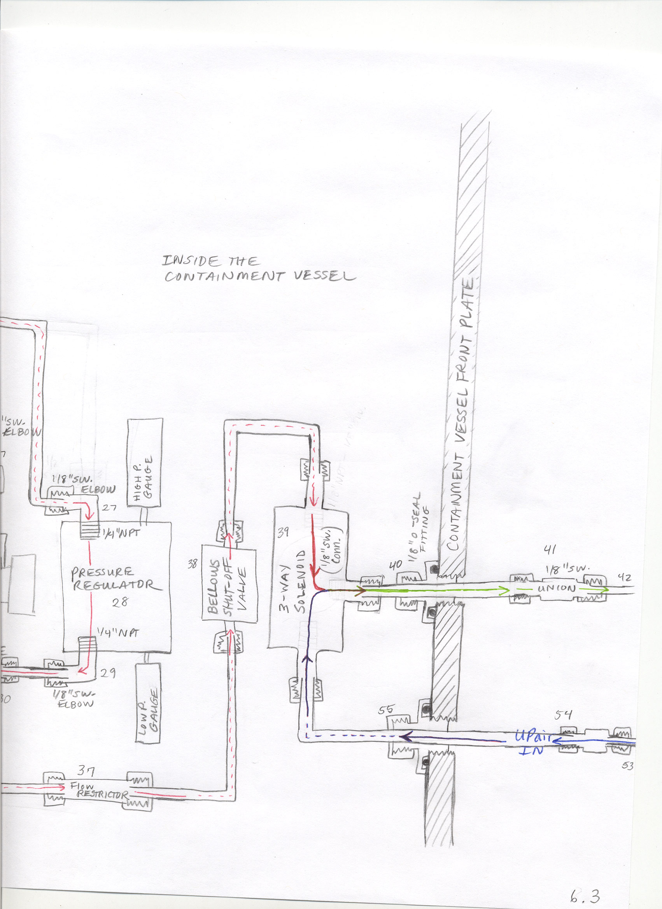
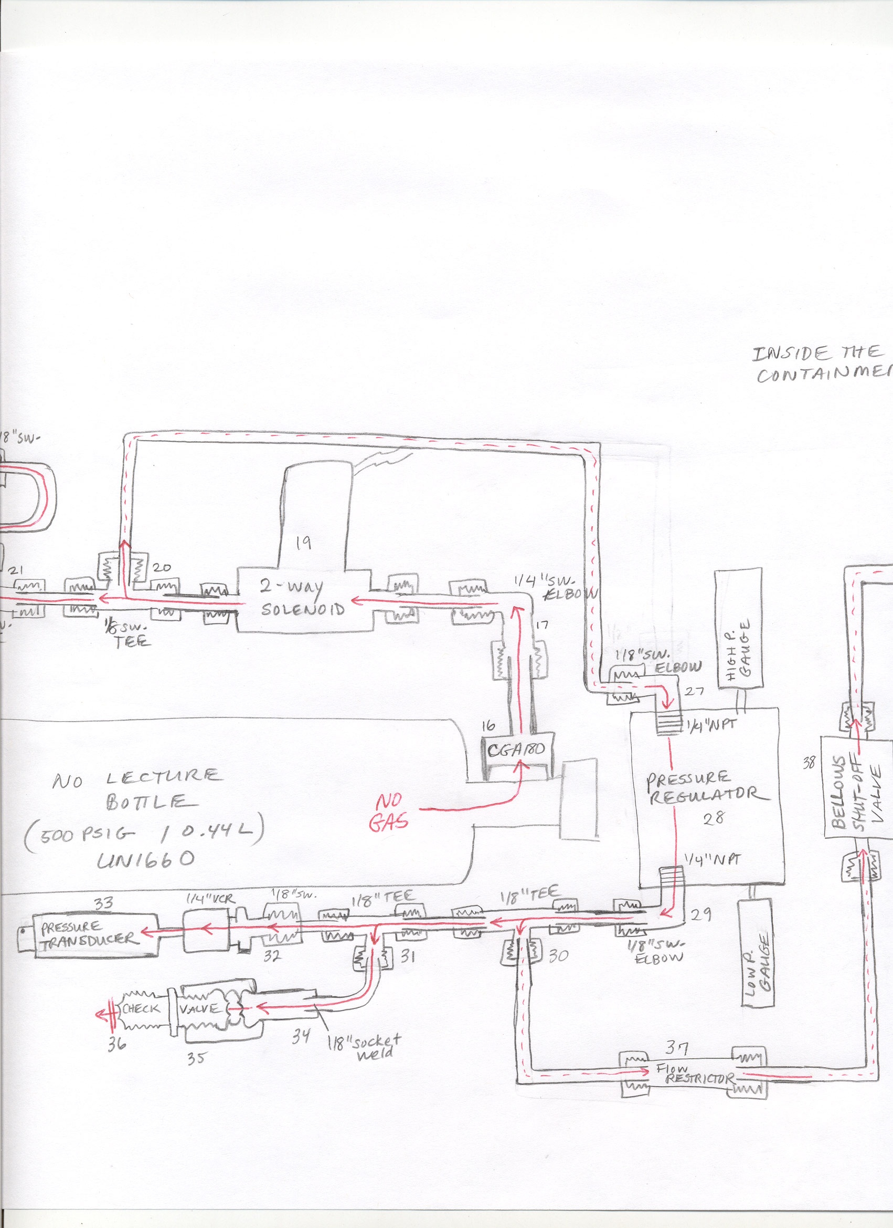
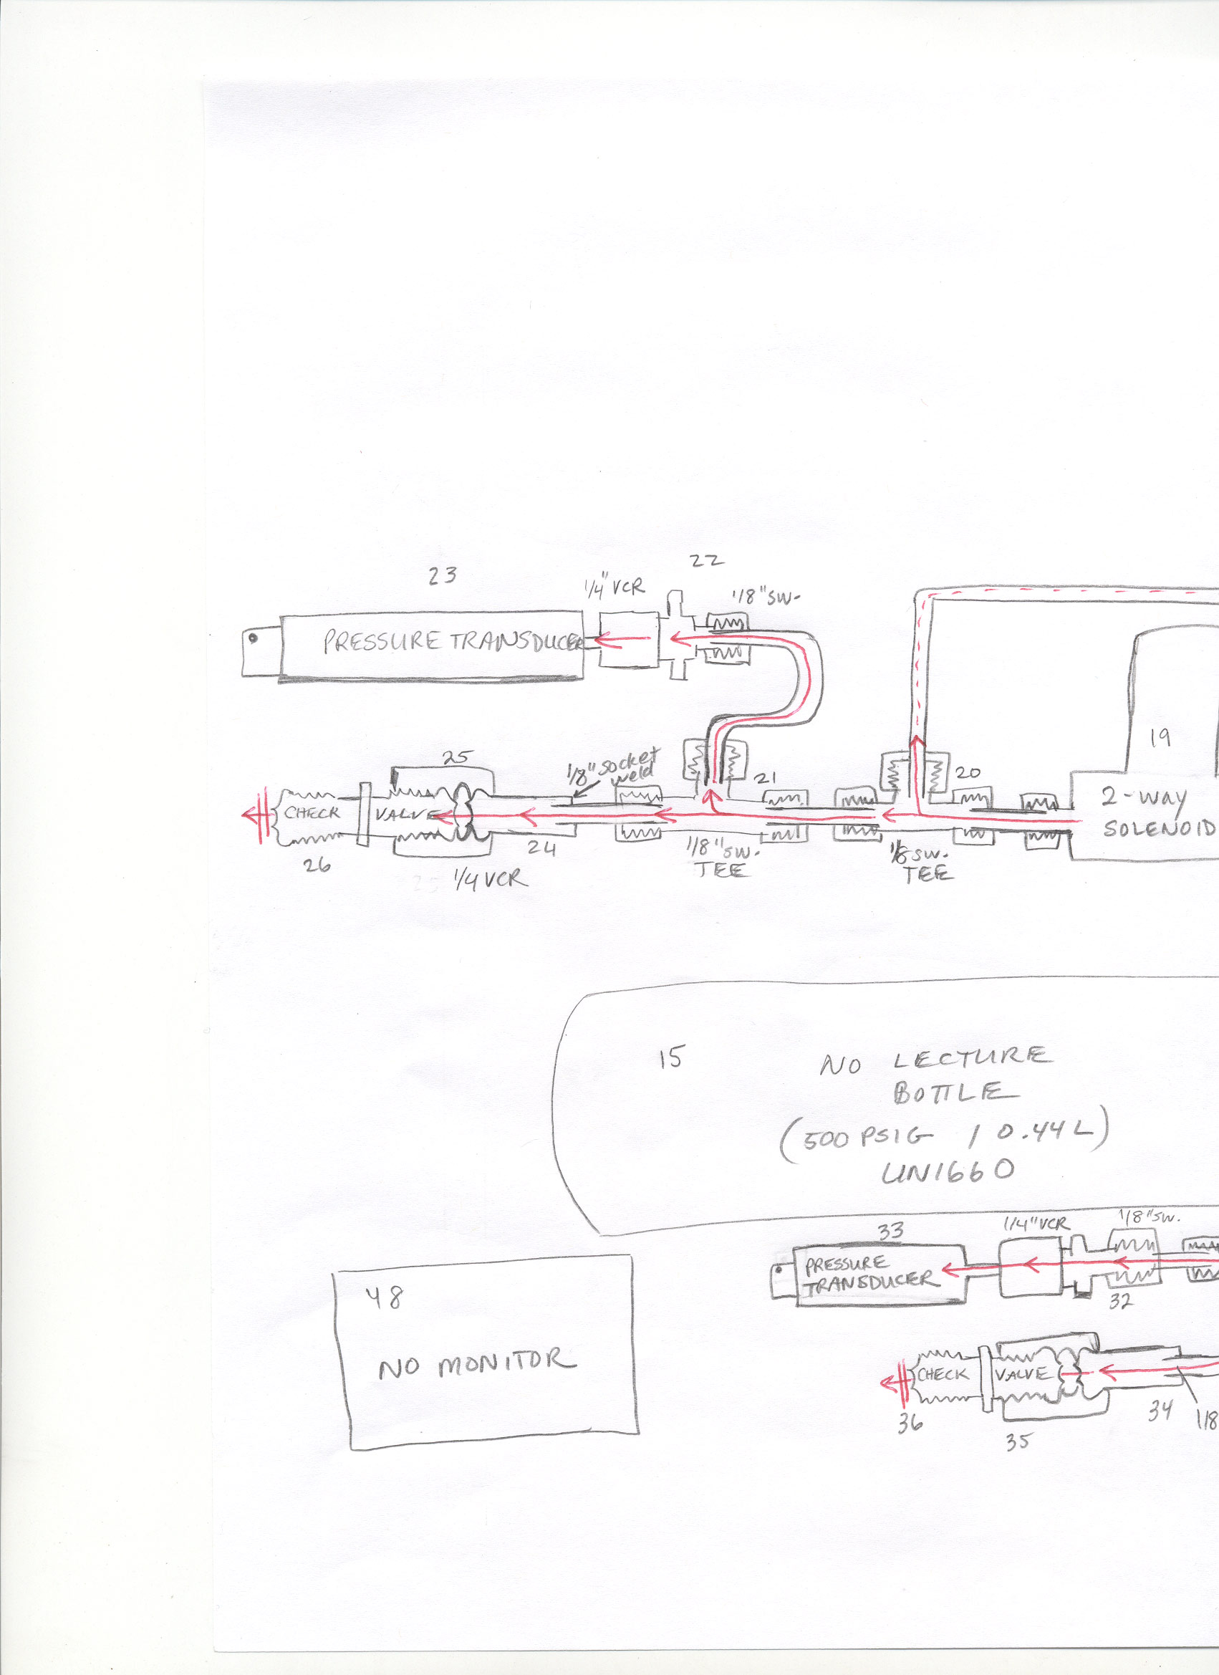

6.4 Sketch of Electrical Feedthrough (top) and Vent System (bottom) for Containment Vessel
(Drawing is not to scale.)
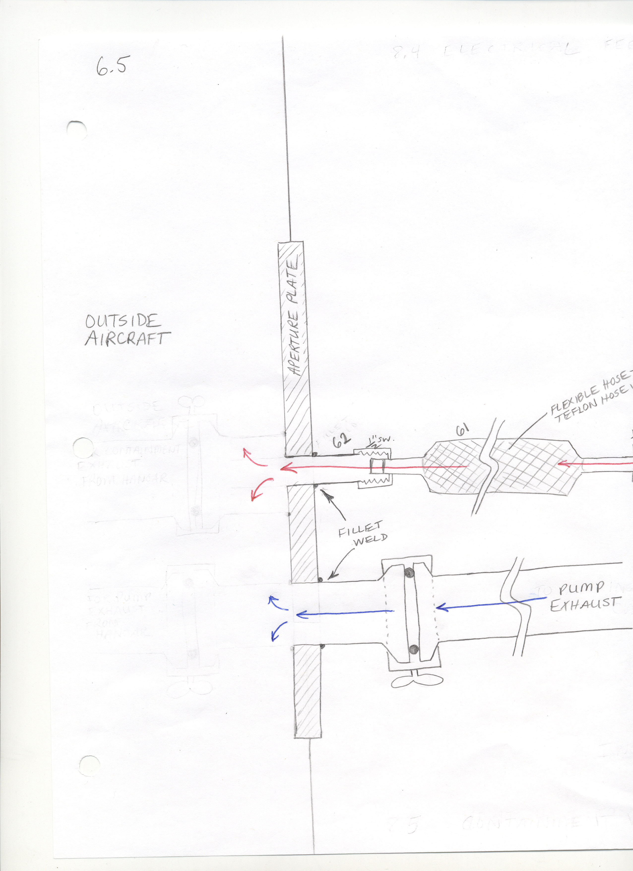
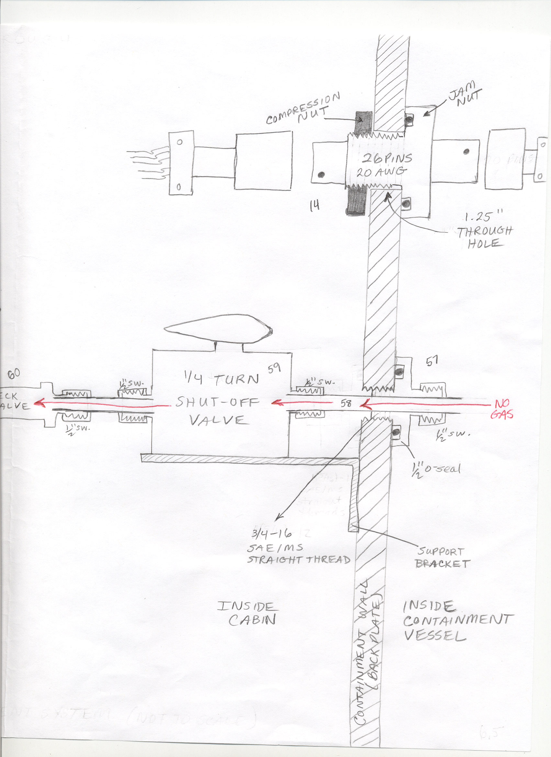
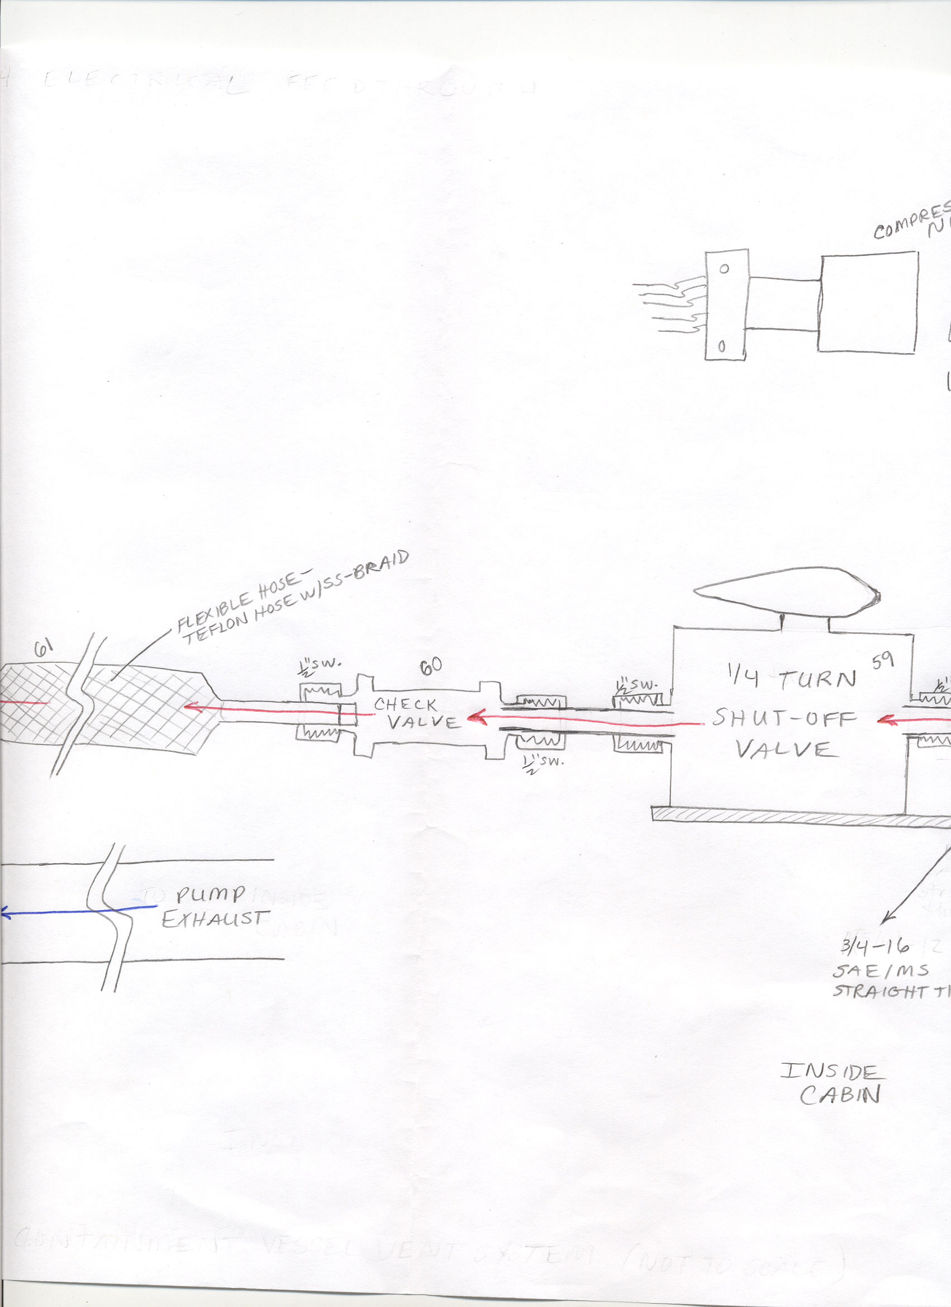

Figure 6.5 (a) isometric
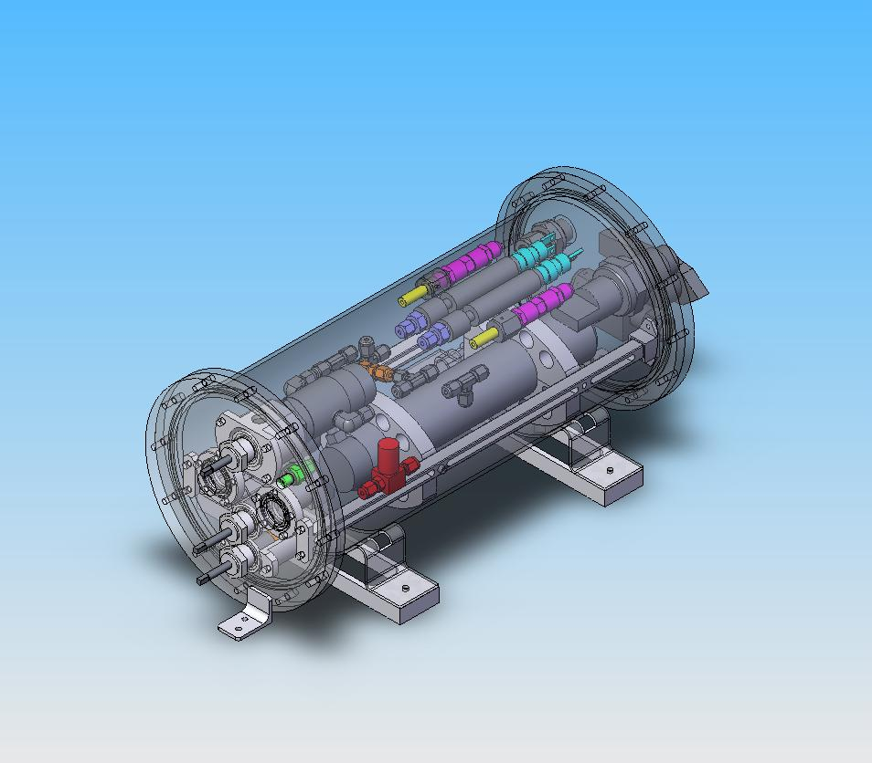

Figure 6.5 (b) back
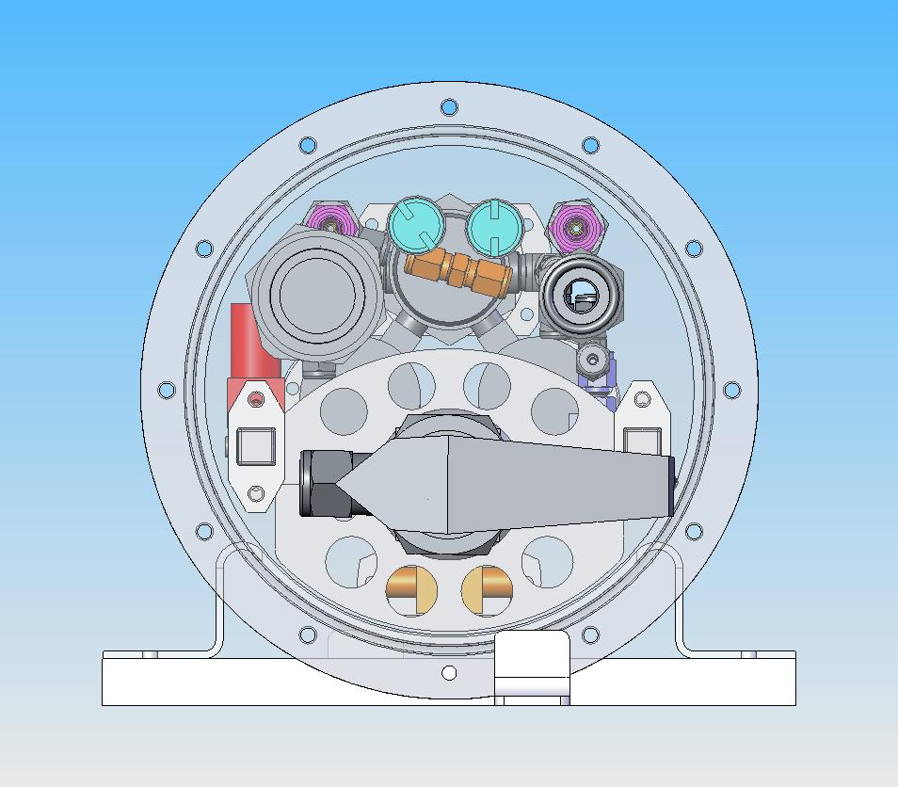
Figure 6.5 (c) bottom
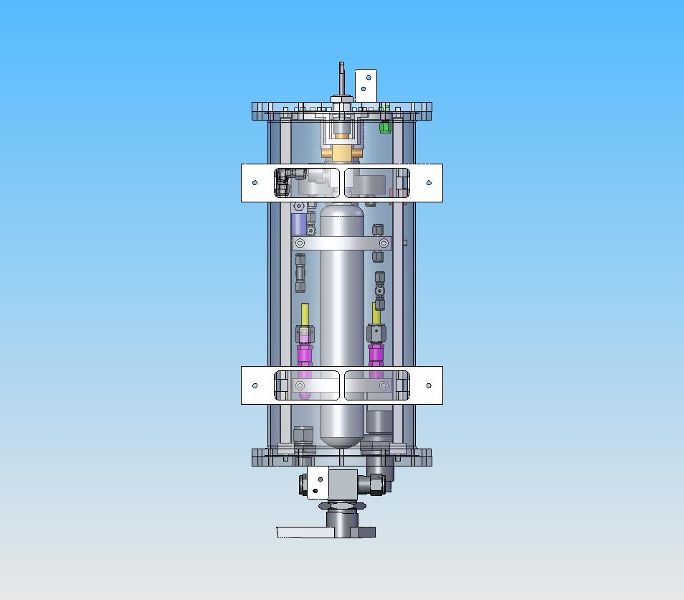
Figure 6.5 (d) front
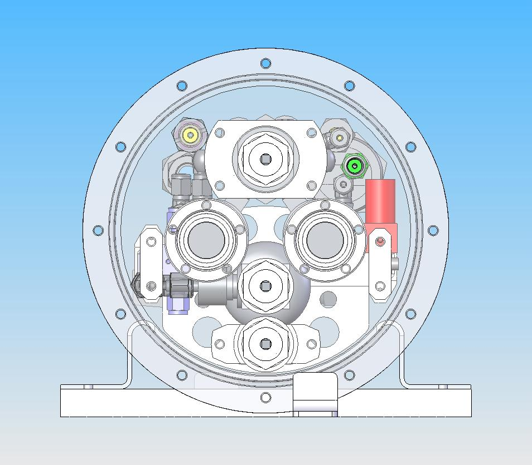
Figure 6.5 (e) top
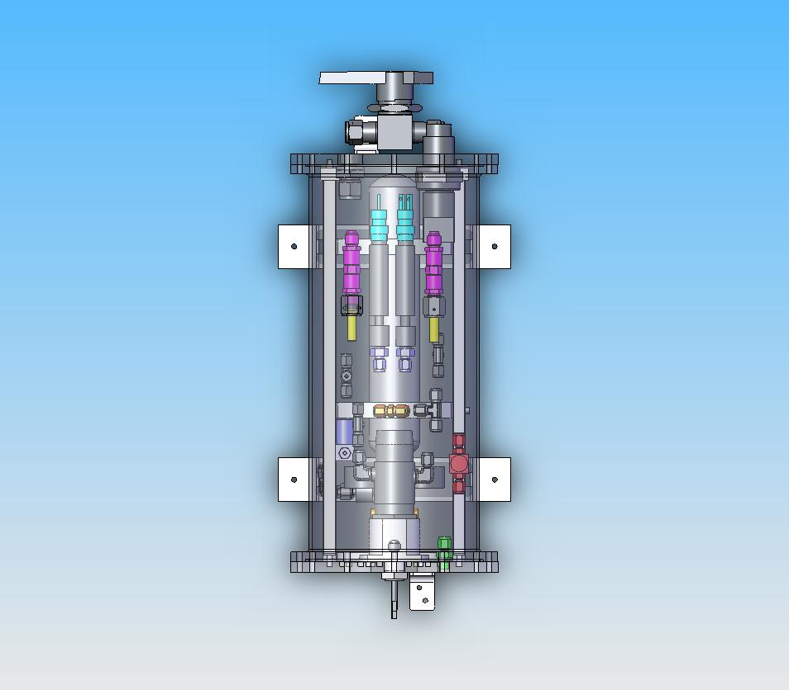
Figure 6.5 (f) left
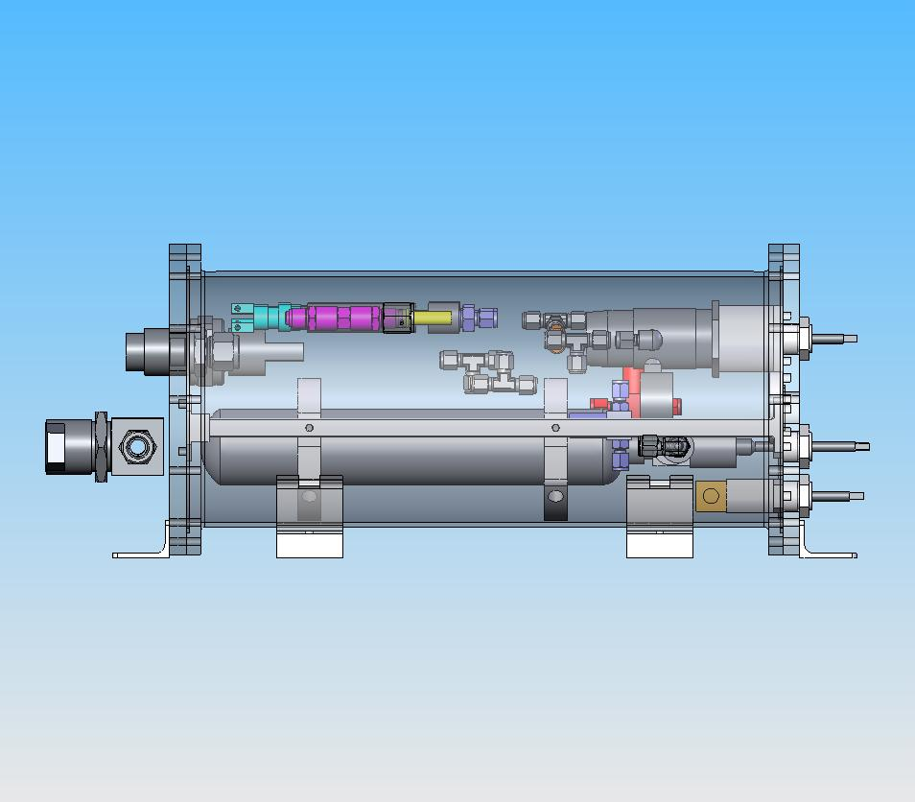
Figure 6.5 (g) right
