Chapter 3: Atlantic Basin Tropical Cyclone Climatology

In this section, the HURDAT2 Atlantic best-track database from 1944-2013 is used to derive climatological statistics regarding the positions of tropical cyclone centers with respect to TCI operating bases. The operating bases considered here are Ellington, MacDill, Langley, Bermuda, and St. Croix. Appendix D Fig. 1 shows 600 nm range rings drawn around these 5 bases. Any TC centered within 600 nm of base should permit at least 2 hours of on-station time assuming a 5.5 h flight at 360 kt. Appendix D Fig. 2 shows 900 nm range rings drawn around the 5 bases. For a TC centered 900 nm away from base, the WB-57 would only have 30 minutes of on-station time under the assumptions listed above. TCs within 600 nm of base would generally be considered good targets, while those between 600 and 900 nm would generally be considered marginal targets (at least from the perspective of on-station time).

Fig. 3 shows the climatological expected number of tropical cyclones (“targets”) within 600 nm (upper panel) and 900 nm (lower panel) of the 5 operating bases. The values shown pertain to a given instant within the time period specified on the x-axis. For example, the climatological expected number of targets within 600 nm of St. Croix, at any particular time in the Oct 1-15 window, is 0.1 targets. Fig 3 shows that for all bases, the highest values occur in the late August, early September, and late September time periods. Comparing the mainland bases, MacDill clearly has the highest values, followed by Langley, and then Ellington.

Fig. 4 shows the climatological expected number of targets within 600 nm (upper panel) and 900 nm (lower panel) of any base within a specified set of bases. Values for three different sets of bases are shown. Note that the values shown in Fig. 4 are not the sums of the values for the individual bases shown in Fig. 3, due to the presence of overlapping regions accessible from multiple bases. For the 600 nm limit, the three mainland bases give a maximum climatological expected number of targets of 0.4 for the early September time period. Adding Bermuda to the mainland bases increases this value to 0.57 targets and adding both Bermuda and St. Croix to the mainland bases increase it further to 0.75 targets.

The results shown in Figs. 3 and 4 pertain to all tropical cyclones, with intensities from tropical depression to Category 5 hurricane (storms categorized as subtropical are also included). However, the desirability of a target for sampling with the WB-57 will likely scale with the intensity of the TC. Fig. 5 shows the climatological likelihood that a target is either a tropical depression, tropical storm, Cat 1-2 hurricane, or Cat 3-5 hurricane. These results pertain to targets with 600 nm of the 4-base set consisting of Langley, Ellington, MacDill, and Bermuda. Early in the season, the proportion of hurricanes (of any category) is low, while the proportion of tropical storms and tropical depression is correspondingly high. For instance, in July the proportion of hurricanes is below 20%, while 50% of targets are in the tropical depression category. However, the situation changes markedly for mid-season and late season targets; from mid-August through the end of October, about 40% of targets are hurricanes. Finally, note that the proportion of Cat 3-5 targets peaks strongly in early September at 16%; it is never more than 10% in any other time period.

Another approach to assess the climatology of Atlantic basin tropical cyclone center positions with respect to TCI operating bases is to calculate the average number of TCs per “year” (considered to be the July 15 – Oct 31 time period) that approach within 600 nm of any of a set of bases. Table 1 shows the results of this approach. Three different set of bases are considered, as well the entire basin for reference. Results are shown for all TCs, TCs of at least tropical storm intensity, TCs of at least hurricane intensity, and major hurricanes. The intensity used for classification is the maximum intensity of the TC during the time it was within 600 nm of a base (which is not necessarily the TC lifetime maximum intensity).

For example, there is an average of 3.2 TCs of at least hurricane strength that approach within 600 nm of either Ellington, MacDill, Langley. This number increases to 5.5 for TCs of at least tropical storm strength and to 6.8 for all TCs.

The average number of TCs of at least hurricane strength that approach within 600 nm of any of a set of bases is perhaps a reasonable estimate of the expected number of “good cases” during the TCI operational period. Considering the Ellington/MacDill/Langley set of bases, for example in 2014 there were 2 such “good cases”: Bertha and Cristobal. Note that Gonzalo does not fit the “good case” definition because it was (just barely) outside the 600 nm range ring for all three bases. So, clearly there are some limitations for this concept of “good cases”.

 | All TCs | TS, H, MH | H, MH | MH
EFD, MCF, LFI | 6.8 | 5.5 | 3.2 | 1.3
EFD, MCF, LFI, BDA | 8.4 | 7.0 | 4.1 | 1.9
EFD, MCF, LFI, BDA, STX | 9.6 | 7.9 | 4.5 | 2.1
Entire basin | 12.2 | 9.5 | 5.5 | 2.5
Table 1: Average number of TCs per “year” (July 15 – Oct 31 time period) that approach within 600 nm of any base within the set of bases shown in the left column. The bases are Ellington (EFD), MacDill (MCF), Langley (LFI), Bermuda (BDA), and St. Croix (STX). The “Entire basin” row shows results for the whole basin. The column show results for all TCs, TCs of at least tropical storm intensity, TCs of at least hurricane intensity, and major hurricanes.

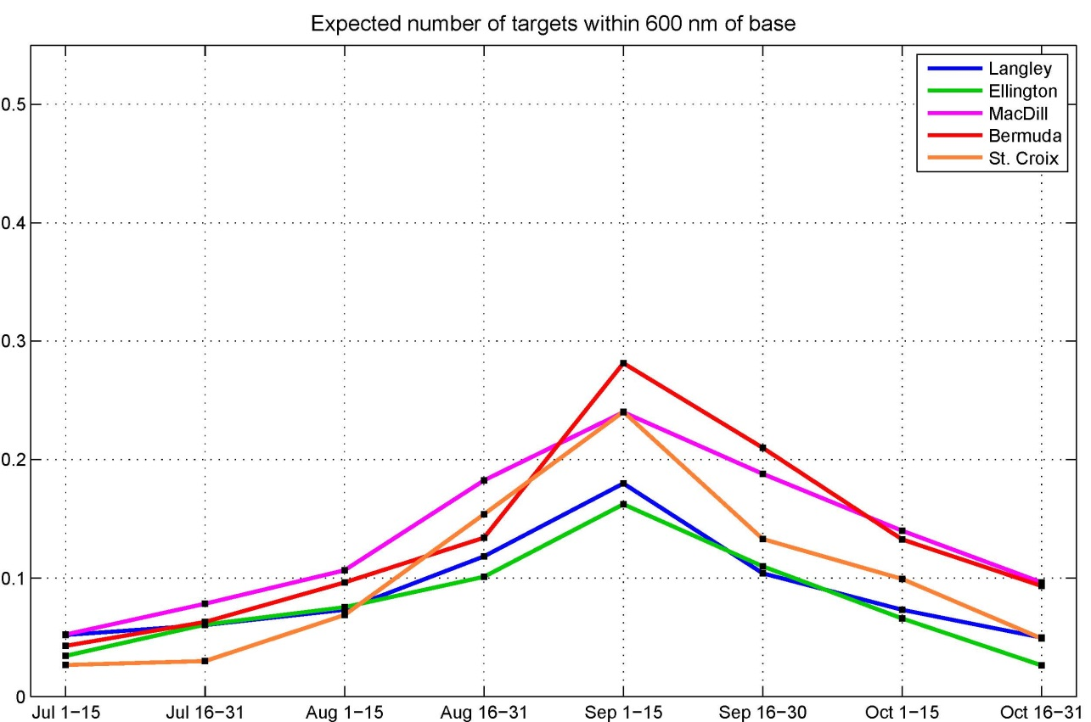

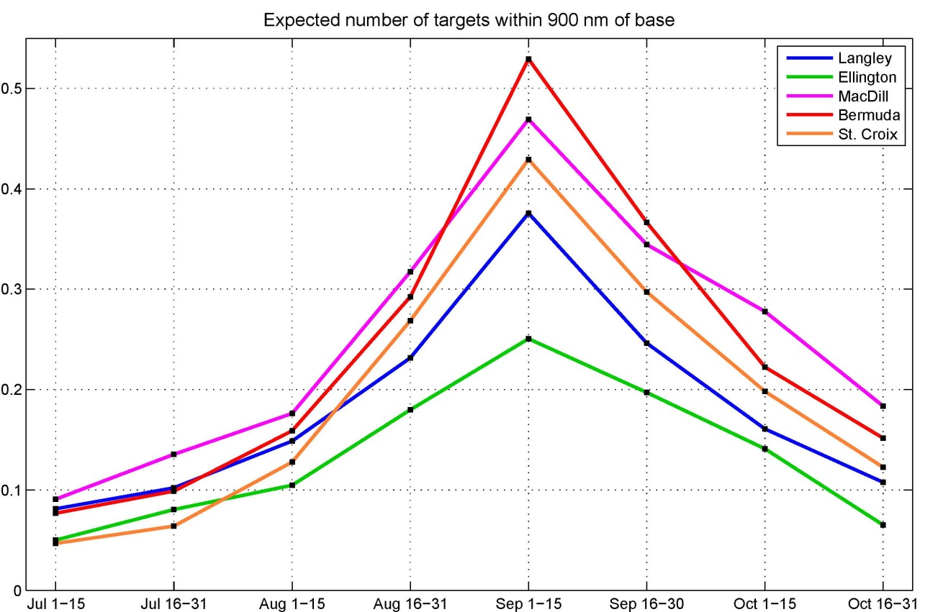

Figure 3: Climatological expected number of tropical cyclones with 600 nm (upper panel) and 900 nm (lower panel) of each of 5 operating bases.

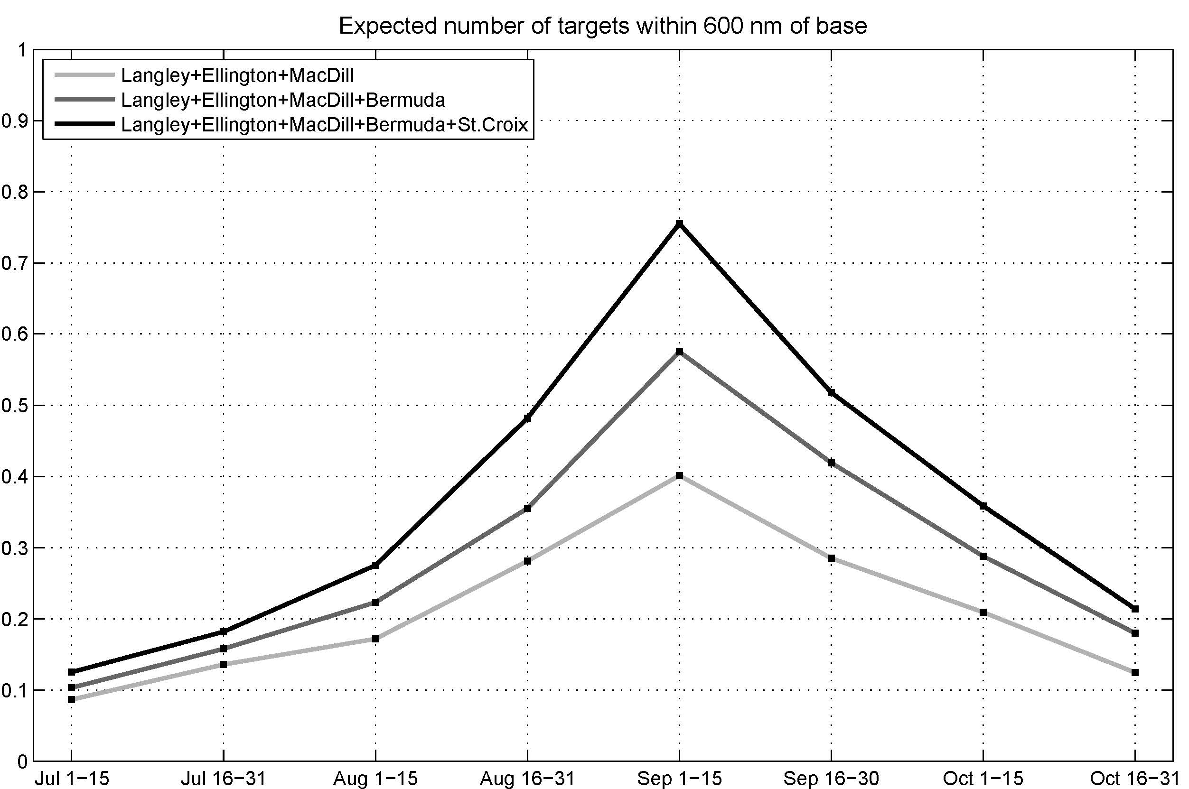

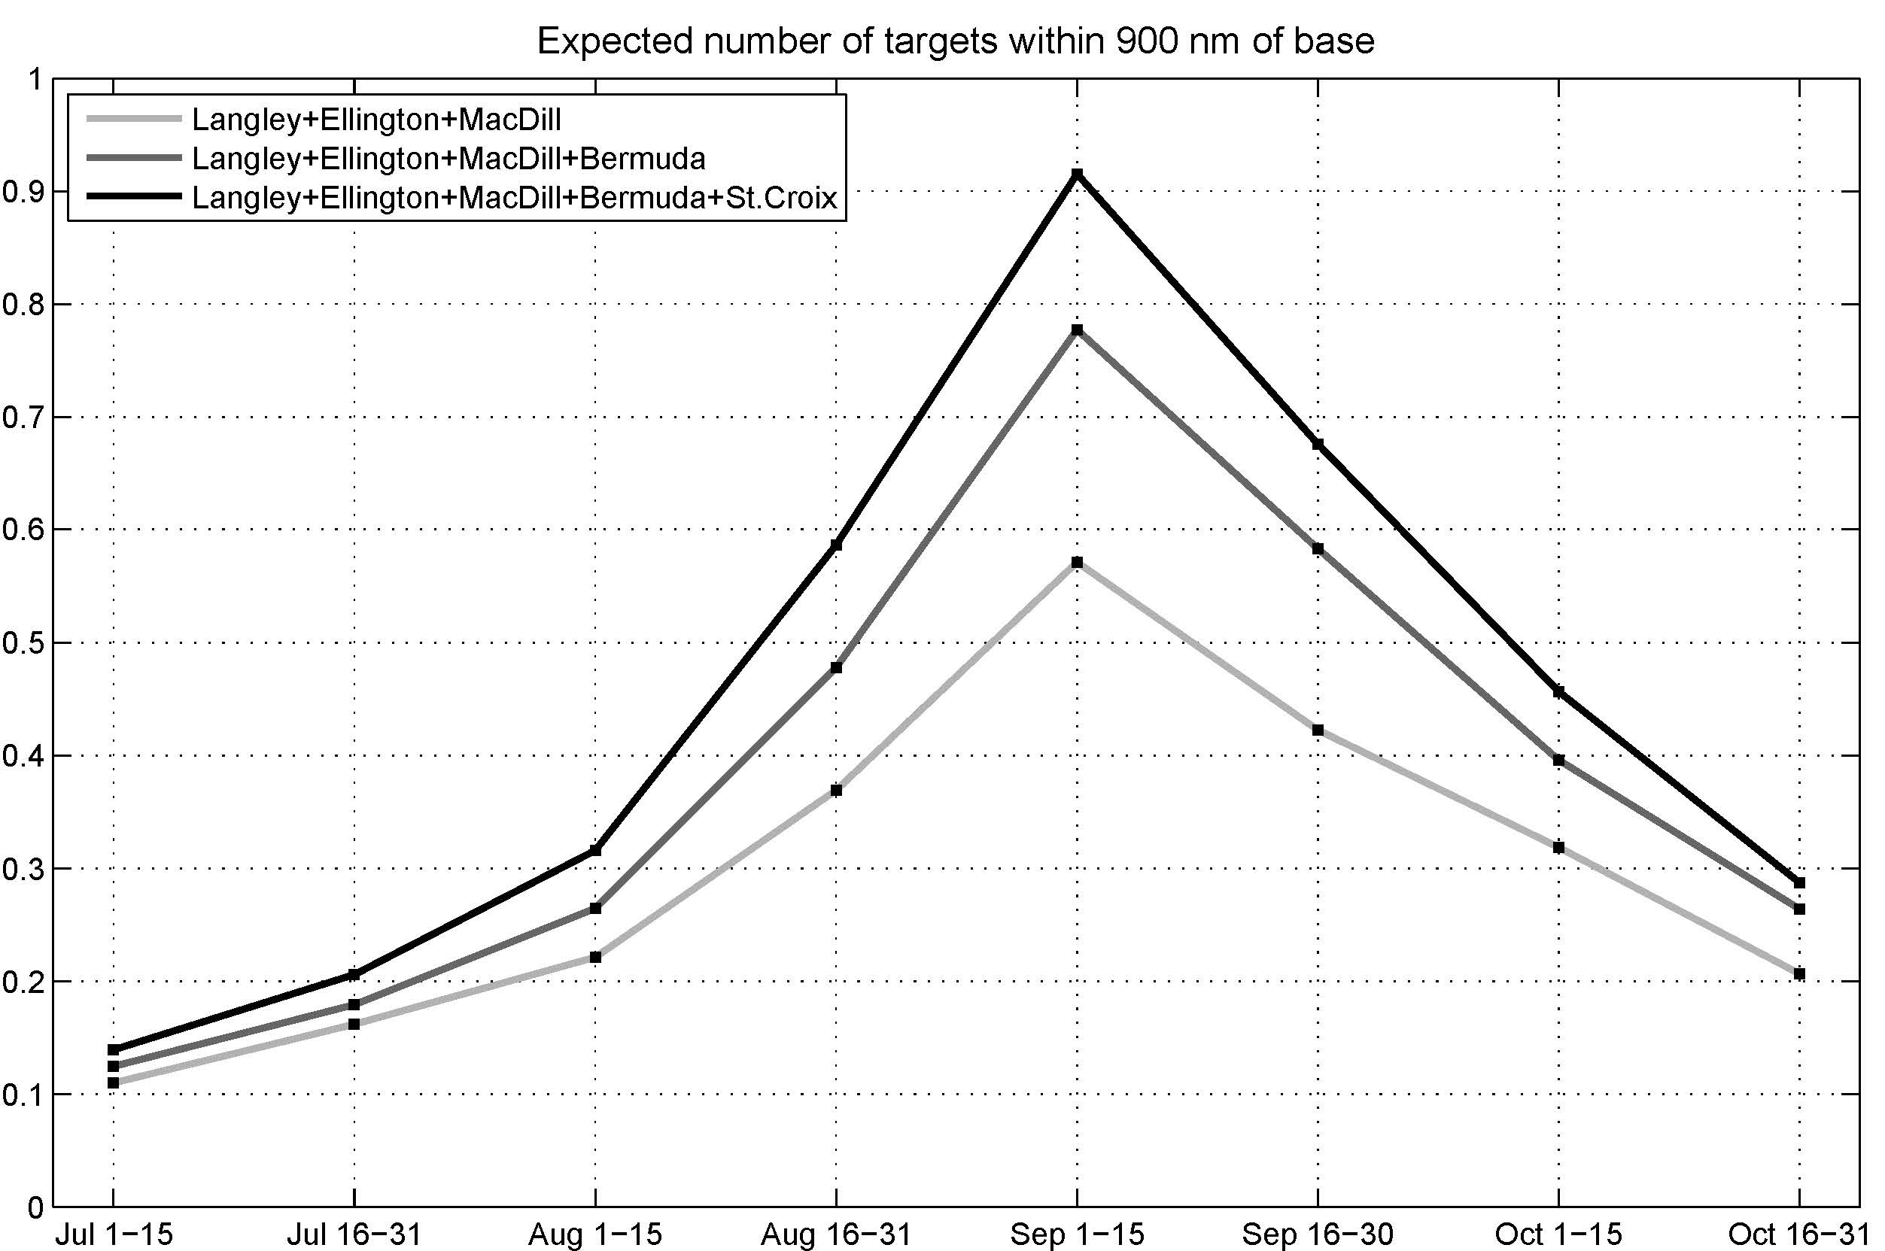

Figure 4: Climatological expected number of tropical cyclones with 600 nm (upper panel) and 900 nm (lower panel) for three different combinations of operating bases.

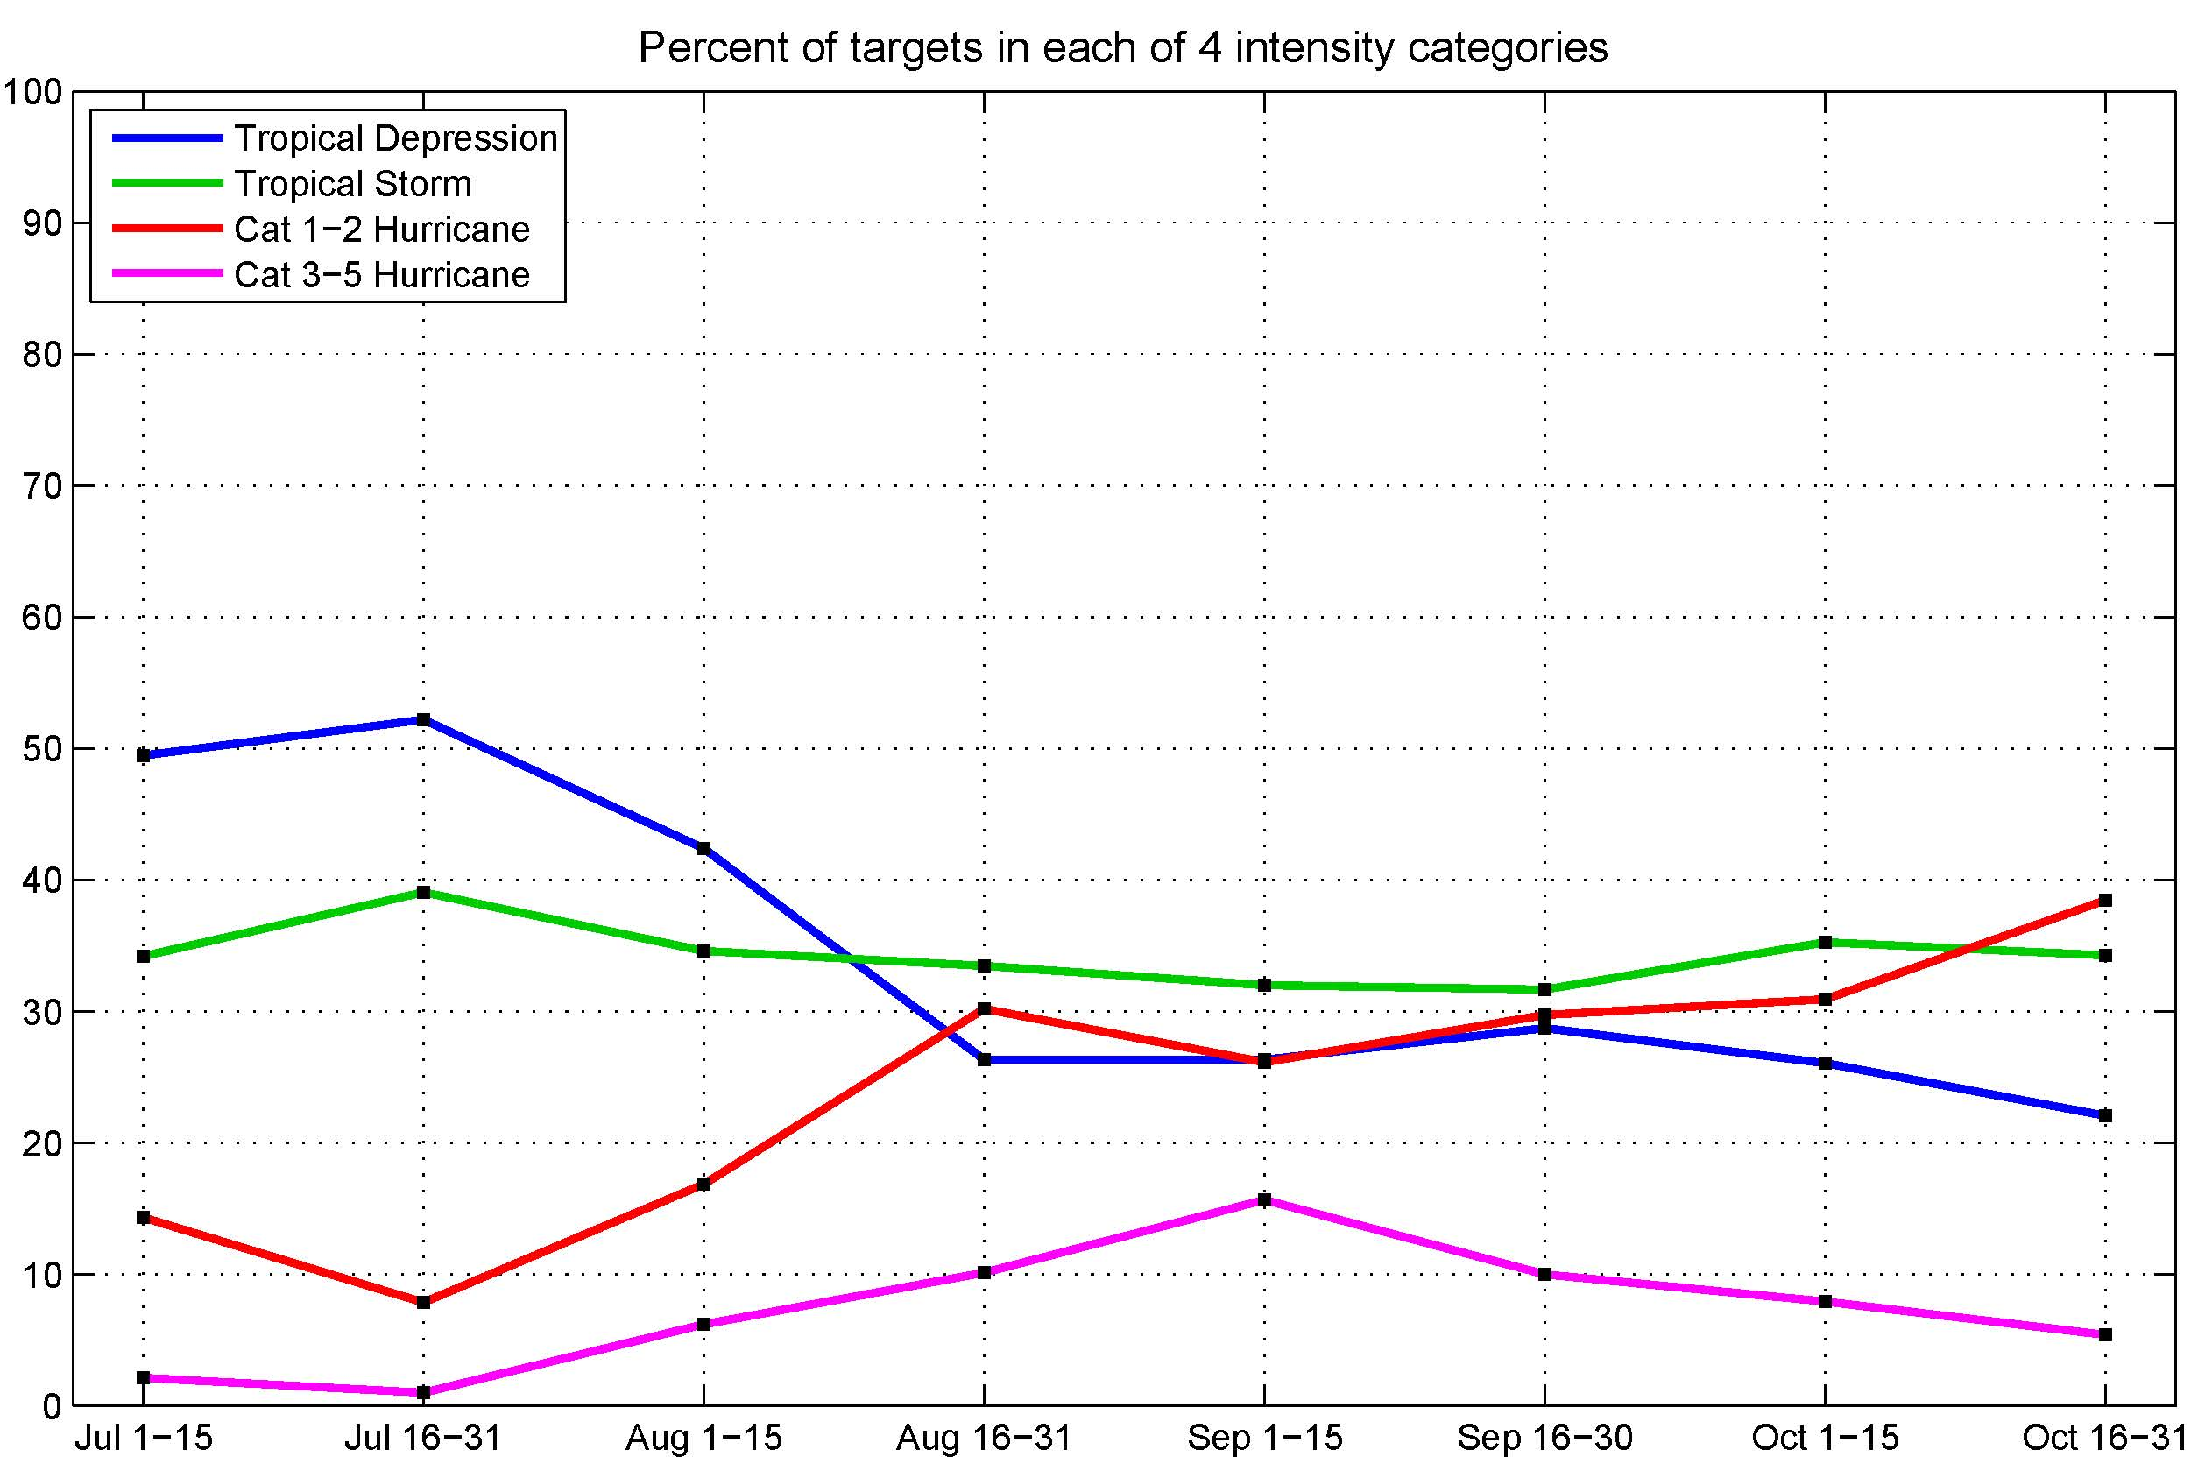

Figure 5: The percent of targets in each of 4 intensity categories, for targets within 600 nm of the 4-base set consisting of Langley, Ellington, MacDill, and Bermuda.

