Chapter 2: Collaboration with partners
TCI is collaborating with the NOAA SHOUT and NOAA IFEX programs that will be conducting operational and research missions into North Atlantic and Eastern North Pacific tropical cyclones. Each project has individual science goals and operational schedules which will need to be carefully coordinated. There is a unique opportunity during these combined field programs to measure the storm inner core, surrounding TC environment, and the TC upper-level outflow layer. Additionally, oceanographic data will be collected by various aircraft to observe the upper-ocean response to the near-surface wind field during TC passages. Communication and understanding of the other science/operational objectives and measurements are important to maximize utility of observational assets.
NOAA SHOUT (23Aug-27Sep)
A portion of the TCI Experiment will be concurrent operations with the NOAA SHOUT Program, which is deploying a single Global Hawk (GH, AV-6) to investigate TC track and intensity change from August 25th through September 27th. The overall goal of SHOUT is to demonstrate and test a prototype UAS concept of operations that could be used to mitigate the risk of diminished high-impact weather forecasts and warnings in the case of polar-orbiting satellite observing gaps.
The sciences objectives will include several data impact studies (track & intensity) that include utilizing adaptive sampling strategies for improving real-time TC track and intensity forecasts, Observing System Experiments (OSEs) using data from GH missions, Observing System Simulation Experiments (OSSE) using simulated GH data, and to investigate processes in the TC inner core (e.g. the TC warm core), boundary layer, and upper-level environment (e.g. the TC cirrus canopy) that impact intensity change.
The GH will be deploying out of the NASA Wallops Flight Facility with the potential to shift to the west coast (NASA Armstrong) if there are no viable storm targets in the North Atlantic. SHOUT GH mission durations will be ~24 hour with a range of ~8,000 nm. The GH flight level is 55-60,000 ft with a flight frequency of 1 mission every 48 hours for a maximum of 3 consecutive flights.
The GH will be gather flight level observations (pressure, wind and thermodynamics) and will be equipped with 4 instrument platforms: 1) the Airborne Vertical Atmospheric Profiling System (AVAPS) that can deploy up tp 88 GPS dropsondes per flight; 2) the High Altitude Monolithic Microwave Integrated Circuit (MMIC) Sounding Radiometer (HAMSR) will be used to measure a 3D distribution of temperature, water vapor, and cloud liquid water; 3) the High-Altitude Imaging Wind and Rain Airborne Profiler (HIWRAP) to measure 3D winds, ocean vector winds, and precipitation; and 4) the Lightning Instrument Project (LIP) that will measure lightening, electric fields, electric field changes, and air conductivity.

The NOAA Intensity Forecasting Experiment (IFEX)
IFEX supports the Hurricane Forecast Improvement Project (HFIP) by serving as the key observational resource (utilizing 2 P-3 Orions and a G-IV jet) for initialization and evaluation of numerical model guidance (e.g. HWRF). IFEX is designed to improve operational forecasts of TC intensity, structure, and rainfall by providing data to improve the operational numerical modeling system (i.e., HWRF) and by improving understanding of the relevant physical processes.
IFEX goals will be accomplished by satisfying a set of requirements and recommendations guiding the collection of the data: Goal 1: Collect observations that span the TC life cycle in a variety of environments for model initialization and evaluation; Goal 2: Develop and refine measurement technologies that provide improved real-time monitoring of TC intensity, structure, and environment; Goal 3: Improve understanding of the physical processes important in intensity change for a TC at all stages of its lifecycle.
IFEX will utilize 3 aircraft to conduct its field campaign: 2 P-3 Orions and a G-IV high-altitude jet. Operational P-3 missions tasked by the NOAA National Hurricane Center (NHC) and Environmental Modeling Center (EMC) receive top tasking priority and are conducted at 12 hr intervals (2:00 AM and 2:00 PM EDT take-off times). Research missions tasked by NOAA HRD are accomplished by working within the constraints of operational missions or are conducted when operational tasking has not been requested. The G-IV is occasionally tasked by NOAA NHC to conduct operational Synoptic Surveillance missions around TCs threatening U.S. interest. These missions are conducted either once or twice per day depending on proximity to land with take-off times of 1730 and 0530 UTC.
IFEX aircraft will typically base from MacDill AFB in Tampa, FL with options to forward deploy to St. Croix, Barbados, La Paz, Baja Mexico, and Tapachula, Mexico; The P-3 Orions typically operate between 5-12,000 ft, have a duration of 8-10 hr, a range of ~3,800 nm, and usually flies throughout the storm environment, including the inner core, eye, and surrounding environment out to ~105 nm from the storm center. These aircraft collect flight level observations of pressure, wind, thermodynamics, and microphysics and are equipped with a tail Doppler radar (TDR), Stepped Frequency Microwave Radiometer (SFMR) for measuring surface wind speeds over the ocean, a Wide Swath Radar Altimeter (WSRA) for examining ocean wave fields, aircraft-deployed COYOTE UASs, GPS dropsondes, and aircraft expendable bathythermographs (AXBTs) for measuring sea surface and sub-surface temperatures.
The G-IV typically operates between 41-45,000 ft, has a duration of 7.5-8.5 hr, a range of ~3,800 nm, and usually samples the storm periphery several hundred kilometers from the center to as close as ~60 nm from the center. This aircraft collects flight level observations of pressure, wind, and thermodynamics and is equipped with a tail Doppler radar (TDR) and a Stepped Frequency Microwave Radiometer (SFMR) for measuring surface wind speeds over the ocean.

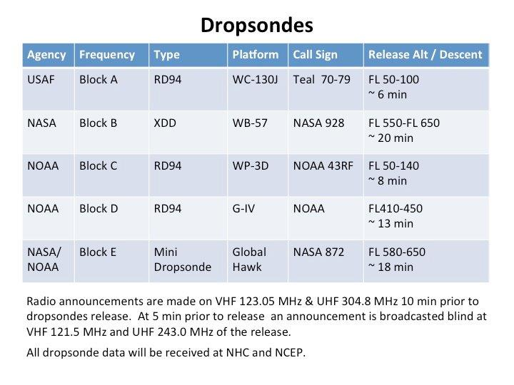
Table 1. Shows the dropsonde frequencies assigned to each platform.

