Chapter 5: Aircraft Flight Operations

WB-57 Flight Modules

In this section, we show some canonical flight modules for the WB-57 during TCI. These modules can be easily modified and in some cases can be combined in a single flight depending on the tropical cyclone structure and its location. Below, we first address the considerations involving aircraft, instrument performance in the design of WB-57 flight patterns. An overview of mission planning software is then provided. Next, canonical flight patterns are presented, within the general categories of vortex-centric and outflow-centric patterns. Finally, a few examples of patterns applicable to past TCs are presented and the aircraft range rings are provided in Appendix #.

Flight planning considerations

HIRAD considerations (*need input from HIRAD)

- 10-m wind speeds > 30 kt are needed for successful retrievals
- Over areas with 10-m wind speed > 30 kt, straight flight legs with level flight are necessary for successful retrievals. Turns are not a relevant consideration for HIRAD over areas in which the 10-m wind speed < 30 kt.
- Swath width is 40-50 km, so spacing of parallel flight legs 40 km apart would achieve overlapping HIRAD coverage
- Can HIRAD obtain useful data during the initial ascent to cruising altitude and descent from cruising altitude (*input needed)? Probably >30 kt winds would not be just offshore of base, but this would be useful to know.
- Is there a delay between when the plane levels out after a turn and the time at which a useful retrieval can be obtained, assuming 10-m wind speed > 30 kt (*input needed)?

HDSS considerations (*need input from HDSS team)

- Turns can affect transmission of data from sonde to plane. This issue will be explored further during the June test flight, and further guidance regarding flight planning implications will need to be developed thereafter (*input needed). Guidance is also needed regarding whether we can drop during a turn (*input needed).

Aircraft considerations

- Flight duration is typically 5.5 h. For planning purposes, the aircraft true airspeed is 380 kt and the route of flight is 2100 nm. It is possible to make up to 400 kt true airspeed, and the route can potentially be stretched to 2200 nm if the landing weather and other conditions are favorable, such as divert field options. Figure 1 shows a number of example “out-and-back” from patterns from MacDill under a slightly more conservative assumption of 1980 nm route of flight.
- At the 60,000 ft flight level, the plane typically turns with 20º angle of bank, at a turn rate of about 1º per second. So, a 90º turn takes ~90 s. The turning radius is 7 nm.
- Time to ascend from take-off to cruising altitude of 50,000 is estimated to be 30 minutes. It will be necessary to get to this cruising altitude to get above the top of typical TC outflow, so performing drops during the initial ascent is probably not warranted. From 50,000 ft, it takes another 45-60 minutes to get to 60,000 ft.
- Time to descent from 60,000 ft to recovery is estimated to be 30 minutes over a distance of about 120 nm. As during the ascent, performing drops during the descent is probably not warranted.

Aircraft Range Rings: See Appendix.

Mission planning software
NASA Mission Tools Suite (MTS)
The NASA Airborne Science Mission Tool Suite (MTS) supports the Airborne Science Program (ASP) and the NASA Science Mission Directorate (SMD) Earth Science Division by providing a suite of web-based capabilities to support Airborne Science Missions. The ASP Mission Tools Suite provides a common operating picture for improved situational awareness for all participants in NASA Airborne Science missions from scientists and engineers, to managers, as well as the general public. Additionally, ASP Mission Tool Suite facilitates communication between mission team members to enable analysis and discussion of multiple data sources to help plan and execute science missions. The Mission Tool Suite contains a core set of tools that provide Airborne Science Participants with a host of capabilities:

- remotely monitor real-time aircraft location
- view current and archived flight tracks
- ability to add information overlays from a curated product registry
- customized user workspaces
- team communication and collaboration tools
- integrated single and multi-user chat client
- plotting and graphing
- FIR overlay
- To access MTS, go to http://mts.nasa.gov/. To request an account, please send an email to ARC-ASP-MTS@mail.nasa.gov. Please specify the SHOUT/TCI as the project that you plan to support.
PATs Flight Planning Software
The PATs tool provides mission planners with a graphical method for quickly and easily calculating storm-relative flight Lat/Lon, way-points and flight durations using Javascript, Google Maps API's, and Chris Veness open-source scripts. This network-based software allows multiple independent users to prepare and evaluate flight patterns and dropwindsonde locations from a single webserver (http://met.nps.edu/~ldm/track/atlx/). A graphical interface with up to 20 product overlays and 10 KML overlays allows users to drag and drop way-points and instantly view flight track parameters within the context of the flight environment. A fully self-documented KML file for Google Earth or PATs is produced with flight date/time labels, dropwindsonde locations, and all user-specified parameters related to the flight track. The way-points and dropwindsonde locations are also available in tabular form in the KML file for the pilot and Air Traffic Control, along with the storm-related range and bearing information needed to recreate and modify the flight track in PATs.

Canonical flight patterns

Basic vortex-centric patterns

Vortex-centric patterns are drawn with respect to the center of the TC, and primarily sample along radials extending from the TC center. These are the preferred patterns for the inner-core / outflow “roots” sampling objective. The two basic patterns are the alpha pattern and butterfly pattern, illustrated in “closed” form in Fig. 2 and Fig. 3, respectively. Note the red dots along the track do not represent drop points; they are instead the points you can grab in PATs to manipulate the pattern (the images are screen shots from PATs). The closed alpha pattern has two radial legs crossing the TC center, and two “tangential” legs covering a total of 180º around the storm. The closed butterfly pattern has three radial legs crossing the TC center, and three “tangential” legs covering a total of 180º around the storm.

To maximize sampling in the radial direction, at the expense of azimuthal sampling, open forms of the alpha (Fig. 4) and butterfly (Fig. 5) can be drawn with the open side of the pattern facing base. For reference, Table 1 is a summary of the length and duration of the radial and tangential legs of the open alpha and open butterfly patterns, as a function of the range of the TC center from base. These calculations assume a 5.5 h duration WB-57 flight at a speed of 380 kt (such patterns are easily calculated in PATs). Since the open butterfly pattern has an additional radial leg w.r.t. the open alpha pattern, the radial extent of the open butterfly pattern at a given TC center range is necessarily smaller than that of the open alpha pattern.

 | Open alpha |  | Open butterfly
TC range | Radial leg | Tangential leg | Radial leg | Tangential leg
200 nm | 612 nm, 97 min | 431 nm, 68 min | 465 nm, 73 min | 232 nm, 37 min
300 nm | 601 nm, 95 min | 424 nm, 67 min | 445 nm, 70 min | 223 nm, 35 min
400 nm | 564 nm, 89 min | 398 nm, 63 min | 398 nm, 63 min | 199 nm, 31 min
500 nm | 501 nm, 79 min | 353 nm, 56 min | 343 nm, 54 min | 171 nm, 27 min
600 nm | 421 nm, 66 min | 297 nm, 47 min | 281 nm, 44 min | 141 nm, 22 min
700 nm | 333 nm, 53 min | 234 nm, 37 min | 218 nm, 34 min | 109 nm, 17 min
800 nm | 241 nm, 38 min | 169 nm, 27 min | 155 nm, 24 min | 78 nm, 12 min
900 nm | 144 nm, 23 min | 102 nm, 16 min | 94 nm, 15 min | 47 nm, 7 min
Table 1: Length and duration of the radial and tangential legs of the open alpha (Fig. 4) and open butterfly (Fig. 5) patterns, as a function of the range of the TC center from base. A 5.5 h duration WB-57 flight at a speed of 380 kt is assumed.

Additional vortex-centric patterns

The closed alpha pattern can be repeated (i.e. rotated figure “4” pattern) such that there are four diagonal legs crossing the TC center, and four tangential legs covering a total of 360º around the storm. Likewise, the closed butterfly pattern can be repeated such that there are six diagonal legs crossing the TC center, and six tangential legs covering a total of 360º around the storm. However, unless the TC is quite close to base or the radial scope of the pattern is quite small, it is unlikely that these lengthy patterns would be feasible with the WB-57.

Outflow-centric flight patterns

TC outflow is typically spatially extensive and differs markedly in morphology from storm-to-storm and at different times in a single storm’s life cycle. It is unrealistic to draw canonical patterns intended to sample the outflow that would be applicable to a reasonably large proportion of TCs. Instead, it is best to consider outflow sampling objectives that should be considered in the flight planning process.

Sampling objective #1: Cross-section normal to outflow jet

Often, outflow from a TC organizes into one or more jets leading away from the TC rather than an azimuthally symmetric pattern. The size of these features varies widely, but in favorable scenarios it should be feasible to completely traverse an outflow jet (traveling perpendicular to the flow direction). An example is shown in Fig. 6 for Arthur (2014), a very favorable scenario in which an outflow jet can be traversed multiple times using a lawnmower-type pattern. As shown in Fig. 6, the lawnmower legs should extend some distance (perhaps 100 km) beyond the apparent edge of outflow jet to sample the gradient region between the outflow layer and the surrounding tropical atmosphere, and to account for uncertainty in the exact position of the edge. The edge of the outflow should be determined using a combination of examining brightness temperature gradients in water vapor imagery and mid-level to upper-level water vapor winds produced by UW-CIMSS and/or NOAA-NESDIS, along with any available rapid scan visible imagery. Ideally, these cross-sections would be repeated along the direction of the outflow (as shown in the Arthur example in Fig. 6), either toward or away from the storm depending on the situation. High-density drops could be used near the cirrus edge to sample that region with high resolution.

Sampling objective #2: Follow outflow downstream from core

It is of interest to understand the nature of the outflow layer from its “roots” in the inner core convection all the way to outer fringes of the TC. A flight can be designed to include a center crossing that then follows along a streamline of the upper-tropospheric winds for a considerable distance away from the storm center. An example is shown in Fig. 7 for Isaac (2012). Note that the center-crossing part of this sampling objective would also address the inner-core sampling objective, including high winds for observation by HIRAD. This module could be combined with legs oriented perpendicular to the outflow jet (see sampling objective #1).

Sampling objective #3: Edge of cirrus canopy / outflow

We have identified sampling on both sides of edge of the cirrus canopy / TC outflow as a science objective, in order to better understand the dynamics and thermodynamics of the cirrus canopy / TC outflow in juxtaposition to the surrounding environment. The example of Hurricane Earl, as shown in Fig. 8, illustrates a situation in which it would be easy to accomplish this objective.

Flight pattern examples for retrospective cases

All patterns in this section were drawn for a 5.5 h duration flight assuming 360 kt speed (more conservative than the 380 kt speed used earlier; in real flights we could go about 100 nm further). CIMSS AMVs are used to represent the observed upper-tropospheric winds for the purposes of this flight planning exercise.

Hurricane Gustav

At 2008083112, Gustav had just crossed Western Cuba into the Gulf of Mexico as a major hurricane (105 kt), and was centered 24.8ºN, 85.5ºW. This center position is only 243 nm from MacDill. An example of a modified closed butterfly pattern taking off and recovering at MacDill is shown in Fig. 9. The pattern involves three center crossings for sampling of the inner core, outflow roots, and obtaining high wind (30+ kt) HIRAD observations. The southern lobe of the butterfly is restricted by land, and is drawn to sample the interface of the cirrus canopy / TC outflow with the environment, which is not too distant from the center in that direction. The northwest and northeast lobes of the butterfly are extended relative to the southern lobe. The tangential component of the northwest lobe provides a cross-section of much of the northwestward-directed outflow jet.

Tropical Storm Bertha

Bertha was nearing hurricane strength (60 kt) at 2014080412, centered at 26.8ºN, 73.6ºW. In this case, the center of the TC is 481 nm from MacDill. This is not the ideal case for TCI by any means, but it is highly unlikely that the cases nature provides will all be major hurricanes like Gustav, so it is useful to think of what could be done with a weaker TC. A simple “rectangle pattern” for Bertha is shown in Fig. 10, with one long leg through the center of the TC and a second long leg through the outflow to the NE of the center. The center crossing examines the inner core convection and outflow roots at a time when the TC was intensifying. Bertha does not have a well-defined outflow jet to sample, but most of the outflow is heading in an easterly direction where it is sampled by the second leg of the rectangle (edge of the cirrus canopy / TC outflow objective).

Hurricane Earl

At 2010090200, Earl was a 120 kt major hurricane centered at 27.1ºN, 73.4ºW, 489 nm from MacDill. Fig 11 shows an example 5.5 h pattern for this case. The pattern involves a lawnmower portion sampling the northwards-directed outflow jet and the interface of the cirrus canopy / TC outflow layer with the environment and two center crossing to sample the inner core.

Module Name | Module Number | Module description | Relevant science objectives
Alpha (“Open” or “closed”) | 1 | Two radial legs crossing center and either one (“open”) or two (“closed”) legs in the “tangential” direction covering 90º in azimuth or 180º in azimuth, respectively. | Primary purpose is for radial legs to address inner-core / outflow roots sampling objective. If long enough, the radial legs could address the cirrus canopy / outflow edge sampling objective. If oriented properly, one of the radial legs could address the follow-outflow-downstream-from-core sampling objective. The “tangential” legs could potentially address the cross-section-normal-to-outflow-jet sampling objective, although azimuthal coverage may be too limited.
Butterfly (“Open” or “closed”) | 2 | Three radial legs crossing center and either two (“open”) or three (“closed”) legs in the “tangential” direction covering 120º in azimuth or 180º in azimuth, respectively. | Primary purpose is for radial legs to address inner-core / outflow roots sampling objective. If long enough, the radial legs could address the cirrus canopy / outflow edge sampling objective. If oriented properly, one of the radial legs could address the follow-outflow-downstream-from-core sampling objective. The “tangential” legs could potentially address the cross-section-normal-to-outflow-jet sampling objective, although azimuthal coverage may be too limited.
Rectangle/  Lawnmower | 3 | Two (rectangle) or more (lawnmower) parallel flight legs. | Primary purpose is for cross-section-normal-to-outflow sampling objective and cirrus canopy/outflow edge sampling objectives. Could include a center crossing to address inner-core/outflow roots sampling objective, and depending on the orientation of the center crossing leg, it could apply to the follow-outflow-downstream-from-core sampling objective.
Table 2: Summary of basic vortex-centric and outflow-centric flight modules and their relationship with science objectives.

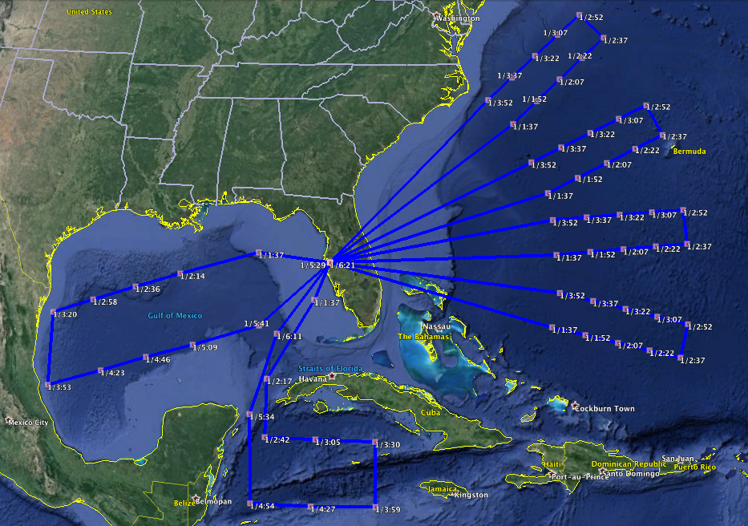
Figure 1: Example patterns for 5.5 h flights for an “out-and-back” flight from MacDill, assuming 1980 nm route of flight, which approximately illustrates the accessible regions.
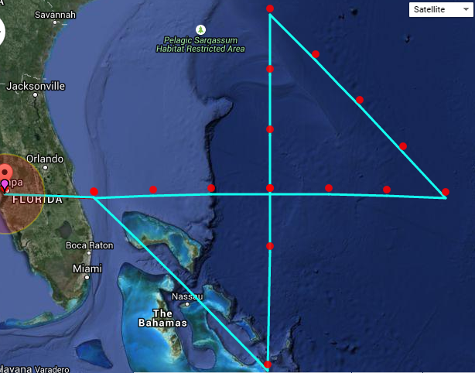

Figure 2: “Closed” alpha flight pattern, scaled such that the flight is of 5.5 h duration, assuming takeoff and recovery at MacDill and 380 kt flight speed. The pattern is drawn as if the center of the TC is located 400 nm due east of MacDill.

Length / duration of 2 radial legs: 530 nm / 84 min
Length / duration of 2 tangential legs: 374 nm / 59 min

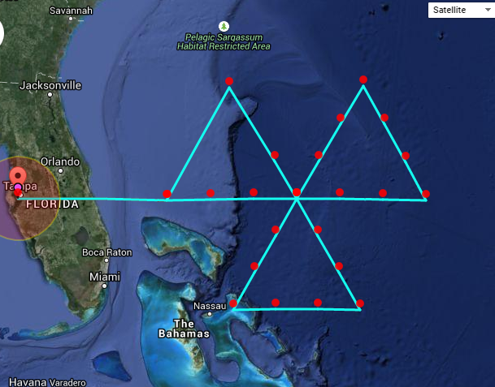

Figure 3: “Closed” butterfly flight pattern, scaled such that the flight is of 5.5 h duration, assuming takeoff and recovery at MacDill and 380 kt flight speed. The pattern is drawn as if the center of the TC is located 400 nm due east of MacDill.

Length / duration of 3 radial legs: 370 nm / 58 min
Length / duration of 3 tangential legs: 185 nm / 29 min

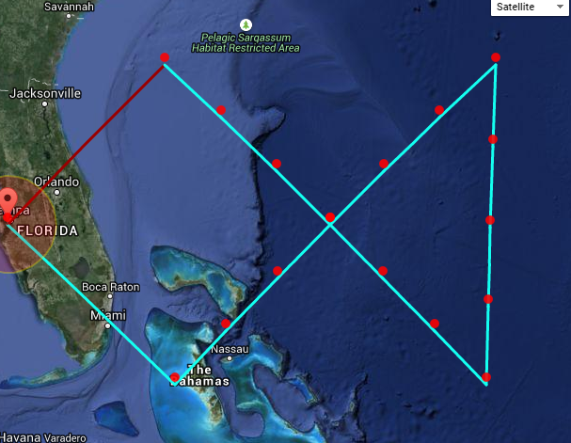

Figure 4: “Open” alpha flight pattern, scaled such that the flight is of 5.5 h duration, assuming takeoff and recovery at MacDill and 380 kt flight speed. The pattern is drawn as if the center of the TC is located 400 nm due east of MacDill.

Length / duration of 2 radial legs: 564 nm / 89 min
Length / duration of 1 tangential leg: 398 nm / 63 min

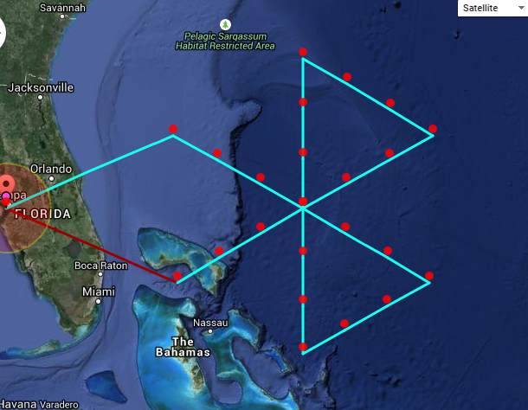

Figure 5: “Open” butterfly flight pattern, scaled such that the flight is of 5.5 h duration, assuming takeoff and recovery at MacDill and 380 kt flight speed. The pattern is drawn as if the center of the TC is located 400 nm due east of MacDill.

Length / duration of 3 radial legs: 398 nm / 63 min
Length / duration of 2 tangential legs: 199 nm / 31 min

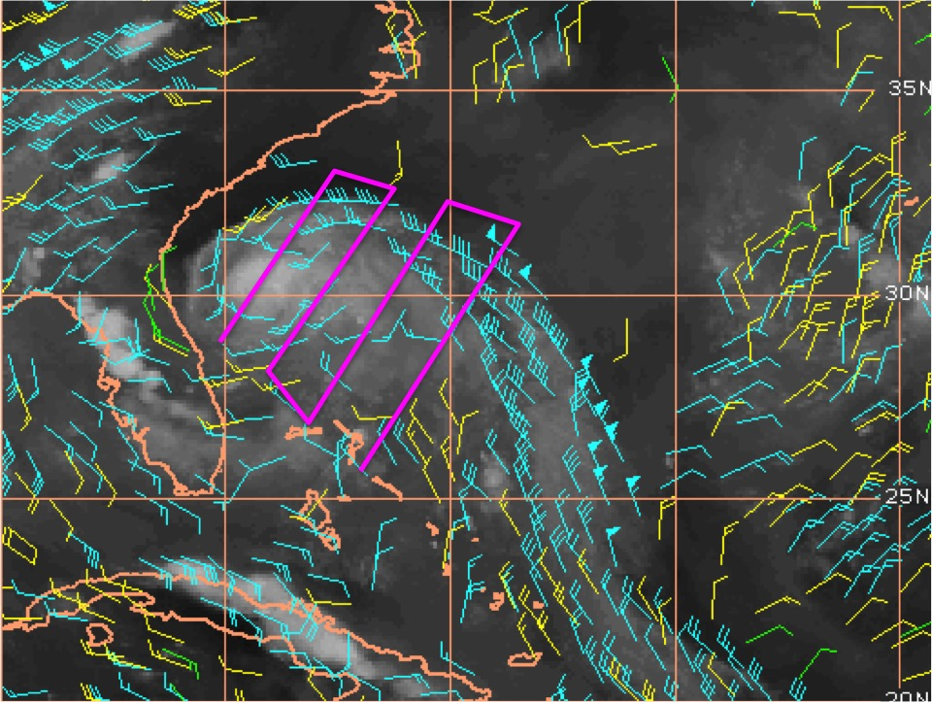
Figure 6: CIMSS AMVs (blue: 100-250 mb, yellow: 251-350 mb, green: 351-500 mb) at 2014070300, showing Tropical Storm Arthur with outflow organized into a jet extending southeast away from the storm. As part of a mission out of MacDill, it would be possible to create multiple cross-sections of the outflow jet along the magenta line, for example.

Figure 7: CIMSS AMVs (blue: 100-250 mb, yellow: 251-350 mb, green: 351-500 mb) at 2012082800, showing Tropical Storm Isaac. Outflow from extensive deep convection in and around the center is directed primarily westward. The outflow could be followed westward and then northwestward out of the core, which would be particularly convenient on the way back to recovery at Ellington.

Figure 8: CIMSS AMVs (blue: 100-250 mb, yellow: 251-350 mb, green: 351-500 mb) at 2010090200, showing Hurricane Earl. The interface between the cirrus canopy / TC outflow and the environment could be examined both on an inbound leg toward the TC from MacDill (for example along the magenta line on the way to the center crossing) and a second time on an outbound leg from to TC towards MacDill.

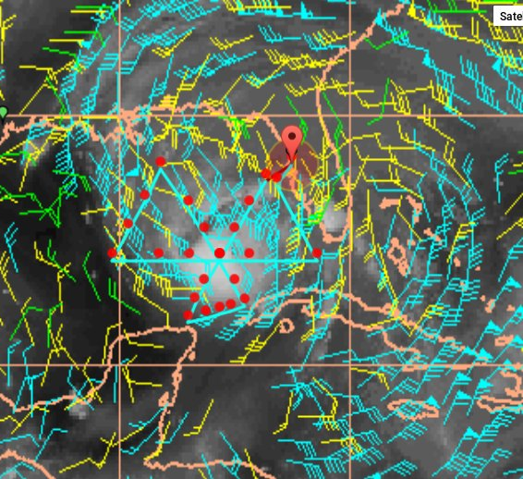
Figure 9: CIMSS AMVs (blue: 100-250 mb, yellow: 251-350 mb, green: 351-500 mb) at 2008083112, showing Hurricane Gustav. An example 5.5 h butterfly pattern is drawn taking off and recovering at MacDill.

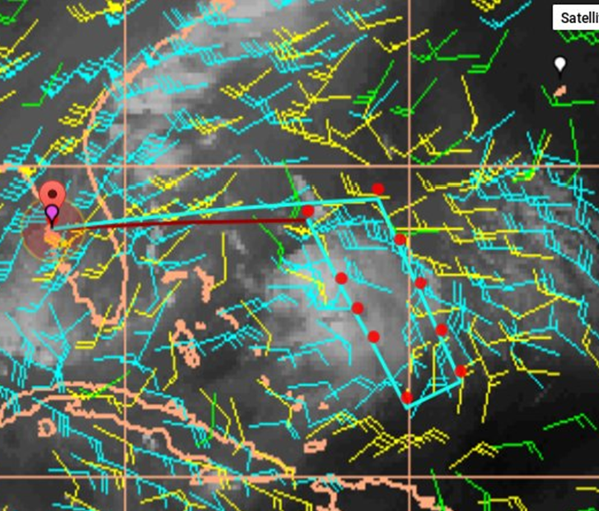
Figure 10: CIMSS AMVs (blue: 100-250 mb, yellow: 251-350 mb, green: 351-500 mb) at 2014080412, showing Tropical Storm Bertha. An example 5.5 h “rectangle pattern” is drawn taking off and recovering at MacDill.

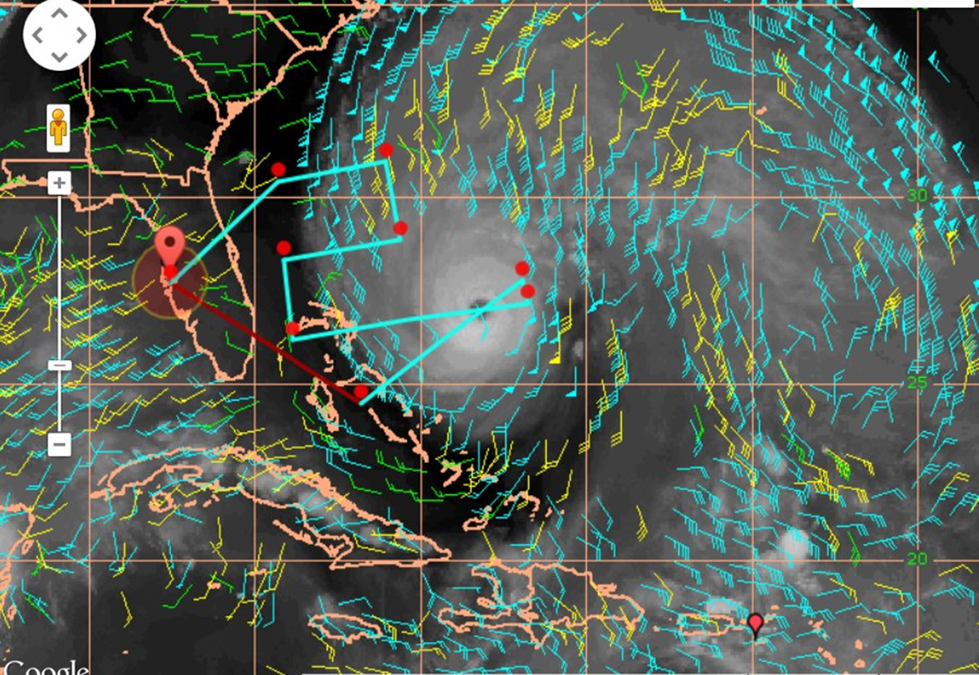
Figure 11: CIMSS AMVs (blue: 100-250 mb, yellow: 251-350 mb, green: 351-500 mb) at 2010090200, showing Hurricane Earl. An example 5.5 h pattern is drawn taking off and recovering at MacDill.

