3. Aircraft Flight Operations

3.1 TCS-08 Formation, Intensification, Structure Change, and Satellite Validation Sampling Strategies

3.2 Targeting for recurvature

3.3 ET Sampling Strategies

It is possible that single and multiple aircraft missions will be undertaken in ET events. However, single aircraft missions will very likely be limited to cases when the DLR Falcon is operated without the NRL P-3 or USAF WC-130J.

a. Single aircraft missions

In the case that only the DLR Falcon is available, the focus will be on the outflow region of the decaying TC and its interaction with the mid-latitude jet (Fig. 3.1). The spacing of dropsondes will depend on conditions that impact operation of the Doppler wind Lidar and DIAL. If conditions are sub-optimal for lidar operations, then dropsondes will be released at approximately 8-10 minute intervals (100-125 km spacing). During periods of optimal conditions for lidar operations, dropsonde spacing may be increased.
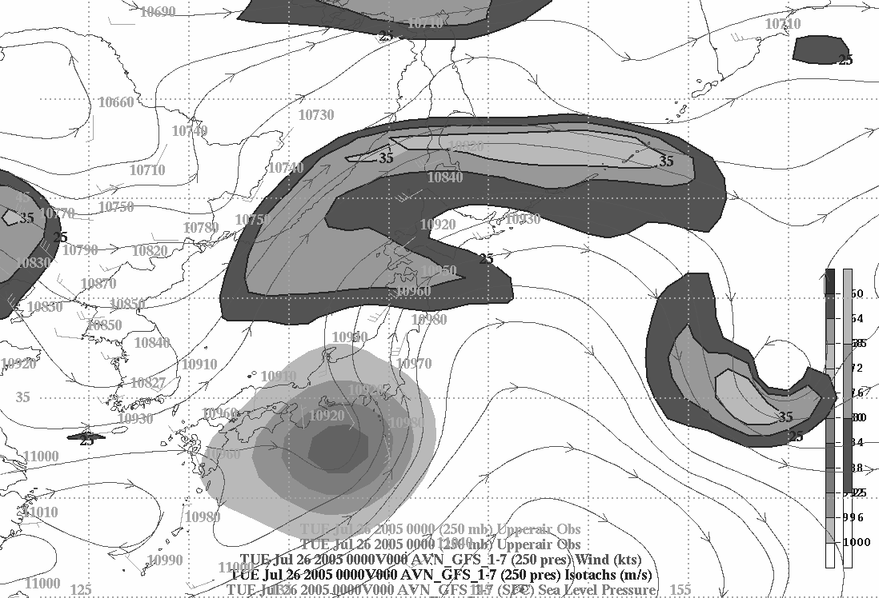
OKO (35.75,139.35) -1 (37.0,132) 405 nm FL 250-280
1 (37.0,132.0) – 2 (38.0,137.0) 180 nm FL 250-280
2 (38.0,137.0) – 3 (40,136.5) 95 nm FL 250-280
(3 (40.0,136.5) – 4 (45,140.0) 341 nm FL 250-280
4 (45, 140.0) - CTS (42.8,141.7) 175 nm
TOTAL (STAGE 1) 1096 nm
TS Banyan (2005) 0000 UTC 26 July
NJAAQAA
MSJ
CTS
1
2
3
4
a
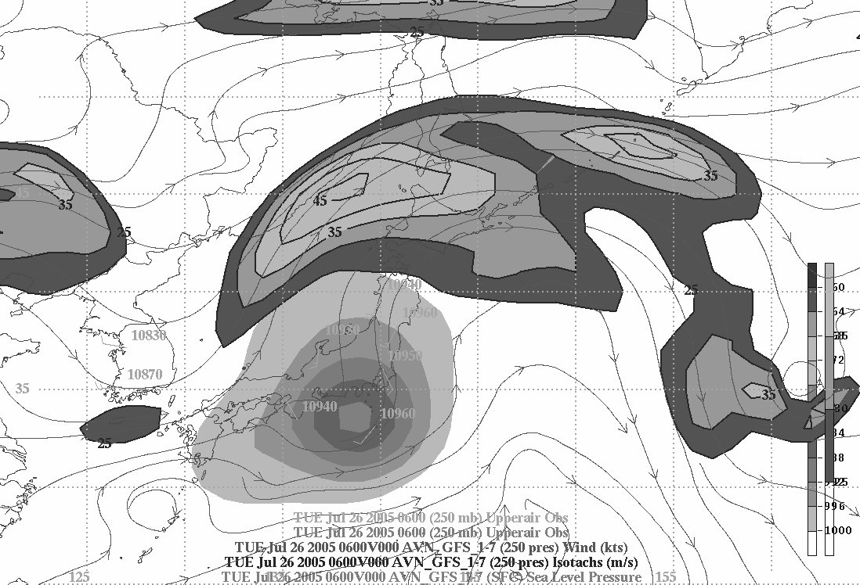
CTS (42.8,141.7) - 5 (40,143) 205 nm FL 250-280
5 (40,143) –6 (40,135) 480 nm FL 250-280
6 (40,135) – 7 (47,141.5) 511 nm FL 250-280
7 (47,141.5) –CTS (42.8,141.7) 300 nm FL 250-280
TOTAL (STAGE 2) 1496 nm

TS Banyan (2005) 0600 UTC 26 July
NJA
MSJ
CTS
3
4
6
7
1
2
5
b
Figure 3.1 Flight tracks for Falcon-only mission to sample the TC-outflow and jet region. Partly transparent shading is sea-level pressure below 1000 hPa in GFS analysis; darker shading indicates 200 hPa wind speeds at 25, 30 and 35 m/s. Streamlines or 200 hPa flow. Valid time is (a) 0600 UTC 26 July, 2005 and (b) 0600 UTC 26 July. The flight path following re-fueling is marked by dashed lines in (b).
The proximity of the decaying cyclone to Japan will allow for an option to refuel and continuation of flight operations. In Fig. 3.1a, refueling at Sapporo, Japan (CTS) occurs after the first stage of a flight that investigates the outflow from Tropical Storm
(TS) Banyan and the midlatitude jet. Following refueling (Fig. 3.1b), a similar pattern will be flown as the jet maximum has extended back toward TS Banyan.

Depending on the track of a target storm, recovery may be required at various locations throughout Japan. In the track of Fig. 3.1b, recovery is at Sapporo since the decaying TS is passing over central Japan and Atsugi NAF or Yokota AFB. The total flight time for the two missions in Fig. 3.1 will be 6-7 hours. The DLR lidars will be operated continuously, although the best observations will be taken beneath the high cirrus layers. The primary altitude of the Falcon will be between 28,000 and 35,000 ft. depending on mission objectives and environmental conditions.

The general pattern shown in Fig. 3.1 will also be valid for Falcon-only missions in the absence of a tropical cyclone. Several science objectives associated with operation of the Falcon are not dependent on having a tropical cyclone present in the area of Japan. For example, one of DLR’s objectives is to assess moisture transport from the tropics to the extratropics with the Falcon’s dropsondes and lidars. Through comparison of several TC and non-TC missions, it will be possible to determine if the poleward moisture transport is significantly greater with a tropical cyclone present.

Limitations to the flight plans depend on the storm track and the ability to fly in various international air spaces. Flight plans will need to be designed to keep the aircraft out of various restricted air spaces that exist in the Sea of Japan, Sea of Okhotsk, and the western North Pacific east of Japan.
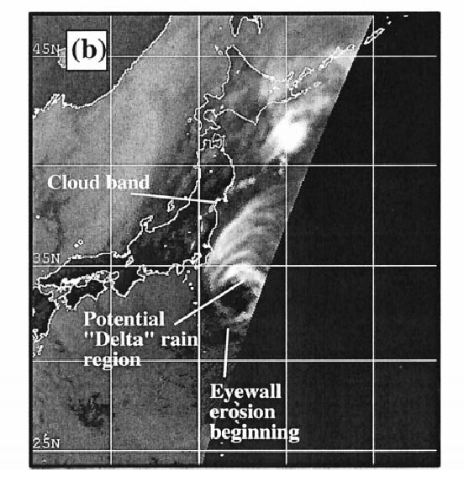
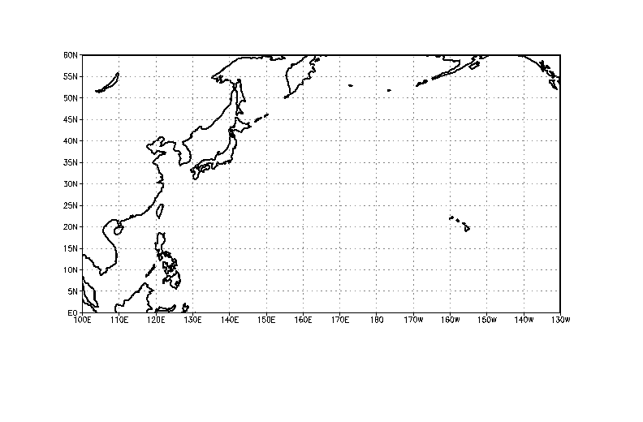
From Klein et al. (2000)
Tropical cyclone
core region
Tropical cyclone-midlatitude interface region
Midlatitude impact region
Upstream trough
Figure 3.2 Schematic of the three regions of sampling during ET; the “mid-latitude” impact region refers to where the TC outflow impinges on the mid-latitude jet; the TC-midlatitude interface region generally refers to developing frontal structures closer to the remnant TC; the TC core region refers to the decaying eye and eye wall structure.
b. Coordinated aircraft missions

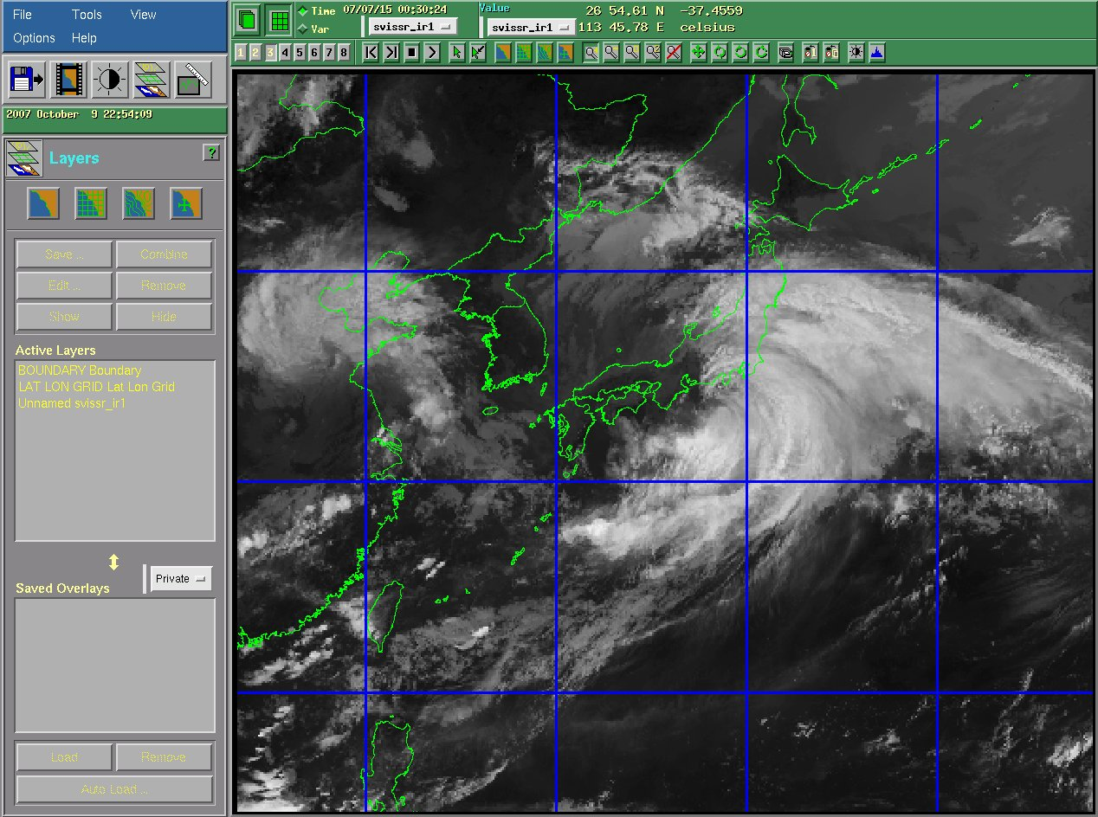
When multiple aircraft are available, the decaying cyclone, developing frontal structures and the outflow/jet interaction will all be sampled. Each of the three aircraft will investigate one of the sub-regions associated with a typical ET event outlined in Fig. 3.2, although there is not necessarily a one-to-one mapping of a particular aircraft to a particular sub-region in all cases. As in the Falcon-only scenario, the Falcon will fly poleward of the cyclone near where the TC outflow impinges on the jet (Fig. 3.3). The Falcon operations will be extended if it is possible to refuel at locations such a Misawa (MSJ), Japan as defined in Fig. 3.3. Falcon missions will last approximately 6-7 hours if refueling can occur. Dropsondes will be released at a regular interval of about 10 minutes, yielding a spacing of about 110 km assuming a ground speed of 200 m s⁻¹. This will yield about 16-20 dropsondes in a typical 2.5-3 h sampling period. The Falcon should plan on carrying as many as 40 dropsondes for a back-to-back mission.
DLR FALCON 20-E5 D-CMET
MSJ – 1 (42ºN, 150ºE) 457 n mi FL 350
1 – 2 (40ºN, 150ºE) 138 n mi
2 – 3 (38ºN,145ºE) 191 n mi
3 – OKO 209 n mi
Total 995 n mi
Dropwindsondes at waypoints and 60 n mi spacing
NRL P-3 all FL 150
NJA – 1 (33ºN,141ºE) 212 n mi
1 – 2 (30ºN, 142.5ºE) 225 n mi
2 – 3 (31.5ºN, 146ºE) 232 n mi
3 – 4 (35ºN, 142.5ºE) 315 n mi
4 – NJA 185 n mi
Total 1169 n mi
Drops at waypoints and 60 n mi intervals
DLR FALCON 20-E5 D-CMET
OKO – 1 (36.5ºN, 131.0ºE) 420 n mi FL 350
1 – 2 (38.5ºN, 136ºE) 307 n mi
2 – 3 (40ºN,133ºE) 191 n mi
3 – 4 (42ºN,136ºE) 209 n mi
4 – MSJ 293 n mi
Total 1470 n mi
Dropwindsondes at waypoints and 60 n mi spacing
MSJ
NJA
Schematic Combined Aircraft Mission in ET Case
FALCON Mission in two stages with a re-fueling stop at MSJ
0030 UTC 15 July 2007 TY Man-Yi
1
2
3
4
1
2
3
4
1
2
3
WC-130 track
Figure 3.3 Schematic flight tracks for coordinated mission with three aircraft, with the Falcon performing two flights (white followed by red) with a refueling in the center. Way-points and track lengths are indicated.

Figure 3.4 shows the reflectivity from CLOUDSAT for the ET case of Kajiki (2007). Near the decaying TC, cloud tops are 14-15 km in intense convection. The cloud top lowers to more like 10 km in the rain shield north of the cyclone. If the Falcon can attain an altitude near 35,000 ft. it would be near cloud top in this region of the TC outflow and able to capture essentially the entire diabatic outflow. However, this environment may prevent use of the Doppler wind lidar, which would require increased frequency of dropsonde release. Furthermore, this level is closer to the jet and more relevant for documenting outflow perturbations to the PV gradient within the jet. If the Falcon flies below the outflow cloud layer, then the environment may be more favorable for lidar operation and decreased dropsonde frequency.

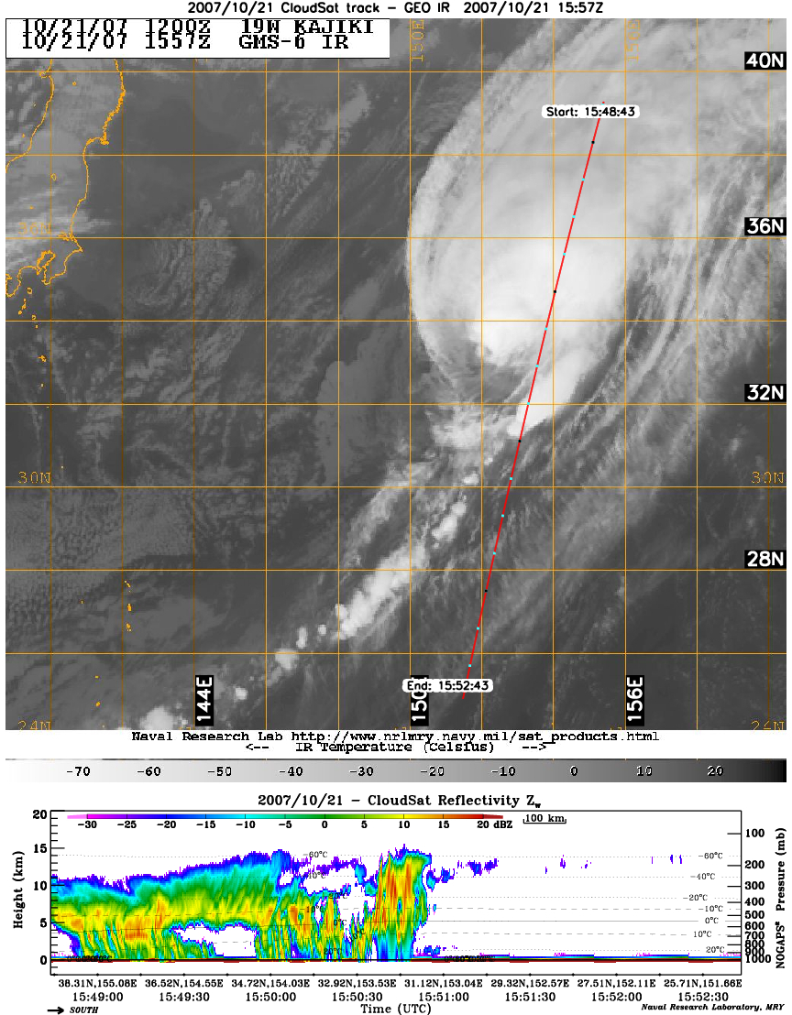
As indicated in Fig. 3.3, the WC-130J will be the platform that penetrates the core of the TC. If there is a closed or nearly closed eye wall still present, the WC-130J will fly at about 10,000 ft. If the eye wall is open, penetrations will occur at a higher altitude. However, this will depend on the characteristics associated with deep convection that remains and the amount of icing encountered by the aircraft. The maximum altitude will be 20,000 feet, and the exact altitude will be chosen by the pilots. The higher altitude is preferred so that more of the vertical structure of the vortex can be observed for validating satellite retrievals of the temperature structure from AMSU, for example. Dropsondes will be released regardless of the altitude, and spaced as closely as possible while executing transects in through the core. From 10,000 ft., drops can be as little as 2.5 minutes apart (sustained), which corresponds to about 18 km. Higher resolution is always possible for a burst of four dropsondes, and can be used to sample the remnant eye wall. This is particularly important for the satellite validation portion of the mission. The SFMR will provide continuous estimates of surface wind. The legs for the C-130J transects will be about 120-150 nm (30-40 minutes). The figure-4 portion of the flight pattern will be completed in about 90 minutes. If time allows, a rotated figure-4 will be executed to better identify the maximum wind and structure of the transitioning vortex.
Figure 3.4. top: IR satellite image of Kajiki at 1557 UTC 21 October, 2007. Red line indicates CLOUDSAT overpass (bottom panel), with north to the left in the cross section.
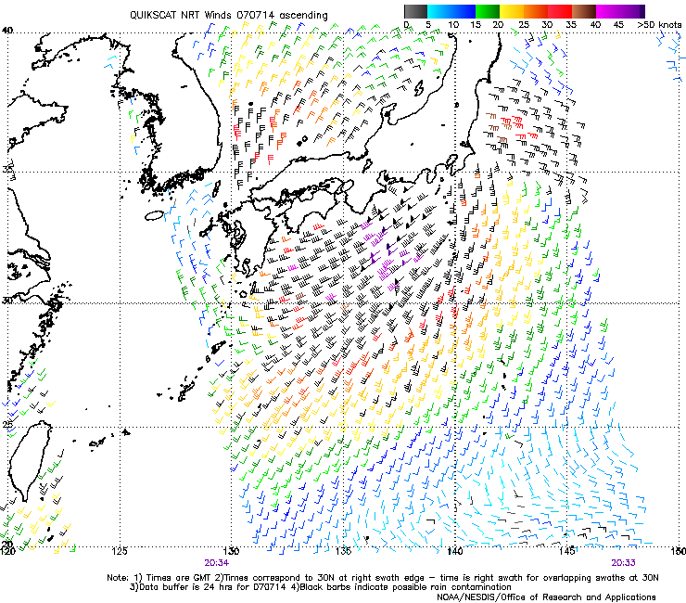
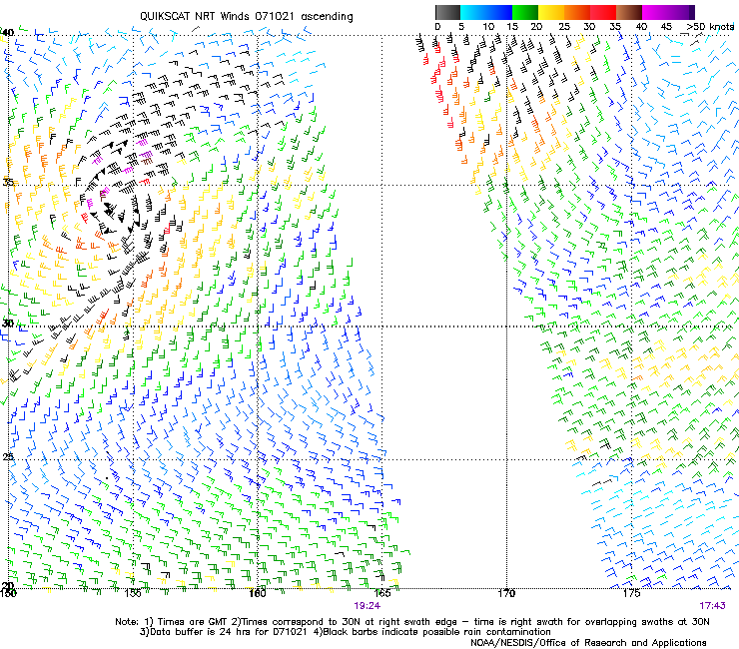
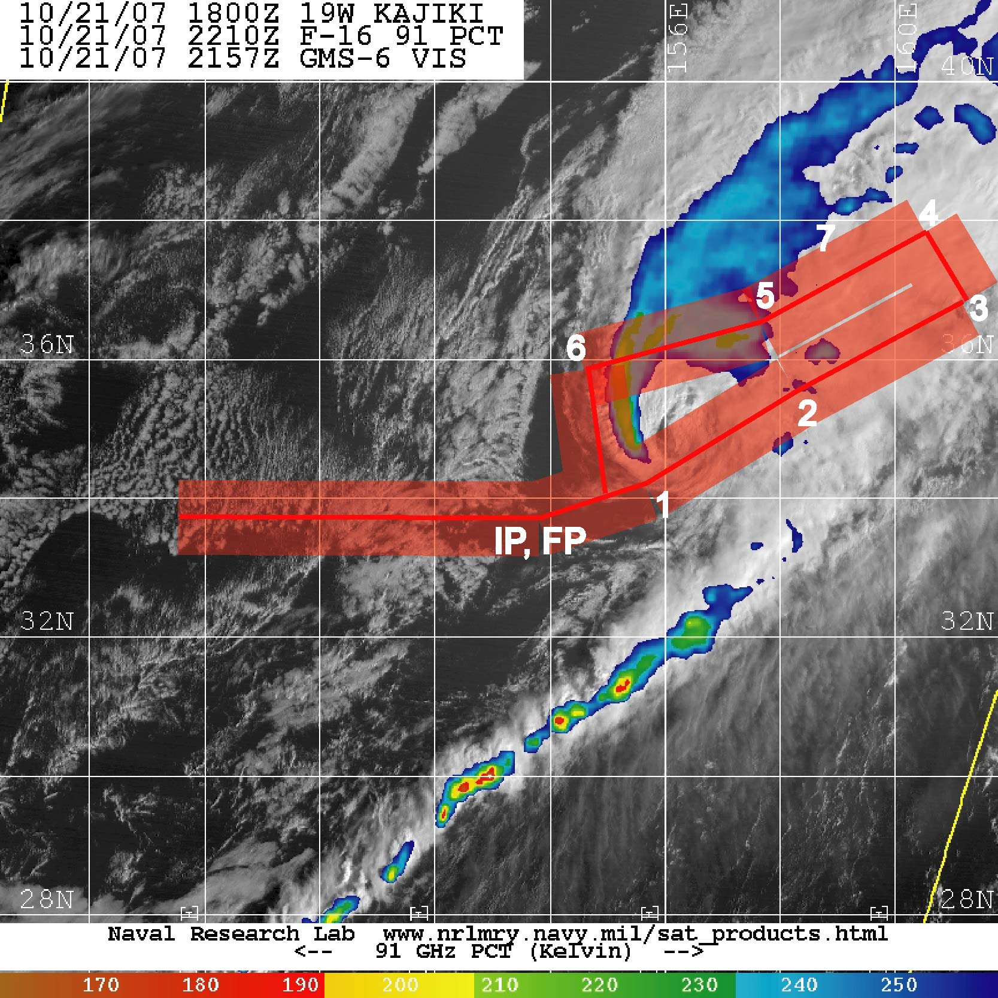
Figure 3.5 QUIKSCAT winds for TY Man-Yi on 15 July (left) and Kajiki on 21 October (right). Location of warm frontal trough indicated by black dashed line.
Figure 3.6 Possible NRL P-3 tracks for storm with open eye (all rainfall confined to two quadrants. Approximate swath covered by ELDORA in red.
ELDORA swath (+/- 50 km)
The NRL P-3 will maximize use of the ELDORA to observe convection and precipitation structures within developing frontal regions, particularly warm fronts northeast or east of the remnant TC center. The rectangle pattern in Figs. 3.3 and 3.6 is designed to maximize radar coverage within the developing frontal region. Warm-frontal regions from Man-Yi and Kajiki are apparent in the QUIKSCAT image in Fig. 3.5. This feature will often serve as the target for P-3 missions. The flight legs parallel to the front will be constructed to encompass as much of the frontal precipitation as possible. Velocities from the radar will document the frontal structure and vertical motion (hence estimate the diabatic heating).

The ELDORA scans approximate 40-50 km on either side of the aircraft, hence, to completely cover an area, the rectangle will be about 100 km across. Multiple precipitation bands could suggest a wider separation of flight legs to sample features within a greater overall area. An addition to the flight pattern for the NRL P-3 is shown in Fig. 3.6, wherein the eye wall of the Kajiki is decidedly open, with rainfall restricted to one, or at most two, quadrants of the vortex. In this case, the southeast sector of the storm contains only low clouds swirling about the decaying tropical cyclone core. The NRL P-3 should be able to traverse the center. ELDORA is sensitive enough to obtain reliable echo and velocities in even light precipitation that might be occurring in the relatively shallow cloud within and surrounding the remnant eye of the storm. The pattern shown in Fig. 3.6 can be executed in about 2.5 hours. ELDORA data near the decaying vortex will be synthesized to more fully capture the three-dimensional vortex structure in the precipitation region. Dropsondes can be released from the NRL P-3 to confirm wind profiles near the storm center in this case. Finally, if the weakening tropical cyclone is near the Japan coastline, then imagery from ground-based Doppler radars will be available for flight guidance near the storm center.

Because the Falcon will not arrive in the field until 25 August, there is the possibility of C-130 and NRL P-3 missions into transitioning cyclones without the Falcon sampling the TC outflow and jet interaction. The maximum realistic altitude for the C-130 is about 30,000 ft (9 km). From the CLOUSAT image in Fig. 3.4, this altitude is still expected to be within the outflow a few hundred kilometers north of the cyclone. Furthermore, the endurance of the C-130 is more than twice that of the Falcon. This more than compensates for the smaller maximum airspeed of the C-130, so that the flight track length will be roughly comparable to total sampling of the Falcon even in back-to-back missions. Returning to the schematic flight tracks in Fig. 3.3, the C-130 could either perform a figure-4 pattern and one of the two Falcon tracks, or it could cover both of the Falcon tracks, provided that the C-130 could remain on station for at least 7-8 hours. Lidars will be absent without the falcon, so the emphasis will be on dropsondes and flight-level data. In this case, it is likely that the WC-130J would recover at Yokota AFB, Japan rather than return to Kadena AFB, Okinawa, which is depicted in Fig. 3.3.

In addition to the core objective of satellite validation of intensity and structure are validations of soundings from geostationary satellite platforms and from GPS radio occultations. The Constellation Observing System for Meteorology/Ionosphere and Climate (COSMIC) program, launched in March 2006, provides several hundred soundings per day distributed around the globe. Recent statistics indicate that at least 50% of the soundings will penetrate to below 0.5 km, with 90% penetrating below 1 km. These soundings are important in areas not directly observed otherwise, and can be validated directly from T-PARC dropsondes. Much of the uncertainty in the retrieved profiles is in the lowest kilometer or so, and there, dropsondes from each of the three aircraft can be used for validation. This requires that the occultation points be known far enough in advance (two days at least) to plan a selected small number of comparison drops and flight tracks that accommodate them.

5. Science Mission Planning Process

5.2 Mission selection and coordination with facilities

5.2.1 TCS-08: Formation , Structure, Intensification, and Satellite Validation

5.2.2 Targeting for Recurvature

5.2.3 Extratropical Transition

In Fig. 5.2.1 is portrayed one way of coordinating back-to-back targeting and ET/satellite validation missions. The same schematic could serve the transition from TCS08 structure missions into ET/validation missions. The central aspect is the forward deployment of all three aircraft to Kadena AFB, which depends on the position of the typhoon. If a storm is within roughly 1000 km of Kadena and is not expected to threaten Okinawa within the next 24 h, all aircraft sampling the storm can recover to Kadena. This will position aircraft for an ET mission either the next day or the day after. The aircraft would then intercept the typhoon, now undergoing ET near Japan, and the NRL P-3 and Falcon would recover to Atsugi NAF and the WC-130J would recover to Yokota AFB (red lines in Fig. 5.2.1).

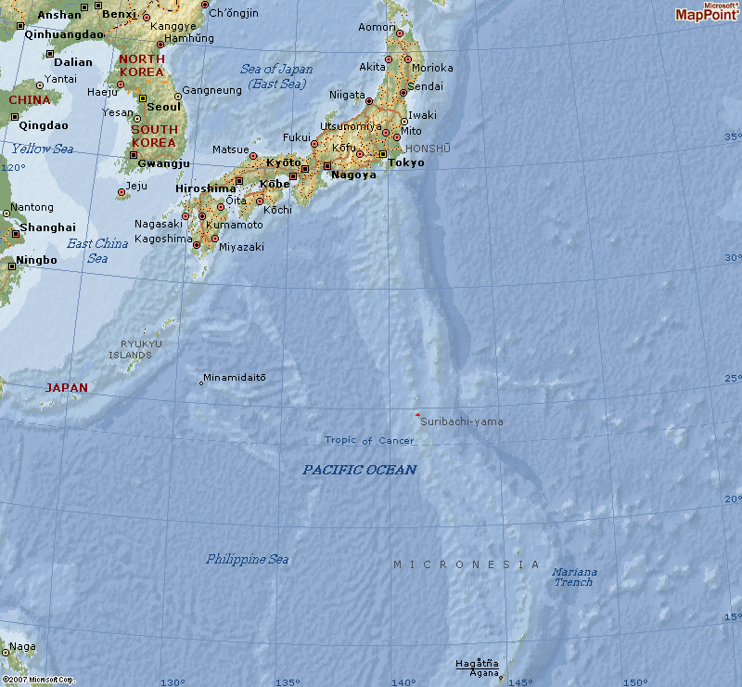
Variations of this concept are possible. For the TCS08 or targeting mission, the Falcon may not fly if the storm is too far from Japan. The case may occur before 25 August, in which case the Falcon will be unavailable anyway. The C-130 and P-3 can still recover to Kadena and still fly a subsequent ET mission with or without the Falcon. If the TCS08 or targeting mission is closer to Japan, aircraft could recover there directly instead of to Kadena. Finally, the Falcon may recover to Atsugi and the WC-130 and P-3 recover to Kadena. In any scenario we expect (a) the WC-130 and NRL P-3 will remain together and (b) the WC-130 and NRL P-3 will return to Guam as soon as the opportunity to study a transitioning storm has passed. In most cases, this means that the WC-130 and NRL P-3 will return to Guam on the day following an ET mission. If another tropical cyclone has formed and is moving into the region of the Philippine Sea or East China Sea, then the aircraft may be able to fly missions related to satellite validation, tropical cyclone structure, intensification, or targeting during the transit to Guam.
1000 km
Atsugi
Kadena
Guam
Figure 5.2.1 Ferry legs of the three T-PARC aircraft in a targeting scenario (black) followed by an ET and satellite calibration mission 1-2 days later (red). Symbols C, P and F represent the C-130, NRL P-3 and DLR Falcon, respectively.
C,P
C,P
F
F

