Chapter 12 Table of Contents
Chapter 12. Modeling Support 1
12.1 Data Targeting products 1
12.1.1 Data Targeting guidance types 2
12.1.2 Data Targeting timeline 3
12.1.3 Data Targeting system 4
12.2 Operational Global Numerical Models 11
12.3 Ensemble prediction systems 12
12.4 Regional and mesoscale prediction systems 13
12.4.1 Coupled Ocean atmosphere prediction system (COAMPS) 13
12.4.2 Taiwan Regional Models 14
12.4.3 German Regional Model 14

Chapter 12. Modeling Support

This Chapter describes the various numerical modeling products that will be used to support T-PARC operations. Numerical model products for T-PARC are supplied for forecast and decision-making support and for identifying regions of initial condition sensitivity to address the data targeting objectives of T-PARC. In general, the numerical forecast products provided for forecast and decision support will be standard products produced at the FNMOC, NCEP/EMC, JMA, ECMWF, and UKMO. Numerical products for data targeting will be provided by a combination of operational numerical weather centers and principal investigators at several institutions in nations participating in T-PARC.

12.1 Data Targeting products

The data targeting objectives of T-PARC address the hypothesis that the assimilation of targeted observations will increase the accuracy of numerical predictions of tropical cyclone formation, structure, intensity change, track, ET, and downstream impacts over numerical predictions made without targeted observations. Several techniques are used to estimate the reduction in forecast error variance due to any hypothetical set of targeted observations. The improvement in numerical forecasts is realized by better representation of physical processes in the initial conditions. Although targeted observations are most effective in regimes of low predictability, it is important to note that the impact of targeted observations in regions of sparse standard observations will be larger than in regions of dense standard observations.

12.1.1 Data Targeting guidance types
The data targeting guidance products that will be supplied to T-PARC will be based on two methodologies. Adjoint-based methods and sensitivities are based on computation of singular vectors (SVs) while linear diagnosis of ensemble forecasts represents a method class as Ensemble Transform Kalman Filter (ETKF).

Adjoint-based techniques use SVs to depict the sensitivity of the forecast to the initial conditions at a future time by assimilating routine and supplementary observations. Computation of the SVs is based on the operational model and its tangent-linear and adjoint versions. The optimal region to place additional targeted observation is linked to where the SVs have the largest amplitude at the initial time.

The ETKF combines error covariance information from ensemble forecasts with error statistics associated with the routine and targeted observation networks to predict the reduction in forecast error variance within a forecast verification region. Generalizations with respect to ETKF sensitive regions are that they tend to be associated with relatively low ensemble spread that amplifies into the verification region. Furthermore, sensitive regions are often associated with large mid-tropospheric baroclinic instability.

The providers of data targeting products and details associated with each product are defined in Table 12.1. It is anticipated that each product will be available at least once per day. Providers of data products will arrange for the graphical output to be placed on the T-PARC data catalog and if possible the digital fields will be archived as part of the Data Targeting System (DTS) at ECMWF (see Section 12.1.2).

Table 12.1 Summary of the data targeting products being supplied to T-PARC
Institution and point of contact | Method | Initialization | Time before flight? | Verification Regions | Grid | Sensitive region overlay with other fields
NRL Monterey (Reynolds) | NOGAPS SVs | 00 UTC | -38 h,  -14 h | Guam, Taiwan, Japan, ET, Downstream | Global Gaussian (can be truncated if needed). Vertical structure can be uploaded. | MSLP and 200 hPa stream-function.
JMA (Komori / Yamaguchi) | JMA SVs | 00 UTC | -42h,  -18h | Guam, Taiwan, Japan only. | Global Gaussian. Vertical structure can be uploaded. | MSLP, 850 hPa vorticity, 500 hPa height.
ECMWF (Prates, Cihan, Richardson) | ECMWF SVs | 00 UTC | -36h,  -12h | Guam, Taiwan, Japan, ET, Downstream, plus varying verification regions entered through DTS | Global. | MSLP, 850 hPa T, 500 hPa height.
Yonsei University (Kim) | MM5 SVs | 00 UTC | -33h | Taiwan and Japan. varying verification region if necessary (e.g. Korea) | Regional: 50x50 grid point domain with 120km resolution. Domains vary depending on verification region. Can provide vertical SV structure. | MSLP, 850 hPa vorticity, 500 hPa height.
NTU (Wu) | MM5 ADSSV | 00 and 12 UTC | -60 h,  -36 h  -12 h | Storm centered | Regional: 85x115 grid point domain with 60km resolution. Can provide vertical ADSSV structure. | MSLP, 850 hPa vorticity, 500 hPa height.
U Miami (Majumdar) | ETKF v2.0: multi-model | 00 UTC | -60h,  -36h,  -12h | Guam, Taiwan, Japan. ET, Downstream | Regional: 60-180E, 0-70N.  No vertical structure. | Ensemble mean 850 hPa streamlines, MSLP, 850 hPa vorticity, 500 hPa height
UKMO (Swinbank, Bovis) | ETKF v1.0: MOGREPS | 00 UTC | -36h,  -12h | Guam, Taiwan, Japan, ET, Downstream, plus varying verification regions entered in DTS | Northern Hemisphere, 2.5 degrees resolution. No vertical structure. | MSLP, 850 hPa T, 500 hPa height.
UWashington (Hakim, Mahajan) | WRF EnKF ensemble sensitivity | 00 and 12 UTC | -63h (27km)  -37h (9km) | Fixed: Guam, Taiwan.  Varying: Storm. | Regional: Upper level: 21.6 N, 115.5 E UR: 21.6 N, 164.4 E Lower Level: 2.0 S, 115.5 E LR: 2.0 S, 164.4 E | MSLP, 850 hPa vorticity, 500 hPa height. Also 300 hPa winds, 700 hPa RH, precipitable water.
NOAA HRD (Aberson) | NCEP GFS Ensemble Variance | 00, 06, 12, 18 UTC | 4x daily | None | Any grid  No vertical structure. | Deep-layer mean wind streamlines

12.1.2 Data Targeting timeline
The following timeline defines the sequence of events over the period that begins nearly two days prior to aircraft takeoff for a data targeting mission.

Table 12.2 Timeline of decision-making events prior to the start of a data targeting aircraft operation.

The primary times are defined as (with negative hours representing the time prior to takeoff):
- -49 h Identify the data targeting case and begin to communicate verification regions;
- -36 h Decide upon the general area for collecting targeted observations;
- -25 h modify the flight plan if necessary and organize crew lists;
- -18 h modify the flight plan if necessary;
- -12 h Last changes in flight plan, which includes dropsonde locations submitted to ATC;
- 00 h Takeoff.

12.1.3 Data Targeting system
The Data Targeting System (DTS) was developed at ECMWF as part of the EURORISK PREVIEW program funded by EUCOS and the European Union. The project arose out of a series of field campaigns in which the utility of data targeting was investigated. In particular, during the Atlantic-THORPEX Regional Campaign in 2003 the work needed to plan the targeted observations proved time consuming and repetitive. The DTS aims to make data targeting practical and viable in an operational environment. This section describes the DTS as it has been configured for T-PARC at ECMWF, and is based largely on the PREVIEW DTS user guide.
There are three levels of access to the DTS. At the lowest level the web pages can be viewed through a general access. The account “tparc_general” is available to all T-PARC participants. At the next level participants (referred to as “users”) can propose and comment on cases or comment on proposed areas for observation requests. At the highest level the lead user makes decisions on proposed cases.
Access to the DTS is for registered users only. Login to DTS is through the following site where one enters their login name and password. http://www.ecmwf.int/login/. After successful login, a user will then be able to view the DTS. Links to the DTS are provided from http://www.ecmwf.int/research/WMO_projects/TPARC/index.html
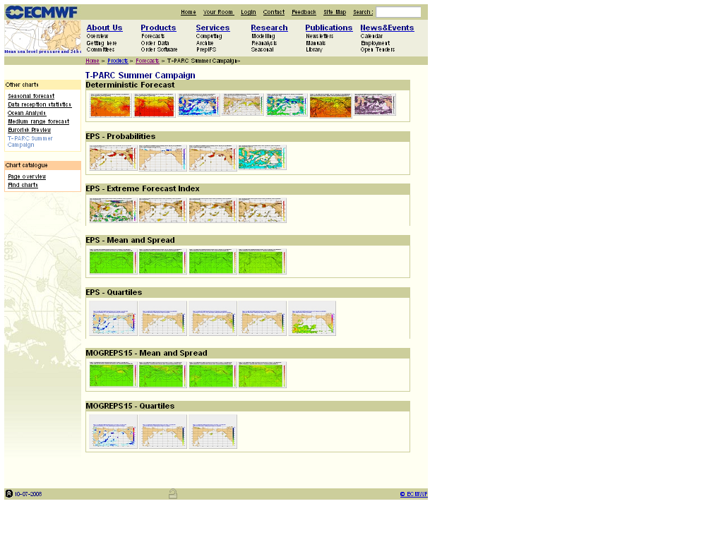
Fig. 12.1 Home page for the DTS Forecast display component.

The T-PARC DTS consists of five main components: Forecast displays are available via http://www.ecmwf.int/products/forecasts/d/charts/tparc. A selection of forecast products from the ECMWF deterministic and ensemble forecasts and the UK Met Office MOGREPS forecasts are displayed on the forecast webpage (Fig 12.1). The forecast products currently displayed are given in Table 12.2.
Table 12.2 The ECMWF and MOGREPS15 forecast products displayed in DTS
Deterministic Products :
T850 and Z500
T2m&30m wind
MSLP& 200hPa wind speed
700hPa RH & Horizontal Wind
850hPa RH & Horizontal Wind
MSLP and 850hPa wet-bulb potential temperature
850hPa RH and vertical velocity
700hPa RH and vertical velocity
Ensemble Prediction System:
Probability charts
10m wind gust probability above 15m/s
10m wind gust probability above 25m/s
2m temperature probability below 273.15K
10m wind speed probability above 10 m/s
10m wind speed probability above 15 m/s
Precipitation probability of at least 1, 5, 10 or 20 mm
Extreme Index Forecast Charts
T2m
10m wind speed
10m wind gust
Precipitation
Ensemble Mean and Spread Charts (ECMWF and MOGREPS15)
MSLP
500 hPa Geopotential
200 hPa Geopotential
850 hPa Temperature
Ensemble Quartiles (ECMWF and MOGREPS15)
Total precipitation
10-m wind
10-m wind gust (ECMWF only)
925-hPa wind
CAPE (only ECMWF)

In the data targeting system, cases are specified for which sensitive area predictions are calculated. Each case is defined for a particular verification area (VA), verification time (VT), and for the targeting time (i.e. the time at which the observations should be deployed, TT). The sensitive area calculations carried out for T-PARC are based on the 0000 UTC initialization time. The lead time is defined as the time between initialization time and targeting time. The optimization time is the time between targeting time and verification time. Sensitive area calculations can be carried out for up to ten cases per day. The timeline for case proposals is indicated in the overall data targeting timeline in Section 12.1.2 and in greater detail in Fig. 12.2.
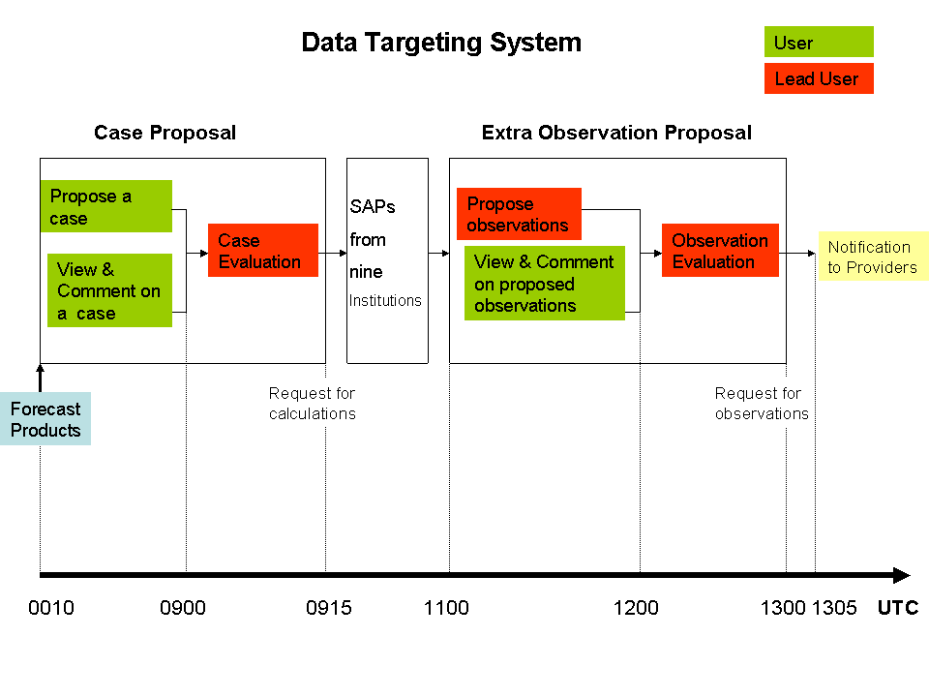
Fig. 12.2 Details of the timeline associated with submission and evaluation of cases to the DTS. Red boxes denote activities performed by the lead user and green boxes define activities done by the level 2 users.
Four cases (Fig. 12.3) have been defined with a fixed area, lead time and optimization time. These areas are defined as the Guam Area, Taiwan Area, Japan Area, and the ET Area. The Downstream Area is located over the central North Pacific in Fig. 12.3 and is submitted for the downstream verification region but not accepted. This can be used as a template to submit cases for the same region but with different lead and optimisation times. Up to five additional cases can be defined using the procedure defined below.
An online form that enables users to select geographic areas over which the forecast event will occur in the range of t+36 to120 h is provided on the DTS main webpage (Fig. 12.4) http://www.ecmwf.int/products/tparc/d/showcase. Sensitive area predictions (SAPs) are also proposed via this form. After being submitted, the case proposal will be recorded and displayed on the web page and accessible to every user. Other users can comment on proposed cases. The lead user should review all proposed cases and decide which ones should result in an SAP request.
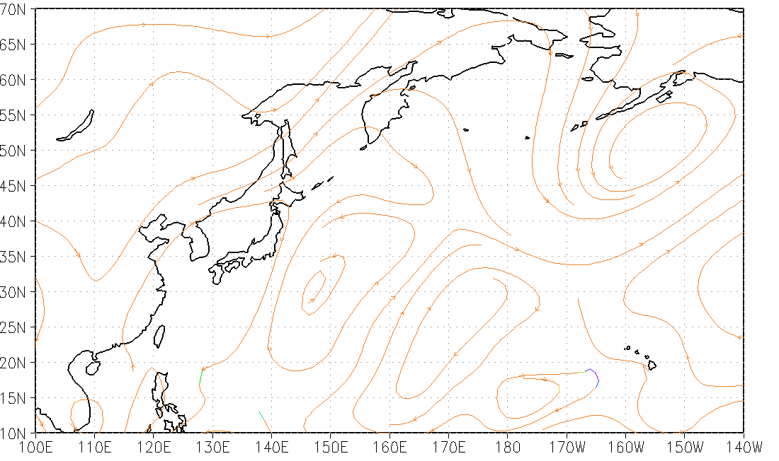

Guam Area

Japan Area
Extratropical Transition Area

Downstream Area

Taiwan Area

Fig. 12.3 Fixed verification areas for sensitivity calculations in DTS.
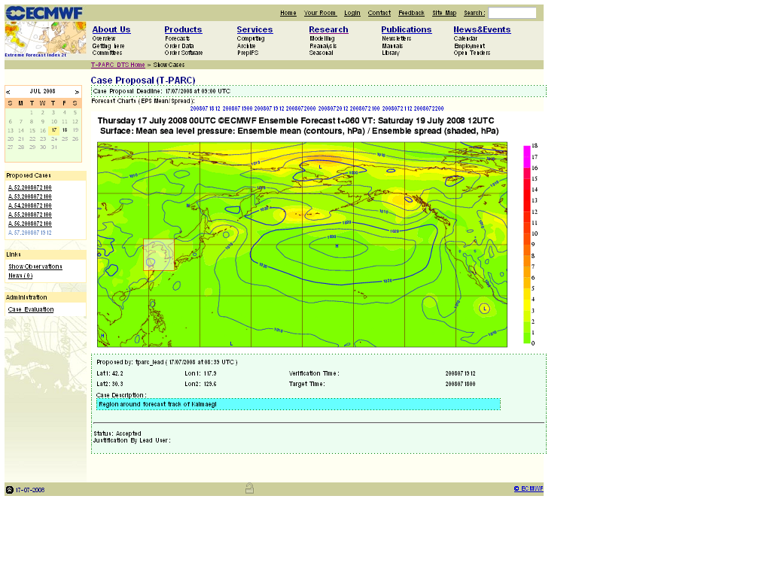
Fig. 12.4 The online form in DTS that enables the user to select a particular area where potential significant weather events are forecasted to occur in the range t+36 to 120 hours and propose a potential SAP request.
The detailed procedure is as follows:
a) Propose a case (0010 UTC – 0900 UTC)
1. Start the case proposal by selecting the VT either by clicking on the date above the chart or choosing the date on the VT box.
2. Click on the chart over the verification region of interest. The size of the box can be changed and the box can be dragged using the mouse.
3. Choose the TT by selecting from the TT box below the VT one (under the chart). The TT is in the range t+18 to t+102 hours.
4. Write a justification for the case in the case description box.
5. Complete the proposal by clicking on Submit button.
The case will appear on the list of proposed cases on the left-hand side of the page. A case name will automatically be assigned - the first proposed case will be U1.yyyymmddhh (yyyymmddhh is the VT). The status of the case is indicated by the first letter: U (unknown) and later A (accepted) or D (discarded) depending on the choice made by the lead user.
Cases that have already been proposed on a given day can be copied by clicking on the case from the list on the left hand side of the page and then on “Copy this case”. This is particularly useful for copying the predefined verification regions and changing the lead time and optimisation time.
Note that the verification time should be changed first and then the targeting time. After changing either verification or targeting time, check that both are correct before submitting the case.
b) View and comment on a case (0010 UTC – 0900 UTC)
Click on one of the “proposed cases” list on the left-hand side of the page. Enter any comment on the form below the chart and click submit.
c) Case evaluation (0010 - 0910 UTC)
The lead user will edit all the proposed cases and change their status from unknown to either accepted or discarded. Only accepted cases will be submitted for SAP. This decision must be justified in the comment box.
- Click on case evaluation under Administration menu on the left-hand side of the page. This will bring up the case evaluation page (Fig. 12.4). The list of proposed cases will be shown on the left side of this page.
- Click on each case in turn and select the status, give a justification and submit.
- Check the status of the case by looking at the case name in the menu on the LHS of the page. The first letter will have changed from U to A or D
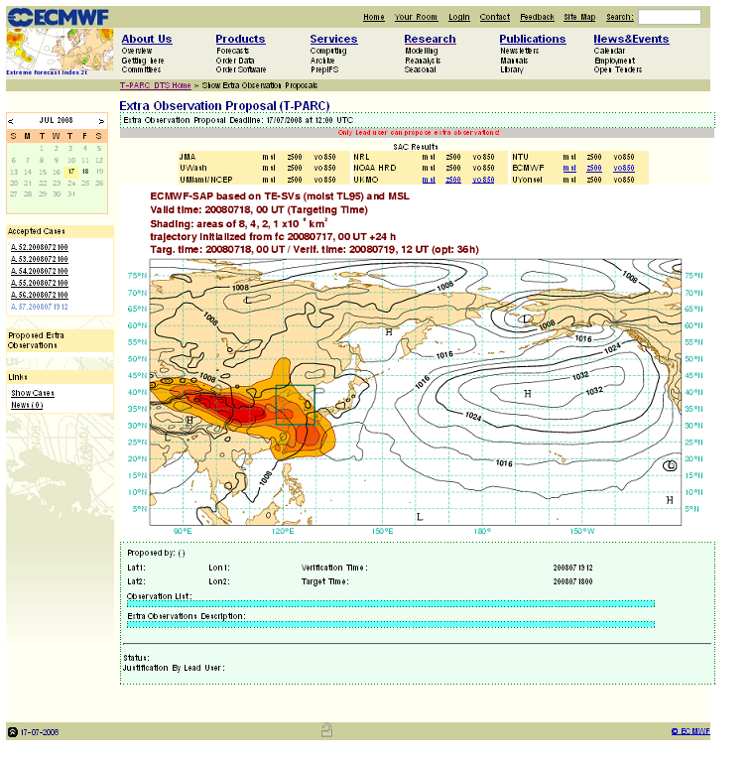
Fig 12.5 The sensitive areas predicted by TESV for additional observations on 18 July 2008 to improve forecasts in the region enclosed by the green contour and verifying at 1200 UTC on 19 July. Sensitive areas of sizes 8, 4, 2 and 1×106 km² are shaded; contours of MSLP are plotted every 4 hPa. The icons above the plot can be used to toggle between different overlays or the calculations from different centers.
The sensitive area calculations will be initiated at 0915 UTC. Sensitive area prediction requests are automatically submitted for all accepted cases. The several available mathematical methods to determine the sensitive areas are either adjoint based (singular vectors (SV) and adjoint sensitivies) or are based on linear diagnosis of ensemble forecasts (e.g. Ensemble Transform Kalman Filter; ETKF). In the T-PARC DTS at ECMWF, results obtained from both types are available; ECMWF is providing SAPs based on SV method, UKMO provide SAPs based on ETKF method. The ECMWF SAPs are plotted in the DTS overlaid with three different ECMWF forecast fields, mean sea level pressure (msl), vorticity at 850 hPa (vo850) and geopotential at 500 hPa. (z500).
The ETKF calculations produced by UKMO uses MOGREPS15 ensemble forecast outputs (horizontal resolution 90km) and a total energy norm. The summary map is the vertical average of the total energy signal variance at 850, 500 and 200 hPa within the verification region produced assuming hypothetical targeted observations at the same three levels vertically aligned. Similarly to ECMWF maps, sensitive areas are plotted for ETKF results overlaid with three different MOGREPS15 forecast fields from control forecast run, mean sea level pressure (mslp), vorticity at 850 hPa (vo850) and geopotential at 500 hPa (z500)
For T-PARC, the results of extra sensitive area predictions will be supplied to the DTS for display from the following institutions: Japan Meteorological Agency (JMA), National Taiwan University (NTU), Naval Research Laboratory (NRL), NOAA/AOML/HRD (NOAA HRD), University of Miami / NCEP (UMiami/NCEP), University of Washington (UWash), Yonsei University (UYonsei), Korea.
The results of all the sensitive area predictions are displayed from between 1030 and 1100 UTC and can be viewed at: http://www.ecmwf.int/products/tparc/d/showobs or by following the show observations link.
In addition to the display of the sensitive area predictions on the DTS website, it is planned that results will be archived at ECMWF. The archive will include information on the vertical structure at ECMWF.

12.2 Operational Global Numerical Models
Several operational global numerical forecast models (Table 12.3) will be utilized during T-PARC. Analysis and forecast fields will be utilized to provide forecast support for large-scale circulation characteristics over the western North Pacific. Furthermore, the operational global models will provide forecast support for tropical cyclone formation. Once a tropical cyclone forms, forecasts from the global models will be used to provide guidance on tropical cyclone track characteristics.
Several forecast products from each operational model will be placed on the T-PARC data catalog. Priority has been given to the generation of products that are relevant to forecasting tropical cyclone formation, track, intensity, and extratropical transition.

Table 12.3 Operational global numerical forecast models used in T-PARC
Model | Horizontal Resolution | Levels | Forecast Length (hours)
NCEP: Global Forecast System (GFS) | T382 | 64 | 180
FNMOC: Navy Operational Global Atmospheric Prediction System (NOGAPS) | T239 | 30 | 144
JMA: Global Spectral Model (GSM) | T319 | 40 | 90
UKMO: Unified Model | 0.56º x 0.375º (~40 km) | 50 | 144
ECMWF: Global Model | T799 | 60 | 168

12.3 Ensemble prediction systems
The THORPEX Interactive Grand Global Ensemble (TIGGE) system will be used to obtain ensemble-based predictions of tropical cyclones and related parameters during T-PARC. The TIGGE program represents a collaboration on development of ensemble prediction among an international group of operational centers and universities. Incorporating TIGGE data into T-PARC operations allows for production and evaluation of ensemble-based predictions of high-impact weather related to tropical cyclones, ET, and downstream impacts associated with ET.
Although the TIGGE data system allows for the use of several sets of meteorological fields, special use will be made of tropical cyclone track locations in forecasts from ensemble members. These data will be obtained via TIGGE in Cyclone-XML (CXML) format for display in the operations center.
The list of producers of ensemble products that are being placed into TIGGE and used during T-PARC is contained in Table 12.4
Provider | Number of Ensemble Members | Forecast Length (days) | Times per Day
ECMWF | 51 | 10 | 2
UKMO | 24 | 15 | 2
JMA | 51 | 9 | 1
NCEP | 21 | 16 | 4
CMA | 15 | 10 | 2
CMC | 21 | 16 | 2
KMA | 17 | 10 | E

12.4 Regional and mesoscale prediction systems

12.4.1 Coupled Ocean atmosphere prediction system (COAMPS)
A three-nest version of the COAMPS mesoscale model will be run over the western North Pacific (Fig. 12.6) throughout the field phase. The resolution of the outer grid is 45 km, while the middle grid is 15 km, and the inner grid is 5 km. The inner grid is triggered at a forecast time of 12 h. The location of the inner grid will be chosen to coincide with an INVEST area or existing tropical cyclone. A message will be sent via email from the MOC to NRL. The message will trigger the COAMPS integration for the specified INVEST/tropical cyclone of interest. A message will be formatted as:
001 COAMPS 080721 0000 20.0N 140.0E WPAC 15 1010.
This message defines a COAMPS integration for 0000 UTC 21 July 2008 with the center of the inner grid located at 20.0ºN, 140.0ºE.

The inner grid will move as the INVEST/tropical cyclone moves throughout the forecast cycle. The grid moves when the mass center of the feature moves away from the center of the inner mesh. The movement of the inner grid is checked at every time step.

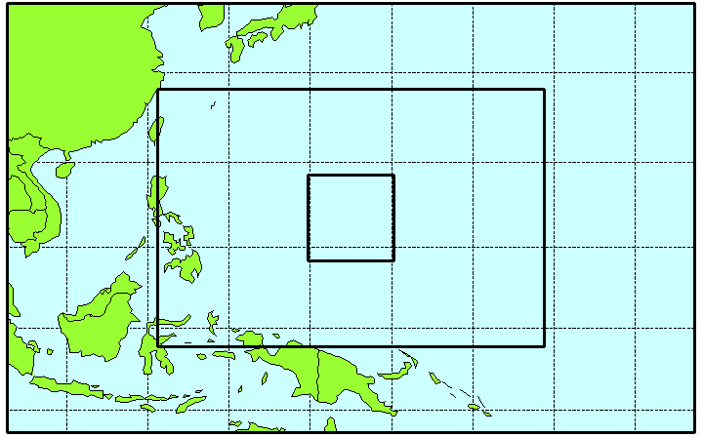

Fig. 12.5 Distribution of the three nests used for the COAMPS integrations during T-PARC.

12.4.2 Taiwan Regional Models

Waiting for description

12.4.3 German Regional Model

Waiting for description

http://www.ecmwf.int/research/EU_projects/PREVIEW/DTS/DTS_userguide_v1_2.pdf

