- Table of Contents
Chapter 1. T-PARC Overview 1
1.1 Science Objectives 3
1.1.1 Tropical Cyclone Formation, Intensification, structure change, and satellite validation 3
1.1.2 Data targeting 4
1.1.3 Extratropical transition of tropical cyclones and downstream impacts 4
1.2 Domain of Interest 5
1.3 Climatology of Events 6
1.4 T-PARC Resources 8

Chapter 1. T-PARC Overview

The THORPEX (THe Observing Research and Predictability EXperiment) Pacific Asian Regional Campaign (T-PARC) is a multi-national field campaign that addresses the shorter-range dynamics and forecast skill associated with high-impact weather events of one region (Eastern Asian and the western North Pacific) and their downstream impacts on the medium-range dynamics and forecast skill of another region (in particular, the eastern North Pacific and North America). Although many significant weather events occur over eastern Asia and the western North Pacific, the focus of T-PARC is on various aspects of typhoon activity, which includes formation, intensification, structure change, motion, and extratropical transition. Because of the significant impact of typhoon activity on the region of eastern Asia and the western North Pacific, T-PARC is comprised of several affiliated programs. These programs and their national sponsor include:
- Tropical Cyclone Structure-2008 (TCS-08) [United States];
- Typhoon Hunter-2008 (TH-08) [Japan];
- Predictability and Observation Experiment (PROBEX) [South Korea];
- Tibetan Plateau Experiment [China];
- The South China Sea Experiment [China];
- Dropsonde Observations for Typhoon Surveillance near the Taiwan Region (DOTSTAR) [Taiwan].
In addition to the above list of field campaigns, a significant international component exists via contribution of specific observation platforms. A high-altitude jet aircraft (FALCON) will be operated by the Deutches Zentrum fur Luft- und Raumfahrt (DLR). Driftsonde balloon operations will be conducted by the Centre National d’Etudes Spatiales (CNES) of France. Although the region of the western North Pacific plays an important and unique role in defining many characteristics of the midlatitude circulation of the Northern Hemisphere, the near-global participation in T-PARC is an indication that the scientific principles being examined with respect to the impacts on downstream weather by significant events upstream are applicable to many regions of the globe.
The combination of observational platforms and collaborative experiments is set such that the experimental design for T-PARC addresses three primary components: (1) A tropical measurement strategy is designed to examine circulations of the tropical western North Pacific monsoon environment as they relate to enhanced and reduced periods of wide-spread deep convection, tropical cyclone formation, tropical cyclone intensification, and tropical cyclone structure change. (2) The measurement strategy for the extratropical transition (ET) and downstream impacts is based on the poleward movement of a decaying tropical cyclone and the resulting intense cyclogenesis that results from its interaction with the midlatitude circulation. The ET process illustrates clearly the need for a tropical-to-extratropical measurement strategies as the predictability of an ET event depends on the intensity and structure of the tropical cyclone, where and when the tropical cyclone arrives in the middle latitude westerlies and the characteristics of the middle latitude wave guide that impact the ET cyclogenesis and the downstream propagation and evolution of the wave packets. (3) The third measurement strategy focuses on identification of regions that in which extra observations may reduce numerical forecast error growth. In T-PARC, the targeted observations will be aimed at primarily at reducing errors associated with forecasts of tropical cyclone track over the western North Pacific. In particular, this includes whether a tropical cyclone will recurve, the longitude of recurvature, and the orientation and speed along the track following recurvature.
The observations collected during the field phase will be used in concert with an unprecedented variety of numerical models, which includes research modeling and assimilation systems together with access to the members of the ensemble forecasts of all the major operational centers through the THORPEX Interactive Global Grand Ensemble (TIGGE). Thus, unlike past weather experiments, T-PARC will be able to readily include the probabilistic nature of the forecast problem, rather than examination of a few deterministic forecasts from research and operational models. An augmented satellite-based observing strategy is also envisioned during T-PARC. For example, observations from the Japanese MTSAT geostationary satellites and GOES-West will be collected in rapid-scan mode. From this rapid-refresh imagery, high-resolution wind fields will be derived from state-of-the-art automated feature-tracking methods during T-PARC intensive observing periods.
During T-PARC and its collaborative programs, several aircraft will be used to obtain measurements in and around western North Pacific tropical cyclones during formation, intensification, and extratropical transition. In addition to the FALCON aircraft mentioned above, a USAF WC-130J from the 53rd Weather Reconnaissance Squadron and a Navy Research Laboratory (NRL) P-3 will participate. A high-flying business class jet (ASTRA) will fly as part of the DOTSTAR program.
This document provides an overview of the facilities, operations, and management strategies for the field phase of T-PARC and affiliated programs. In keeping with the definition of three primary components given above, separate sections refer to tropical cyclone formation, intensification, and structure change, data targeting, and extratropical transition and downstream impacts.

1.1 Science Objectives

In general, the science objectives of T-PARC are associated with increasing predictability of high-impact weather events (i.e., tropical cyclone formation, intensification, motion, and extratropical transition) and the forcing of one region on the forecasts of a downstream region. As such, the specific objectives are divided into three categories.

1.1.1 Tropical Cyclone Formation, Intensification, structure change, and satellite validation

The key objectives associated with the tropical cyclone component contained in the affiliated TCS-08 program address understanding and predictability of tropical cyclone formation, intensification, and structure change. In particular, outer structure change is a special focus as changes at outer radii impact interactions between the tropical cyclone and its environment that will affect recurvature. Specific objectives are:
- Define the factors that impact the large-scale atmospheric and oceanic control on tropical cyclone formation;
- Define the relative roles of mesoscale processes during tropical cyclone formation. Specifically, identify contributions from the organization of low-level vorticity in deep convective towers versus mid-level circulations embedded in stratiform regions of mature mesoscale convective systems. This objective addresses the predictability associated with the location, timing, and rate of tropical cyclone formation over the western North Pacific;
- Define the relative role of environmentally-induced, vortex-generated mechanisms versus cyclogenesis determined initial conditions in determining the outer wind structure of a mature tropical cyclone;
- Define the key structural characteristics that limit the predictability of recurvature and the start of extratropical transition over the western North Pacific;
- Define representative wind distributions and maximum intensities of tropical cyclones from in situ data obtained at times coincident with satellite overpasses. The purpose of this objective is to provide baseline measurements and validation of satellite-based estimates of tropical cyclone intensity and structure.

1.1.2 Data targeting

To advance forecast skill of high-impact weather events such as tropical cyclones over the western North Pacific and their downstream impacts, it is necessary to address issues associated with such factors such as reducing analysis and forecast errors, observational network design, data calibration, and data assimilation. The use and evaluation of a variety of adaptive sampling strategies for reducing errors in numerical forecasts is an integral part of the T-PARC field program design. The adaptive sampling strategies will include in situ data as well as remotely-sensed observations. Specific objectives include:
- Define the influence of adaptive sampling based on dropwindsonde measurements from aircraft in the synoptic environment of tropical cyclones over the western North Pacific on the forecast skill of the tropical cyclone track;
- Increase understanding of the significant differences in the prediction of targeting locations produced by different targeting techniques;
- Identify the impact of assimilating additional observations from a variety of platforms, which includes in situ aircraft observations and satellite remote sensing;
- Identify the impact of data on a multiple spatial and temporal scales using a variety of data assimilation methods.

1.1.3 Extratropical transition of tropical cyclones and downstream impacts

The extratropical transition of a tropical cyclone often has far-reaching effects on the midlatitude circulation. Furthermore, there is a large amount of variability in the occurrence and amplitude of the downstream impacts. Forecasts of the downstream circulations tend to have reduced skill and the variability among ensemble members during extratropical transition events suggests that the predictability associated with these cases is low. Combinations of aircraft, radar, dropwindsonde, and satellite observations will be used in conjunction with model simulations to define the interactions between a decaying tropical cyclone and the midlatitude circulation into which it is moving that affect the downstream impact. Specific objectives are:
- Document the contributions from various physical processes that impact the development of the deep tropospheric anticyclone immediately downstream of an ET event. Physical mechanisms associated with such features as the poleward movement of heat and moisture along the eastern side of the decaying tropical cyclone, warm frontogenesis, and the interaction of the tropical cyclone outflow and the midlatitude jet stream will be examined;
- Examine the temporal evolution of the processes by which the decaying tropical cyclone impacts the midlatitude circulation;
- Define the relative roles of a variety of tropical cyclone and midlatitude circulation characteristics as they influence the variability of downstream impacts during ET;
- Examine the utility of satellite data in defining the important physical characteristics of an ET event;
- Examine the importance of the re-intensification of the decaying tropical cyclone as an extratropical cyclone on maintaining the downstream transport of energy;
- Examine the impact on forecast accuracy due to improved analysis of key structural characteristics during the ET of a decaying tropical cyclone.

1.2 Domain of Interest

The field phase of T-PARC and affiliated programs will be located over the western North Pacific (Fig. 1.1). The WC-130J and the NRL P-3 will primarily be operated from Guam with periods of deployment to Okinawa and Japan. The FALCON will primarily be flying from Japan with periods of deployment to Okinawa. The DOTSTAR aircraft will operate from Taipei, Taiwan.
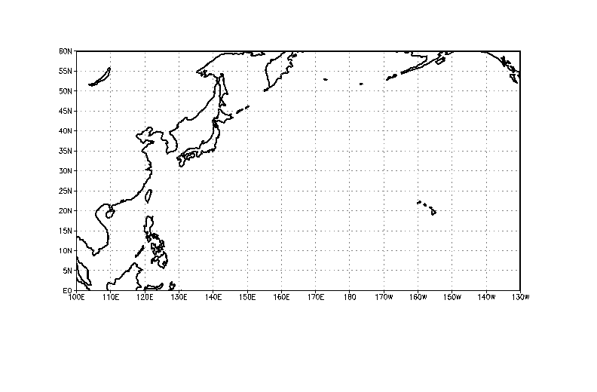
Guam
Okinawa
Atsugi
Taipei
Figure 1.1 T-PARC and collaborative programs domain of interest.

1.3 Climatology of Events

The field phase of T-PARC and collaborative programs is 1 August – 5 October 2008. This period was chosen to coincide with the climatological maximum of tropical cyclone activity over the western North Pacific (Fig. 1.2). On average, 13 tropical cyclones occur over the western North Pacific during these two months. Approximately seven of these disturbances will be of typhoon intensity. Furthermore, just under half of these tropical cyclones undergo extratropical transition (Fig. 1.3).

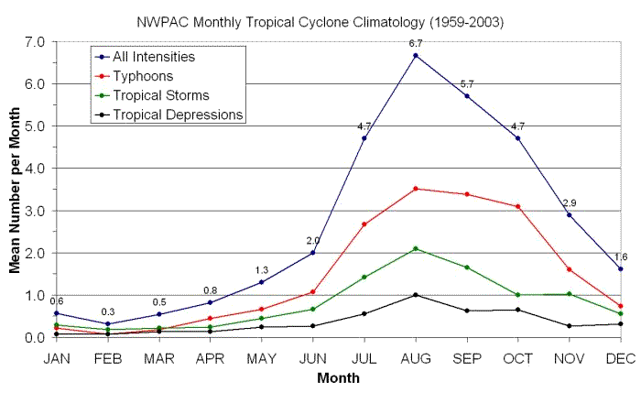
Fig. 1.2 Average number of tropical disturbances by month and classification over the western North Pacific (From the Joint Typhoon Warning Center).

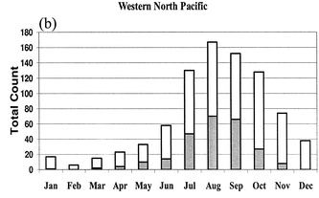
Fig. 1.3 Monthly total number of tropical cyclones (open bars) over the western North Pacific during 1970-1999 and the number of tropical cyclones that underwent extratropical transition (shaded bars). (After Jones et al. Weather and Forecasting, Vol. 18, 1052-1092).
The largest factor that governs interannual variability of tropical cyclone activity over the western North Pacific is the El Nino-Southern Oscillation (ENSO) cycle. During warm events, the western North Pacific monsoon trough extends farther east than normal and there is an eastward shift in the mean location of tropical cyclone formation (Fig. 1.4). Since tropical cyclones tend to form farther eastward, they follow long over-water tracks that tend to contribute to stronger cyclones that recurve. Typically, the longitude of recurvature is farther eastward than a climatological longitude of recurvature. During cold events, the monsoon trough is retracted westward and tropical cyclones tend to form farther west than normal (Fig. 1.4). The tracks will then be shorter such that storms will not reach significant intensities before either turning poleward or making landfall.

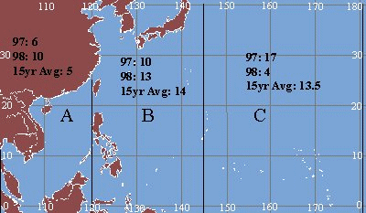
Equally likely
Track types
More likely to recurve
Joint Typhoon Warning Center, Annual Tropical Cyclone Report (1998)
Fig. 1.4 Distribution of tropical cyclone formation locations during 1997 (warm ENSO event) and 1998 (cold ENSO event).

1.4 T-PARC Resources

Observational facilities for T-PARC involve Earth Observing Laboratory (EOL) facilities, which includes the NCAR ELDORA dual-Doppler radar system onboard the NRL P-3. The NRL P-3 will also deploy GPS dropwindsondes. Also, the Twin Otter Doppler Wind Lidar will be operational on the NRL P-3. There are approximately 150 h of research flight hours planned for the NRL P-3. This would allow for approximately 15 flights throughout the tropical and ET phases of T-PARC.
To provide a capability to obtain measurements in the inner core of a developing and mature tropical cyclone, a WC-130J aircraft from the 53rd Weather Reconnaissance Squadron at Keesler Air Force Base (AFB) will be utilized. The WC-130J will be deployed from Andersen AFB, Guam beginning 1 August through 30 September. The WC-130J will deploy GPS dropwindsondes and it will use the stepped frequency microwave radiometer (SFMR) to obtain estimates of the surface wind. It is anticipated that approximately 20 flights with average duration of 10 h will be conducted by the WC-130J.
While the WC-130J and the NRL P-3 with ELDORA and GPS dropwindsonde capabilities are able to provide detailed views of the physical characteristics associated with the tropical cyclone lifecycle, the interaction of the upper-level outflow and midlatitude jet will be observed by the Deutsches Zentrum fur Luft- und Raumfahrt (DLR) Falcon aircraft that will be outfitted with an airborne Doppler wind lidar and a water vapor differential absorption lidar (DIAL). The 2 μm Doppler lidar was used in the Atlantic THORPEX Regional Campaign (A-TReC) in autumn 2003. The wind lidar provides profiles between 0.5 and 12 km altitude with accuracy better than 1 m s⁻¹. The horizontal resolution is up to 5 km and the vertical resolution is up to 100 m. The initial use of the combined Doppler wind lidar and DIAL is to take place in summer 2007. The precursor to the DIAL system has participated in numerous international field programs to provide profiles of water vapor from 0.5 to 12 km altitude and 10% accuracy. The horizontal resolution varies between 2 km and 14 km and the vertical resolution varies between 0.2 km and 2 km depending on the boundary conditions. The DIAL instrument that is to begin deployment in 2007 is expected to exceed these specifications. The DLR Falcon will also deploy GPS dropwindsondes. Approximately 100 h of research flight hours have been requested for the DLR falcon.
To support the collection of observations at upper levels for data targeting the DOTSTAR project ASTRA business class jet will be used in cases when a tropical cyclone enters the region of the northern Philippine Sea and there is uncertainty in the track of the storm as it nears Taiwan. The ASTRA aircraft contains the Airborne Vertical Atmospheric Profiling System (AVAPS) and deploys GPS dropwindsondes. Data from the dropwindsondes are relayed to the Central Weather Bureau in Taiwan and placed on the GTS weather data network where they will be used in operational numerical weather prediction systems.
The driftsonde is a zero-pressure high-altitude balloon system that includes a gondola that carries approximately 40 miniature dropwindsondes (MIST). Approximately 18 balloon systems are available for launch during the 6-week period beginning on 15 August. Communication with the balloon through a satellite link will allow coordination of the release of the MIST sondes. Communications with the balloon system will be made from the Monterey Operations Center.
In addition to the in situ observation systems described above, substantive use is being made of satellite data from geostationary and polar-orbiting platforms. Various tropical cyclone-related products will be provided to aid in the decision-making procedure. Through coordination with the Japan Meteorological Agency, rapid scan operations from the MTSAT-2 geostationary satellite will be implemented over several special observing periods when tropical cyclones are forecast to approach Japan.
Finally, through special programs such as the Predictability and Observation Experiment (PROBEX) in Korea and Typhoon Hunter-2008 (TH-08) in Japan certain radiosonde sites will be obtaining special observations during the T-PARC period. In addition, the Japan Meteorological Agency (JMA) will deploy four observation ships at various locations in the East China Sea to obtain special radiosonde data. During aircraft operations, special radiosonde launches will also be made from U.S. National Weather Service sites on several islands throughout the tropical western North Pacific.

