Table of Contents
Chapter 5. Operations and Support Center Logistics 1
5.1 T-PARC Monterey Operations Center 3
5.2 Aircraft Support Center Functions and Support Services 3
5.3 Guam (Andersen AFB) –NRL P-3 and USAF C-130 4
5.4 Japan (Atsugi NAF) –DLR Falcon 20 6
5.5 Alternate Aircraft Support Sites 6
5.6 Aircraft Support Centers and Alternate Sites Emergency and Evacuation Procedures 6

Chapter 5. Operations and Support Center Logistics

There are multiple centers supporting the T-PARC field phase. Each of these centers has specific activities and responsibilities that are key to the success of T-PARC. We discuss these tasks in this chapter and provide logistical details for each site. We have included two maps (Fig. 5.1 and 5.2) that show these centers geographically spread from Colorado in the US to the coast of China. We provide some specific details below on activities at each site.
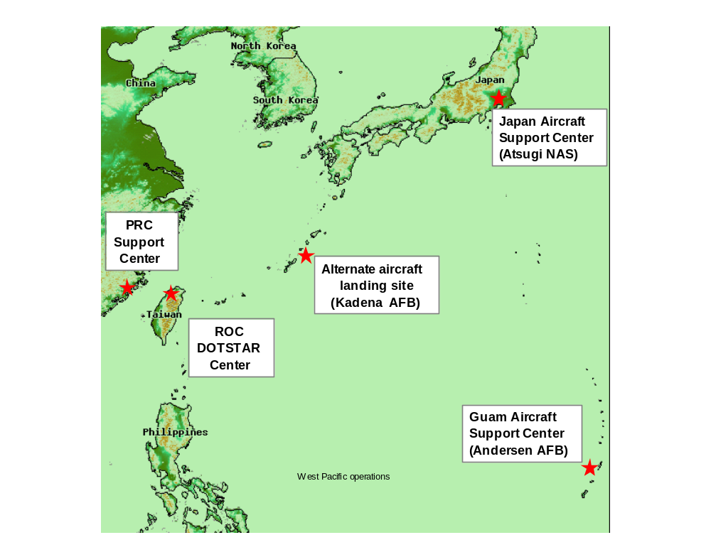
Figure 5.1 T-PARC Coordination Centers in Western Pacific, Japan, Taiwan and China
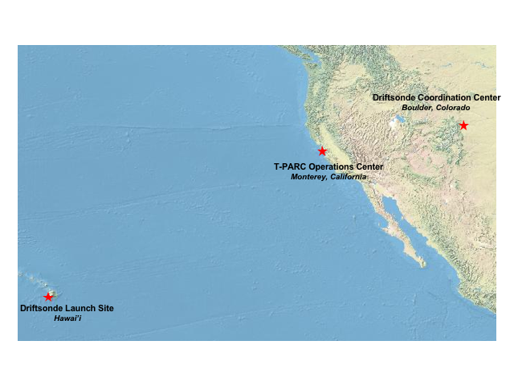
Figure 5.2 T-PARC Coordination Centers in the Eastern Pacific and US Mainland

5.1 T-PARC Monterey Operations Center

The T-PARC Monterey Operations Center (MOC) is located at the Naval Postgraduate School (NPS) in Monterey CA. The layout of NPS and the location of MOC related facilities are given in Figures 5.3 and 5.4 (to be provided by HARR). The MOC has overall responsibility for the conduct of operations during the field phase of T-PARC. The Daily Science Meeting (DSM) and DPM both originate from the MOC and are open to all project participants using the Elluminate® real-time Internet video teleconferencing system. Daily operations summaries are generated at the MOC as well as Science Summaries and other updates as required.
INSERT Fig 3&4

5.2 Aircraft Support Center Functions and Support Services

The T-PARC research aircraft from the US and Germany will be based at Andersen AFB http://www.andersen.af.mil/ on the Island of Guam and Atsugi NAF http://www.atsugi.navy.mil/ in Japan, respectively. The positioning of T-PARC aircraft in the region is intended to place the aircraft as close to the kinds of events each will be investigating. There are also options for the aircraft to transit or recover to alternate bases as needed to meet mission science objectives. This section describes the main and alternate bases for each aircraft as well as location and support details.

5.3 Guam (Andersen AFB) –NRL P-3 and USAF C-130

The NRL P-3 with ELDORA radar, Dropsondes and Lidar, and the USAF C-130 Reconnaissance Aircraft with Dropsondes, deployable buoys and SFMR will be based at Andersen AFB on the island of Guam (See Figs. 5.5 and 5.6). Both aircraft will normally conduct operations in the vicinity of Guam (approximately 1000 nmi radius) to support tropical cyclone formation missions. or they can fly a mission and recover in Okinawa, Japan, at Kadena AFB to support ET science requirements.
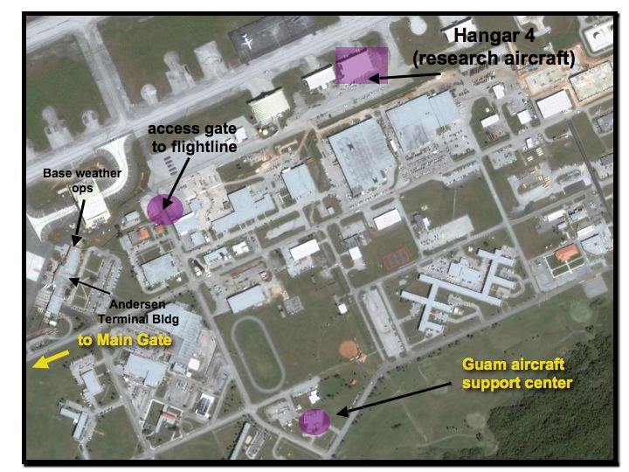
Figure 5.5 Overview of Guam Aircraft support Center. NRL P-3 and USAF C-130 will be located here.
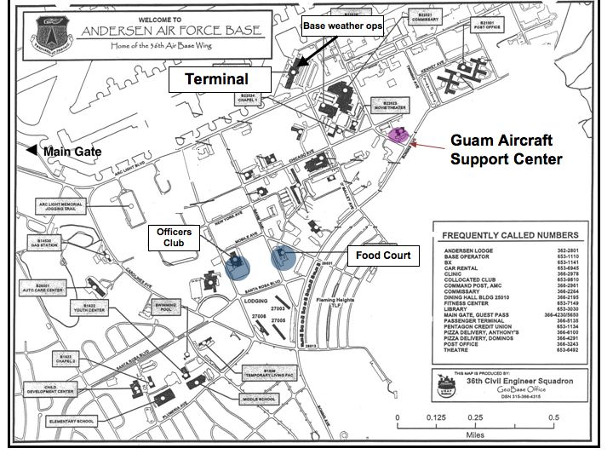
Figure 5.6 Andersen AFB Street Map with T-PARC Aircraft Support Center and other logistics located.
The support center is located at Upper Bay 15, Building 21000, 2nd floor (see Figs. 5.5, 5.6), and will include Internet connectivity of adequate bandwidth over a XX Mbit commercial Digital Subscriber Line (DSL) with a Local Area Network in place with wired Ethernet access. The availability of wireless network is undetermined at this time. The space has a large communal room with a few individual offices close by. Daily briefings, weather briefings and post flight debriefs will take place here. The ELDORA radar data analysis workstation and the USAF 53rd WRS “ground station” will be located at the center. EOL will provide on-site systems administration support. It is expected that the support center will start operations by July 25, 2008, with daily briefings from the Monterey Operations Center starting around 25 July as well.
Research aircraft will be parked on the apron behind Hangar 4 (Fig. 5.5). We expect a limited amount of office space for military aircrews inside Hangar 4. The aircraft hangar and flight line are accessible through a gate at the end of Vandenberg Avenue, past the control tower. It is a sturdy 20-min walk in the tropical sun between the support center and the hangar.
Lodging for project participants will be at the Guam Marriott in the hotel area on Tumon Bay in west central Guam. It is approximately a 30-minute drive from Tumon Bay to the Main Gate at Andersen AFB. Participants will need to clear security and vehicle inspection before proceeding into the base. Foreign nationals may need to be escorted by a U.S. citizen in order to gain access to the base.

5.4 Japan (Atsugi NAF) –DLR Falcon 20

The DLR Falcon 20 with lidars, dropsondes and other flight level data will be housed at the Atsugi NAF near Tokyo, Japan. (See Fig. 5.7) The aircraft will normally conduct operations in the vicinity on Honshu Island (approximately 500 nmi radius of Atsugi). However, there may be opportunities to fly and refuel for a second mission using other sites such as Misawa NAS, Iwo Jima and Kadena AFB. The Falcon’s primary mission is to support measurements to address ET and targeting scientific objectives.

5.5 Alternate Aircraft Support Sites

T-PARC has identified several alternative bases that may be used for recovery and deployment of project aircraft. A regional map showing these optional landing locations is shown in Fig 5.8.
Auxiliary Operations Support Site functions and services JMA/EOL
(JMA, Boulder DS,…)???
Alternate base procedures, services JGM
(Yokoto, Kadena, for Guam?)???

5.6 Aircraft Support Centers and Alternate Sites Emergency and Evacuation Procedures

All of the locations described above and in Fig. 5.1 are potentially in the path of tropical cyclones during T-PARC.
Communications protocol
Real time products SFW
Space and facilities (layout?) PH
Administrative and technical support PH
Site logistics—security, parking, access, services PH

