WAMO Project Manager Report
October 25 – November 16, 2010
This summary outlines the general instrumentation status and problems affecting the quality of the data set and is not intended to point out every detail of questionable data.
This report covers only the RAF supplied instrumentation and is organized into two sections. The first section lists general instrument characteristics, limitations, recurring problems, and systematic biases in the standard RAF measurements. The second section lists isolated problems occurring on a flight-by-flight basis. A discussion of the performance of the chemistry sensors (CO and ozone) will be provided separately, along will the respective finalized data sets. Preliminary chemistry data are included with the RAF core data as a courtesy and should not be used in publications.

Section I: Instrumentation
RAF staff have reviewed the data set for instrumentation problems. When an instrument has been found to be malfunctioning, specific time intervals are noted. In those instances the bad data intervals have been filled in the netCDF data files with the missing data code of -32767. In some cases a system can be out for an entire flight.
Position Data. Both a Garmin Global Positioning System (variables labeled GGxxx_GMN) and a Novatel Global Positioning System (variables labeled GGxxx) were used as position references during WAMO. The systems generally performed well. With no real differences between the two sets of data, it was decided to only output the Novatel variables in order to avoid confusion in the data analysis. The algorithm referred to in (3) below also blends the GPS and IRS position to yield a best position (LATC, LONC) that generally removes any GPS spikes but can be prone to jumps in case of more extended GPS data gaps.
3D- Wind Data. The wind data for this project were derived from measurements taken with the 5-hole radome wind gust probe. The ambient wind calculations can be adversely affected by either sharp changes in the aircraft's flight attitude or excessive drift in the onboard inertial reference system (IRS). Turns, or more importantly, climbing turns are particularly disruptive to this type of measurement technique. Wind data should be plotted against the attitude data and should be used with caution unless the aircraft is in straight and level flight.
SPECIAL NOTE: RAF flies redundant sensors to assure data quality. Performance characteristics differ from sensor to sensor with certain units being more susceptible to various thermal and dynamic effects than others. Good comparisons were typically obtained between the two static pressures (PSFDC, PSFC), the three standard temperatures (ATRL, ATRR, ATWH), three dynamic pressures (QCRC, QCFC, QCFRC), and the two dew pointers (DPT, DPB). Exceptions are noted in the flight-by-flight summary. The backup static pressure system showed smaller turbulent fluctuations in the signal (PSFRD) and therefore was selected as the reference pressure (PSXC) used in all of the derived parameters.
Ambient Temperature Data. Temperature measurements were made using the standard heated (ATWH) and unheated (ATRR) Rosemount temperature sensors. Performance of all three sensors remained stable throughout the rest of the project and showed excellent agreement. ATRR was installed onto the C-130 prior to the beginning of intercomparison flights in France and is unavailable for the earlier ferry flights. Due to its fast response, ATRR was selected as the reference value (ATX) used in calculating the derived parameters for most flights. ATWH was used as the reference temperature on a few selected flights where significant icing conditions adversely affected the response of the ATRR system.
Humidity Data. Humidity measurements were made using two collocated thermoelectric dew point sensors. Under conditions where the units had been cold soaked at high altitude or experienced a rapid transition into a moist environment, both units show a tendency to overshoot. Extended legs in cloud and/or icing conditions showed some degradation in the data. Oscillations in the signals were common under these conditions and restricted sample flows led to unrealistically high dew point temperatures during some of these passes. In general, DPBC seemed less susceptible to these problems and was selected as the reference output (DPXC) for most flights. The DPXC data should generally not be used for looking at fine atmospheric structure unless very carefully examined for the signs of instrument instability, visible in the time series as a pronounced "ringing" (see example picture below).
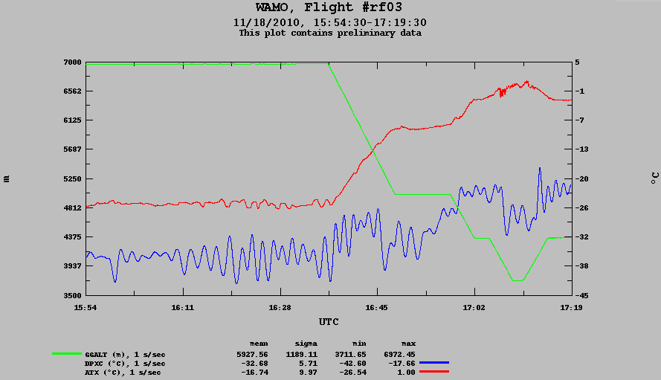
DPXC has been blanked out during periods where the "ringing" is strong or the sensor is not working normally otherwise. However, in a number of cases the average value of the dewpoint is reasonable, as in the figure above and in such cases DPXC was not blanked out. This is a somewhat subjective process, and it is advised that DPBC is also looked at to see what sections of data should also be removed in the particular research application.
Note: Even in the best case, the response time of the thermoelectric dew point sensors is about 2 seconds. Response times are dependent upon ambient dew point depression and can exceed 10-15 seconds under very dry conditions.
The UV hygrometer was an experimental instrument and only operated on TF01, TF02, TF03, RF02 (part of flight) and RF03 (part of flight). The instrument malfunctioned on the rest of the flights. The UV hygrometer data are loosely coupled with the thermoelectric dewpoint sensor data to compensate for long term drift while providing fast time response. Currently the algorithm for the loose coupling is incorrect, causing lags in the DPUV data (not included in the final release). The UV hygrometer data are available by special request and not included in the final data release.
Surface Temperature Data. Heimann radiometric sensors were used to remotely measure surface temperature (RSTB & RSTB1 nadir, RSTT zenith). RSTT also functioned well. Note that when no clouds are present above the aircraft the RSTT signal will be pegged at its maximum “cold” limit of roughly -60 C.
Altitude Data. The altitude of the aircraft was measured in several ways. A pressure based altitude (PALT, PALTF) is derived from the static pressure using the hydrostatic equation and normally using the U.S. Standard Atmosphere, which assumes a constant surface pressure of 1013 mb and a mean surface temperature of 288 K.
The GPS positioning systems also provide altitude data (GGALT & GGALT_GMN). These outputs normally provide a fairly accurate MSL altitude based on a ellipsoid model of the Earth (WGS-84; see also Position Data above).
A radar altimeter was onboard the aircraft for the project but did not operate properly.
Aerosol & Cloud Droplet Sizing Data. Four PMS 1D particle probes (SPP200, CDP, SPP-300 and UHSAS) were used on the project. Concentration data from these sensors are stored as time series in the final netDCF files and can be viewed using Aeros, ncplot or any other time series visualization tool. Size distribution data are also stored in the netCDF files and can be accessed using the ncpp program, available for download from the RAF web site. Some specific details on each of the probes are summarized below:
PCASP, SPP-200 (PCASP, Passive Cavity Aerosol Spectrometer Probe) has the measurement range of 0.1 - 3 um and measures aerosols, (NH₄)₂SO₄. The instrument was intermittent on several flights, see flight specific notes.
SPP-300 (FSSP) has the measurement range of 0.3 - 20 um and measures un-activated cloud droplets / haze size.
CDP - This probe basically matches the same droplet size distribution as covered by the SPP100 probes (2 - 50 um, water droplets) but has difficulty in sampling ice particles. Under the conditions targeted by the PLOWS flights, the CDP particle concentration data and calculated liquid water content will under estimate the true values of these variables.
UHSAS (Ultra High resolution Aerosol Spectrometer) measures aerosols in the range from 0.075 - 1 um.
TECO Ozone. This is a dual channel system that cycles between channels every 10 seconds, leading to the stair step nature of the data. The unit was normally turned off prior to landing to avoid contamination. Short data gaps at the end of each flight are normal.
Picarro CRS: flown for the first time in the experimental mode, the cavity ringdown spectrometer provides data on the CO and CH4 mixing ratios.

General Notes
- Only preliminary data from TECO and Picarro are provided in the netCDF files at the time of release. Final data will be provided by the ACD CARI group at a later date.
- ADIFR and all variables recording raw vertical airframe or air motion data exhibit strong oscillation on occasion. Examples of this are FF03, FF05 and some other flights. It is believed that the cause for this is the operation of the autopilot, which software was being modified by the manufacturer during and after the project. The autopilot caused excessive airplane motion after extended periods of straight and level flight. When identified by the pilots the motion was checked by resetting the autopilot but the issue was new for this project and several periods were affected. Vertical wind algorithms were able to remove most of this motion from the delivered wind data.
- Virtually all measurements made on the aircraft require some sort of airspeed correction or the systems simply do not become active while the aircraft remains on the ground. None of the data collected while the aircraft is on the ground should be considered as valid.

Section II: Flight specific notes
FF01: The data acquisition for this flight was terminated at 17:35 prior to landing due to an agreement on an international flight.
FF02: The data acquisition for this flight started after take-off and was terminated prior to landing due to an agreement on an international flight. PCASP intermittent.
FF03: The data acquisition for this flight started after take-off and was terminated prior to landing due to an agreement on an international flight. PCASP intermittent.
FF04: The data acquisition for this flight was terminated prior to landing due to an agreement on an international flight.
FF05: The data acquisition for this flight was terminated prior to landing due to an agreement on an international flight.
FF06: The data acquisition for this flight started after take-off due to an agreement on an international flight.
FF07: Pilot proficiency (?)
TF03: Radome icing encountered from 16:55 to 17:21 and from 18:21 to 18:26. QCR data affected.
FF03: Radome gust probe affected by ice or water, causing noisy ADIFR and QCR from the beginning of data acquisition to 12:35.
RF01: PCASP operated, never reached high altitude.
RF02: This flight has a period on the ground from 17:20 to 20:13. Radome icing encountered at 21:31; OCR affected until 23:48.
RF03: This flight has a period on the ground from 18:21 to 19:40. Data system restarted prior to take-off. UHSAS did not work after take off; fixed on the ground in CA; UHSAS laptop was turned off at some undetermined point. Analog boards did not work at the beginning of the flight for over an hour until restarted. Satcom dark territory encountered over Utah, both ways.

