Table of Contents
Chapter 10: Satellite Digital Data and Products 2
10.1 Satellite Operations 2
10.2 Geostationary Satellite Data: MTSAT 2
10.2.1 Routine Data Collection 2
10.2.2 MTSAT Rapid Scan Operations 3
10.2.3 Tropical Cyclone Intensity Via Geostationary Digital Data 6
10.2.4 MTSAT Archival Procedure for TPARC 6
10.3 Low Earth Orbiting (LEO) Data 6
10.3.1 LEO Visible/Infrared Imagers Overview 6
10.3.2 Advanced Very High Resolution Radiometer (AVHRR) 7
10.3.3 DMSP Operational Linescan Sensor (OLS) 9
10.3.4 MODIS 10
10.3.5 Sea-viewing Wide Field-of-View (SeaWiFS) 13
10.3.6 Quick Scatterometer (QuikSCAT) 14
10.4 Passive Microwave Imager/Sounder Data 16
10.4.1 Microwave Imagers/Applications Overview 16
10.4.2 Microwave Satellite Data Sets 19
10.4.3 Mapping Inner-Core Structure for Intense Tropical Cyclones 22
10.4.4 Microwave Sounder Data Sets 24
10.4.5 Microwave Sounder Intensity Estimates 25
10.4.6 CloudSat Cloud Radar 29
10.4.7 Altimeter Sea Surface Height (SSH) 31
10.5 Tailored Web Page Product Suite 33
10.5.1 Naval Research Laboratory (NRL-MRY: 34
10.5.2 CIMSS near real-time satellite product web sites for TPARC 36
10.6 Overpass schedules for selected satellites 38
10.7 Browse products for field campaign 41
10.8 Satellite Data Archival at NCAR EOL 42

Chapter 10: Satellite Digital Data and Products

10.1 Satellite Operations
Satellite data collection for the TPARC project will begin in mid July with the commencement of field ‘spin-up’ operations, and will continue uninterrupted through the TPARC tropical campaign [Tropical Cyclone Structure (TCS-08)] into mid October. Data will be routinely acquired and collected in near real-time from a suite of operational and research and development (R&D) geostationary and low earth orbiting (LEO) sensors in order to support both the field program and scientific endeavors. The MTSAT-1R GEO satellite is a major observing platform for TCS-08 and will provide the high temporal visible, infrared (vis/IR) and water vapor (WV) imagery that will meet multiple application needs. This data will also be made available to the JOSS Field Catalog. Data from more than fifteen (15) polar orbiting satellite sensors will also be collected in near real-time during the project in order to take advantage of their unique spectral and spatial characteristics. All LEO jpeg images and derived products will be made available via the JOSS Field Catalog. Some satellite data/products are unlikely to be available during the field operations timeframe, but will be available afterward for post-analysis. The following sections outline the full suite of GEO/LEO satellite sensors, imagery and derived products and information on satellite overpass times for TCS-08.

10.2 Geostationary Satellite Data: MTSAT

10.2.1 Routine Data Collection
The primary source for routinely available high temporal resolution satellite data for TPARC is the Japanese Meteorological Agency’s (JMA) Multi-functional Transport Satellite (MTSAT)-1R satellite. Vis/IR and WV imagery will be routinely provided at half-hourly intervals. Table 10.1 lists MTSAT data attributes.
Table 10.1 MTSAT Imager Channels
Band | Central Wavelength (microns) | Resolution (km) | Spectral Range
IR1 | 10.8 | 4 | Longwave window
IR2 | 12.0 | 4 | Longwave window
IR3 | 6.7 | 4 | Water Vapor
IR4 | 3.8 | 4 | Shortwave window
VIS | 0.7 | 1 | Visible
Table 10.1: List of Japanese geostationary MTSAT spectral channel characteristics.

Images covering the TPARC area of interest will be produced from the above channels as the data are received and made available through the Earth Observation Laboratory (EOL) Field Catalog. The digital data will be routinely collected and archived at the U. of Wisconsin’s – Cooperative Institute for Meteorological Satellite Studies (CIMSS). These data will be available immediately to users, although this will require the user to have the Man computer Interactive Data Access System (McIDAS) satellite processing software in order to work with the data. For post-analysis efforts, the data can be made available in other formats. In addition, static jpeg vis/IR and WV imagery will be accessible via the NRL TC web page.

10.2.2 MTSAT Rapid Scan Operations
Routine MTSAT-1R imager operations provide half-hourly coverage of the TPARC area. Higher temporal resolution is possible through special requests for Rapid-Scan (RS) operations. The JMA may use the MTSAT-2 satellite (on orbit spare) for RS operations on a limited basis in order not to interrupt MTSAT-1R schedules. As of now, the details of special TPARC RS requests have not been formalized with JMA. However, it is expected these operations will be available in some form, on a limited case-by-case basis during TPARC. Expected conditions/limitations to this service currently include:
- The procedure to request an MTSAT-2R RS will be based on the forecast products. If on Friday of the current week, they look favorable for TC monitoring the following week, we can ask/alert the Japan Aviation Authorities (whom control the satellite operations) for possible RS operations in the coming week (next Monday through Friday). Then, the Japan MSC can request RS operations during this week at any time. However, the request must be made at least 2 days before the operation day. The RS operations will be in effect for at least 24 hours, and expandable to another 24 hours.
- The RS imaging cycle (per every hour) will consist of three 15-min northern hemisphere images, then three 4-min limited-area images OR two 7-min limited-area images in succession for RS winds (see Fig. 10.1). It is not known yet how this decision will be made. For the 4-min limited images, we have to tell the MSC the lat-lon of the NW and SE edges of the desired coverage box. For the 7-min limited images, only the latitude of the northern edge will be needed.
- JMA and aviation operations take precedence, so TPARC special RS requests may be denied depending on all other factors.

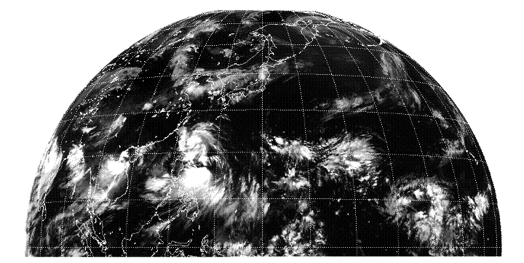
Fig 10.1: Sample TPARC and TCS-08 rapid scan sector coverage (blue box). Left: 7-minute scan, right panel: 4-minute scan. The boxes are relocatable with 2 days notice.
Routine (30-min) MTSAT vis/IR and WV imagery will also be processed to create near real-time cloud and water vapor-tracked winds. This capability has evolved from early manual efforts in the 60s to fully automated and quality controlled data sets today (Velden, et al, 2005). These automated motion vectors (AMV) are crucial in mitigating the huge oceanic data voids. Figure 10.2 depicts a test CIMSS-derived AMV data set created using 7-minute rapid scan MTSAT data (courtesy of JMA).
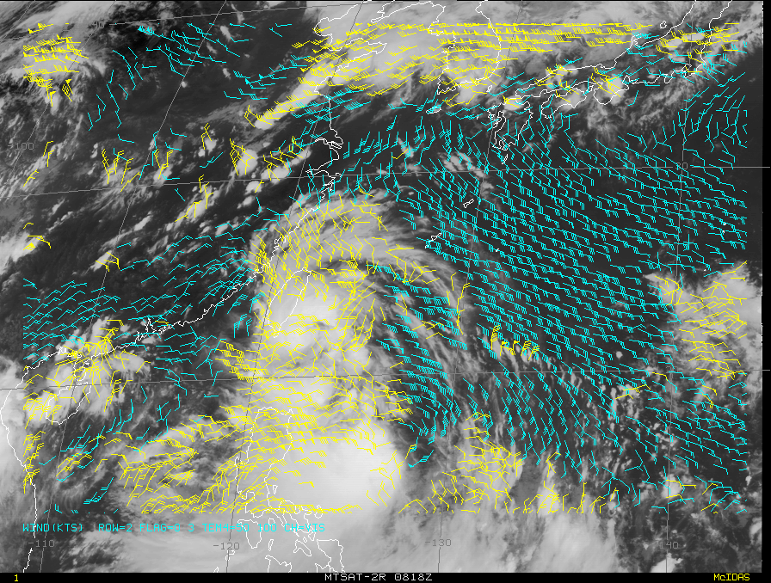
Figure 10.2: Example of geostationary cloud and water vapor-tracked winds using 7-minute rapid scan winds with MTSAT digital data processed by CIMSS.
Note the excellent spatial coverage of the upper-level (light blue) vectors associated with the WV channel and the cloud-tracked winds (yellow vectors) that are tagged using both convective and cirrus cloud targets. The TCS-08 field program will incorporate these winds in both near real-time analyses (in particular upper-level wind fields due to the abundance of 200-550 mb retrievals) that will help in the production of upper-level diagnostics (convergence/divergence and wind shear between upper and lower levels).
AMV data greatly assists tropical analysts by mitigating the previous data void, especially aloft. Some ship and buoy data is available to assist surface analyses, but few aircraft routes/reports exist in the deep tropics and AMV data has significantly augmented the Joint Typhoon Warning Center’s (JTWC) ability to monitor synoptic and mesoscale upper-level wind patterns/features that can both steer tropical cyclones and/or impact their intensity and formation. AMVs have proven to be one of the top two satellite inputs to numerical weather prediction models (NWP), often on par with AMSU radiances (Velden, et al, 1995, Goerss, et al., 1998, Goerss and Hogan, 2006).

10.2.3 Tropical Cyclone Intensity Via Geostationary Digital Data
The well-known Dvorak technique (Velden, et al 2006) is based on the principles of satellite imagery cloud pattern recognition with the amount of organization directly correlated to hurricane intensity. Trained satellite analysts determine the cloud pattern type and relate it to storm development stages. As satellite IR sensors became more sophisticated in the 1970s, Dvorak expanded his techniques to include special enhancements (Dvorak 1984). Recently, scientists collaborated to automate the Dvorak technique, called the Advanced Dvorak Technique (ADT, Velden et al. 1998b; Olander and Velden 2007). The ADT was designed to minimize human judgment in the cloud pattern typing and rules application stages. This algorithm now operates on both GEO and LEO satellite IR imagery, and is competitive with subjective applications. The ADT is now operational at NOAA/NWS and other global TC centers use the ADT in their analysis procedures. The near real-time ADT values for all numbered JTWC systems will be available to TCS-08 participants via web and/or email, including the Naval Post Graduate School (NPS) operations center.

10.2.4 MTSAT Archival Procedure for TPARC
As stated above, MTSAT-1R data is routinely archived in McIDAS AREA format on the CIMSS mass storage system upon ingest. We also hope to obtain all MTSAT-2R RS data from JMA servers during the experiment. Users wishing to view/apply MTSAT data in digital format for post-analysis should contact Chris Velden at chrisv@ssec.wisc.edu. All attempts will be made to provide the data in formats that the majority of users can readily handle. In addition, all static vis/IR and WV jpeg/tiff images will be entered into the JOSS field catalog from the combined resources of the CIMSS and NRL TC web and tropical web pages.

10.3 Low Earth Orbiting (LEO) Data
LEO data provides a suite of sensors with spectral and spatial capabilities not found on GEO platforms and are critical to the science and field program missions within the TPARC and TCS-08 projects. Multi-channel vis/IR, microwave imagers/sounders and radars use different parts of the electromagnetic spectrum to extract environmental measurements and derived parameters that can greatly aid the overall and specific TPARC and TCS-08 goals. Each sensor has inherent advantages and disadvantages that will be summarized below to ensure all participants comprehend their capabilities.

10.3.1 LEO Visible/Infrared Imagers Overview
The TPARC TCS-08 project will have access to a constellation of both operational and research vis/IR/WV imagers. The operational National Oceanic and Atmospheric Administration’s (NOAA) Advanced Very High Resolution Radiometer (AVHRR) and the Defense Meteorological Satellite Program’s (DMSP) Operational Linescan System (OLS) are the two operational sensor series, each with multiple satellites currently in operation. Research grade vis/IR imagers augment the operational sensors via the NASA Moderate Resolution Imaging Spectroradiometers (MODIS) and the Sea-viewing Wide Field-of-view Sensor (SeaWiFS). The two MODIS sensors (Earth Observation System [EOS] Aqua and Terra) and SeaWiFS provide enhanced spatial and spectral sensitivity in comparison to AVHRR/OLS data.

10.3.2 Advanced Very High Resolution Radiometer (AVHRR)
These legacy instruments have been on the NOAA polar orbiting environmental satellites (POES) for the past several decades and are the work horse for multiple basic observational products (global clouds, sea surface temperature, etc). The AVHRR is a broad-band, six channel scanner, sensing in the visible, near-infrared, and thermal infrared portions of the electromagnetic spectrum. Table 10.2 lists the wavelengths observed by the AVHRR instrument.
Table 10.2 AVHRR Characteristics
Channel Number | Resolution at Nadir | Wavelength (μm) | Typical Use
1 | 1.09 km | 0.58-0.68 | Daytime cloud and surface mapping
2 | 1.09 km | 0.725-1.0 | Land-Water Boundaries
3A | 1.09 km | 1.58-1.64 | Snow and Ice Detection
3B | 1.09 km | 3.55-3.93 | Night Cloud Mapping, SST
4 | 1.09 km | 10.30-11.30 | Night Cloud Mapping, SST Temperature
5 | 1.09 km | 11.50-12.50 | Sea-Surface Temperature

Table 10.2: List of NOAA AVHRR sensor characteristics.
Currently, there are five NOAA LEO satellites in orbit providing calibrated data from an AVHRR. These satellites and their approximate overpass times for Guam are listed below in Table 10.3 along with sunrise/sunset times for comparison (all times UTC).
Table 10.3: NOAA AVHRR Sensors – Approximate Guam Crossing Times (UTC)
Instrument | Daytime Pass | Nighttime Pass
NOAA-15
NOAA-16
NOAA-17
NOAA-18
MetOp-1
Sunrise/Sunset | Aug 1: 2006/0848 | Oct 1: 2010/0811
Table 10.3: List of daytime and nighttime overpass times for the NOAA AVHRR sensors for the Guam area.
AVHRR data are acquired in three formats:
- High Resolution Picture Transmission (HRPT)
- Local Area Coverage (LAC)
- Global Area Coverage (GAC)
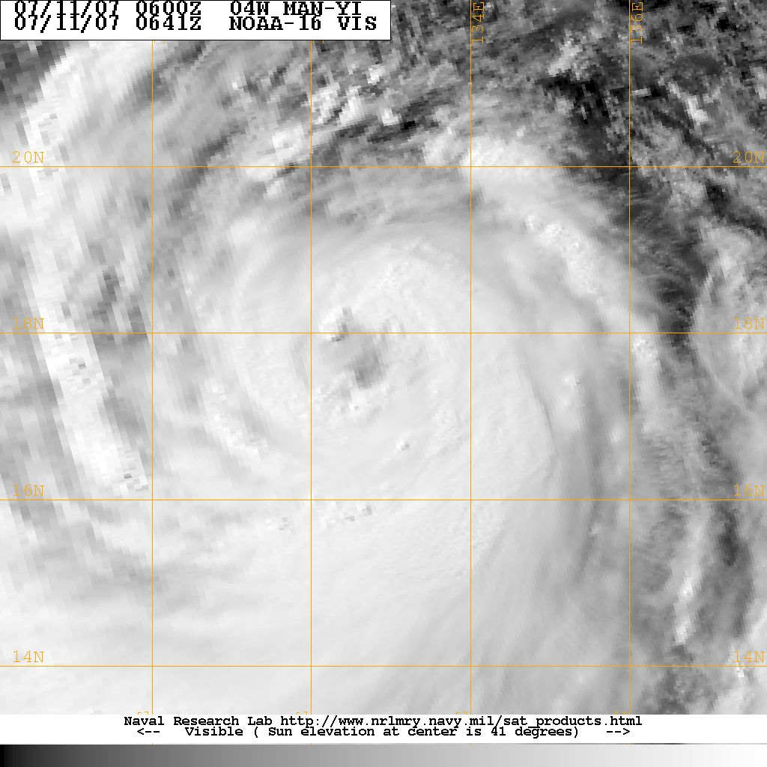
HRPT data are full resolution real-time image data transmitted to a ground station within line of site of the satellite. The spatial ground resolution at nadir is 1.1 km, expanding to more than 6 km at the edge of the 2800 km swath. There are HRPT receiving stations on Guam and Kadena, Japan operated by the Air Force (Mark IV-B) as well as a Navy (FMQ-17) system in Yokosuka, Japan. NRL/FNMOC will work to extract this data for processing and display on TCS-08 web resources with less than 30 minute data latency.

Figure 10.3: AVHRR GAC visible image for Typhoon Man-yi on July 11, 2007. Note the coarse spatial resolution and blockiness toward the left/west side of the image as the sensor reaches the edge of scan.
LAC is stored full resolution data (1.1 km) that is retransmitted during a command data acquisition (CDA) station overpass (high latitude receiving station). Very few LAC passes are programmed for the western pacific, since most requests cover the higher latitudes (sea ice mapping) and some areas for DOD customers.
GAC data is stored 4 km (nadir) full orbit digital data that is derived from a sample averaging of the full resolution HRPT AVHRR data. GAC data is routinely processed by the Naval Oceanographic Office (NAVO, Stennis Space Center, MS) to create multi-channel sea surface temperature (MCSST) that are used to create global and regional SST maps both as a separate product and merged with microwave SST values for an all-weather product that would benefit the TCS-08 mission. A GAC visible image example is shown in Fig. 10.3 from NOAA-16’s AVHRR.
These data are archived at the NOAA Comprehensive Large Array-data Stewardship System (CLASS) formerly known as the Satellite Active Archive. NRL will access all AVHRR data within the TCS-08 domain during the period July 15, 2008 till Oct 7, 2008 for near real-time utilization and work with NCAR EOL to appropriately store the data for catalog retrieval. Jpeg products will be the predominate vis/IR product, but digital data will be saved as well. In addition, the Mark IV-B at Anderson Air Force Base, Guam will be used to bring back near real-time AVHRR data for select cases since bandwidth is limited. For more information on the AVHRR sensor, please see the following link: http://www.oso.noaa.gov/poes/index.htm .

10.3.3 DMSP Operational Linescan Sensor (OLS)
There are currently five (5) operational DMSP satellites, named F-13, 14, 15, 16, and 17. The Operational Linescan System (OLS) includes vis/IR channels with a 3000 km swath, providing global coverage twice per day. The combination of day/night and dawn/dusk satellites allows monitoring of global information such as clouds every 6 hours. Some DMSP satellites occupy what is called a “terminator” orbit, meaning they come over just after “first light” and before “last light” and capture cloud imagery with very low sun angles. While not including full sunlight, these imagery data sets frequently highlight convective organization via the ability to clearly see overshooting cloud tops, since the low sun angle creates cloud shadows for those hot towers that can stand alone from the surrounding cirrus shield.
The OLS sensor has a visible telescope sensitive to radiation from 0.40 - 1.10 um (0.58 - 0.91 um FWHM) and 10-3 - 10-5 Watts per cm2 per steradian. The infrared telescope is sensitive to radiation from 10.0 - 13.4 um (10.3 - 12.9 um FWHM) and 190 to 310 Kelvins. The Photo Multiplier Tube (PMT) is sensitive to radiation from 0.47 - 0.95 um (0.51 - 0.86 um FWHM) at 10-5 - 10-9 Watts per cm2 per sterradian and is used for night time visible imagery. The OLS sensor is a cross track scanner with one very unique feature; it essentially speeds up as it looks away from nadir in order to keep a constant spatial sampling across the entire 3000 km swath (unlike the AVHRR, SeaWiFS and MODIS sensors).
OLS data is broadcast in real-time (like AVHRR HRPT) in a mode called Real Time Downlink (RTD) using the “fine” mode resolution. “Fine” data contains 7,325 pixels and 670 meter spatial resolution. The RTD data stream will be captured by the Air Force Mark IV-B and Navy FMQ-17 receiving systems. A limited amount of stored “fine” data is rebroadcast at high latitude CDA stations, but unlikely to cover the TCS-08 area.
The OLS sensor stores global reduced resolution data ( 2.8 km) onboard and are referred to as “smooth” data. Smooth data is downlinked at polar latitude CDAs and then rebroadcast to both FNMOC and AFWA. Data latency for smooth OLS data is 1-3 hours for western pacific data. Ascending orbits will have shorter data latencies since they will pass over northern latitude readout stations within 15-20 minutes of the western pacific, while descending orbits need to go around the southern hemisphere first, thus taking closer to 75-85 minutes to reach the readout stations.
OLS data is stored as 6-bit data, meaning 64 gray shades are available to characterize the cloud/ocean/land scene. This is 1960’s technology and the lack of adequate calibration means that automated algorithms to extract cloud properties are basically fruitless. The imagery is still excellent for qualitative applications, but the sensor does not share the AVHRR’s high calibration capabilities. Thus, OLS SSTs and cloud top temperatures are poor at best and the SSTs are even worse since there is only one IR channel available and two are needed to permit a moisture correction that can range from 0 to 4-5 degrees C. An example of OLS visible imagery is shown in Fig. 10.4 below.
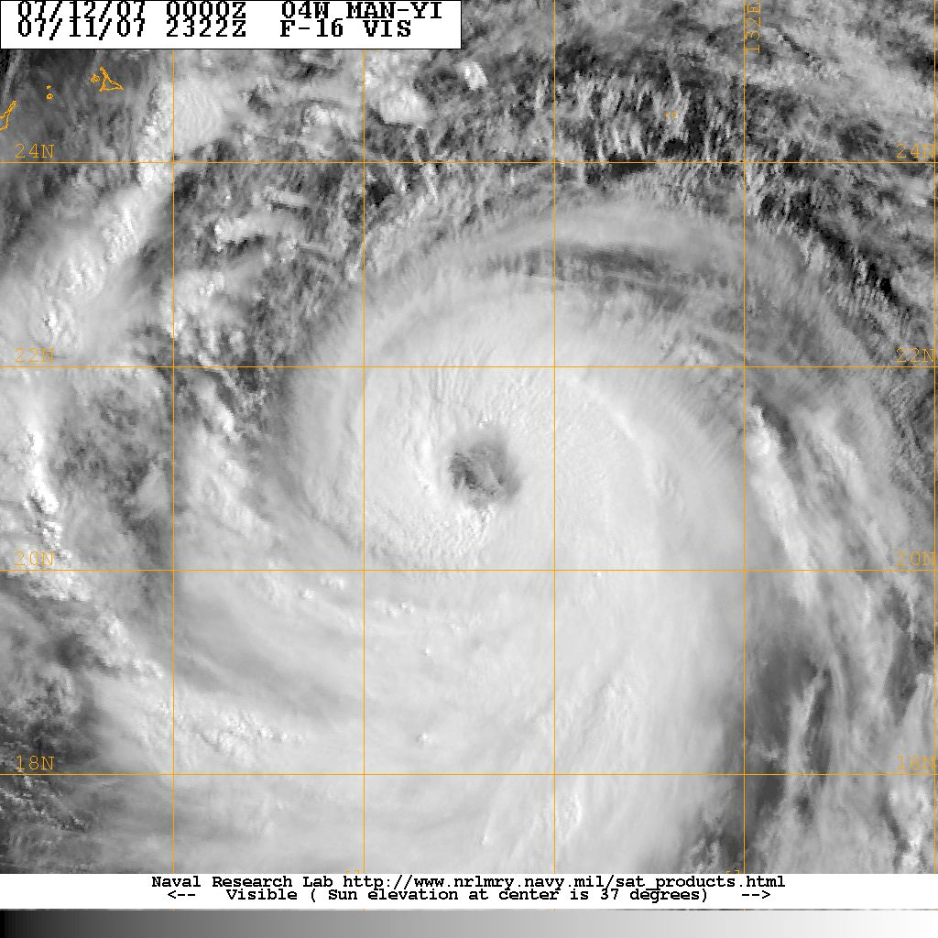

Figure 10.4: DMSP OLS visible image of typhoon Man-yi on July 11, 2007 at 2322 UTC from F-16. This is a sample of “smooth” visible data at 2.8 km resolution near nadir with excellent solar illumination. For more information on DMSP please see: http://dmsp.ngdc.noaa.gov/dmsp.html .

10.3.4 MODIS

The NASA MODIS (Moderate Resolution Imaging Spectroradiometer) sensor is a key instrument aboard the Terra (EOS AM) and Aqua (EOS PM) satellites. Terra's orbit is keyed to ascending overpasses at ~1030 local (0030 UTC Guam), while Aqua’s comes over 2.5 hours later at ~1300 local (0300 UTC Guam). Both MODIS sensors view the entire Earth's surface every 1 to 2 days, acquiring data in 36 spectral bands. Table 10.4 lists band characteristics for the MODIS instrument.
Table 10.4: MODIS Channel Characteristics
Band | Spatial Resolution | Bandwidth (μm) | Primary Use
1 | 250 m | .620-.670 | Land/Cloud/Aerosols Boundaries
2 | 250 m | .841-.876 | Land/Cloud/Aerosols Boundaries
3 | 500 m | .459-.479 | Land/Cloud/Aerosols Properties
4 | 500 m | .545-.565 | Land/Cloud/Aerosols Properties
5 | 500 m | 1.230-1.250 | Land/Cloud/Aerosols Properties
6 | 500 m | 1.628-1.652 | Land/Cloud/Aerosols Properties
7 | 500 m | 2.105-2.155 | Land/Cloud/Aerosols Properties
8 | 1 km | .405-.420 | Ocean Color/  Phytoplankton/  Biogeochemistry
9 | 1 km | .438-.448 | Ocean Color/  Phytoplankton/  Biogeochemistry
10 | 1 km | .483-.493 | Ocean Color/  Phytoplankton/  Biogeochemistry
11 | 1 km | .526-.536 | Ocean Color/  Phytoplankton/  Biogeochemistry
12 | 1 km | .546-.556 | Ocean Color/  Phytoplankton/  Biogeochemistry
13 | 1 km | .662-.672 | Ocean Color/  Phytoplankton/  Biogeochemistry
14 | 1 km | .673-.683 | Ocean Color/  Phytoplankton/  Biogeochemistry
15 | 1 km | .743-.753 | Ocean Color/  Phytoplankton/  Biogeochemistry
16 | 1 km | .862-.877 | Ocean Color/  Phytoplankton/  Biogeochemistry
17 | 1 km | .890-.920 | Atmospheric Water Vapor
18 | 1 km | .931-.941 | Atmospheric Water Vapor
19 | 1 km | .915-.965 | Atmospheric Water Vapor
20 | 1 km | 3.660-3.840 | Surface/ Cloud Temperature
21 | 1 km | 3.929-3.989 | Surface/ Cloud Temperature
22 | 1 km | 3.929-3.989 | Surface/ Cloud Temperature
23 | 1 km | 4.020-4.080 | Surface/ Cloud Temperature
24 | 1 km | 4.433-4.498 | Atmospheric Temperature
25 | 1 km | 4.482-4.549 | Atmospheric Temperature
26 | 1 km | 1.360-1.390 | Cirrus Clouds/ Water Vapor
27 | 1 km | 6.535-6.895 | Cirrus Clouds/ Water Vapor
28 | 1 km | 7.175-7.475 | Cirrus Clouds/ Water Vapor
29 | 1 km | 8.400-8.700 | Cloud Properties
30 | 1 km | 9.580-9.880 | Ozone
31 | 1 km | 10.780-11.280 | Surface & Cloud Temperature
32 | 1 km | 11.770-12.270 | Surface & Cloud Temperature
33 | 1 km | 13.185-13.485 | Cloud Top Altitude
34 | 1 km | 13.485-13.785 | Cloud Top Altitude
35 | 1 km | 13.785-14.085 | Cloud Top Altitude
36 | 1 km | 14.085-14.385 | Cloud Top Altitude
Table 10.4: List of MODIS spectral channels and generic applications.
MODIS has the benefit of viewing TCs with its 250 m visible channel, sometimes catching spectacular imagery of cloud-free eyes as illustrated in Fig. 10.5 for typhoon Man-yi. Eyewall mesovortices have been captured on multiple TCs, providing dramatic information for dynamical simulations/studies on inner core structure.
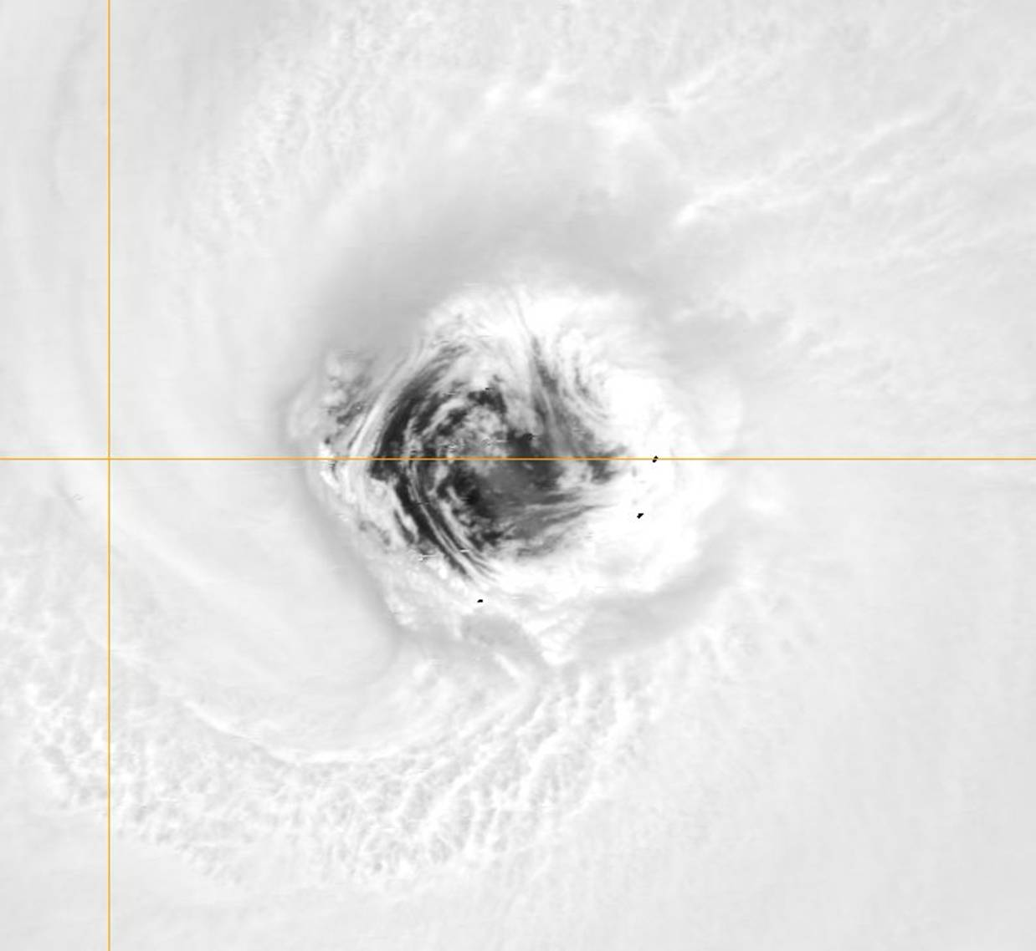
Figure 10.5: MODIS 250-m visible image of typhoon Man-yi on July 12, 2007 at 0503 UTC while the storm is ~ 120 kts. MODIS resolution can permit identification of meso-vortices inside cloud free eyewalls for some storms.
The Terra and Aqua MODIS orbits produce generic Guam overflight times as listed in Table 10.5. A range is provided since the MODIS swath is so large, that multiple overpasses could “image” a storm on any given day from an orbit considerably east or west of Guam.
Table 10.5: NASA EOS Satellites – Approximate Guam Crossing Times (UTC)
Satellite | Daytime Pass | Nighttime Pass
Terra 1030 Local | 0030-0200 | 1230-1400
Aqua 1330 Local | 1545-1730 | 0230-0415
Sunrise/Sunset | Aug 1: 2006/0848 | Oct 1: 2010/0811
Table 10.5: List of generic MODIS overpass times for the general Guam area (UTC).
NRL has access to near real-time 5-minute MODIS granules via the NOAA Near Real Time Processing Effort (NRTPE) and will provide MODIS imagery via the NRL TCS-08 web page and via archive in the NCAR EOL catalog. The NRTPE data latency ranges from 1-3 hours, again with ascending passes getting to NRL quicker due to the shorter times to CDA stations. Terra data can be quicker than Aqua since it uses the TDRSS communication relay satellite system. The jpeg products will be archived on the NRL TCS-08 web page and at EOL, and the digital data will be available via the NASA DAAC where an easy interface permits users to select and download desired data sets. NASA is rebuilding their NRTPE now and might be able to serve as a NOAA backup facility in time for TCS-08 field program. For more information on MODIS, please see: http://modis-atmos.gsfc.nasa.gov/ .

10.3.5 Sea-viewing Wide Field-of-View (SeaWiFS)
SeaWiFS is on the Orbview-2 (SeaStar) spacecraft in a sun synchronous orbit (705 km) with a local noon equatorial crossing time (thus in between the Terra and Aqua MODIS overpasses). A scanner tilt mechanism enables the instrument to be oriented in the along-track direction to +20, 0 -20 degrees to avoid sun glint from the sea surface. When the sensor is tilted to avoid sunglint, useless data will occur until the sensor is stable at the new look angle. Table 10.6 lists the SeaWiFS instrument channels. The LAC/HRPT swath width is 2801 km while the GAC data is smaller at 1502 km. The spatial resolution is 1.1 km for LAC/HRPT and 4.5 km for sub-sampled GAC.
SeaWiFS 1 km data is collected by a Navy FMQ-17 satellite receiving and processing site at Yokosuka, Japan and relayed to NAVO. NAVO retransmits the data to NRL, typically with a data latency of 90 minutes. LAC data are recorded on-board the satellite and downlinked several times per day and may be retrieved from the SeaWiFS data repository. NRL can investigate the particular data access issues if TCS-08 personnel are interested in gathering data other than the FMQ-17 available data sets (data coverage will NOT include the Guam area). SeaWiFS has undergone data issues over the past few months (Feb/March) and the sensor should be turned back on shortly. The SeaWiFS true color and visible imagery will be added to the TCS-08 web site in jpeg form and the digital data can be archived at NRL and/or EOL.

Table 10.6: SeaWiFS Instrument Bands
Channel | Wavelength (nm)
1 | 402-422
2 | 433-453
3 | 480-500
4 | 500-520
5 | 545-565
6 | 660-680
7 | 745-785
8 | 845-885
Table 10.6: Spectral channel characteristics for the SeaWiFS sensor.
It should be noted that access to global SeaWiFS data requires the user to register with NASA and provide some information on the research being done. This registration will authorize the user to obtain SeaWiFS data. For more information on SeaWiFS and the data sets, please see: http://seawifs.gsfc.nasa.gov/SEAWIFS.html .

10.3.6 Quick Scatterometer (QuikSCAT)
The SeaWinds instrument on the QuikSCAT satellite is one of the few active microwave radars that measure near-surface oceanic wind vectors (speed and direction). Wind vectors can be derived at multiple resolutions, with accuracy degrading as the resolution increases. Standard 50 and 25 km wind vectors are operationally available from NESDIS/FNMOC and 12.5 and 2.5 km products are experimental via NESDIS and Brigham Young University (BYU, Dr. Long). QuikSCAT operates at 13.4 GHz (Ku-band) and has a large 1,800-km swath compared to the 500 km ERS-1/2 scatterometers and the 1100 km MetOp Advanced Scatterometer (ASCAT) swath, making approximately 400,000 measurements and covering 90% of Earth's surface in one day.
NRL acquires operational QuikSCAT wind vectors from FNMOC/NOAA and adds these products to the TCS-08 web page with a data latency of 1-3 hours. An example of this imagery is shown in Fig. 10.5. The NRL TCS-08 web page will archive the jpeg QuikSCAT products, including: a) scatterometer vectors overlain in coincident vis/IR imagery, b) QuikSCAT wind vectors overlain on 85 GHz H-pol microwave imagery, c) QuikSCAT wind vectors overlain on the NRL 85 “color” product that enhances low level circulation centers, d) QuikSCAT ambiguities overlain on vis/IR imagery, and e) QuikSCAT ambiguities overlain on microwave imagery.
For more information on QuikSCAT, NOAA-NESDIS real-time products and the BYU high resolution 2.5 km wind vector data sets, please see:
http://winds.jpl.nasa.gov/missions/quikscat/index.cfm
http://manati.orbit.nesdis.noaa.gov/quikscat/
http://www.scp.byu.edu/data/Quikscat/HRStorms.html
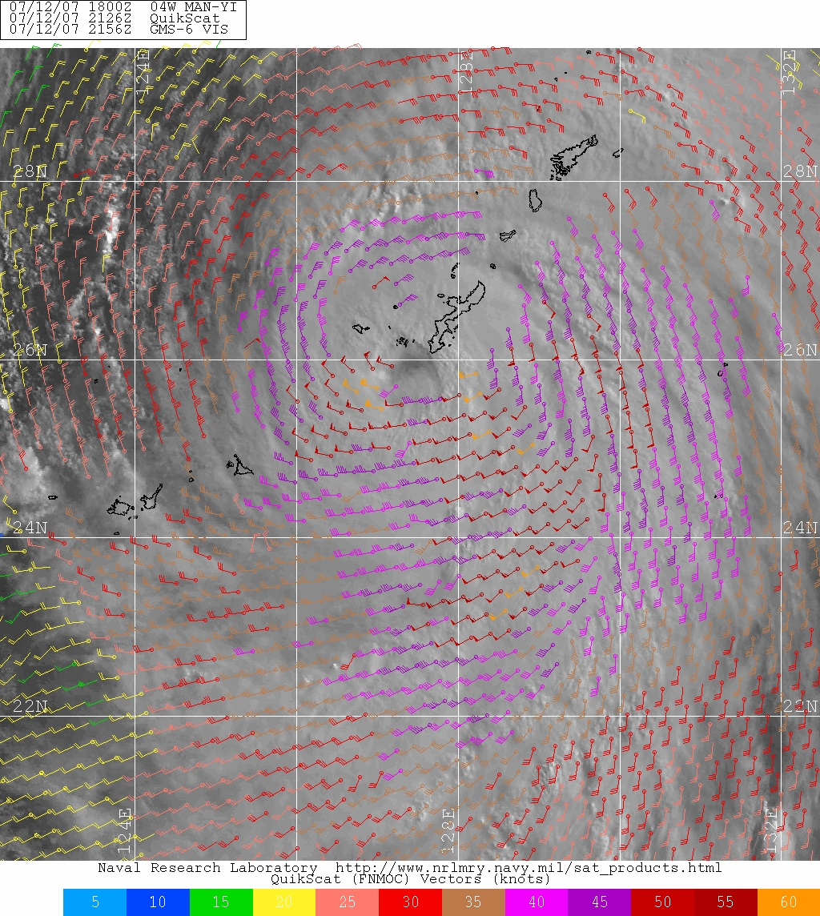
Fig 10.5. Example of 50-km resolution QuikSCAT ocean surface wind vectors overlain on MTSAT visible imagery for Typhoon Man-yi on July 12, 2007 near Okinawa.
The wind vectors are color coded by wind speed to assist the analyst in quickly noting areas of gale and 50 kt winds. Wind vectors flagged for possible rain contamination are denoted with a circle at the tail of the stick or wind barb. Current versions of the retrieval algorithm actually do well in rain conditions, unless viewing at the edge of swath where only one polarization is available. Rain flagged data in genesis cases (<35 knots) will be problematic and need to be treated with caution.
The MetOp ASCAT sensor has a unique swath configuration, with twin 550 km swaths to each side of nadir, separated by a 672 km “hole” or area of no wind retrievals as depicted in Fig. 10.6 below. A NRL TC web page example highlighting one 550 km swath over TC Kamba in the southern hemisphere is shown in the right hand panel of Fig. 10.6 Routine 50 km oceanic surface wind vectors are being produced now, but 25 km winds are available in an experimental mode. The near real-time digital data set is provided via collaborative agreements with EUMETSAT and NOAA.
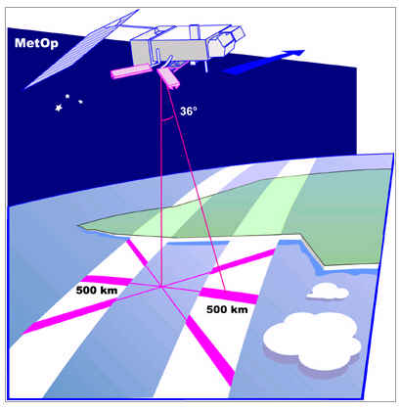
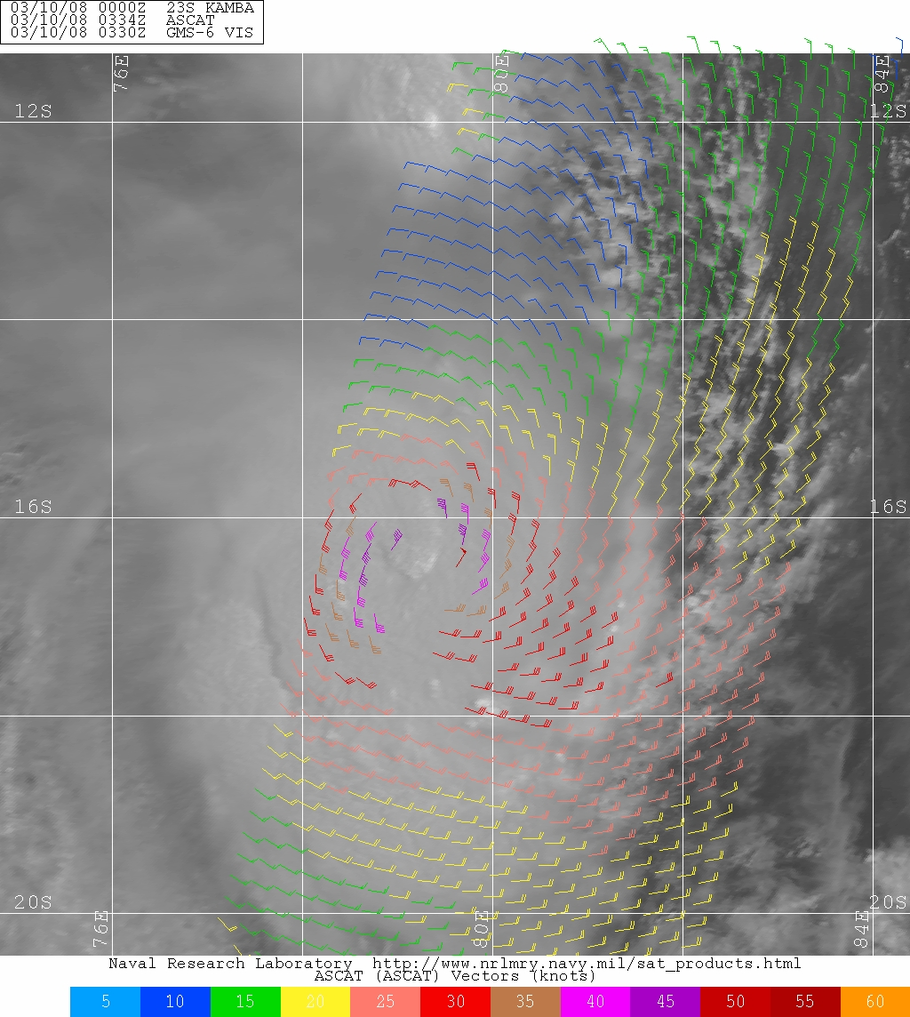
Figure 10.6 Schematic of the ASCAT twin 550 km swaths with the 672 km non-retrieval zone in the middle (left panel) and an example of ASCAT winds for TC Kamba on March 10, 2008 at 0334 UTC. Wind vectors are color coded by wind speed.

10.4 Passive Microwave Imager/Sounder Data

10.4.1 Microwave Imagers/Applications Overview
Passive microwave digital imagery and products have proven to significantly aid the global tropical cyclone (TC) reconnaissance effort as demonstrated by the TC web pages developed by NRL’s Marine Meteorology Division and now operational at FNMOC. These storm-centered, medium-resolution brightness temperature (T_{B}) images display evolving storm rainband and eyewall structure that is critical in monitoring TC location, structure and intensity that is not always evident in coincident vis/IR imagery. Upper-level clouds often obscure vital mid and low-level cloud signatures within vis/IR images. This masking is a serious drawback because vis/IR imagery provides the bulk of the TC position and intensity information available to forecasters everywhere. Subjective Dvorak and automated Dvorak technique (ADT) intensity estimates are created for TCs in formative stages, but IR data frequently misses early eyewall structural details due to clouds aloft, while microwave imagers can. Efforts are underway to provide microwave eyewall information to coincident ADT to mitigate this inherent problem.
The ice-scattering channels on most microwave imagers (85-91 GHz) are particularly adept at isolating TC rainband and eyewall structure. These channels react to intense convection by viewing dramatically lowered equivalent blackbody brightness temperatures (T_{B}) caused by scattering from precipitation-size ice hydrometeors (Spencer et. 1989). Fortunately, cirrus canopies, which may cover very large non-raining areas, contain small ice crystals and do not produce signatures at these frequencies. Figure 10.7 (lower left panel) depicts one 85 GHz horizontal polarization (H-pol) example and reveals the magnitude of the T_{B} differential between rainbands and the rest of the TC environment. Note the scale covers a range from 180-280 deg K, with rain and heavy rain typically being represented by T_{B} values well below 240 K. Satellite analysts can quickly learn how to observe the convective rainband structure of each TC to more precisely locate the storm and infer important intensity information and thus create higher fidelity preliminary best track and warning estimates (Hawkins, et al., 2001).
Figure 10.7 illustrates a classic case where clouds hide the true TC low-level center that can often be identified within microwave imagery products. As TC Mindulle is in its formative stages, cloud organization can be confusing, especially when limited to coarser resolution IR (4-km) nighttime imagery. Both the regular IR and Dvorak IR enhancements appear to indicate organization west of the imager center with clouds swirling in to an “apparent” storm center (easier to view in animation). However, coincident SSM/I 85 GHz and NRL 85 GHz “color” products readily reveal the low-level circulation or true storm center is ~ three (3) degrees or 180 km to the east-southeast.
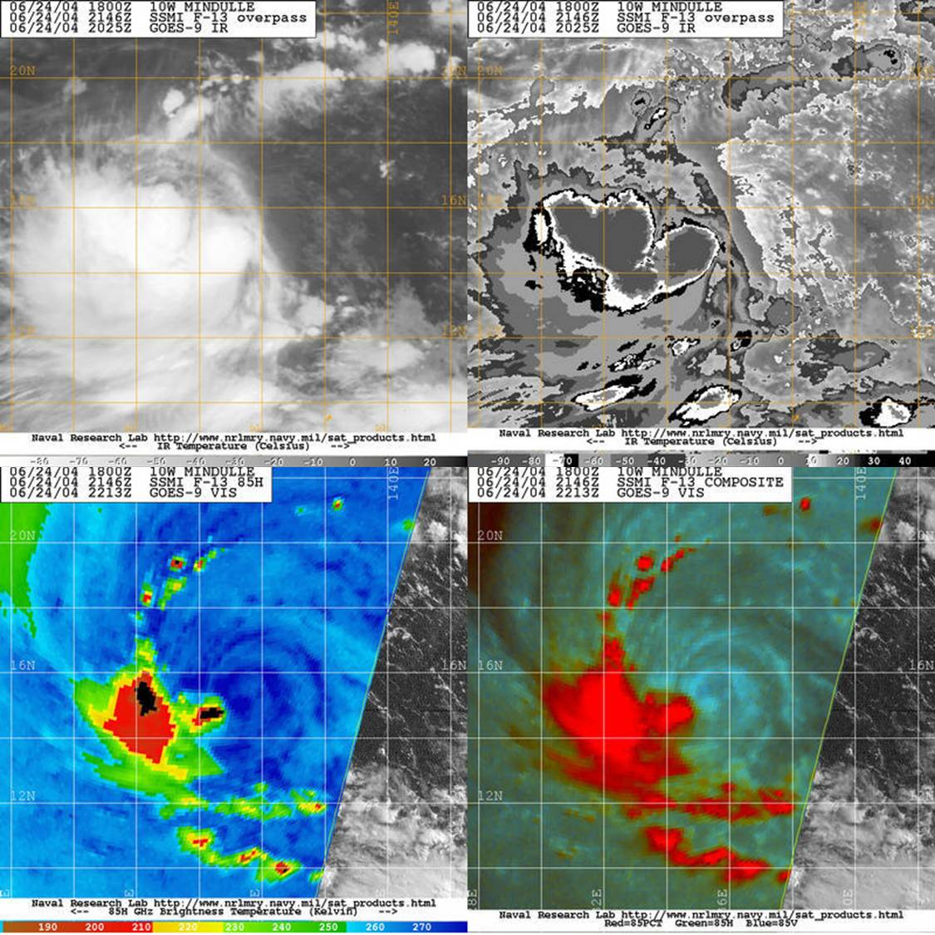
Figure 10.7: IR and Dvorak IR imagery for typhoon Mindulle on June 24, 2004 at 2025 UTC in the western pacific (top panel) compared with SSM/I microwave products (85 GHz, lower-left) and 85 GHz “color” product (lower-right) from the NRL TC web page.
Away from deep convection, emission from shallow clouds, warm rain (no ice processes), and significant low-level water vapor will cause 85 GHz T_{B} to increase against a radiometrically cold ocean background. Passive microwave signatures at 85 GHz often represent a combination of emission and scattering effects. However, on 85 GHz images, it is usually possible to distinguish deep convection (depressed T_{B}) from the combined effects of water clouds, water vapor, and warm rain (all elevated T_{B}). Precipitation-sized particles induce scattering to a lesser degree at the other microwave frequencies, but these signatures are more difficult to detect on images. At the lower frequencies the emission signatures dominate over the scattering signatures such that all precipitation generally appears as “warm” against a “cold” ocean background.
Interpretation of 85 GHz imagery (either polarization) suffers from one major ambiguity. In regions just beyond the influence of TCs, water vapor, cloud water, and convection are diminished. The low-emissivity sea surface, seen through these relatively transparent atmospheres, is associated with relatively low T_{B}. Thus, on images, this sea surface can be mistaken as “cold” convection and vice versa. To correct for possible misinterpretations, we compute a polarization corrected temperature (PCT) based on the horizontal and vertical polarizations of 85-91 GHz (Spencer et al. 1989). The PCT is an excellent indicator of convective precipitation and correlates well with lightning flashes over land (Mohr et al. 1996). On PCT images, T_{B} lower than ~ 255 K indicate precipitation. The PCT corrects T_{B} over problematic regions of low moisture to represent the relatively high temperatures of the near-surface atmosphere. Thus, the PCT allows a way to distinguish between deep convection and adjacent convection-free regions.
Unfortunately, compared to raw 85 GHz images (V and H); the PCT image has its own limitation: it nearly eliminates the contrast between low-level vapor/clouds/rain and the adjacent cloud-free ocean. To combine the best aspects of the PCT and uncorrected 85 GHz images, we derive a “color-blended” image (Figure 10.7 uses Table 10.7). The effect of the PCT is to make convective precipitation appear red on this image. The two uncorrected 85 GHz channels combine to make low-level cloud water appear as blue-green. Cloud-free regions become gray or black over the ocean. These images show precipitation above the freezing level as red and low-level phenomena (water clouds, water vapor and light rain) as blue-green. Precipitating convection (red) and the sea surfaces (black or gray) can now be distinguished from one another. This technique is similar to the “false-color” images of tropical convection produced by Negri et al. 1989, who included 85 GHz (V and H) and 37 GHz (V) in a three-color combination.

Channel | 85 GHz (V) Blue | 85 GHz (H) Green | 85 GHz PCT
Range (T_{B} K) | 270 – 290 | 240 – 300 | 220 – 310
Tonality | Positive | Positive | Inverse
Table 10.7: Scaling for the 85-91 GHz NRL “color” combination product.
The 85 GHz “color” product highlights cloud liquid water (CLW) and thus details the low-level cloud lines that make up the low-level circulation spiraling into the storm center. The color product is great in helping detect shear and often reveals reduced convection within storm quadrants or semi-circles in advance of other wind shear products such as those created using a combination of geostationary winds and NWP output. Shear can be subtle, but when convection signals are so “stark” in microwave T_{B} values, reduced convective signatures are a tell-tale sign shear is ongoing. In Fig. 10.7, NE shear has completely removed strong convection from the NE semi-circle, exposing the low-level circulation. All active convection with high cloud tops and frozen hydrometeors are downwind of these strong shear conditions.

10.4.2 Microwave Satellite Data Sets
The DMSP spacecraft carry the current suite of “operational” microwave imagers in the form of the Special Sensor Microwave/Imager (SSM/I) and the more recent Special Sensor Microwave Imager Sounder (SSMIS). As noted in Table 10.8, both these sensors contain an ice scattering channel (85 GHz and 91 GHz respectively). Thus, they can highlight rainbands and eyewalls relatively easily, but have important frequency differences. The channel change to 91 GHz on SSMIS causes decreased or lower T_{B}s in TC inner cores since the scattering due to heavy amounts of frozen hydrometeors is stronger at 91 than at 85 GHz. Hawkins and Turk, 2008 illustrate how this T_{B} depression can range from 2-8 deg C for inner core conditions.
Modest temporal sampling is afforded by the medium size SSM/I swath (1400-km) and slightly large swath SSMIS (1700-km) due to the fact there are currently three (3) SSMIs (F-13, 14 and 15) and two (2) SSMIS (F-16 and 17) flying. F-18 will be launched in the summer of 2008 but will NOT be available for TPARC utilization. Table 10.8 indicates that 85-91 GHz footprints are in the 12 km range and thus able to sample most TC features, but these sensors can NOT monitor smaller eyewall structures associated with compact and/or small intense systems or western pacific midgets. Some eyewall cycles can not be adequately monitored via these sensors alone. Additional SSM/I info:
http://www.ncdc.noaa.gov/oa/rsad/ssmi/ssmi.html

Channel  SENSOR | 6-7 GHz | 10-11  GHz | 18-19  GHz | 22-24  GHz | 36-37  GHz | 85-91  GHz | 150 GHz | Swath  km
SSM/I |  |  | 56 | 50 | 33 | 12 |  | 1400
SSMIS |  |  | 55 | 55 | 35 | 12 | 13 | 1700
TMI |  | 50 | 24 | 20 | 12 | 5 |  | 800
AMSR-E | 50 | 50 | 25 | 25 | 15 | 5 |  | 1600
WindSat | 55 | 40 | 20 | 13 | 11 |  |  | 1025
AMSU-B |  |  |  |  |  | 16* | 16* | 2300

Table 10.8: Intercomparison of microwave image and sounder spatial footprint sizes and swaths for the current constellation of sensors. Note the disparity between the R&D sensors (TMI, AMSR-E and WindSat) and the operational sensor suite (SSM/I, SSMIS). AMSU-B is a sounder with inherently poorer resolutions and the values noted are for nadir only, values near the edge of scan can reach 26x50 km.
DMSP satellites are sun synchronous, thereby imaging the same earth location at the same local time of day (with some drift, thus what is observed one year will be different the next year). There are significant gaps between successive passes, especially in the tropics, limiting storm detection to, at most, twice during a 24-hour period per satellite. Since the DMSP satellites were purposely launched into morning/evening orbits, there is never any coverage during the middle of the day and middle of the night.
Table 10.9 lists the local time of the ascending node (LTAN, satellite orbit terminology to help quickly comprehend the generic orbit and time each sensor will view the same spot on earth each day). The times are in local (not UTC) time, thus each of the DMSP spacecraft will be ascending northward across the equator in the afternoon or early evening time (example: F-13 will ascend at 1830 or 6:30 PM local time). The LTAN values are “grouped” on purpose, with F-13, 14 and 15 representing one orbital plane in the 1715-1830 slot and F-15/16 in the 1930-2000 slot. In other words, these two groupings of sensors will follow one another relatively closely in time, though their specific swath coverage will be different. Table 10.9 helps understand the temporal sampling the SSMI and SSMIS data will provide, no matter where a TC is within the overall TCS-08 or TPARC domain.

 | WindSat | AMSRE | TMI | F-13 | F-14 | F-15 | F-16 | F-17
LTAN | 1759 | 1330 | Varies | 1830 | 1715 | 1930 | 2000 | 1730

Table 10.9: List of the local time of ascending nodes [LTAN, local time the satellite will ascend across the equator on a path to the North Pole] for the five DMSP spacecraft, Coriolis WindSat, Aqua AMSR-E and the TRMM TMI.

DMSP measurements have been problematic for intense small systems whose eyewall diameters are less than 15-20 km and when trying to determine if concentric eyewalls have completed formation. Adequate spatial resolution is a key aspect and the relatively small 1.5’ SSM/I & SSMIS antenna has inherent limitations. These antenna restraints are not associated with the three research-grade microwave imagers currently available.
The Tropical Rainfall Measuring Mission (TRMM) microwave imager (TMI) has three times better ice scattering channel imagery due to a combination of its 400 km orbit (versus 850 km for DMSP) satellites and its antenna size. Thus, TMI 85 GHz imagery has 6 km resolution across its 800 km swath (Lee, et al, 2002). This resolution is needed to resolve small TC eyewalls as depicted in Figure 10.8 below for hurricane Dean in 2007. The TMI 85 GHz image (left panel) clearly resolves the main features of an inner and outer eyewall for this average to small size storm. The clear details even at the edge of scan illustrate the fact conical scanners maintain their footprint across the entire scan. The AMSU-B (middle panel) is near the edge of scan and has problems with basically all aspects of storm structure (inner eyewall is ambiguous and would not be effectively noted without corresponding evidence) and the larger outer eyewall is “fuzzy”. This is not the case with the modest resolution SSM/I image (right panel) that can monitor both the intense convection surrounding the inner eyewall as well as the impressive secondary eyewall that is nearly compete in addition to other rainbands to the NW. Note that TRMM is in a 35 deg tropical inclination and thus frequently samples TCs in the 28-38 deg N belt and thus makes up in part for its relatively small swath with frequent sampling for some storms. Users should also remember that TRMM is NOT sun-synchronous, thus it does not come over at the same time each day for a given region, it changes in order to sample the diurnal precipitation cycle and not be aliased for the long term averages and climate related studies needed for its primary mission. More TRMM info:
http://trmm.gsfc.nasa.gov/overview_dir/tmi.html
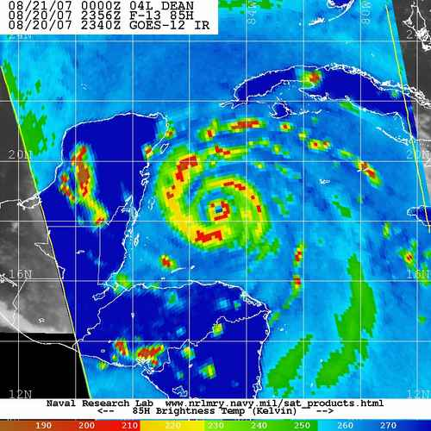
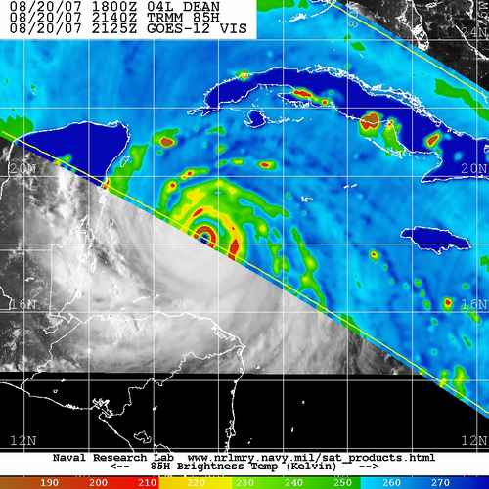
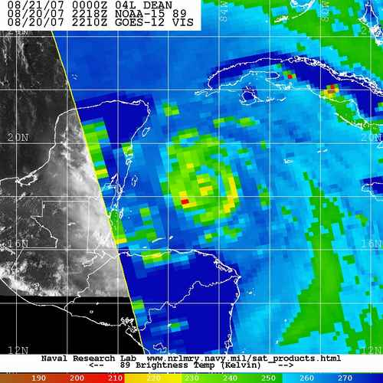
Figure 10.8: Example of ice scattering channels from TMI, AMSU-B and SSM/I for hurricane Dean on August 20, 2007 at 2140, 2218, and 2356 UTC respectively. All three images have the same scale and projection, with two degree latitude and longitude lines in white (courtesy NRL TC web page).
TMI data is complimented by the more recent Advanced Microwave Scanning Radiometer (AMSR-E) launched onboard the NASA EOS Aqua platform in May 2002 that combines a “huge” 1800 km swath with TMI-like spatial resolution as noted in Table 10.8. This research sensor has been a major boon to TC monitoring due to its resolution and swath attributes and the fact it has a sea surface temperature (SST) capability in addition to an ice scattering channel (89 GHz), 37 GHz and the ability to produce rainrate, total precipitable water and ocean surface wind speeds. When all factors are combined, the AMSR-E is the best microwave imager for TC monitoring within the constellation. More info: http://aqua.nasa.gov/about/instrument_amsr.php
The Coriolis WindSat instrument was launched in January 2003 and operates in five discrete frequency bands with the 10.7, 18.7, and 37.0 GHz channels being fully polarimetric, while the 6.8 and 23.8 GHz channels are vertical and horizontal polarizations only (Gaiser, et al, 2004). WindSat’s antenna is similar in size to AMSR-E, but lacks the ice scattering channel at 85-91 GHz. WindSat’s excellent resolution at 37 GHz is a major plus as is its capability to derive rainrate, SST, total precipitable water, and cloud liquid water. WindSat’s 1025 km swath is a limiting factor and will be enlarged to 1700-km in the follow on Microwave Imager Sounder (MIS) on NPOESS C2.

10.4.3 Mapping Inner-Core Structure for Intense Tropical Cyclones
Tropical cyclones (TCs) reaching a maximum sustained wind speed greater than or equal to 120 kts often form double or concentric eyewalls as revealed by passive microwave imagery (WMO, 2006a, b, OFCM, 2006, Hawkins, et al, 2006, Velden et al, 2006). These intense TCs can create a single eyewall followed by the formation of a secondary eyewall at a larger radii. The outer eyewall usually constricts the inflow of moisture, mass and momentum into the inner eyewall and the inner eye weakens and/or dies completely. The outer eyewall then becomes the primary eyewall and begins to shrink in size while the storm regains strength. This process can continue several times if environmental conditions are favorable. Mapping this eyewall replacement cycle (ERC) is vital to understanding inner storm dynamics, short-term intensity trends, modeling simulations and upgrading land falling warnings.

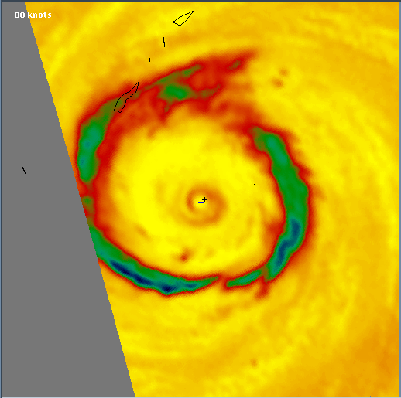
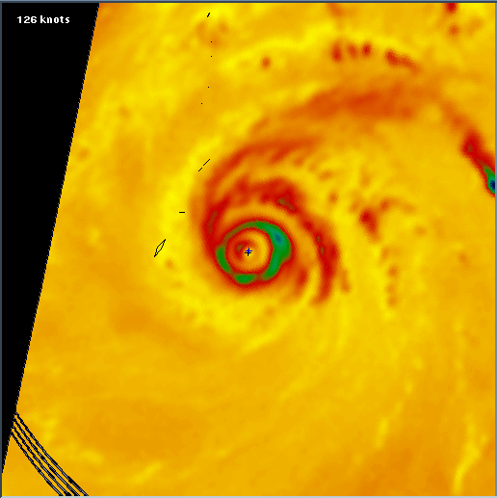
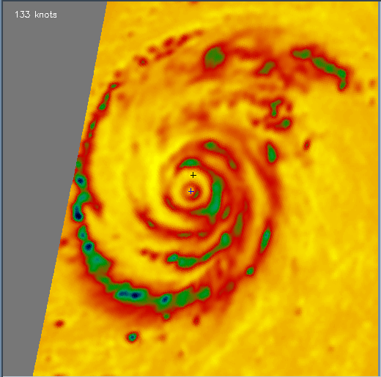
Figure 10.9: 85 GHz T_{B} imagery for three TCs exhibiting double eyewall structure in 1997. Typhoon Winnie (left), typhoon Paka (middle) and typhoon Rosie (right) each have unique size and structure characteristics as noted in these 1024x1024 km images.
1024 Km
TCs come in all shapes and sizes and this is also true for cases with double eyewalls. Figure 10.9 displays three TCs, each with very distinct attributes that would impact aircraft flight patterns. Typhoon Winnie (far left) has a very weak and small inner eye and a main eyewall with a diameter of ~ 500 km! This would present quite the dilemma to the NPS ops center. Typhoon Paka (center panel) was a very small intense system whose inner eye is barely captured here while just east of Guam. Rosie (right panel) not only has two eyewalls, but is working hard on a third one, which has been verified before via eastern pacific aircraft radar.
TCS-08 has one focus on genesis and another on storm structure. Figure 10.10 depicts how microwave imagery and its ability to discern precipitation and cloud liquid water organization will help monitor each “invest” or beginning stage system. Typhoon Man-yi in 2001 was sampled by SSM/I alone 15 times from late on 1 Aug to mid day 6 Aug. Convective cluster organization is weak in the first three frames, but undergoes a significant upgrade late on 2 Aug as evidenced by the 2234 UTC example. Clear circulation features are in place in all quadrants, hard convection is present near the apparent center, and active banding has formed at a large radii. Within 10 hours, consolidation has occurred, the band has wrapped and contracted significantly and additional convection is near the center. A single small intense eyewall occurs at 0753 UTC on 4 Aug, while it is quickly encircled by an outer eyewall later on the 4th and the inner one slowly decays by the end of 5 Aug such that a single larger diameter eyewall results. Note the scales here are 512x512 km for aircraft pattern consideration.

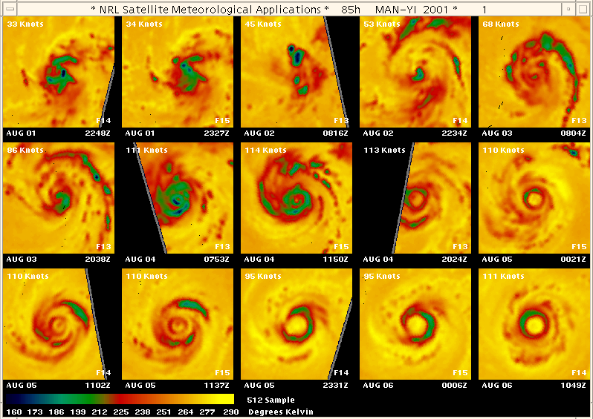
Figure 10.10: SSM/I 85 GHz H-pol T_{B} readily depict inner storm structure evolution for typhoon Man-yi in 2001. Each image covers 512x512 km per side and are false colored according to the scale in the bottom left. Note that cold convective areas are green/blue in this rendition and ambient conditions are yellow.

10.4.4 Microwave Sounder Data Sets
Microwave sounder data on the NOAA series of polar orbiters has served multiple functions in the TC monitoring effort; 1) create T_{B} imagery using sounder channels that are similar in frequency to microwave imager channels, 2) utilize temperature sounding capabilities to extract TC intensity estimates, and 3) produce rainfall estimates with multi-channel retrievals.
The Advanced Microwave Sounding Unit (AMSU) sensor has been a mainstay on the NOAA operational spacecraft and has channels sensitive to both temperature (AMSU-A1/A2) and moisture (AMSU-B). Since the AMSU-B sensor has an 89 GHz channel, NRL and FNMOC have used this poor resolution cousin to the imager version at 85-91 GHz to create “images” of TC rainbands and to a lesser degree eyewalls. Although AMSU-B has a nominal resolution of 16-km at nadir, the value at the edge of scan is 60-km. Thus, the cross track scanner can resolve TC features to varying degrees depending on where in the scan the TC falls.
Figure 10.11 highlights the inherent benefits and weaknesses of AMSU-B TC imagery. The left panel views hurricane Katrina on the left side of the ascending scan which results in blockiness due to the coarse resolution, but the storm is large enough that AMSU-B data is helpful in understanding rainband and even eyewall structure. The right panel AMSU-B overpass is closer to the swath center and shows storm evolution, with decreasing strong convection on the west side as dry air and shear impact this storm. The TMI data in the middle panel clearly depicts an intense single eyewall storm with a very strong secondary band nearing completion to form a concentric eyewall.
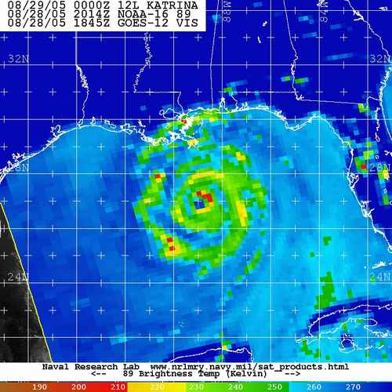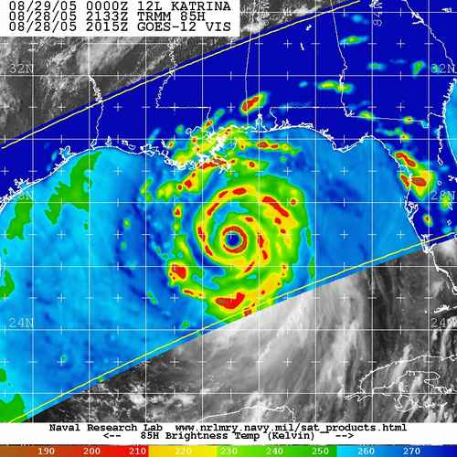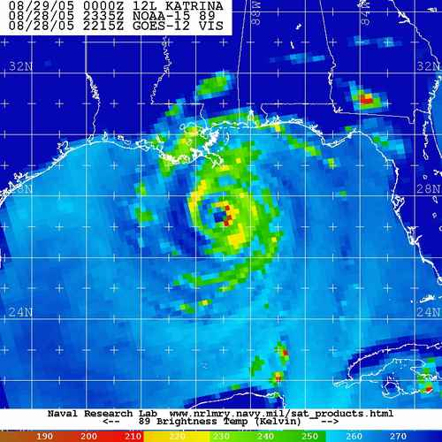
Figure 10.11: Intercomparison of 89 GHz H-pol T_{B} “images” from AMSU-B for hurricane Katrina (left and right most panels) on August 28th within several hours of one another that sandwich a TRMM TMI 85 GHz H-pol image (center panel).
Use of microwave sounder data to estimate TC intensity via the so called “warm core anomaly” method has been around since the 1980s. However, the old microwave sounding unit (MSU) was severely limited by its poor spatial resolution. The AMSU-A temperature sounder has mitigated many of these issues and is now used to demonstrate in near real-time TC intensity retrievals with accuracies approaching RMS errors of 12 MB when validated against Atlantic-based recon measurements.

 | N-15 | N-16 | N-17 | N-18 | MetOp-1
LTAN | 1706 | 1635 | 2158 | 1336 | 1730
Table 10.10: Listing of the local times of ascending nodes (LTAN) for the NOAA polar orbiters that contain functioning AMSU-A/B and/or AVHRR sensors. Note that EUMETSAT’s MetOp-1 spacecraft has been enlisted by NOAA via a “joint” international effort with our European partners and this will extend well past 2020 and through the NPOESS era. MetOp occupies the primary AM (morning orbit) while N-18 is the primary PM (evening orbit) spacecraft. NOAA-17 AMSU is non-functioning (red).

10.4.5 Microwave Sounder Intensity Estimates

The concept of estimating TC structure, intensity, and intensity change using polar-orbiting satellite passive microwave sounder observations spans over three decades. NOAA series microwave sounder data have been used to map a TC’s warm core and via hydrostatic approximations, related to storm intensity. Radiation sensed by oxygen emission in the 55 GHz region is used to derive upper-tropospheric temperatures in the storm core. Several factors including coarse spatial resolution and the ever-changing position of the storm within the instrument observation swath between successive observations limited the success of early attempts.

Within the last decade, progress has been made in understanding, treating, and reducing the undesirable effects of instrument-related warm core sampling limitations. This progress has been partially due to advanced microwave sounding instrumentation on the most recent NOAA satellites, starting with NOAA-15’s inclusion of the Advanced Microwave Sounding Unit (AMSU-A). The AMSU-A instrument is a cross-track scanning microwave sounder containing 15 channels with frequencies ranging from 23.8 – 89 GHz. Resolution varies from 48-km at nadir to ~ 100-km near the limb. The primary channels used for tropical cyclone monitoring are the ~55 GHz oxygen band channels 5-8 and the moisture channels 1-4 (AMSU-A) and 16 (AMSU-B).

The qualitative relationship between the strength and vertical distribution of the AMSU-A observed warm core and TC intensity is well illustrated by a time series of NOAA-15 AMSU-A observations of Hurricane Floyd from September 8-16, 1999 and near-coincident aircraft reconnaissance sea-level pressure estimates (Figure 10.12). Floyd’s sea-level pressures are at their minimum values (<930 hPa) during periods when the warm core is well defined - particularly when upper-tropospheric temperature anomalies are at their maximum values.

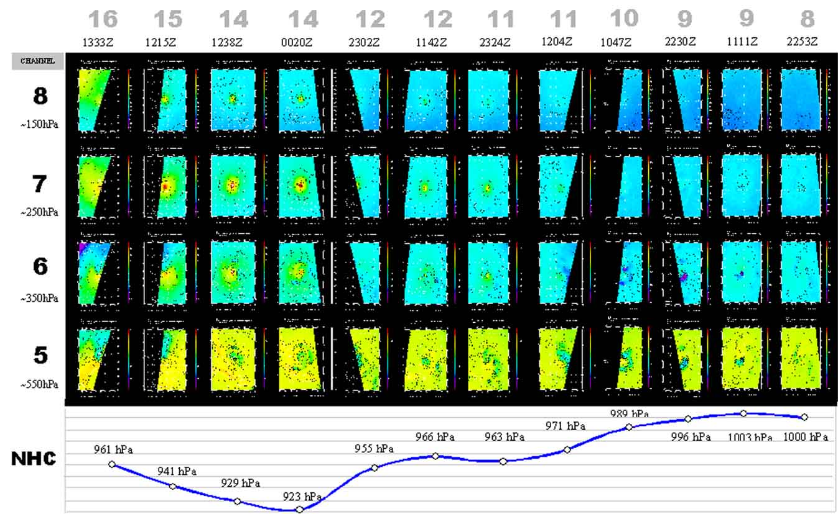

Figure 10.12: Image-time matrix of AMSU channels 5-8 over a period 8-16 September, 1999 during Atlantic hurricane Floyd. The coincident recon MSLP trace is indicated at the bottom. Floyd’s strongest warm core temperature anomalies are illustrated by the yellow/red signatures in channels 6-8 late in the period.

Recent attempts at quantifying this relationship have led to intensity estimation algorithms that have become competitive with the IR-based Dvorak Technique. These techniques rely on the magnitude of the AMSU-A observed warm core (Figure 10.13). Scientists at the Cooperative Institute for Research in the Atmosphere (CIRA) have developed an algorithm that utilizes the retrieved vertical temperature structure from the multispectral AMSU-A radiances, that are then combined with a number of additional AMSU-A based predictors to derive MSLP and maximum sustained wind (MSW) estimates (Demuth, et al 2006). A retrieval algorithm is used to determine the temperature as a function of pressure from the AMSU radiances. The hydrostatic equation is then integrated downward from 50 hPa (mb) to the surface using an upper-level boundary condition provided from a numerical model analysis. Prior to the hydrostatic integration, an empirical correction is applied to the temperature profiles to adjust for attenuation of the AMSU-A radiances by liquid water and scattering by ice. Once the height field is determined as a function of pressure, the wind field is calculated assuming gradient balance. The height field is azimuthally averaged relative to the storm center. The AMSU-A data does not have adequate resolution to fully sample the inner core structure of intense TCs. To help correct this problem, a statistical algorithm has been developed to estimate the maximum winds and the radii of 34, 50, and 64 kt winds from properties of the AMSU-A analyses. The inputs are analysis properties such as surface pressure drop from 600 km to the storm center, the maximum retrieved gradient wind, and the average cloud liquid water near the storm center. The output is an estimate of the observed maximum wind and wind radii. [Demuth et al., 2006].

Another algorithm developed at the CIMSS uses the raw AMSU radiance anomalies along with corrective measures for AMSU footprint size and offsets to estimate MSLP (Velden, et al, 1989). Limb corrections are applied to the AMSU data to compensate for decreasing T_{B}s as viewing angle increases from nadir. Eye size is used as a proxy for the warm core dimension, and is derived by the ADT algorithm for “clear eye” cases, or from the radius of maximum winds estimated by operational forecast centers in other cases. An initial estimate of MSLP is performed using the raw Tb anomaly. If the eye size is small compared to the AMSU FOV then a bias correction is subtracted. The T_{B} signal can also change slightly from one estimate to the next as a function of storm position within the scan swath. To account for this effect, a second regression predictor (distance in FOV steps from nadir) was added. The end result is a slight intensity increase for cases near the swath edge and a slight decrease for those cases near nadir. Hydrometeor contamination problems decrease effective Tbs, requiring a correction using AMSU-A channels 2 and 15. A two-channel difference can determine if Tbs are being depressed due to hydrometeor scattering. A correction is then applied to the raw Tbs resulting in a new set of regression coefficients (Wacker et al, 2004). Improved performance was validated and transitioned for real-time use in 2003 (Herndon, 2004).

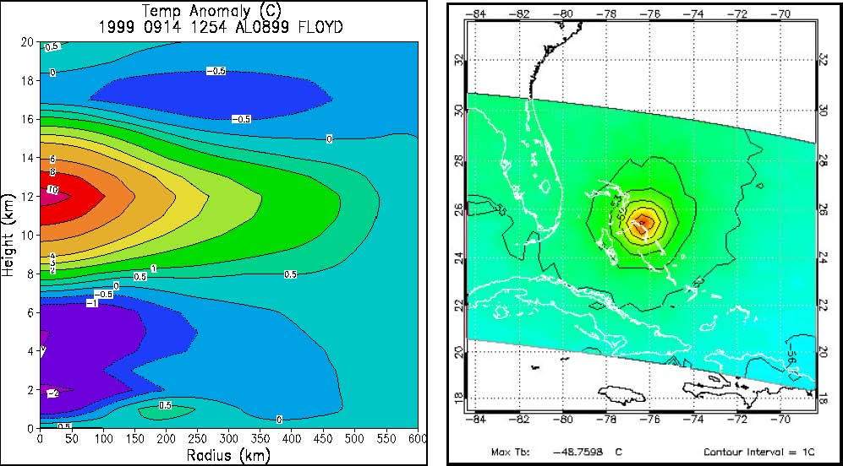

Figure 10.13. Representation of AMSU-A retrieved vertical temperature anomaly from CIRA (left) and horizontal raw Tb anomaly for channel 8 (~150 hPa) from CIMSS (right) for Hurricane Floyd on September 14, 1999.

10.4.6 CloudSat Cloud Radar
CloudSat is a NASA Earth System Pathfinder mission that utilizes a millimeter-wavelength cloud radar with the goal of advancing our understanding of cloud abundance, distribution, structure and radiative properties. CloudSat’s radar is 1000 times more sensitive than existing weather radars and enables CloudSat to detect the small particles of cloud liquid water (CLW) and ice within clouds that can NOT be seen by ground-based radars. Thus, CloudSat’s 4 GHz (3 mm) nadir-viewing radar (2.5x1.4 km spot) and it’s 500 m resolution (interpolated to 240 m) provides us with a 1st ever capability to map the 3-D profile of CLW and ice and compliments the heavy to mid- range precipitation sensing better accomplished by the TRMM precipitation radar.
CloudSat is a “free flyer” (single sensor payload) that was purposely placed in the “A”-train orbit that includes nearly coincident measurements by the EOS Aqua spacecraft (MODIS and AMSR-E), the Cloud-Aerosol Lidar and Infrared Pathfinder Satellite Observations (CALIPSO) lidar, Aura and Parasol. CloudSat’s unique wavelength’s enable it to monitor a wide variety of cloud systems, whether they be high thin cirrus, low level stratus, and/or deep convective clouds. The measured backscatter signal is a function of the cloud particle number, concentration, size and shape of the cloud droplets and is sensitive to the temperature and phase. This dependence permits us to extract basic cloud microphysical properties after extensive processing and use of auxiliary data.
CloudSat overpasses for all active TCs and “invests” covered by the NRL TCS-08 web page are acquired and processed in near real-time (1-6 hours) whenever the sensor comes within 1000 km of a TC. Vertical cross sections of radar reflectivity are created at NRL via extensive post processing and a graphic is created that includes the CloudSat overpass on top of coincident GEO, MODIS vis/IR imagery, and AMSR-E 89 GHz T_{B} (Mitrescu et al, 2008). Figure 10.14 illustrates the wealth of detail CloudSat can provide for tropical cyclone Ileana during 2006. CloudSat effectively maps the cloud top/base, areal extent, light and moderate rain, freezing level and hot tower locations and rain free zones as the eyewall is transected. Note the high vertical resolving capabilities for cloud extent and ability to map the “hot” towers usually reserved for the TRMM PR as well as the detailed information depicting “rain-free” regions between the rainbands and in the eye itself. In addition, structural details highlighting the leaning of eyewalls with height and mapping the extensive cirrus cloud shields is simply not available in any vis/IR data set. This data set will compliment the cloud microphysical information derived with the NRL P-3 Eldora Doppler radar and any NEXRAD data gathered via Guam’s NWS radar.

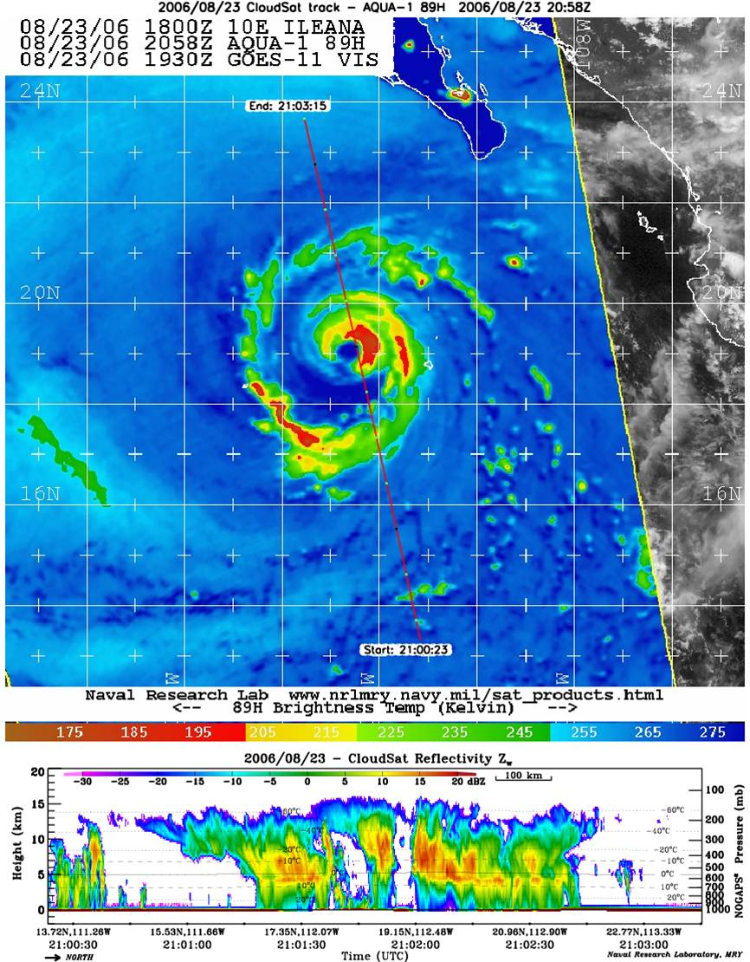
Figure 10.14: CloudSat cloud radar reflectivity vertical cross section (altitude scale 0-20 km) for transect through hurricane Ileana in the eastern pacific on Aug. 23, 2006 at 2058 UTC. CloudSat ground track is overlain on coincident AMSR-E 89 GHz T_{B} image. The radar overpass goes from south to north and intersects both the rainbands and eyewalls

10.4.7 Altimeter Sea Surface Height (SSH)
Spaceborne altimeters have been used for several decades to accurately measure global oceanic sea level heights. The altimeter measures the range between the satellite and the ocean surface and knowledge of the satellite height above the reference ellipsoid provides a value for sea level height. Accurate knowledge of the earth’s geoid then provides the ability to compute the sea surface height (SSH) values needed to monitor mesoscale oceanic currents and eddies that can impact TC intensity. One method to mitigate geoid errors is to view sea level changes or deviations from a mean created by flying the altimeter in an exact repeat mission where the orbit is constrained to repeat within 1 km of the predefined ground track (Jacobs, 2006).

Satellite | Launch | Ionosphere Correction | Water Vapor Correction | Orbit Inclination & Altitude | Repeat Period (Days) | Ground Track Separation (km)
TOPEX Poseidon | Aug 92 | Dual freq radiometer | Radiometer | 66 ⁰ 1,335 km | 9.95 | 315
ERS-2 | Aug 95 | Model | Radiometer | 98⁰ 780 km | 35 | 80
GFO | Nov 99 | Model | Radiometer | 108⁰ 785 km | 17.05 | 164
JASON-1 | Jan 02 | Dual freq altimeter | Radiometer | 66⁰ 1335 km | 9.95 | 315
ENVISAT | Feb 02 | Dual freq altimeter | Radiometer | 98⁰ 780 km | 35 | 80
Table 10.11: Current slate of satellite altimeters providing near real-time data for at least portions of the globe (GFO is only providing daytime data and ERS-2 is only available in the north Atlantic and portions of the NE Pacific ocean). Table follows that provided by Jacobs, 2006.
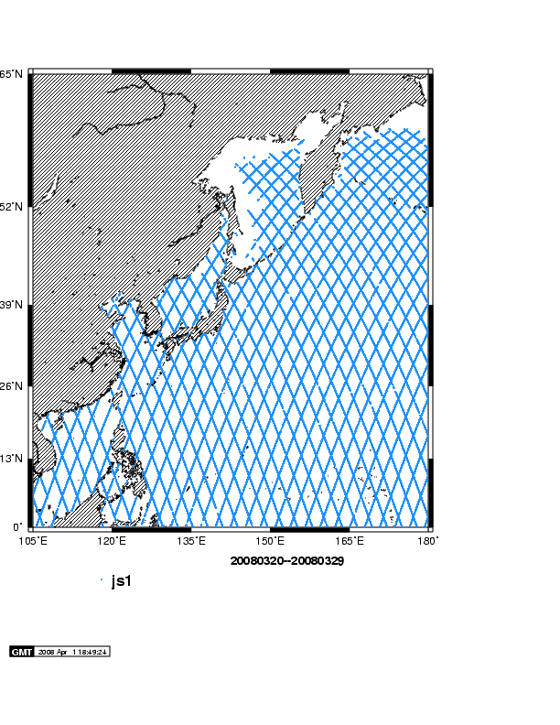
While exact repeat missions help remove geoid issues, selecting the length of time over which the ground track exactly repeats directly determines the spacing between adjacent orbits and thus the ability to map ocean features. If mesoscale features are a primary interest, then orbits similar to the SeaSat, GEOSAT and GEOSAT Follow On (GFO) are desired (17 days as shown in Table 10.11) where a balance between revisit time and track separation (164 km) is carefully weighed prior to launch. TOPEX and JASON-1 are in relatively short repeat track orbits (9.95) with large track separations (315 km) and high altitudes (1335 km) in order to minimize orbital drag and mitigate tidal aliasing for climatic record applications. However, the 315 km track separation will likely miss many ocean features that GFO’s 164 km would otherwise capture. Examples of the GFO and JASON-1 exact repeat mission ground tracks are mapped in Fig. 10.15 and clearly reveal the substantial enlargement in ground track separation experienced by JASON-1.
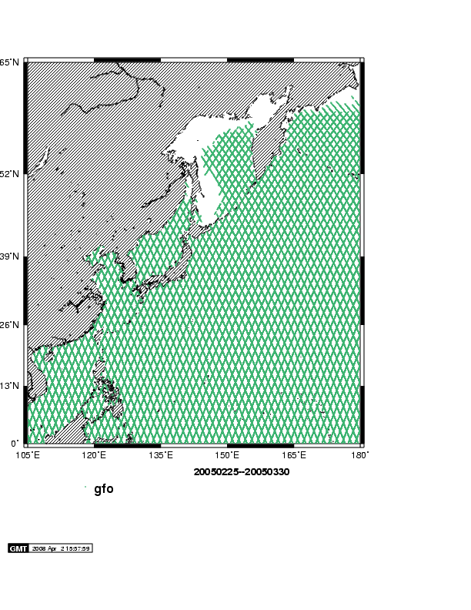
Figure 10.15: Repeat track patterns for GFO (17.05 day repeat) and Jason-1 (9.95 day repeat) in the TPARC/TCS-08 domain for the end of March (provided by Doug May, NAVO) readily illustrates the different mesoscale mapping capabilities.
Shay et al. (2000) and more recently Mainelli-Huber (2000) have shown that oceanic heat content variations are linked to TC intensity change and in some cases rapid intensification. The approach is to use sea surface topography from the multiple altimeters denoted in Table 10.11 that encompass multiple spatial and temporal sampling scales. When cast within a two-layer reduced ocean model, the depth of the 26ºC isotherm can be estimated from these objectively analyzed and mapped SSH anomaly fields. Using monthly, seasonal or annual climatologies, the integrated thermal structure or oceanic heat content can be estimated from that depth to the surface where the sea surface temperature is used as the surface boundary conditions. This approach provides locations of warm and cold features in front of the projected track of tropical cyclones as discussed in Shay (2008). The uncertainties in these estimations are within 10 to 15% of in situ measurements from buoys, floats and expendables (Shay and Brewster 2008).
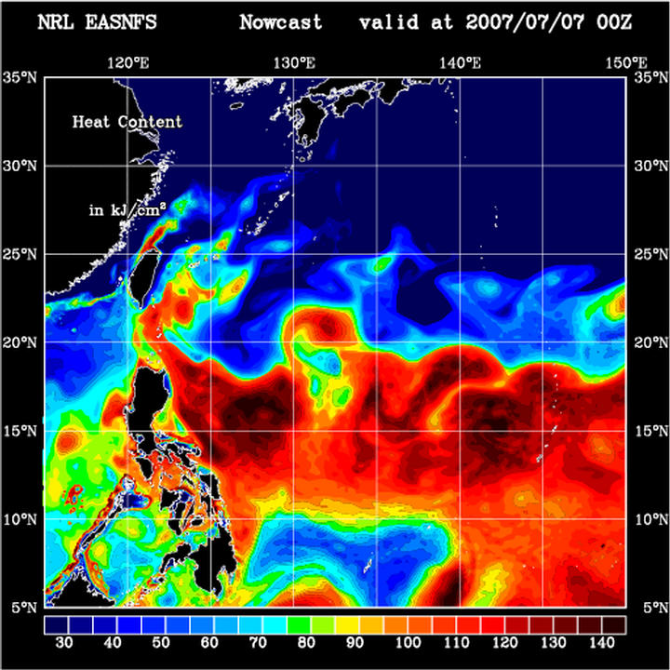
Near real-time SSH maps now exist to monitor mesoscale ocean front and eddy activity such as Fig. 10.16 provided courtesy of NRL-SSC (Ko) for typhoon Man-yi on July 7, 2007 (large OHC values are denoted in orange/brown, while low values are in blue). Warm currents and eddies can provide a deep source of heat content (OHC) that can not readily be stripped away by TC surface winds. Instead, the ocean then becomes a constant source of warm moist air that drives the TC heat engine as the air rises, condenses and releases the latent heat of condensation, fueling TC intensification. On the flip side, weak areas of OHC or cold regions can act in a negative manner and cause TCs to weaken and/or not intensify as they might otherwise do when traversing over high OHC waters. TCS-08 will utilize the NRL-SSC near real-time OHC product in order to monitor TC position relative to OHC and will also preview altimeter ground tracks in order to drop AXBTs along track segments as TC position, altimeter track location and mesoscale activity permit.

Figure 10.16: OHC map on July 7, 2007 for a western pacific domain during typhoon Man-yi provided by NRL-SSC (Ko). Data set assimilates multiple altimeter SSH measurements into an ocean model nowcast product.

10.5 Tailored Web Page Product Suite

10.5.1 Naval Research Laboratory (NRL-MRY:
NRL has demonstrated the use of web technology to remove one of the main obstacles in using PMW for TC reconnaissance by providing efficient, broad distribution of near real time, storm-centered, PMW imagery products. It utilizes precise storm locations from the NRL-developed Automated Tropical Cyclone Forecast (ATCF) system (Sampson and Schrader, 1997) to position all satellite products. The web page:
http://www.nrlmry.navy.mil/TC.html
can be accessed from any computer with Internet access and a frames-capable browser. Users are presented with a graphical user interface (GUI) that permits them to select the storm of interest and view a suite of passive microwave and vis/IR products that are all collocated for each PMW satellite overpass that covers a storm (referred to as a “hit”). Background processing algorithms automatically update the web page with new products as they come online. The web page also includes the latest TC warning messages (from JTWC for all west pacific storms) and official track forecasts that enable the user to visually see the most recent storm motion, size and short-term forecast.
The NRL TC web page contains a full suite of microwave imagery (ice scattering channel, 37 GHz, PCT, “color”) as well as derived products (rainrate, ocean surface wind speed, and total precipitable water) and coincident vis/IR imagery for all “active” systems. In addition, the TC page includes all geostationary and polar orbiter vis/IR/WV imagery, including DMSP OLS night time visible data. Ocean surface wind vectors from the QuikSCAT, ASCAT, WindSat and some ERS-2 scatterometer sensors are available in overlay form to permit the user to extract gale force wind radii estimates and storm size.
NRL has transitioned the R&D version of the TC web page to 24/7 operations at FNMOC. This page requires users to be DoD personnel or login in under a .gov or .edu domain name and obtain a certificate before access is permitted:
https://portal.fnmoc.navy.mil/tcweb/cgi-bin/tc_home.cgi

FNMOC also maintains a public web page that is open to ALL users, but it is not supported 24/7, thus there is the potential for down time during the weekends:
https://www.fnmoc.navy.mil/tcweb/cgi-bin/tc_home.cgi

The FNMOC TC page contains the vast majority of the NRL TC page products and is constantly being updated. Please note it currently does not have the CloudSat vertical cross sections, the ASCAT ocean surface wind vectors, nor the ability to overlay the QuikSCAT wind vectors or ambiguities on top of coincident microwave imager data sets. FNMOC’s 24/7 uptime is superb due to their operational status and commitment. The FNMOC TC page is sometimes slower to respond than NRL due to server hardware issues. Data products typically appear on both pages near the same time, but in theory, they should be on FNMOC’s site first since they provide the bulk of the GEO and microwave data and thus have first crack at processing the digital data sets. The FNMOC GUI is slightly different due to operational software configuration constraints.
The TCS-07 dry run exercised the NRL TC web page link to the NPS operations center via near real-time modifications to start and stop “invests” and thus provide products for specific TCS areas of disturbed weather. NPS personnel controlled which cloud clusters were monitored via the full NRL TC web page product suite by sending a short message to NRL. The new lat/lon information and invest ID (062.TCS062) would tell the NRL processing system how to automatically handle a “new” area, move an existing system or remove an active invest from monitoring. Over 100 “invests” were handled during the four months NPS actively exercised the NRL TCS web page.
Figure 10.16 shows a real-time TCS-07 dry run version on the TC web page with two active NPS invest areas (062 and 063). The product buttons (green, yellow, red) are for system 062, indicating many recent data sets (green means data latency is six hours old, yellow- data from 6-12 hours old, and red – data > 12 hours old) in addition to the latest 1-km geostationary visible imagery in the bottom left. The data latency color coding applies to “all” NRL TC web products. The user selects the desired “storm” in the left panel and then clicks on the “button” representing the product they wish to display in the main panel. A thumbnail jpeg will be displayed and the user can click on it again to get the full resolution version for enhanced detail. If the user wishes to stay in the “full resolution” or large jpeg viewing mode, they can click “full” in the upper left line of buttons to make this their default mode, otherwise “thumb” will keep them in the small jpeg mode.
NRL TC web page users can quickly ascertain the most recent good microwave passes by clicking on pass_mosaic option in the top middle row. This function will then display the most recent 24 hours of microwave overpasses (85-91 GHz default) and display them in chronological order and color code the images (green, yellow, red) to aid the user in identifying the most recent data sets. In addition, each green, yellow, and red row is further stratified by placing those passes with excellent coverage and spatial resolution (TMI, AMSR-E, and WindSat) first or to the left. The user can then click on any of these thumbnail versions to view a larger display. This web page will be accessible to all TPARC participants with web browser functionality, both on the ground and in the air.

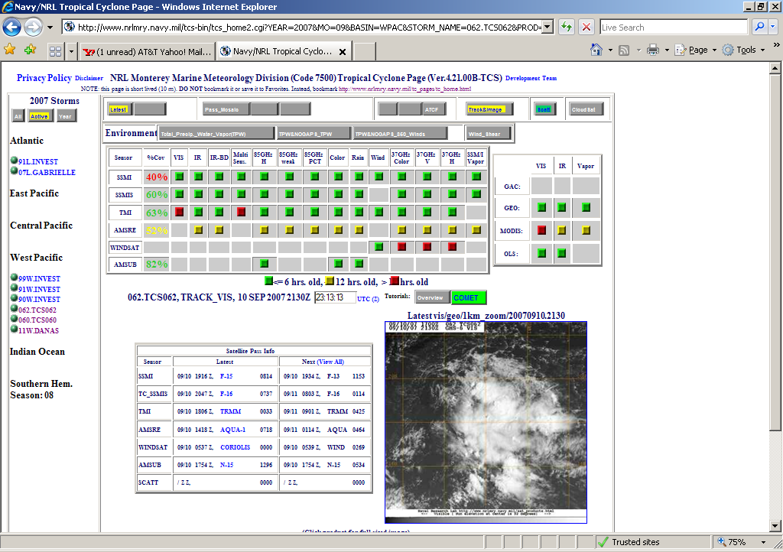
Figure 10.16: Sample NRL TC page display during hurricane Wilma, illustrating the active storms in the left frame, the suite of microwave products associated with each of sensors (SSM/I, SSMIS, TMI, AMSR-E, WindSat, and AMSU-B). Vis/IR products are gathered in the top right, the ATCF graphic is in the bottom left and the most recent vis/IR image is in the bottom right panel.

10.5.2 CIMSS near real-time satellite product web sites for TPARC
There are two sites that forecasters and TPARC planners can use for specialized satellite products derived and displayed by CIMSS. The general Tropical Cyclone page (Fig. 10.17) has recently been updated and includes both regional product displays, and an interactive storm window that a user can manipulate. This site is found at:
http://cimss.ssec.wisc.edu/tropic2/
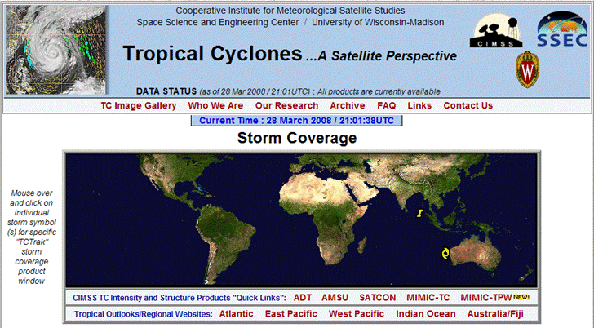
Active storms and invests will be displayed as icons on the global map. The user can click on these icons to activate the interactive window for a system of interest. The window product suite includes a wide array of TC-relevant data and analyses that can be overlain on various options of satellite imagery and/or derived analyses.

Figure 10.17: CIMSS TC web page with symbols for active “invests” (I, in Bay of Bengal) and TC symbol (NW of Australia) to highlight ongoing tropical areas being watched by JTWC.
Users can also view larger scale imagery and products via the web interface displayed in Fig. 10.18 below which covers each TC basin with overlapping sides. A suite of imagery, diagnostic products and overlays permit the user to interrogate the environmental conditions encompassing each TC.
The other site has been developed just for the TPARC experiment. It is still being constructed, but will focus on the TPARC WestPac domain. The special product of interest at this site will be the high-resolution MTSAT cloud-drift wind products. Both the routine hourly datasets, as well as the special rapid scan winds (if JMA makes the imagery available to us) will be on display at this site. We will include analyses derived from these data as well. The site will be found at:
http://cimss.ssec.wisc.edu/tropic/tparc/
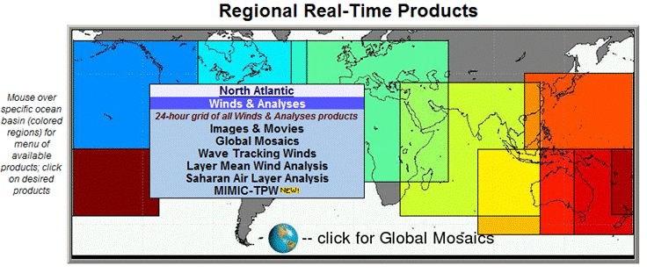
Figure 10.18: CIMSS TC web page that includes diagnostic products such as geostationary winds, convergence/divergence, wind shear, shear tendency and the MIMIC total precipitable water animated imagery.
The general CIMSS TC web site keeps real time analyses for 24 hours. The TPARC site will contain an on-line archive of all days during the TPARC field campaign. The images/data/products will be downloadable as gifs/tiffs. ASCII files of the MTSAT winds will also be available for download.

10.6 Overpass schedules for selected satellites
During the field campaign, NRL will provide overpass times and satellite coverage maps each day for passes of interest from the suite of vis/IR imagers (NOAA AVHRR, Terra, Aqua, SeaWiFS, DMSP OLS) and the constellation of microwave imagers, sounders and radars) via the NRL TCS-08 web page. Information containing the time each overpass will be at its “closest point of approach” (CPA) to the storm or invest will be displayed in a pop-up menu as shown in Table 10.12 below.

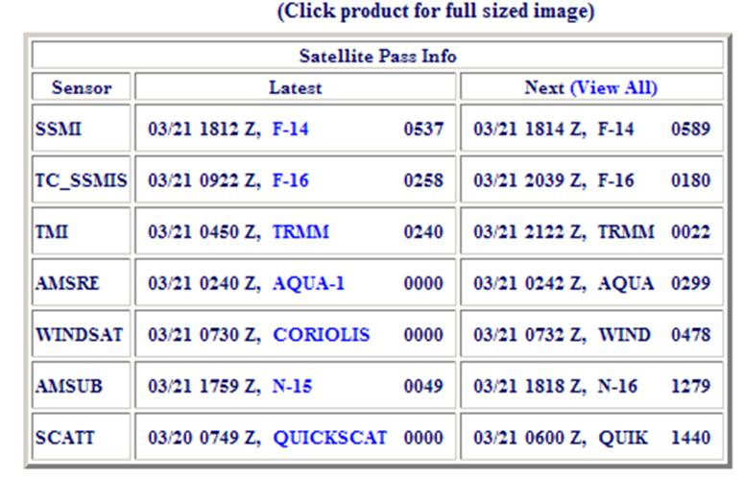
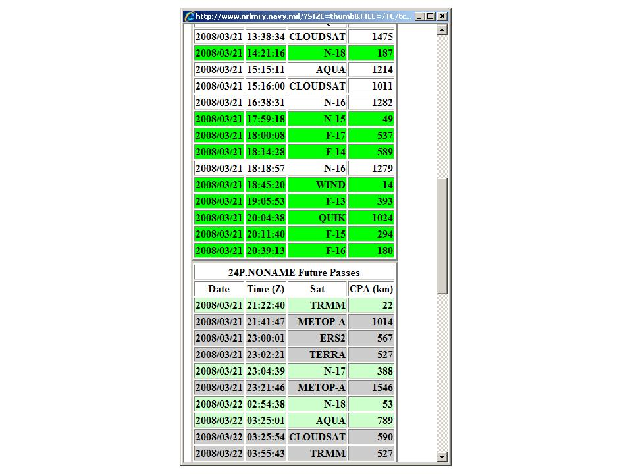
Table 10.12: Example of NRL TC web table highlighting a list of the most recent microwave sensor overpasses using date, time (UTC) and satellite sensor name, along with the CPA values in km. The “next” overpass for each sensor suite is listed on the right side of the table. In addition, the user can click “View All” in the upper-right and see an expanded table showing the passes for the past 24 and future 24 hours. The table entries are color coded, highlighting the good passes in green. The color coding takes into account both the sensor swath as well as the CPA values, thus an AMSU-B swath with 2300-km view can tolerate a larger CPA value than a 800-km TMI overpass.

Table 10.13: Listing of microwave imager, sounder and radar overpasses for storm 24P as noted on the NRL TC web page. Pop-up window lists all passes in the previous and future 24 hours, noting the date, time, sensor and CPA values. Good passes are annotated with green shading to quickly alert the user to high value data sets. The CPA calculation does NOT yet use the storm forecast motion, only the current location.
In addition, a pop-up graphic illustrating the lay down of the swath on a graphical map will enable the user to visualize each sensor’s potential to capture the storm/invest under study. An example of these coverage maps is shown below in Fig. 10.19.

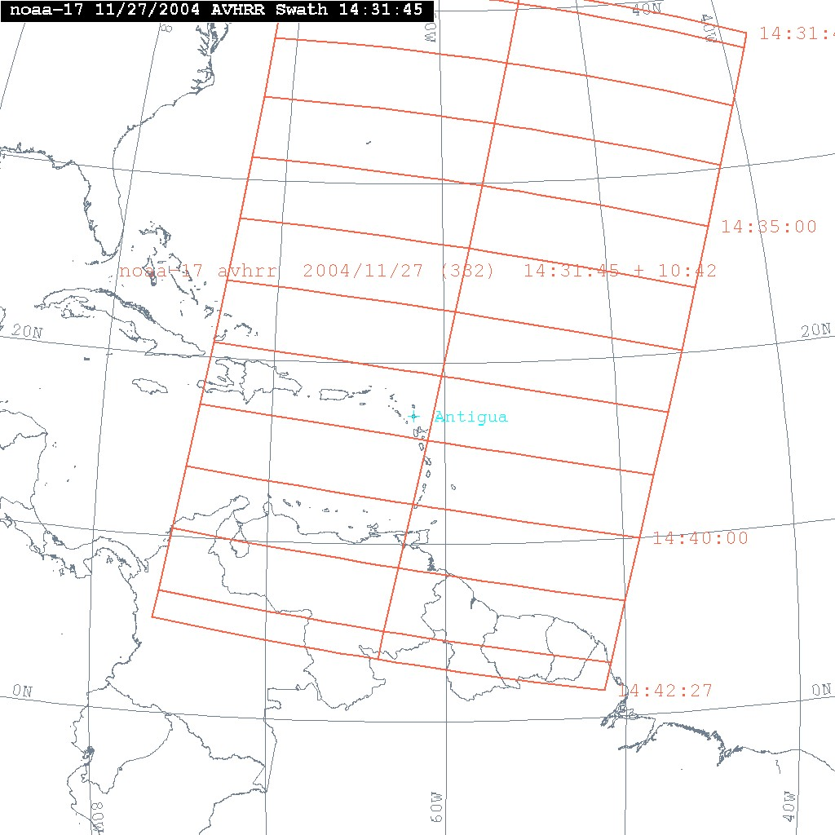
Fig. 10.19. Example swath coverage of AVHRR instrument aboard NOAA-17. Will adapt for TCS-08 and change graphic.

10.7 Browse products for field campaign
NRL will provide jpeg browse products for selected satellites and instruments based on near real-time availability. The products will be in jpeg image format and provided typically via the NRL TCS-08 web page, as demonstrated via the 2007 dry run. A list of satellite browse products NRL expects to provide are listed in Table 10.14.

Table 10.14 Satellite Browse Products provided by NRL to the EOL catalog (Near real-time)
Instrument | Channel/ Product | Spatial Resolution | Temporal Resolution | File Format
MTSAT | 1 | 1 km | 30 min | jpeg
MTSAT | 3,4 | 4 km | 30 min | jpeg
MTSAT | Cloud Drift Winds | Low-level  Upper-level | 6 hourly | tiff
MODIS | 1,2 | 250 m | ~ 2/day | jpeg
MODIS | True color composite | 500 m | ~ 2/day | jpeg
MODIS | Infrared | 1 km | ~ 2/day | jpeg
AVHRR | Vis/IR | 1 km HRPT Mark IV-B | ~ 2/day per satellite | jpeg
AVHRR | Vis/IR | 4 km GAC | ~ 2/day per satellite | jpeg
OLS | Vis/IR Nighttime Vis | 700 m Mark IV-B | ~ 2/day per satellite | jpeg
OLS | Vis/IR Nighttime Vis | 2.8 km Smooth | ~ 2/day per satellite | jpeg
QuikSCAT | Surface Wind Vectors | 12 & 25 km | 0-2/day | jpeg & ascii
ASCAT | Surface Wind Vectors | 25 & 50 km | 0-2/day | jpeg & ascii
WindSat | Surface Wind Vectors | 25 & 50 km | 0-2/day | jpeg & ascii
AVHRR | SST Composite | 6 km | Daily | jpeg
Microwave Sensors (all) | 37, 85-91 GHz, PCT, “color” | 6-35 km | 5-12/day per system | jpeg
Microwave Sensors (all) | Wind speeds, rainrate, TPW | 6-35 km | 5-12/day per system | jpeg
CloudSat | Radar cross-sections | 500 m vertical nadir only | Infrequent | jpeg
Polar Orbiting satellites | Daily Overpass Times | - | - | Table
 | Overpass swaths | - | - | jpeg

Table 10.14: List of satellite imagery and products that will be available in near real-time via the NCAR EOL portal.

10.8 Satellite Data Archival at NCAR EOL
The TCS-08 Data Archive will be described in detail in the TCS-08 Data Management Plan. Satellite data of interest to TCS-08 PIs will be available in that archive in one of two ways. First, satellite data held at EOL will be directly orderable by PIs through the EOL archive. Table 10.15 lists items likely to be in this category. Second, for satellite data held elsewhere, the EOL archive will contain active links that direct the user to the appropriate DAAC or other archive center.

Table 10.15 Satellite Data Archived by NCAR EOL
Instrument | Channel/  Product | Archived Resolution | Units | File Format | Comments
MTSAT | 1 | 1, 4 km | Albedo | netCDF | Raw data is not saved from MTSAT, only calibrated units.
MTSAT | 2, 3, 4, 5 | 4 km | Temp (C) | netCDF | Raw data is not saved from MTSAT, only calibrated units.
AVHRR | 1-5 | 1 km | Raw | L1b | GAC data from NOAA Class system and some Mark IV-B from Guam/Kadena.
DMSP-OLS | VIS, IR | 670 m | Raw | netCDF | Via FNMOC/AFWA
DMSP-OLS | VIS, IR | 2.8 km | Raw | netCDF | Via FNMOC/AFWA
MODIS | VIS, IR | 1 km | Temp C | netCDF | Via NOAA NRTPE
SeaWiFS | Vis | 1.1 km | Albedo | netCDF | Via NAVO
Microwave All sensors | 6-91 GHz T_{B} | 6-35 km | Temp (K) | netCDF | Via FNMOC/AFWA
Microwave All Sensors | Wind Speed, rainrate, TPW | 25 km | m/s, mm/hr, mm | Ascii | Via FNMOC/AFWA
QuikSCAT, ASCAT, WindSat | Surface wind vectors | 12, 25, 50 km | m/s, direction (deg) | Ascii | Via FNMOC & NOAA
Table 10.15: List of satellite imagery and products that will be archived at EOL.
REFERENCES:
Demuth, J.L., M. DeMaria, and J.A. Knaff, 2006: Improvement of advanced microwave sounding unit tropical cyclone intensity and size estimation algorithms. J. Appl. Meteor., 45, 1573-1581.

Gaiser, P.W., K.M. St. Germain, E.M. Twarog, G.A. Poe, W. Purdy, D. Richardson, W. Grossman, W. L. Jones, D. Spencer, G. Golba, M. Mook, J. Cleveland, L. Choy, R.M. Bevilacqua, and P.S. Chang, 2004, “The WindSat space borne polarimetric microwave radiometer: sensor description and early orbit performance”, IEEE Trans. Geosci. Remote Sensing, Vol 42, 11, 2347-2361.

Goerss, J., C. Velden, and J. Hawkins, 1998: The impact of multispectral GOES-8 wind information on Atlantic tropical cyclone track forecasts in 19910. Part II: NOGAPS forecasts. Mon. Wea. Rev., 126, 1219-1227.

Goerss, J., and T. Hogan, 2006: Impact of satellite observations and forecast model improvements on tropical cyclone track forecasts. Preprints, 27th Conf. on Hurricanes and Tropical Meteorology, Monterey, CA.

Hawkins, J. D., M. Helveston, T. F. Lee, F. J. Turk, K. Richardson, C. Sampson, J. Kent and R. Wade, 2006, Tropical cyclone multiple eyewall configurations, 27th AMS Conf. on Hurricanes and Tropical Meteorology, CD-ROM.

Hawkins, J. D., F. J. Turk, T. F. Lee, and K. Richardson, 2008, Observations of tropical cyclones with SSMIS, Special SSMIS issue of IEEE Trans. Geosci. Remote Sensing, April Issue.
Hawkins, J. D., T. F. Lee, K. Richardson, C. Sampson, F. J. Turk, and J. E. Kent, 2001, Satellite multi-sensor tropical cyclone structure monitoring, Bull. Amer. Meteor. Soc., Vol. 82, 4, 567-578.
Herndon, D.C., and C. S. Velden, 2004: Upgrades to the UW CIMSS AMSU-based Tropical Cyclone Intensity Algorithm, 26th AMS Conf. On Hurricanes and Tropical Meteorology. Jacobs, G: 2006.
Kossin, J. P., J. A. Knaff, H. I. Berger, D. C. Herndon, T. A. Cram, C. S. Velden, R. J. Murname, and J. D. Hawkins, 2007, Estimating hurricane wind structure in the absence of aircraft reconnaissance, Weather & Forecasting, Volume 22, Issue 1, 2007, 89-101.
Lee, T. F., F. J. Turk, J. D. Hawkins, and K. A. Richardson, 2002, Interpretation of TRMM TMI images of tropical cyclones, Earth Interactions E-Journal, 6, 3.
Mitrescu, C., S. Miller, J. Hawkins, T. L’Ecuyer, J. Turk, P. Partain, and G. Stephens, 2008: Operational applications of CloudSat data, J. Appl. Meteor., In press.
Mohr, K. I., and E. J. Zipser, 1996, Defining mesoscale convective systems by their 85-GHz ice-scattering signatures, Vol. 77, 6, 1179-1189. June
Negri, A. J., R. F. Adler, and C. D. Kummerow, 1989, False-color display of Special Sensor Microwave/Imager (SSM/I) data, Bull. Amer. Meteor. Soc., Vol. 70, 2, 146-151.
OFCM-NOAA, 2007, Interagency strategic research plan for tropical cyclones: The way ahead, Available via OFCM web site.
Olander, T. and C.S. Velden, 2006: The Advanced Dvorak Technique (ADT) -- Continued development of an objective scheme to estimate TC intensity using geostationary IR satellite imagery. Weather and Forecasting, 22, 287-298.
Olander, T.L. and C.S. Velden, 2007: The Advanced Dvorak Technique: Continued development of an objective scheme to estimate tropical cyclone intensity using geostationary infrared satellite imagery, Weather & Forecasting, 22, 287-298.
Shay
Sampson, C., and A. Schraeder, 1997,
Turk, F. J., S. DiMichele, and J. D. Hawkins, 2006, Observations of tropical cyclone structure from WindSat, IEEE Trans. Geosci. Remote Sensing, 44, 3, 645-6510.
Turk, J., S. Miller, J. Hawkins, K. Richardson, 2007: Dynamically updated environmental satellite data in Google Earth: An application to tropical meteorology, AGU Fall Meeting, San Francisco, Dec.
Wacker, R.S., C.S. Velden, and G.W. Petty, 2004: Toward a correction for precipitation scattering effects in satellite-based passive microwave tropical cyclone intensity estimation, 26th AMS Conf. on Hurricanes and Tropical Meteorology.
Wimmers, A. J. and C. S. Velden, 2007: 'MIMIC': A new approach to visualizing satellite microwave imagery of tropical cyclones, Bull. Amer. Meteor. Soc., 88, 1187-1196.
Velden, C., et al 2005: Recent innovations in deriving tropospheric winds from meteorological satellites. Bull. Amer. Meteor. Soc., 86, 205-223.
Velden, C. S., 1989: Observational analysis of North Atlantic tropical cyclones from NOAA Polar-orbiting satellite microwave data. J. Appl. Meteor., 28, 59-70.

Velden, C. S., T. L. Olander and S. Wanzong, 1998a, The Impact of multispectral GOES-8 Wind Information on Atlantic Tropical Cyclone Track Forecasts in 19910. Part I: Dataset Methodology, Description, and Case Studies, Mon. Wea. Rev., 126, 1202-1218.

Velden, C. S., T. Olander, and R. M. Zehr, 1998b: Development of an objective scheme to estimate tropical cyclone intensity from digital geostationary satellite imagery. Wea. and Fore., 13, 1720186.
Velden, C., et al 2006: The Dvorak Tropical Cyclone Intensity Estimation Technique: A Satellite-Based Method that has Endured for over 30 Years. Bull. Amer. Meteor. Soc., 87, 1195-1210.
Velden, C., J. Simpson, W. T. Liu, J. Hawkins, K. Brueske, and R. Anthes: Chapter 11: The Burgeoning Role of Weather Satellites, Hurricane! Coping with Disaster, American Geophysical Union Publication, Robert Simpson, Editor, 2003.
WMO/IWTC Report: Tropical cyclone inner core dynamics, 2006a, 6th International Workshop on Tropical Cyclones, Co-author.
WMO/ITWC Report: Tutorial on the use of satellite data to define tropical cyclone structure, 2006b, 6th International Workshop on Tropical Cyclones, Co-author.

Acronyms:
AFWA Air Force Weather Agency
AMSR-E Advanced Microwave Scanning Radiometer
AMSU-A Advanced Microwave Sounding Unit –A (Temperature)
AMSU-B Advanced Microwave Sounding Unit –B (Moisture)
ASCAT Advanced Scatterometer
AVHRR Advanced Very High Resolution Radiometer
CIMSS Cooperative Institute for Meteorological Satellite Studies
CloudSat Cloud Satellite
Coriolis Spacecraft bus for WindSat sensor
DMSP Defense Meteorological Satellite Program (F-13, 14, 15, 16, 17)
EOL Earth Observation Laboratory
EOS Earth Observation System
ERS European Remote sensing Satellite
EUMETSAT European Organization for the Exploitation of Meteorological Satellites
FNMOC Fleet Numerical Meteorological and Oceanographic Center
GAC Global Area Coverage
GPM Global Precipitation Mission
JTWC Joint Typhoon Warning Center
LAC Local Area Coverage
McIDAS Man computer Interactive Data Access System
MCSST Multi-Channel Sea Surface Temperature
MODIS Moderate resolution Imaging Spectroradiometer (on Aqua/Terra)
MSU Microwave Sounding Unit
MTSAT Multi-functional Transport Satellite (1R and 2R)
NASA National Aeronautics and Space Administration
NAVO Naval Oceanographic Office
NESDIS National Environmental Satellite, Data, and Information Service
NOAA National Oceanic and Atmospheric Administration
NPS Naval Postgraduate School
NRL Naval Research Laboratory
NWS National Weather Service
OLS Operational Linescan System (on DMSP platforms F-13, 14, 15, 16 & 17)
PCT Polarization Corrected Temperature
PR Precipitation Radar (on TRMM)
QuikSCAT Quick Scatterometer (follow on to SeaWinds)
SeaWiFS Sea viewing Wide Field of view Sensor
SSM/I Special Sensor Microwave/Imager (on DMSP platforms)
SSMIS Special Sensor Microwave Imager Sounder (on F-16, 17)
TCS-08 Tropical Cyclone Structure -08
TMI TRMM Microwave Imager
TRMM Tropical Rainfall Measuring Mission
WindSat Wind vector Satellite

