Christmas Island Site Survey

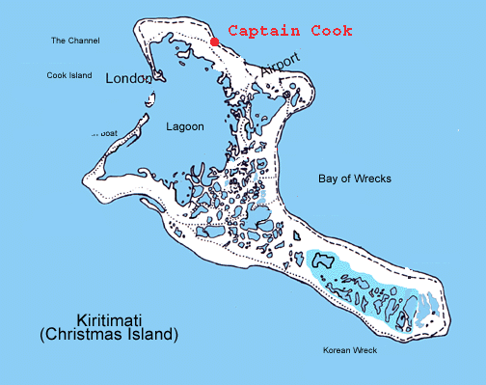
January 8 – 15, 2007

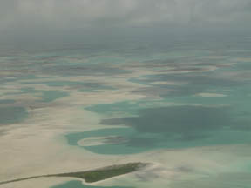

Participants:
Brigitte Baeuerle, Henry Boynton, Bob Olson, John Merrill, Al Schanot, Joe Vinson

How to get there: Denver – Honolulu - CXI

Hotel and flight arrangements should be made through Frontiers International:

Susan Fitzgerald
Frontiers International Travel
P.O. Box 959
Wexford, PA 15090
724-935-1577, 1-800-245-1950
FAX: 724-935-5774
www.frontierstravel.com
sfitzgerald@frontierstravel.com

Denver to Honolulu:
- Most convenient flight is on Mondays at 11:45 am, UA 43 directly from Denver to Honolulu.
- Paper ticket holders need to check in with United Airlines Special Services to obtain a valid boarding pass. Electronic check-in will not work.
- Seven hour flight, very limited service, food has to be purchased (boxed lunches and sandwiches available for $5).
- Arrival around 4 pm in the afternoon; Time change is 3 hours behind Denver.

Honolulu:
- Two hotels at airport; we stayed at Best Western Plaza Hotel which provides free shuttle service. Call 63 at hotel information display in baggage area to get courtesy shuttle then go through “H” exit door, keep to left, cross to the meridian and wait at the curb that is painted with a green line.
- Hotel is older, somewhat noisy; bar with basic bar food; breakfast in restaurant starting at 6:30 am ($10-15).
- Shuttle leaves on the hour and half hour from the hotel back to the airport.
- Hotel shop is last chance to stock up on needed items; airport stores are a lot more expensive.

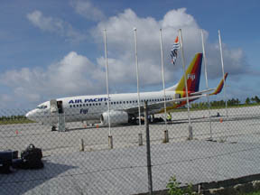
Honolulu to Christmas Island:
Previously (ended on April 26, 2004) a charter flight by Air Kiribati (done by Aloha Airlines) connected Christmas to Honolulu every week with a Boeing 737. Provisional jets shortly replaced it. Since October 2005, Fijian Air Pacific makes a weekly stop between Honolulu and Nadi in Fiji. Cassidy Airport (IATA-code CXI) has a paved runway with a length of 6900 ft/2103 m.
Currently Air Pacific flies to and from Christmas Island once a week, leaving Honolulu on Tuesdays and returning on Wednesday (Chrismtas Island Time).
- Check in at the Air Pacific counter which opens at 9:30 am.
- Visa required, which can be obtained either ahead of time or at the counter ($25)
- Baggage is limited to two bags per person with a combined max weight of 66 lbs plus one carry-on that may not exceed 20 lbs and that must fit into overhead compartment. Additional charge is $15 for every two pounds that exceed the weight restriction.
- Food provided on aircraft (warm lunch)
- 3 hr flight time
- Kiribati Arrival card needs to be filled out; don’t mark “government business” on entry form.
- If you don’t plan to fish, don’t fill out fishing license paperwork (Aus$35) upon arrival.
- Identify and receive luggage before leaving shed;
- Christmas Island is on the same time as Honolulu but one day ahead.

Accommodations at the Hotel Captain Cook

The Frontier Travel description states “With each year, the management matures by mainstream travel standards, although it will no doubt require a little time and patience for the psyche of the newly-arrived travel-hardened American to get into sync with the island’s atmosphere.”

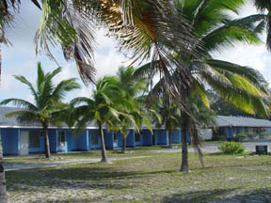
The Captain Cook is located about 4 miles from Cassidy airport, within sight and earshot of the island’s barrier reef. It is operated by an English-speaking staff and rather basic. One travel website states that “The hotel is reminiscent of an inexpensive, back country hotel built in the United States in the 1950's - cement block, spartan - but prices are high owing to remoteness and difficulty of getting supplies there.”

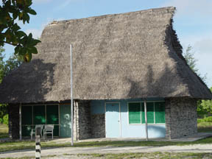
The hotel features 24 simple rooms, some of which are air conditioned. All are on one floor and open onto a courtyard facing the beach. There are also ten duplex, thatch-roofed cottages situated near the beach. Each room/duplex has two beds, two chairs, a small desk, wardrobe, side table and a small refrigerator. The private bath includes a sink, a shower heated by solar energy and a toilet. Towels and soap is provided; shampoo, conditioner and any other needed toiletries need to be brought from home. Rooms are equipped with standard American power plugs. While windows are covered by mosquito netting, rooms do get visited by the occasional crab, ant or bug. Not everything works all the time but one has to keep in mind that Christmas Island is one of the more remote places and most of the local Micronesians live without electricity, plumbing, or running water.

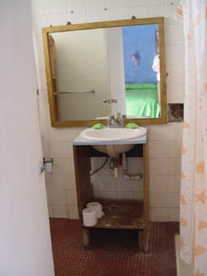
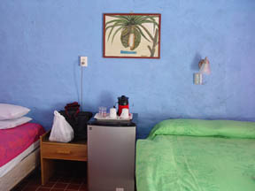
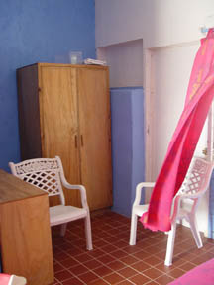

Food and Meal Schedule:

Food is served buffet style in a common dining room and includes a variety of meals including some local dishes, i.e., FISH. Breakfast consists of pan cakes, eggs, bacon, toast, cereal, OJ, milk, coffee and tea. During breakfast, the hotel provides sandwich makings (bread, tuna, cheese, meats) and fruit for people to prepare their own lunch. Otherwise the hotel provides a warm entrée and salad at lunch time for an additional cost of Aus$8. Dinner consists of salad, vegetables, rice/potatoes/noodles, fish and meat as well as ice cream. While the fish is local, everything else is flown in from Hawaii. Groups are also treated to a weekly Saturday night outdoor luau by the beach, featuring fresh lobster, a pig roast, grilled fish and traditional native singing and dancing at the beach.

Breakfast: 5:30 am to 8 am;
Lunch: Noon to 1:30 pm
Happy Hour: 5:30 pm at Maneaba with free appetizer sushimi
Dinner: 7 pm; buffet style

Beer (Aus$2.50) and spirits can be purchased in the Frigate Bar or the open-air Maneaba on the beach where people usually gather before dinner. Drinks, potato chips and candy may be purchased at the hotel store behind the dining hall.

All expenses including the cost of drinks are tabulated and charged to your room, payable before departure. The Captain Cook accepts US and Australian Dollars as well as traveler’s checks but no credit cards. All costs at the hotel are subject to a 10% sales tax.

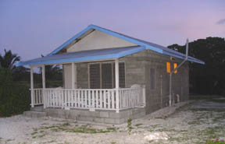
Other Accommodations:

“Shark Place Lodge” or Christmas Island Outfitter
Owned by ex-minister of the environment (Jim)
Rate (breakfast & dinner included): US$77/day
About 8 miles from Captain Cook on the way to London

Jacob Team’s Hotel:
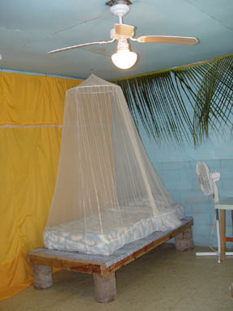
Owned by one of the island representatives
5 separate rooms in one building
Located in the town of London

Eddies Place
Owned by Big Eddy
Motel Style building with six rooms, five of which have air conditioning
About 1 Mile from Captain Cook
$70/night/person plus $30/food (breakfast and dinner)

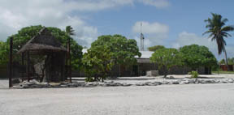

Research Permit and Government Interactions

While aircraft operations will be requested through official US State Department channels, a request to conduct research on Christmas Island will have to go through the main ministries in Tarawa, which includes the Ministry of Aviation, Ministry of Finance and Ministry of Environment and Tourism. According to the Immigration Officer, Tangi Robuti, the approval will cost $350

Representation on Christmas Island:
Hon. Tarvita Temoku
Minister for Line and Phoenix Island Development
ttemoku@hotmail.com
686 81 211 (Phone)
686 81 278 (Fax)
Ronton, Kiritimati Island, Republic of Kiribati

Mrs. Teramweai (“Teramay”) Itinraoi
psmlpid@myway.com
Secretary of T. Temoku
Board of Directors – Captain Cook Hotel
Hotel manager for one of the hotels

Help can also be requested from the Kiribati government representative in Honolulu:

Bill Poppey
Honorary Council, Government Representative
Honolulu
Also owns South Sea’s Air which imports on Asia Pacific Airfreighter

The government and the entire island shut down from 6 to 16 July to celebrate Independence Day (12 July). No services will be available during this time frame. PASE participants should
not arrive before the 17 July and preferably not until the 24^{th.}

Transportation, Rental Cars and Driving
As a result of the British influence, people drive on the left side of the road but steering wheels are routinely on the left side as most cars are imported from the US. The roads are in surprisingly good shape and paved between the main villages except for the road to Poland. Speed limit is 50 km/hour and substantial speed “humps” have been installed especially near schools, churches and throughout town.

Rental cars arrangements have to be made through local contacts and range from Aus$50 to US$60 per day depending on the owner. There is no insurance coverage and in case of an accident, drivers are expected to pay for the damage. Vans are available for rent through the Island Council in London.

The closest gas station is right across from the hotel at LMD Enterprises. The cost per liter of gas is about Aus$1.25 or about $4.40 per gallon.

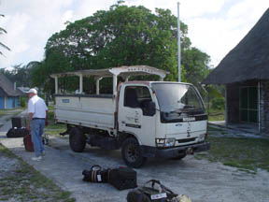
Local transportation is provided by the “Rainbow Bus System”, which runs in between villages and costs 50 cents per ride.

During PASE, transportation between the airport and the hotel will be arranged by NCAR through the hotel. The hotel has several open trucks that seat about 8 to 10 people in the back and are usually used to take fishermen to the lagoon. The distance from Cassidy Airport to the hotel is about 4 miles and walking is not really an option.
Operations Center:

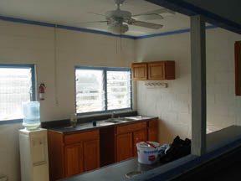
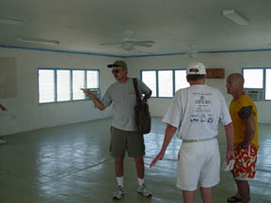

The SEC Building on the Captain Cook compound was suggested by hotel management as a possible ops center. The building is divided into a kitchen area, a small bathroom and a large room (28 ft x 42 ft); of the six air conditioners, only one worked. The room is currently empty, so tables and chairs need to be brought in. The electricity is currently supplied by several generators (Wisperwatt) that also belong to SEC. SEC is also using one of the cottages as an office.
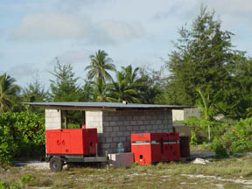
SEC Contact:
Ron Dresen
President of SEC
Safety and Ecology Corporation
SEC Business Center 2800 Solway Road
Knoxville, Tennessee 37931
United States
Direct phone: (865) 342 7619, (865) 216 0230
Phone: (865)690-0501
Fax: (865)539-9868
Local contact: Mike Loyd and Dominic

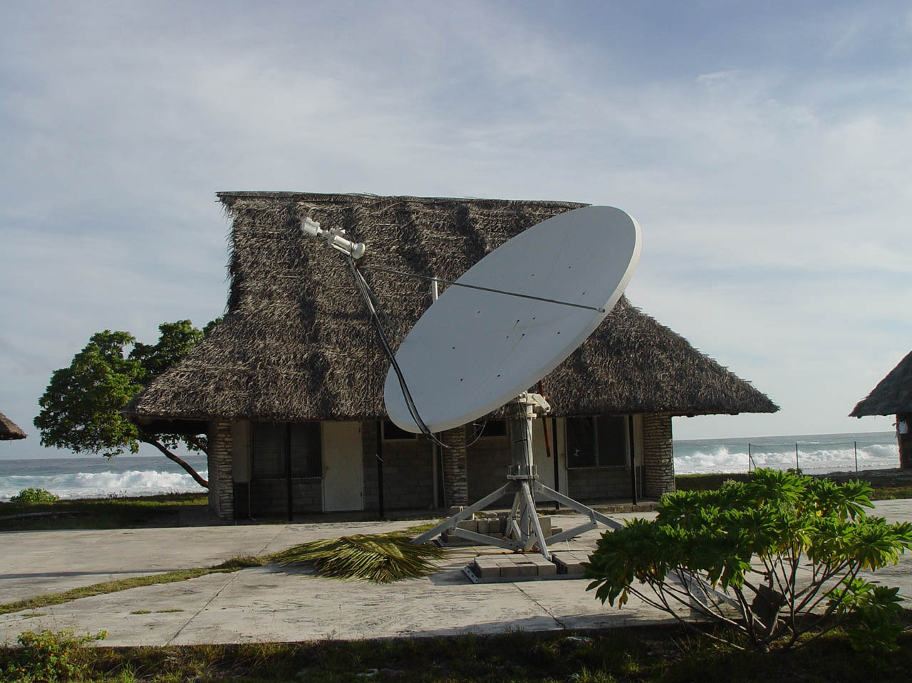
Communications
SEC used a satellite system for communications. The dish is located near the SEC building on the Captain Cook hotel compound. Cost for Internet access was about $10,000 per month. SEC will leave the island end of February/beginning of March and access has already been discontinued. Most of the equipment will be transferred to the Christmas Island Government including the satellite dish for use by the local Internet/Phone provider TSKL.

TSKL runs an “internet café” with four computers in London. Access is very slow and works primarily in the afternoon. Cost is $1.50 per 30 minutes or $6 per hour. http://www.tskl.net.ki/internet.htm

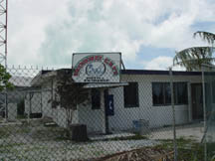
Communications between airport and OPS center could be done by either handheld VHF, which is what the hotel does with the fishing guides, or via walkie-talkies.

A new cellular service is planned near Banana but reliability is currently unknown.

Phone calls to the US will have to be done via Iridium. Currently, the dive shop provides minutes on a handheld Iridium phone for $2/min.

Banking
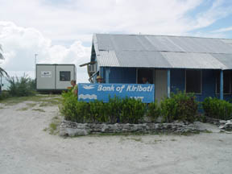
The Bank of Kiribati, a branch of the Australian ANZ bank is located in London. The local currency is the Australian Dollar although the hotel will accept US Dollars and Traveler’s Checks as well. It is suggested that PASE participants bring Australian dollars with them not to overwhelm the bank. The bank charges $15 commission fee for US Traveler’s Checks. There are no ATMs on the island, credit cards are not accepted and everything has to be therefore paid with cash.

Money transfers can be made through John Brighton of LMD Enterprises, who has a US account in Honolulu. He uses a standard exchange rate of 1:1.20.

John and Anna Brighton
jmb@tskl.net.ki
686 81 501 or 686 81 505
Safety And Security

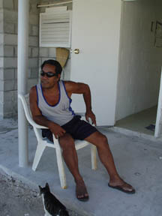
The island seems relatively safe but common sense should be used. Stealing is a serious crime and associated with enormous shame but still common. Valuables such as phones, electronic devices and cash should not be openly displayed. The hotel rooms are routinely unlocked during the day when cleaning occurs.

SEC suggested hiring two security guards each for the airport as well as the Ops Center. Guards can be hired and paid through John Brighton at $2/hour. Watchmen suggested by SEC included Matthew (“Matu”) Tebetao, Teiteiwa (“Sasawa”), Bereo, Eriata, and Iairo. Since those positions would be short term, the hiring does not have to be done through the government. Ketu was recommended as a handy man if needed.

Storage At Airport
Kim Anderson will arrange for two 20ft seatainers for storage at the airport. The cost quoted was $2,500 and included transport and rental. A canvas will close off the space in between the two containers to protect from the wind and rain. Power at the airport will be provided by the GPU and a Honda generator with an extension cord to provide light.

Fuel Supply

Jet A fuel is available from Kiribati Oil Company LTD (KOIL). The manager requires notification of the amount needed about two months before arrival. Tanks will be cleaned in March and his maximum load is 550,000 liters (NCAR requires about 350-400K liters).

Mr. Teanoki Tonako
Branch Manager
Kiribati Oil Company LTD
London, Christmas Island
bm.koil@tskl.net.ki
686 81 138 (phone)
686 81 221 (fax)

Gases
Kim Anderson can provide the following gases:
Aviation oxygen (92% medical grade)
Dry air -70 deg dewpoint, 03 E grade for consumption
Helium
CO2 but no liquid CO2
Dry Ice is not available on the island. We have determined that it could be shipped weekly with the Pacific Air passenger flight in quantities up to 200 kg. However, due to the limited freight options to the island it is possible that any specific shipment could be bumped for a high priority item.

Health Risks and Medical Facilities:
The main health risks on Christmas Island are related to being in the tropics: sun burn, heat stroke, dehydration, diarrhea and infections due to cuts and scrapes. In addition, there is risk associated with water sports such as swimming, diving, surfing and snorkeling.

Medical facilities on Christmas Island are minimal at best. Participants with pre-existing medical conditions should consult their doctors prior to any stay on the island. All participants are required through Frontier Travel to sign up for emergency medical evacuation insurance, which will be charged to the hotel cost.

Participants are encouraged to see a dentist before leaving for the island since no dental care is currently available.

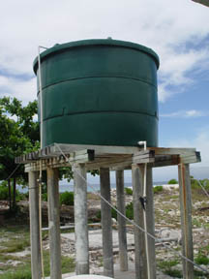
Water
Ground water on the island is about 5 ft below the surface. There are some holding tanks but no septic systems on the island. Water is treated with sand filters and chlorination but is high in nitrates as well as bacteria.

Tap water should be avoided at all cost as it is not purified. The hotel staff will provide fresh drinking water in each room and in the restaurant. There is also a Hot Pot to boil water in the room and coffee/tea bags are complementary. NCAR will arrange for bottled water either through LMD Enterprises or by bringing it in on the C130s.
Kim Anderson can provide drinking water for the aircraft; his limit is 12,000 gallons.

Discussions were held about aiding Project Cure and the Thornton Colorado Rotary Club in shipping medical supplies on a space available basis:

George and Sharon Maybee
gkmaybee@aol.com
303 655 9831
Medical supplies, Project Care

Shipping of Equipment

Note: All forms of shipment require somebody on site to receive shipment.

Military Air Cargo – 2 C130s or 1 C-17
Planned arrival: 25th - 27th July, NSF/NCAR C-130 will be there on 2nd August
Set up crew of 5 to fly with cargo plane.
Loading at Buckley AFB in Colorado

Asia Pacific Charter Flight – 727-200 freighters
Operates three long range Boeing 727-200 Freighters from Honolulu with extra fuel for Pacific operations. One of the aircraft is a Super 27 which is a re-engined aircraft.
Averaged about 38,000 pounds gross payload on flights to CXI; payload is 46,500 plus depending on which aircraft. 12 LD7 pallet positions, which are 88 inches x 125 inches and can be loaded squarely up to 64 inches; have to curve inward from their 125 inch width to 85 inches in the middle. Pallets are unloaded inside aircraft as forklift cannot drop a full heavy pallet.
Cargo door is 134 inches wide x 86 inches high. About six hour round trip plus 5 hours on ground depending on light conditions.

Asia Pacific Air Freighter – Boeing 737
Melbourne, Australia
Tel +61 3 9682 33 22
FAX +61 3 9682 33 00
Email: admin@airservices.com.au

Aircraft comes in every 3 to 4 weeks;
Freight forwarder required;
For more information, smaller shipment arrangements and import duty questions, go through Bill Poppy in Honolulu.
Prices quoted out of Honolulu and dimension limit of no more than 4 ft3 packages.
More information available from John Brighton

Air Pacific Freight (passenger flight)
Maintenance & Administration Centre Nasoso Rd
Nadi Airport, Fiji
Tel +679 673 7248 / 672 2694
FAX + 679 672 1985
Email: freight@airpacific.com.fj

One flight per week. $15/kg, very limited space

Government ocean freighter
Arrives every four to six weeks from Tarawa to CXM but is routinely delayed;
Able to transport 20ft containers;

Sailing vessel Kwai
c/o April Fountain or Mama Kwai
15-2874 Puna Rd #9088
Pahoa, Hawaii 96778-7799
Phone: (808) 966-9428
Fax: (808) 966-9260
Email: cargo@svkwai.com
http://www.svkwai.com/index.html

Heavy Equipment
Heavy equipment is available on the island; flatbed trucks with cranes, forklift at port and some of the hardware stores (near bank, brand new Nissan, Kiribati Supply Hardware Store). Most of the equipment is located near the jetty, which is handling some cargo and was built by the Japanese. Captain “Nosinwa” is the contact.
Kim Anderson’s wife, Totinnang “Tosingyang” owns Christmas Equipment and Rental Services.

Entertainment

News: There is no newspaper or TV station on the island – so bring your own DVDs, I-pod, and books. It may be useful to have a small FM/AM radio as well. There is a local radio station, 93.5 FM, which was established as part of the Kiribati Water Supply & Sanitation Project (KWASP). Funded through Australia's International Aid Agency (AusAID), the radio station fulfills a requirement of the project to educate the local people in health and hygiene throughout the five-year life cycle of the project. AM stations from Hawaii can be heard after sunset.

Fishing and Diving: The main (and probably only) thing to do (other than working and reading) is to fish, dive or bird watch. Christmas Island is considered one of the best fishing places in the world for both beginning and advanced saltwater anglers. People from primarily the US and Canada pay a lot of money to fly fish for bonefish and trevally in the flats and for tuna, wahoo, and billfish off shore. Kim Anderson runs Dive Kiribati, a local outfit that offers scuba diving, snorkeling, and boat tours. If there is enough interest, he would be willing to offer a certification course.

Shopping: There is no such thing as “shopping” on the island. The closest store is at the hotel and sells a limited selection of souvenirs, fishing flies, some food (instant noodles) and T-shirts. LMD Enterprise across the street from the hotel has probably the best selection of items including toner cartridges, tooth paste, candy, water and potato chips. The store is open Monday through Saturday, 8 am to 6 pm. There are various other small stores in London that sell food and some clothing. A handicraft shop in London only opens when the cruise ship is in port.

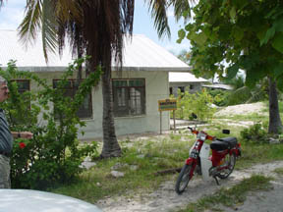
Restaurants: There are two restaurants in London. One is Kristina’s, which serves fish and rice plus a can of beer for Aust$5 per meal. There is also a Chinese restaurant that we did not get to try.

Miscellaneous Information About Kiribati

President: Anote Tong (2003)
Total area: 313 sq mi (811 sq km)
Population (2006 est.): 105,432 (growth rate: 2.2%); birth rate: 30.6/1000; infant mortality rate: 47.3/1000; life expectancy: 62.1; density per sq mi: 381
Capital and largest city (2003 est.): Tarawa, 26,600
Monetary unit: Australian dollar
Languages: English (official), I-Kiribati (Gilbertese)
Ethnicity/race: Micronesian 98.8%, other 1.2%
Religions: Roman Catholic 52%, Protestant (Congregational) 40%, some Seventh-Day Adventist, Muslim, Baha'i, Latter-day Saints, and Church of God (1999)
Economic summary: GDP/PPP (2001 est.): $79 million, supplemented by a nearly equal amount from external sources; per capita $800. Real growth rate: 1.5%. Inflation: 2.5%. Unemployment: 2%; under-employment 70% (1992 est.). Arable land: 3%. Agriculture: copra, taro, breadfruit, sweet potatoes, vegetables; fish. Labor force: 7,870 economically active, not including subsistence farmers (2001 est.). Industries: fishing, handicrafts. Natural resources: phosphate (production discontinued in 1979). Exports: $17 million f.o.b. (2004 est.): copra 62%, coconuts, seaweed, fish. Imports: $62 million c.i.f. (2004): foodstuffs, machinery and equipment, miscellaneous manufactured goods, fuel. Major trading partners: France, Japan, U.S., Thailand, Australia, Fiji, New Zealand (2004).
Member of Commonwealth of Nations
Communications: Telephones: main lines in use: 3,800 (1999); mobile cellular: n.a. Radio broadcast stations: AM 1, FM 1, shortwave 1; note: the FM and shortwave stations may be inactive (2002). Radios: 17,000 (1997). Television broadcast stations: 1 (not reported to be active) (2002). Televisions: 1,000 (1997). Internet Service Providers (ISPs): 1 (2000). Internet users: 1,000 (2000).
Transportation: Railways: 0 km. Highways: total: 670 km (1999 est.); paved: n.a.; unpaved: n.a. Waterways: small network of canals, totaling 5 km, in Line Islands. Ports and harbors: Banaba, Betio, English Harbor, Kanton. Airports: 20 (2002).
International disputes: none.

GOVERNMENT
The constitution promulgated at independence establishes Kiribati as a sovereign democratic republic and guarantees the fundamental rights of its citizens.
The unicameral House of Assembly (Maneaba) has 42 members: 40 elected representatives, one appointed member from Banaba island, and the Attorney General on an ex officio basis. All of the members of the Maneaba serve 4-year terms. The speaker for the legislature is elected by the Maneaba from outside of its membership and is not a voting member of Parliament.
After each general election, the new Maneaba nominates at least three but not more than four of its members to stand as candidates for president, locally referred to as "His Excellency Te Beretitenti." The voting public then elects the president from among these candidates. A cabinet of up to 10 members is appointed by the president from among the members of the Maneaba. Although popularly elected, the president can be deposed by a majority vote in Parliament. In this case, a new election for President must be held. A person can serve as president for only three terms, no matter how short each term is. As a result of this provision, former Presidents Tabai and Tito are constitutionally forbidden from serving as president again.
The judicial system consists of the High Court, a court of appeal, and magistrates' courts. All judicial appointments are made by the president.
Principal Government Officials
Head of State/Government--President Anote Tong
Vice President--Teima Onorio
Ambassador to the United States--vacant

POLITICAL CONDITIONS
Political parties exist but are more similar to informal coalitions in behavior. They do not have official platforms or party structures. Most candidates formally present themselves as independents. Campaigning is by word of mouth and informal gatherings in traditional meeting houses.
While he is head of a minority party, President Anote Tong enjoys a comfortable majority in Parliament. The biggest political issue today is finding employment opportunities for a crowded and growing population. In 2003, the losses incurred by government-owned Air Kiribati became a major political issue as well.
An emotional issue has been the protracted bid by the residents of Banaba Island to secede and have their island placed under the protection of Fiji. Because Banaba was devastated by phosphate mining, the vast majority of Banabans moved to the island of Rabi in the Fiji Islands in the 1940s. They enjoy full Fiji citizenship. The Kiribati Government has responded by including several special provisions in the constitution, such as the designation of a Banaban seat in the legislature and the return of land previously acquired by the government for phosphate mining. Only 200-300 people remain on Banaba.

ECONOMY
Kiribati's per capita GNP of less than U.S. $1,000 makes it one of the poorest countries in the world. Phosphates had been profitably exported from Banaba Island since the turn of the century, but the deposits were exhausted in 1979.
The end of phosphate revenue in 1979 had a devastating impact on the economy. Receipts from phosphates had accounted for roughly 80% of export earnings and 50% of government revenue. Per capita GDP was more than cut in half between 1979 and 1981. A trust fund financed by phosphate earnings over the years--the Revenue Equalization Reserve Fund--still exists and contained more than U.S. $400 million in 2003. Kiribati has received high marks for its prudent management of the reserve fund, which is vital for the long-term welfare of the country.
In one form or another, Kiribati gets a large portion of its income from abroad. Examples include fishing licenses, development assistance, worker remittances, and tourism. In particular, about 2000 I-Kiribati work as sailors on foreign merchant ships. Given Kiribati's limited domestic production ability, it must import nearly all of its essential foodstuffs and manufactured items, and it depends on these external sources of income for financing.
Fishing fleets from South Korea, Japan, China, Taiwan, and the United States pay licensing fees to operate in Kiribati's territorial waters. These licenses produce revenue worth U.S. $20 million to $35 million annually. Due to its small land mass and huge maritime area, however, Kiribati also loses untold millions of dollars per year from illegal, unlicensed fishing in its exclusive economic zone.
Another U.S. $20 million to $25 million of external income takes the form of direct financial transfers. Official development assistance amounts to between U.S. $15 million and $20 million per year. The largest donors are Japan, the United Kingdom, Australia, and New Zealand. In addition, Taiwan is widely expected to become an important bilateral donor in the coming years. U.S. assistance is provided through multilateral institutions. Remittances from Kiribati workers living abroad provide more than $7.5 million annually.
Tourism is a relatively small, but important domestic sector. Between 3,000 and 4,000 visitors per year provide U.S. $5 million to $10 million in revenue. Attractions include World War II battle sites, game fishing, ecotourism, and the Millennium Islands, situated just inside the International Date Line and the first place on earth to celebrate New Year. The vast majority of American tourists only visit Christmas Island in the Line Islands on fishing and diving vacations via weekly charter flights from Honolulu.
Most islanders engage in subsistence activities ranging from fishing to the growing of food crops like bananas, breadfruit, and papaya. The leading export is the coconut product, copra, which accounts for about two-thirds of export revenue. Currently, copra is exported to Bangladesh for processing, but there are plans to process copra in Tarawa. Other exports include pet fish, shark fins, and seaweed. Kiribati's principal trading partners are Australia and Japan.
Transportation and communications are a challenge for Kiribati. International air links to the capital of Tarawa are provided only by the near-bankrupt Air Nauru. Air Kiribati provides service to most of the populated atolls in the Gilberts using small planes flying from Tarawa. Small ships serve outlying islands, including in the Line Islands, with irregular schedules. Hawaiian Air flies to Christmas Island once a week. It is not possible to travel from the Line Islands to the Gilbert Islands by air without traveling via Hawaii and either Fiji or the Marshall Islands.
Telecommunications are expensive, and service is mediocre. There is no broadband. The monopoly Internet provider on Tarawa is one of the most expensive in the world.

FOREIGN RELATIONS
Kiribati maintains friendly relations with most countries and has particularly close ties to its Pacific neighbors--Japan, Australia, New Zealand, and Fiji. Under President Tito, Kiribati had particularly close relations with China and allowed Beijing to establish a satellite tracking station on South Tarawa. In November 2003, however, President Tong announced the establishment of full diplomatic relations with Taiwan. China's tracking station closed shortly thereafter. Australia, Taiwan, New Zealand, and the United Kingdom maintain resident diplomatic missions in Kiribati.

U.S.-KIRIBATI RELATIONS
Relations between Kiribati and the United States are excellent. Kiribati signed a treaty of friendship with the United States after independence in 1979. The United States has no consular or diplomatic facilities in the country. Officers of the American Embassy in Suva, Fiji, are concurrently accredited to Kiribati and make periodic visits. The U.S. Peace Corps has maintained a program in Kiribati since 1967. Currently there are about 50 Peace Corps volunteers serving in the county.
Kiribati became a member of the United Nations in 1999, but does not maintain a resident ambassador in New York. In September 2003, President Tong requested authority from Parliament to establish a UN mission. Kiribati also is a member of the Pacific Islands Forum, Asian Development Bank, the Commonwealth, International Monetary Fund, the Pacific Community, and the World Bank. Kiribati is particularly active in the Pacific Islands Forum. The only Kiribati diplomatic missions overseas are a high commission in Fiji and an honorary consulate in Honolulu.
Principal U.S. Embassy Officials
Ambassador-- Larry M. Dinger
Deputy Chief of Mission--Ted Mann
Political/Economic/Commercial Affairs--Brian J. Siler
Consul--Kirk Lindly
Management Officer--Jeffrey Robertson
The U.S. Embassy responsible for Kiribati is located in Suva, Republic of the Fiji Islands. Its location is 31 Loftus Street, Suva, Fiji. Mailing address: P.O. Box 218, Suva, Fiji. Tel: +679-331-4466, fax: +679 330-0081.

Miscellaneous Information About Christmas Island

Many of the place names on Christmas Island date from Father Emmanuel Rougier, a French priest who leased the island from 1917 to 1939 and planted some 800,000 coconut trees there. He lived in his Paris house (now, only small ruins) located across the Burgle Channel (main entrance to the lagoon) from Londres (or London, which he established as a port). La colline de Joe (Joe's Hill) is the highest point on the atoll (less than 12 m or 40 ft above sea level) near Artemia Corners

London is the main village with a small port facility. Banana is a small community near Cassidy Airport. There are plans to relocate Banana closer to London to prevent contamination of the groundwater since the area has the largest freshwater lens on the island. About 400 people live in Poland; Kawaki Village is the biggest village on island.
A census was done in June 05 when the island had about 5,000 inhabitants. The current estimate is closer to 6000 to 7000 people. The island has two representatives in the Maneaba ni Maungatabu. The ministry of the Line and Phoenix islands is located in London.
The British tested their first H-Bomb on Christmas Island in May 1957, and the United States conducted Operation Dominic there in 1962. Some toponyms come from the nuclear test period (like Banana and Main Camp). There were at least four airfield on the island during WWII. About 150 families lived on the island during bomb testing. After the 1979 Independence from Great Britain, Kiribati received a 400 Million trust fund.
Kiritimati (Christmas Island) in the Pacific Ocean was originally selected by Von Braun in his Collier magazine series of the early 1950's as an ideal equatorial launch site. A half century later, Boeing Sea Launch used the location for orbital launches. The launch platform was a seagoing converted Norwegian offshore oil rig. Between missions it was berthed in Long Beach, California. It was towed to a location off Kiritimati for launches of the Ukrainian Zenit-3 launch vehicle.
There is a Japanese JAXA satellite tracking station and an abandoned airfield (Aeon Field) proposed for reuse by the Japanese for their now-canceled HOPE-X project (a space shuttle).
There are hardly any natural resources on the island, other than fish and coconut. About ½ Million coconut trees were planted on the island. People raise pigs and chicken. There are only male dogs on the island. Rainfall is low except during El Niño years. The flora and the fauna are unique, but the island is affected by regular, severe droughts. Most of the atoll's food supplies have to be imported, although marine fish are plentiful. Exports of the atoll include aquarium fish, coconuts, and seaweed. Additionally, there is a small amount of tourism, mainly associated with anglers interested in lagoon bonefish fishing or offshore fishing.

Before You Go
- Remember to bring your passport, valid for six months beyond travel dates.
- A visa is required for entry to Kiribati if you are a US citizen. Visas can be requested ahead of time through the office in Honolulu or you may secure one at the check in counter on the morning of your departure for Christmas Island. The cost for a multiple entry visa is $25.
- Fishing gear should be packed in your checked luggage including rods, reels, flies and fishing tools. Otherwise expect delays and possible confiscation at security check points.
- Remember to bring the Frontiers hotel reservation voucher, indicating full payment and your room assignment. The voucher needs to be presented at check in at the Captain Cook.

What to bring:
- Sun glasses
- Sun screen (35 or higher)
- Lip balm
- Hat
- Sandals
- Loose clothing
- Imodium and probably some zibro
- Electrolytes in case of dehydration (Propelle)
- Shampoo, conditioner, hair dryer etc.
- Australian Dollars
- Own entertainment: CDs, DVDs, books etc.
- Booties for beach walking
- Snorkeling/diving gear
- Fishing gear
- Disinfectant (hands)
- Snacks
- Hammock
- Mosquito repellant for evenings
- Flashlight to walk from main area to cottage
- Antibiotic cream for cuts and scrapes
- Beach towel
- Swim trunks
- Gifts for staff (sandals, lotion, etc)

SEC stands for Safety and Ecology Cooperation, a company located in Knoxville, TN. In late December 2004, SEC was awarded a multi-million pound contract for the removal of over 23,000 cubic meters of military waste from the Pacific Island of Kiribati. The contract was awarded by the Defense Estates on behalf Britain’s Ministry of Defense. SEC aided in remediation of the island, which was used by the British government for the nuclear bomb testing in the 1950s and 1960s. According to their website, Safety and Ecology Corporation (SEC) offers comprehensive services in the areas of environmental remediation of radiological and hazardous waste-contaminated sites; contaminated facility decontamination, decommissioning, and demolition; health physics services; industrial hygiene services; industrial health and safety; radiological/industrial hygiene instrumentation rental, calibration, and repair; and waste and material management and disposal. Founded in 1991, SEC has about 400 staff conducting more than $75 million dollars of business per year. Until recently 30 to 35 people worked full time on Christmas Island.

