Report of Issues/Actions/Recommendations from the First CEOP Model Output Development and Analysis Workshop and the Third Coordinated Enhanced Observing Period (CEOP) International Implementation Planning Meeting

8-12 March 2004, Irvine, California

First Draft, 15 April 2004

1. INTRODUCTION

The Coordinated Enhanced Observing Period (CEOP) is an element of World Climate Research Programme (WCRP) that was motivated by the international efforts of the Global Energy and Water Cycle Experiment (GEWEX) to measure, understand and model the water and energy cycles within the climate system. Professor Toshio Koike, the Lead Scientist for the Coordinated Enhanced Observing Period (CEOP), and Professor Soroosh Sorooshian, Chairman of the World Climate Research Programme (WCRP) Global Energy and Water Cycle Experiment (GEWEX) Science Steering Group (SSG) invited an extensive group from the international climate and water cycle modeling and research community to attend the CEOP Model Output Workshop (8-9 March 2004) and Implementation Planning meeting (10-12 March 2004) both of which took place, at the John V. Croul Hall conference room, University of California, Irvine Campus (UCI), at Irvine California, USA. The Host for both these events was the Department of Earth System Science and the Henry Samueli School of Engineering Department of Civil and Environmental Engineering at UCI. The final revision of the agendas/timelines for the workshop and meeting are contained in Appendixes A and B respectively and a unified list of participants at both meetings is provided in Appendix C. This report endeavors to compile in an integrated fashion the notes/recommendations/actions for both CEOP events.

1.2 Internet Access to the Meeting Agenda and Presentations

More specifics about CEOP and the Model Workshop and Implementation meeting can be found through the CEOP Internet site: http://www.ceop.net by clicking on “meetings”. Through the assistance of the CEOP Coordination Office in Tokyo, the agendas and presentations that were made at both the workshop and meeting, as referenced in the body of this report can be accessed directly on the Internet at: http://monsoon.t.u-tokyo.ac.jp/ceop/meeting.html by clicking on the presenter’s name.

1.3 Format and Scope of the Meeting Report

The dates for accomplishing actions as presented in this report are goals set at the time of the meeting, but it was understood and accepted by the participants that, in all cases, additional factors may intervene to alter the priority and timing of completion of any one specific item. An on-going process of coordination and review of work in CEOP, through regular monthly teleconference calls, is continuing. This process will continually address the most important implementation issues and their timeline for accomplishment. Each of the main items discussed have kept their lineage to a related topic in the CEOP Implementation Plan as established earlier. The Plan, which was finalized following recommendations formulated at a CEOP Implementation Workshop held at the Goddard Space Flight Center (GSFC) in March 2001, was published in May 2001 and can be found at: http://www.gewex.com/ceop/ceop_ip.pdf.

The actions and recommendations, which are identified in this report, came out of the presentations and discussions at the first CEOP Model Output Development and Analysis Workshop and the Third Formal CEOP International Implementation Planning meeting. The items are presented for review and comment.

The underlying concept is that a set of activities had been endorsed by the CEOP SSC at the Second CEOP International Implementation Planning Meeting held at Berlin, Germany from 4-6 April 2003. These actions became a follow-up CEOP action plan for the intervening year that led up to the current meetings. The action plan was implemented by the CEOP Secretariat Office and the International Coordination function. The coordination activity has been assisting the CEOP SSC and the CEOP Working Groups and other implementing individuals and groups, to set priorities for the completion of relevant milestones and has carried on a series of international conference calls as a regular (approximately monthly) review procedure for ensuring that the work is undertaken in an integrated manner. A separate series of conference calls that deals specifically with the CEOP Model Output issues has also been instituted. Those calls stimulated the need for the CEOP Model Output Development and Analysis Workshop.

The outcome of all of these efforts has been an orderly advancement of the main goals of CEOP. Through this mechanism the SSC Chairman and the CEOP Lead Scientist have been able to adjust the implementation priorities as required while maintaining oversight of the overall status of CEOP progress. The CEOP Coordination unit has been responsive to the SSC and the CEOP Working Group Co-Chairs in their efforts to meet their responsibilities.

Several of the actions and recommendations agreed to at the meeting have, therefore, been undertaken in an order and manner that was modified through the on-going CEOP implementation and review process just outlined. Where it was consistent with the content of the report, updates of actions have been added for completeness based on subsequent effort, meetings, workshops, discussions and other related events.

This report, therefore, gives a summary and overview of most of the activities on-going in CEOP up to the current time. It may still be necessary, however, to request minutes of the regular CEOP conference calls or Model Output issue calls to know the specific stage of completion of any specific action or recommendation noted in this report. These are available on the Internet at the CEOP home page: http://www.ceop.net or in the case of the Model Output issues reports, at the CEOP Data Management web page: http://www.joss.ucar.edu/ghp/ceopdm/. They can also be obtained directly from Ms Akiko Goda goda@hydra.t.u-tokyo.ac.jp at the CEOP Secretariat at the University of Tokyo.

Please contact S. Benedict: sam.benedict@gerwex.org with any comments or questions about the material contained in this report.

1.4 Plans for the Formal CEOP International Implementation Planning Meeting

It was agreed that the next (Fourth) CEOP International Implementation Planning meeting would take place from 28 February to 4 March 2005 at the University of Tokyo (UT), Tokyo, Japan, possibly in conjunction or jointly with an IGOS-P meeting.

2. OPENING OF THE MEETING AND CEOP OVERVIEW

A number of points were discussed that put CEOP in context within the WCRP and the international climate/water-cycle research community at large.

2.1 CEOP Science and Implementation Strategy Overview

Professor Koike briefly summarized the CEOP implementation strategy for the participants. CEOP is seeking to achieve a database of common measurements from both in situ and satellite remote sensing measurements, as well as matching model output that includes Model Output Location Time Series (MOLTS) data along with four-dimensional data analyses (4DDA; including global and regional reanalyses) for a specified period. Carefully selected reference stations are linked closely with the existing network of observing sites involved in the GEWEX Continental Scale Experiments (CSEs), which are distributed around the world. The measurements from these sites are being developed into composited datasets. These datasets are critical to the achievement of CEOP Science goals particularly those that relate to the methodology CEOP will use in applying enhanced observations to better document and simulate water and energy fluxes and reservoirs over land for water resource applications. The CEOP international research project to validate and assess the capabilities of climate models in simulating physical processes in monsoon regions around the globe is also dependent on the coordinated CEOP datasets. A key element of the CEOP implementation strategy includes exploitation of satellite data, which focuses on data collection, visualization, integration and analysis.

2.2 Overall CEOP Organization/Coordination

To carry the CEOP science and Implementation strategy forward, the existing projects and sub-activities in CEOP have been grouped under five main scientific and technical thrusts namely Water and Energy Simulation and Prediction, Monsoon Systems, Satellite Data Integration and Data Management and Model Output Development. A Science Steering Committee (SSC) has been established to guide the work of the five main working groups and a CEOP Advisory and Oversight Committee (AOC) has been organized to provide additional oversight and connections to the main supporting agencies. A CEOP Coordination unit has been established, which consists of an International CEOP Coordination Office funded by Japanese Government Agencies and an International Coordinator Function partially supported by USA and Japanese sources. This structure is depicted in Figure 1.

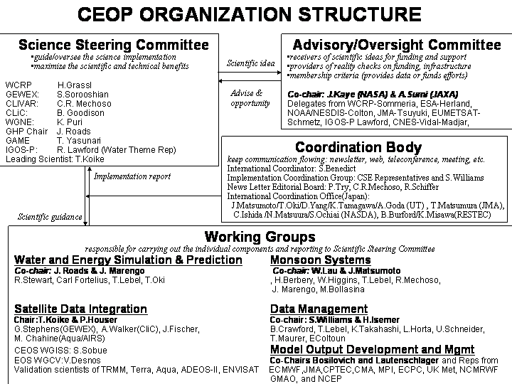
Figure 1: CEOP Organization Structure

2.3 CEOP Connections within WCRP

Dr Soroosh Sorooshian, speaking as the Chair of the GEWEX SSG noted that close connections between CEOP and GEWEX were necessary to ensure that the requirements of GEWEX were taken fully into account in the CEOP implementation strategy. Speaking on behalf of Dr David Carson, the Director of WCRP, Dr Sorooshian also expressed the need for CEOP to maintain close ties with the Climate Variability and Predictability (CLIVAR) initiative, the Climate and Cryosphere (CliC) Project and the other WCRP core projects as well as the climate research community at large. Evidence that this interaction was well underway within CEOP was provided through the definition of the specific plans CEOP has to assist research into the global atmospheric circulation and changes in water resources. That CEOP will serve numerical modeling and analyses needs was also highlighted in the opening session.

Drs J. Roads Chair of the GEWEX Hydrometeorology Panel (GHP); J. Polcher Chair of the GEWEX Modeling and Prediction Panel (GMPP); D. Lettenmaier (University of Washington); T. Ohata, Representing Dr Barry Goodison, Chair of CliC each representing a research groups within WCRP or the broader international water cycle research community, jointly focused further on how CEOP is developing within the WCRP international science framework. In specific, CEOP is heavily entrained into the activities that have been undertaken by the GEWEX Hydrometeorology Panel (GHP). CEOP has taken advantage of the five most comprehensive GEWEX Continental-Scale Experiments (CSEs) namely, GAPP (Mississippi River Basin), BALTEX (Baltic Sea region), MAGS (Canadian Mackenzie River Basin), LBA (Amazon region) and CAMP (Asian monsoon region). CEOP is assisting GEWEX to demonstrate skill in predicting variability in water resources and soil moisture on time scales up to seasonal and annual as an element of WCRP's prediction goals for the climate system. Implementation of CEOP was also prompted by the continued evolution of the current suite of operational meteorological satellites and the timing of a new generation of Earth observing satellites, as promoted by the Committee on Earth Observation Satellites (CEOS). By exploiting these new tools and the progress being made by the individual GEWEX CSE’s, in cooperation with their National Numerical Weather Prediction (NWP) Centers, CEOP is proving that a great deal of scientific benefit can be derived from a more coordinated observation period that leverages off of the large investments of intellectual and economic resources and adds value to the existing infrastructure.

The application of data from the GHP CSE’s; the concept of a CEOP Watershed Hydrology Working Group, the definition of a CEOP and CliC joint effort to improve understanding of the role of cold regions precipitation in the global water cycle; the connection to CLIVAR to enhance understanding of monsoon characteristics were all cited by these guest speakers at the meeting as important steps that have advanced over the past year in CEOP. This work shows that CEOP is being responsive to the challenges and priorities that relate to variations in the earth’s water and energy budgets and the cycling rate of the hydrological cycle as posed by the International Panel on Climate Change (IPCC). To do this CEOP has increased its interaction with elements of WCRP and other international organizations and efforts that are focused on the measurement, understanding and modeling of water and energy cycles within the climate system.

2.4 The CEOP Role in IGOS-P

Dr Rick Lawford noted that by being selected as ‘the first element of the Integrated Global Water Cycle Observations (IGWCO)’ theme within the framework of the International Global Observing Strategy Partnership (IGOS-P), CEOP has been recognized as an important scientific effort by the broad association of international organizations which make up the Committee on Earth Observation Satellites (CEOS). The implications of this commitment were identified by the CEOP Science Steering Committee (SSC) to include the following actions (A1a,b,c) to be undertaken by CEOP through its International Coordination and Secretariat functions:

(i) CEOP will identify representatives from within its organization/community to serve as a subcommittee to the IGWCO science committee. A decision as to whether this element would be an existing unit of CEOP or a newly formed sub-group will be made by the SSC by 1 June 2004.

(ii) As part of its responsibilities to IGOS-P, the CEOP International Coordination Function with support of the CEOP Secretariat will arrange for a written report to be prepared on its activities that can be presented at a future IGOS meeting in 2005.

(iii) As part of its commitment to the IGWCO the CEOP International Coordination Function with the support of the CEOP Secretariat will coordinate the development of a plan that defines CEOP activities beyond the completion of its initial observational phase at the end of 2004 and which can then be integrated with the IGWCO implementation plan. A preliminary version of the CEOP extended activities plan will be ready by the end of June 2004 and a more complete form of the plan will be finalized in 2005.

2.5 CEOP links to the Third World Water Forum (3rd WWF), the Earth Observations (EO) Summit and the ad hoc Group on Earth Observations (GEO)

To broaden the impact of CEOP further Koike reported that CEOP had been represented in a series of international initiatives that began with the World Summit on Sustainable Development (WSSD) at Johannesburg, South Africa, in 2002. The plan of Implementation adopted by the WSSD recognized that it was necessary to "Improve water resource management and scientific understanding of the water cycle through cooperation in joint observation and research, and encourage and promote knowledge sharing, and provide capacity-building and the transfer of technology, as mutually agreed, including remote-sensing and satellite technologies, particularly to developing countries as well as countries with economies in transition, for this purpose."(WSSD Paragraph 28).

Similarly, CEOP had an input through its representatives to the "The Third World Water Forum" (3rd WWF) that was held at Kyoto/Osaka, Japan from 16-23 March 2003. That ministerial level conference declared that "We will further encourage scientific research on predicting and monitoring the global water cycle, including the effect of climate change, and develop information systems that enable the sharing of such valuable data worldwide." A Group of 8 (G8) Action Plan for Water agreed in Evian, France in 2003 to promote "co-ordination of mechanisms for information sharing and monitoring".

The First Earth Observation Summit held in Washington, DC, in July 31, 2003, affirmed the need for timely, quality controlled, long-term, global information as a basis for sound decision making and recognized the need to support improved coordination of strategies and systems for observations of the Earth and identification of measures to minimize data gaps. "Improving global water resource management and understanding of the water cycle" is recognized as one of the most important societal issues and potential benefits by the Subgroup on User Requirements and Outreach under the ad hoc Group on Earth Observations (GEO), which is preparing a 10-year Implementation Plan for a comprehensive, coordinated, and sustained Earth observation system or systems. Professor Koike is a member of two of the GEO Subgroups that will be finalizing the draft version of the proposed GEO ten-year implementation plan and has asked the CEOP community to assist him with his duties on these groups as appropriate.

2.6 CEOP links to Agencies

The underlying basis for CEOP discussions with Agencies is how CEOP can advance and promote science that is in line with national and international plans and funding priorities for efficient coordination of the collection, processing and application of field data, satellite products and model outputs, without ever promoting a separate “CEOP” project/initiative in any one of these domains. CEOP is appealing to funding groups by promoting its unifying and integrating framework supported by the Scientific Community, Space Agencies and Modeling Centers that is designed to leverage off of existing and future initiatives underway or planned within current climate research criterion. In this context, CEOP has been timed to take account of the fact that data have begun to arrive from the first of the new series of earth system satellites. This group of satellites includes several, which have already been launched such as TERRA, TRMM, AQUA, ADEOS-II and ENVISAT, and others, which are planned. The operational satellites are also of critical importance to on-going and planned GEWEX initiatives.

Representatives from JAXA, NASA and NOAA were at the meeting and reported on the issues and concerns they have with respect to the CEOP implementation process and their commitments to the CEOP infrastructure. Earlier meetings with ESA representatives have also resulted in important commitments to assist CEOP in its quest for specialized satellite datasets.

2.6.1 JAXA

Dr N. Matsuura reported to the group that On 1 October 2003, the Institute of Space and Astronautical Science (ISAS), devoted to space and planetary research; the National Aerospace Laboratory of Japan (NAL), which is focused on research and development of next-generation aviation; and the National Space Development Agency of Japan (NASDA), which is responsible for development of large-size launch vehicles, satellites and the International Space Agency were merged into one independent administrative institution: the Japan Aerospace Exploration Agency (JAXA). The consolidation of these organizations was undertaken to enable a continuous systematic approach to space exploration from basic research to development and application.

JAXA is made up of two Offices and two Institutes. The Office of Space Flight and Operations is involved in research and development of space-transportation systems used for various purposes. The Office of Space Application engages in the research, development and practical applications of satellite systems for land surveys, for the spotting and study of natural disasters, and in coastal surveillance for security purposes. The Institute of Space Technology and Aeronautics devotes itself to the research and development of basic technologies to assure steady progress in space development. The Institute of Space and Astronautical Science devotes its efforts to searching for a better understanding of the birth and evolution of the Universe. CEOP is being given oversight in this new structure as part of the Earth Observations Research and Applications element of the Office of Space Application.

Table-1 JAXA Earth Observation Program Prospectus
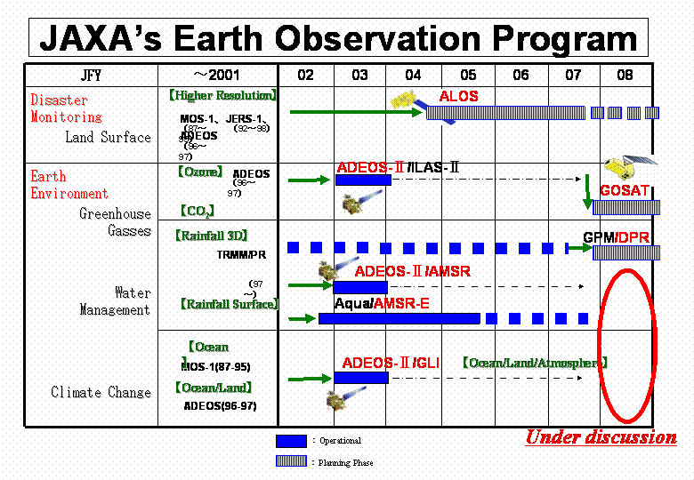
Dr N. Matsuura also informed the group that JAXA had investigated the possibility of recovering the observations of ADEOS-II after an anomaly was detected in the satellite on 25 October 2003. However, as a result of the investigation, analysis, and inability to re-establish any communications with the satellite, JAXA has determined that the possibility of restoring the operations of ADEOS-II is unlikely. Matsuura verified that JAXA was committed to continuing its work with the new satellite data that had been received for the ADEOS-II operational period from April to September 2003. JAXA will also continue its collaborative investigations with data from complementary instruments on board other earth observing spacecraft such as the USA Aqua and Terra and the ESA Envisat platforms. As an example JAXA is discussing obtaining and analyzing MODIS data from NASA as a way obtain important research results that were to undertaken with the ADEOS-II GLI instrument data. In this manner JAXA expects to meet its main commitments to CEOP.

Similarly, support to the efforts at the University Of Tokyo (UT), at JAXA and at JMA related to data integration, Land Data Assimilation and Data mining, which will be applied to CEOP technical development is being supported by Japanese Government funding Agencies. JMA and UT are using this support to begin development of an improved LDAS capability. The existing 500 Terra Byte data handling system at the Institute of Industrial Science will also be expanded for handling of CEOP sub-setted satellite data and integration processes. Table 2 shows the commitment by JAXA of satellite data/products through JAXA, JMA and UT.

Table 2- CEOP Data Integration Commitments by JAXA, JMA and UT
In situ Measurement | Satellite Sensor
Atmospheric Profiles over Land
Temperature | AIRS | MODIS
Water Vapor | AIRS | MODIS | GLI
Dry Static Energy | AIRS
Wind
Water Vapor Flux
Dry Static Energy Flux
Vapor Flux Divergence
Longwave Flux | AIRS | CERES
Shortwave Flux | AIRS | CERES
TOA Flux | CERES
Cloudiness | CERES | MODIS | GLI | MISR
Net Radiative Heating | AIRS | CERES
Condensation Heating | AIRS | PR
Aerosol concentration | MODIS | GLI | MISR
PBL
Land Surface
Elevation
Vegetation | MODIS | GLI
Precipitation (liquid) | PR | TMI | AMSR
Snow Water Equivalent | AMSR | ASAR
Snow Depth | AMSR
Streamflow
Stream discharge
Reservoir Storage
Air Temperature
Albedo | MODIS | GLI
Specific Humidity
Skin Temperature | MODIS | GLI | ASTER
Wind
Sensible Heat Flux
Latent Heat Flux | (MODIS)
Longwave Radiation | CERES | MISR
Shortwave Radiation | CERES | MISR
Sub-Surface
Water Table
Soil Moisture | AMSR
Soil Temperature | AMSR

The CEOP SSC and AOC members at the meeting commended JAXA, JMA and UT for their support to CEOP and agreed that it was important for the CEOP Coordination function to maintain close connection with these agencies to provide them with continued support through the CEOP international infrastructure to ensure further advancement in a consistent manner of all the activities undertaken by these agencies and groups.

2.6.2 NOAA

Dr M. Colton, Director of Research and Applications at the USA National Oceanic and Atmospheric Administration (NOAA), National Environmental Satellite, Data, and Information Service (NESDIS) and member of the CEOP Advisory and Oversight Committee (AOC), reported that an agreement has been reached for NESDIS to provide CEOP with data from NOAA operational satellites per a request made, by Prof T. Koike, lead Scientist for CEOP, through Dr D. Carson the Director of WCRP. The basic agreement is expected to be fulfilled through the NESDIS archive computing system known as the Comprehensive Large Array-data Stewardship System (CLASS).

The data required include operational satellite imager and sounder data, for the globally distributed CEOP reference sites, as well as level 2 products for those sites and for predefined CEOP Monsoon regions. CEOP will therefore be provided with data from the AVHRR and GOES imager for all sites and data from AMSU, TOVS and GOES sounder for the Model Output Location Time Series (MOLTS) locations. Level 2 products will be provided for the Monsoon regions and experimental products such as AMSU surface and precipitation products (MSPPS), cloud products (CLAVR) and atmospheric pathfinder (PATMOS) may be included. Data that have been “thinned” will also be provided from the Atmospheric Infrared Sounder (AIRS) instrument on board the Aqua platform.

The CEOP international coordination function and staff at the NOAA, Office of Research and Applications (ORA) have the action (A2) to continue the detailed discussions necessary to complete the technical work leading to the final achievement of this request.

2.6.3 NASA

Dr J. Kaye, Director of the Research Division at the USA National Aeronautics and Space Administration (NASA), and Co-Chair of the CEOP Advisory and Oversight Committee (AOC), noted the importance of CEOP’s role in increasing the focus on the important topic of water resources applications. Many aspects of the existing National priorities parallel those within the international community related to building new global descriptions of the Earth’s environment and upgrading model representations on which to base predictions, and improve descriptions of key local and regional processes. The global products and data sets derived through the exploitation of new satellite sensors will be critical to these developments and will serve to extend our current knowledge very considerably.

Continued support by NASA and participation by NASA scientists and engineers in CEOP has been motivated by our desire to promote a broad set of efforts focusing on the measurement, understanding and modeling of water and energy cycles within the climate system.

The work within NASA in support of CEOP includes some upgrading of the Global Land Data Assimilation System (GLDAS) initiative, which is being applied in specialized runs at fine resolutions that are producing products of importance to CEOP. Dr M. Bosilovich reported that a proposal to NASA that includes CEOP reprocessing and EOS surface temperature data assimilation has been accepted and fully funded. CEOP was heavily included as a major validation benchmark in this work and it clearly states that the work will provide data to CEOP. The aim for this project is for it to be the means whereby NASA data assimilation is brought into CEOP as well as for it to provide a strong scientific project for both CEOP and Water and Energy Balance Studies (WEBS) in the Water and Energy Simulation and Prediction (WESP) component of CEOP. In addition, while it was understood that this effort would not do the work that had been proposed but not funded earlier in GLDAS, there was an understand that the effort could possibly enable the collection of a core of EOS data needed for model development and validation as a compliment to some of the CEOP data integration effort being undertaken at UT.

Other work at NASA that was noted as being central to the continued development of CEOP included the CEOP Inter-Monsoon Model Study (CIMS) model physics studies taking place at the Laboratory for Atmospheres at the Goddard Spaceflight Center (GSFC). The work at the newly formed Global Modeling and Assimilation Office (GMAO) formerly the Data Assimilation Office (DAO) was also emphasized as an important component of CEOP research that needed to be continued.

NASA has also agreed to provide sub-setted satellite system data to CEOP from other Earth Observations Satellite (EOS) instruments that include AIRS full resolution and MODIS data as outlined with respect to the connections and authority established for this commitment by way of CEOS. There is agreement to ensure that proper connections are made at the Jet Propulsion Laboratory and GSFC to enhance the prospects of CEOP receiving the satellite data. Dr Kaye provided the group with a summary chart of the work and plans related to NASA’s interest in Global Water Cycle research pointing out that several areas overlap work being done or planned in CEOP. The summary is provided below:

Figure 2 – NASA Global Water and Energy Cycle priority issues (as of 12 March 2004)
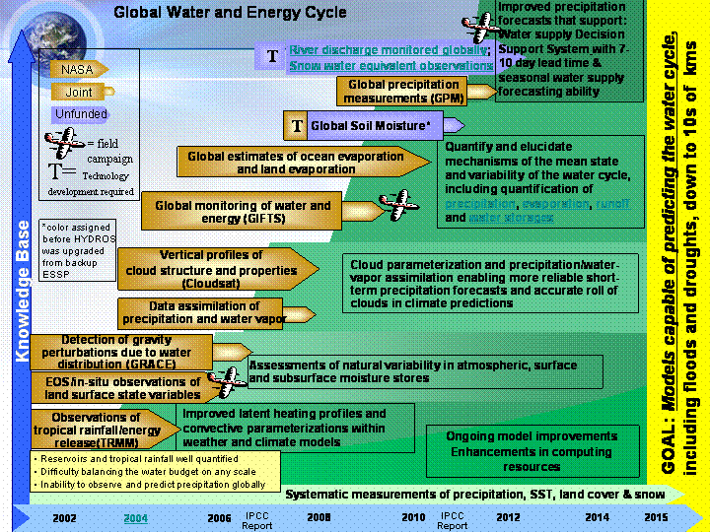

The agreements with NASA and NOAA have established an important initial step in the development of a formal framework within which CEOP Satellite Data Requirements will be recognized and responded to by the USA. It is the responsibility of the CEOP International Coordination function to follow-up on these agreements so that they are finalized and the data provided as agreed.

2.6.4 ESA and EUMETSAT

Dr E-A. Herland of ESA, who is a member of the CEOP Advisory and Oversight Committee (AOC) was unable to attend the meeting, but in his written input he reported that, during a meeting at ESA/ESTEC, Nordwijk, The Netherlands, on 21 January 2004 with himself and P. Ingmann of ESA and CEOP representatives (Koike, Benedict) an agreement had been reached for ESA to provide CEOP with sub-setted ENVISAT instrument data.

The Meeting Participants concurred that there was a need for ESA datasets to be provided to CEOP in the same way JAXA and NOAA, NASA data are to be contributed.

The main conclusions from the meeting were:

(i) The provision by ESA of global and sub-setted data from ASAR and MERIS as appropriate and in accordance with CEOP Requirements (CEOP has defined level 1b and level 2 products and has provided the Reference Site, MOLTS and Monsoon Regions where sub-setted data are required);

(ii) The Data will be provided in a timely manner through a process that is aligned with ESA standard practices.

Dr J. Schmetz of EUMETSAT, who is a member of the CEOP AOC, was unable to attend the meeting. However, communication with EUMETSAT has resulted in a reaffirmation of the earlier announcement of support within EUMETSAT for CEOP. CEOP has been assured that its requirements for data from EUMETSAT satellites including from METEOSAT’s 5 and 7 and from the first Meteosat Second Generation spacecraft, MSG-1, will be honored in a timely manner. The MSG-1 spacecraft is to be named METEOSAT-8 when it becomes operational and although, various instrument data will be available at different times beginning at the end of the first quarter of 2003, full operational service is foreseen by end of 2003. The CEOP Science Steering Committee (SSC), Chaired by Dr Grassl considered the issue of further follow-up with regard to CEOP requirements for satellite data and specific actions were noted for completion on this matter in due course (See Item 3., below).

3. CEOP JOINT ADVISORY AND OVERSIGHT COMMITTEE (AOC) and SCIENCE STEERING COMMITTEE (SSC) DELIBERATIONS

Dr H. Grassl, SSC Chairman, and Dr Jack Kaye, AOC Co-Chair, convened a joint working session of the CEOP SSC and AOC. Besides Drs Kaye (NASA) and Grassl (EU and BALTEX), the session included members of the SSC and AOC including Drs Koike (CEOP, UT), Matsuura (JAXA), Ohata (for Goodison/CliC), Lawford (GEWEX and IGOS-P), Sorooshian (GEWEX), Colton (NOAA/NESDIS), Isemer (BALTEX), Aggarwal (IAEA), Lau (NASA GSFC), and Mechoso (CLIVAR). The participants addressed several important issues including methods and metrics for how to: (a) maximize the science and technology benefits from CEOP; (b) improve the framework for oversight of CEOP implementation/science plans and results; (c) make and implement specific recommendations for efficient organization/management of CEOP; (d) achieve the main CEOP science objectives; (e) initiate a successful CEOP Science Workshop in 2005; (f) highlight items relevant to CEOP implementation and planning that require further development; (g) focus CEOP implementation plans and schedules in the context of the priorities being set by the broader International Climate Research Community and recommend changes in scope and areas where gaps exist; (h) develop a strategy to continue the work being carried out within the International framework built up in CEOP beyond the current CEOP observational phase.

3.1 SSC and AOC Working Arrangements

The SSC has as a main role in CEOP to hold periodic reviews of CEOP science that will take the form of teleconferences, brief meetings and broader CEOP Science Workshops. To fulfil this role, the SSC will establish a process whereby it can address CEOP science issues as they arise through formal conference calls, which will be planned in advance and include specific topics for discussion and resolution. As part of this activity the Committee will ask the CEOP Working Group (WG) Chairs to provide background for the topics of interest and to participate in the calls when appropriate. Each year the SSC will meet in a plenary session (usually in coordination with the annual CEOP Implementation Planning Meetings) and at that time the CEOP WG Chairs will be asked to participate in the SSC’s review of their activities through presentations that relate to the establishment of priorities, setting of milestones and integration of the work of the WG’s, as a minimum. The SSC will also work with the CEOP Advisory and Oversight Committee (AOC) to raise the awareness of funding agencies in support of relevant CEOP science.

The AOC will in turn, assist WCRP in efforts to provide CEOP with advice on how to effectively meet its main objectives. In contrast to the CEOP Scientific Steering Committee (SSC), which focuses on the CEOP science strategy, the AOC’s focus will be on ensuring that the CEOP implementation process takes into account the priorities of the widest possible array of International agencies involved in the study of the water cycle. The AOC will be comprised of delegates of Agencies and Organizations committed to helping CEOP succeed. As its primary role the AOC would instigate and maintain a process for underwriting of the CEOP infrastructure ensuring its stability and relevance to national and international water cycle research perspectives. Each year the AOC will meet in a plenary session (usually in coordination with the annual CEOP Implementation Planning Meetings) and discuss and recommend the establishment of priorities, setting of milestones and integration of the work in ways that are synergistic with the projects and plans being supported by national and international funding agencies for the purpose of improving understanding of the role of the water and energy cycle in climate research. The AOC will work in concert with the CEOP Lead Scientist and the Chair of the CEOP SSC who will be “ad hoc“ members of the AOC.

The general consensus as expressed by Dr Kaye was that the infrastructure that had evolved in CEOP over its initial observation period was a very positive contribution to the overall context of water and energy cycle research in climate studies. This structure should be maintained and extended, but to do this must define its next phase using specific metrics for defining success and sharpening its science objectives to clearly show its linkage with other elements of WCRP and other national and international efforts but which also differentiates CEOP from those same efforts. CEOP must show its capability to add value to a wide spectrum of water and energy cycle research without being redundant to other existing efforts in this arena. CEOP should also use its unique framework to provide the basis for integrating more similar efforts that may be planned or underway.

The positive features of CEOP were summarized to include:

(i) Cooperation, Coordination and exploitation of data from GEWEX Continental Scale Experiments on a broad global scale;

(ii) International participation by a number of weather prediction and modeling centers interested in seasonal to interannual time periods;

(iii) Involvement of space agencies through broad international groups such as CEOS and IGOS-P;
(iv) Advancement of an active data integration process with real and valuable tools for visualization of satellite, in-situ and model data and products;

(v) A timely emphasis on water cycle research;

(vi) An evolving notion of the characterization and implementation of an international climate observations reference network with prototypical land and water observations available to a broad set of users; and

(vii) Initial Implementation of actual Long-term archive quality datasets as a contribution to the EO/GEO processes (See Item 2.5 above).

3.2 SSC/AOC Review of CEOP Connections to WCRP and Related National/International Water and Energy Cycle Research Projects

The SSC/AOC was interested in several interfaces and interactions between CEOP and WCRP. It was the collective view of the joint meeting participants that the connections of CEOP to all elements of WCRP are critical to the success of CEOP. It is especially important that CEOP maintain its close relationship to GEWEX (particularly GEWEX Phase-2) but to also take advantage of activities planned in CLIVAR and CliC and that the outcome of this process lead CEOP itself to becoming a wholly integrated element of WCRP. Particular emphasis needs to be on ensuring that the next phase of CEOP is clearly defined in an expanded implementation plan which identifies current successes and sharpens its science objectives. CEOP must show more details about how it plans to better document and simulate water and energy fluxes and reservoirs over land on diurnal to annual temporal scales and to better predict these on temporal scales up to seasonal for water resource applications and to document the seasonal march of the monsoon systems, assess their driving mechanisms, and investigate their possible physical connections. The discussions on these matters resulted in a number of actions and recommendations.

3.2.1 CEOP-First Element of the Climate Observation and Prediction Experiment (COPE)

The WCRP is proposing to establish COPE as a unifying and integrating experiment designed to capitalize on successes in the development of specialized observing networks that have been established around the globe for measuring and monitoring climate related parameters, that include ocean and land based instrumentation. These measurement networks have been set up as part of the efforts by WCRP core projects through international working groups to ensure datasets for long-term climate research are developed and maintained. COPE will aim to ensure that the datasets, so developed, meet the needs of the modeling community to aid in improving parameterizations and climate predictability.

The SSC/AOC agreed to ask Dr Gilles Sommeria, to act on behalf of the Director of WCRP, as an ad hoc member of both the SSC and AOC, to assist the CEOP International Coordination function in undertaking steps necessary to ensure that proper coordination is achieved between the COPE implementation process and CEOP Phase 2 implementation activities (action A3). This action is related an early request from the 2003 CEOP meeting associated with CEOP connections to the proposed new WCRP modeling council and observational council. These actions must be considered on-going but substantive arrangements for CEOP involvement in the proposed councils and in the COPE implementation activities should be started as soon as possible.

3.2.2 SSC/AOC Perspectives on CEOP Phase 2

In concert with the effort to align CEOP with COPE in WCRP, the SSC/AOC joint meeting participants agreed that CEOP must expand its current Implementation plan to define its next phase that should include expanded dataset activities, but must refine its science objectives.

The CEOP International Coordination Function was tasked to undertake work to coordinate the expansion of the current CEOP Implementation Plan (action A3a). With assistance from the GEWEX International Project Office (IGPO), an updated (Phase 2) CEOP Implementation Plan should be drafted and distributed for comment to the SSC/AOC membership at least 2 months ahead of the 2004 CEOP meeting in Tokyo (28 February to 4 March 2005).

The new version of the CEOP Implementation plan should tout the unique benefits of CEOP as the basis for extending and enhancing stewardship over its current datasets and further refining and expanding its current science objectives in line with IGOS-P and COPE science priorities. In specific, up-grading of the current dataset must be undertaken by adding easily accessible and easily reformatted (to match the common CEOP Format) parameter sets such as the WCRP Baseline Surface Radiation Network (BSRN) data. Other datasets of this type that should be investigated include the Fluxnet data and GEWEX datasets such as the International Satellite Cloud Climatology Project (ISCCP) data, the Surface Radiation Budget (SRB) Project data and the Global Precipitation Climatology Project (GPCP) Data. As a further expansion of the dataset for science, Dr P. Aggarwal, showed how the CEOP Reference Sites may be able to contribute isotopic data that could be entered into the CEOP database. In response to these discussions Dr S. Williams accepted the action (A3b) to link the CEOP data management web page with the BSRN web page and to begin efforts for including the BSRN data formally into the CEOP database. Dr P. Aggarwal agreed to work with Williams (action A3c) to investigate the process whereby the CEOP reference sites might be able to begin collecting isotopic data as appropriate for inclusion into the CEOP database. The CEOP International Coordination function agreed to begin investigating options for links to other relevant datasets.

Explicit in the endorsement of a CEOP Phase 2 was the agreement by the SSC/AOC members that the first phase of CEOP could already be considered a success. The SSC had earlier endorsed the plans for the CEOP datasets and the joint meeting was now in agreement that the EOP-1 dataset had been an important accomplishment and represented a very useful tool for further improvements in prediction of variations in water and energy cycle characteristics in climate. The further review and acceptance of the success in the start of the EOP-3 dataset implementation process as presented at this year’s meeting and the build-up of CEOP model data output and analyses and the ability of CEOP to engage agencies to provide satellite data for use with the new data integration tools being developed in the CEOP framework underscored the recognition of the achievements so far in CEOP, by the SSC/AOC. Implicit in the success of reaching this point in CEOP implementation is the approval of the SSC/AOC to continue to move forward with the current timeline while planning for the next phase of CEOP. Figure 3 shows the CEOP timeline that is consistent with the SSC/AOC recommendations.
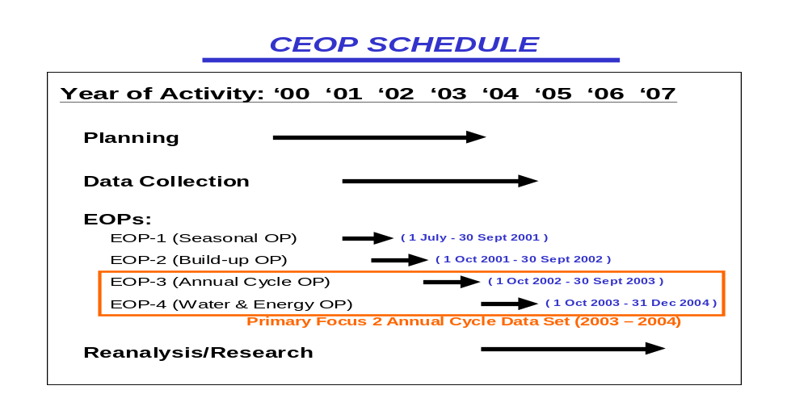
Figure 3: CEOP Implementation timeline
3.2.3 CEOP Connections to GEWEX and Endorsement of Focus on Diurnal Cycle

The GEWEX Continental Scale Experiments (CSEs), which have evolved under the auspices of the GEWEX Hydrometeorology Panel (GHP), are the basis for the CEOP International Reference Site Database. It is critically important that the interactions between CEOP and GHP be closely maintained. Dr J. Roads, Chair of the GEWEX GHP and Chair of the CEOP Water and Energy Simulation and Prediction (WESP) Working Group, agreed to work with the CEOP International Coordination Function to maintain the close relationship already built up between CEOP and GHP (action A3d).

It was agreed at the 2003 CEOP meeting that connections between CEOP and GEWEX are well established but that more direct involvement between the Global Land-Atmosphere System Study (GLASS), under the auspices of the GEWEX Modeling and Prediction Panel (GMPP) and CEOP, was necessary. As a result this year the Chair of GMPP, Dr J. Polcher, attended the CEOP meeting and reported that there were two areas of interest that overlap between CEOP and GMPP/GLASS. First, GLASS will use the CEOP time period and datasets to further advance its efforts under the Global Land Atmosphere Coupling Experiment (GLACÉ) where the intensity of surface/atmosphere coupling in coupled models will be compared. In a related manner, this work is also connected to the second phase of the Global Soil Wetness Project (GSWP-2) in which land-surface models will be evaluated globally in an “off-line” mode without any coupling. This work is being pursued by Dr P. Dirmeyer, Chairman of GLASS. Polcher also noted that the strategy for the future in GMPP will converge with CEOP in relation to the focus that CEOP and GMPP have determined to place on the diurnal cycle. In this context, the focus will shift to the interactions between the land-surface, the PBL and clouds leading to a specific “diurnal cycle theme”, which CEOP has also agreed to emphasize in its research phase. CEOP and GEWEX/GMPP agreed at the meeting to pursue mutually beneficial interactions around this theme. Polcher agreed to assist the CEOP International Coordination Function with this GEWEX/CEOP interface (action A3e).

As reported in the CEOP 2003 meeting the CEOP International Coordinator, is continuing to liaise with the Chairman of the other GEWEX Panel, the GEWEX Radiation Panel (GRP). Dr William Rossow, Chairman of GRP, was invited to participate in the CEOP 2004 meeting but was unable to attend. An action (A3d) to ensure cross communications between GRP, which has responsibility for GEWEX Global datasets and CEOP, is therefore on going.

3.2.4 CEOP Validation of Cold Season Parameters with CliC

The Chair of the CliC Science Steering Group (SSG), Dr B. Goodison, has been in discussion with CEOP to undertake a joint CEOP/CliC related initiative. Several of the CEOP stations are in regions where snow occurs. It is imperative that snowfall precipitation is measured to have a complete precipitation record for the CEOP study period. From initial data submissions, it is not clear that stations measure snowfall precipitation. This situation has resulted in Dr Goodison following up on an action from the CEOP 2003 meeting, which called for the development of a template for homogenization of the “snow” data from CEOP high latitude sites in concert with efforts by CliC to obtain and utilize such data in studies that link these sites. A questionnaire has evolved and has been placed on the internet by the CEOP Data Management Working Group Co-Chairman, Dr S. Williams. The questionnaire, at: http://www.joss.ucar.edu/cgi-bin/ceop/ceop_snow will provide basic background information for the CEOP Reference Site metadata file and will identify which sites can be used for development, validation and analysis of cold region observations, processes and modeling. Those Site Managers in CEOP that were contacted about this activity have been asked to respond to the questionnaire. Responses will be added to the metadata file. Further metadata may be requested after responses are received and reviewed.

According to Reference Site Data Sets, Submission Schedule, and Formats http://www.joss.ucar.edu/ghp/ceopdm/refdata_report/ceop_sfc_met_format.html CEOP sites are to provide 30 min incremental precipitation values in mm and snow depth in cm for EOP-3 & EOP-4. It is recognized that manual gauge measurements cannot be at this interval, and that processing algorithms may be at a longer interval. Data at a longer time increment are acceptable (e.g. 6-hourly synoptic) as CEOP wants a complete record. Similarly, snow course measurements may be made weekly or bi-weekly. The exact type of equipment must be stated; processing algorithms should be available for users. Gauge measurements of solid precipitation are subject to both random and systematic errors, the greatest systematic error is the under measurement due to wind. For adjustment, wind speed at gauge height is desirable (at same interval as precipitation measurement); otherwise it must be estimated from a wind measurement at a higher level. A good site diagram will be required. For reference, precipitation is reported in mm and snow depth in cm. Likewise, for snow courses, snow depth is cm and SWE in mm.

Drs Goodison and Williams accepted the action (A3f) to follow-up on this work and report progress on it by mid-2004.

3.2.5 Connections to CLIVAR for CEOP Monsoon Studies and Ocean Data Requirements

Koike reported that on 22 May 2003, he had met at NOAA’s, Office of Global Programs facilities at Silver Spring, Maryland USA with Dr Bill Murray: Climate Change Detection Project; and Dr Mike Patterson: Ocean Data Program Manager. The main points at these meetings were the connections to the global datasets from the GEWEX International Satellite Cloud Climatology Project (ISCCP) and Global Precipitation Climatology Project (GPCP) through the Climate Change Detection (CCD) initiative in OGP, headed by Dr Murray and access to the Global Ocean data sets available in connection with OGP support of CLIVAR ocean studies. The SSC/AOC was pleased to know about these interactions and asked Koike and the CEOP International Coordination function to undertake further action (A3g) to follow-up with Dr Murray to determine the viability of including elements of ISCCP and GPCP datasets in the CEOP data activity and to contact Dr Patterson again to determine the feasibility of obtaining an inventory and gaining access to appropriate ocean datasets from possible in-situ ocean reference sites for application to CEOP water and energy and monsoon studies. Selection of CEOP Ocean Reference sites could lead to the establishment of a formal CEOP Ocean component supported by USA and International CLIVAR groups. This work relates closely to the evolution of a CEOP Phase 2 as outlined in item 3.2.2 above, whereby these datasets might be part of the stewardship aspect of a second phase of CEOP dataset establishment.

Drs Lau, Mechoso and Marengo reported their agreement to move forward with a targeted CEOP Monsoon Workshop in South America that would take the form of a targeted CEOP Inter-Monsoon Model Study (CIMS) meeting for the South American monsoon to be held in September 2004, in conjunction with the GHP-10 meeting most in Montevideo, Uruguay. SSC/AOC endorsed the plan to move forward with this meeting, however, the participants reiterated their mandate to have this meeting connect with other work in this field of research particularly as associated with CLIVAR and other elements of WCRP. They also reiterated their broader directive to the CEOP Monsoon Systems Studies Working Group Co-Chairs, Drs Lau and Matsumoto, to have CEOP exploit its formal relationships with elements of CLIVAR, in this field, to specify the CEOP need to represent the ocean atmosphere interactions in its analyses. As stated earlier, CEOP needs to obtain sea surface temperature and ocean surface flux measurements through CLIVAR as a complement to the land surface data being obtained through the GEWEX CSEs. This requirement needs to be raised to the highest levels within the CLIVAR Panel structure and should emphasize the potential for mutually beneficial scientific and technical interactions including data coordinated data management and exchange, joint science workshops, and interdisciplinary interactions. Support for this effort was backed by Dr Howard Cattle Director of the International CLIVAR Project Office at the CEOP meeting in Berlin in April 2003. Lau agreed to ensure (action A3h) that such interactions are maintained as a high priority in the CIMS implementation plan and to interface with Dr Cattle to address the issues raised again during this year’s discussion on the matter. Feedback on the outcome of these efforts is expected by mid-2004.

In turn, Marengo and the CEOP International Coordination Function, accepted the action (A3i) to finalize a list of names for the organizing committee of the September 2004, South American CIMS monsoon workshop. A preliminary list of names for the organizing committee and a draft agenda are attached as Appendix D, for comment.

The SSC/AOC commended the CEOP Monsoon Working Group for reaching out to the general community in defining CIMS and providing a whitepaper that was generated at the initial CIMS targeted workshop and provided in a follow-up report on that meeting, which took place at IRI in September 2002 and also for continuing this outreach by scheduling another targeted Monsoon Workshop entitled "The Role of the Himalayas and the Tibetan Plateau within the Asian Monsoon Season", which took place at EPSON facilities in Milan, Italy, in April 2003. The report of that meeting has been tentatively scheduled for publication in the May 2004 issue of the Bulletin of the American Meteorological Society (BAMS).

3.2.6 CEOP Watershed Hydrology Component

The SSC/AOC joint meeting participants considered two options for fulfilling the need in CEOP to ensure that there are formal CEOP Reference Sites which observe directly most of components of the surface water budget (precipitation, streamflow, evapotranspiration, and surface and subsurface storage change) and that such data becomes part of the CEOP database.

Dr D. Lettenmaier provided a plan for a “grassroots” led CEOP/GHP CSE based effort to try to establish a consortium of sites globally at which there is both hydrologic information (precipitation/streamflow) sufficient to estimate a catchment water balance, and energy flux information that can or could in one way or another be transferred to the catchment.

As a result of a previous action an example summary for a sample site (Kyeamba Creek) was prepared and put on the Internet at: http://hydrology.princeton.edu/~luo/ceop.php. This example shows how data could be provided and includes a template for submitting the data. A contributor could modify/edit the Kyeamba Creek material to fit their special circumstances or could use the template to provide their own summary using the Kyeamba Creek summary as a guide. The work of establishing the web page was accomplished with the support of Dr E. Wood at Princeton University. The SSC/AOC endorsed this approach as an expedient method for getting the hydrologic component of CEOP started quickly. The key issue in the discussion was that the distribution of the request for contributions had been made to a selected group of researchers in catchments and basins that have not been in the main group of CEOP GHP/CSE points of contact.

The SSC/AOC asked Lettenmaier and Wood to continue to pursue this effort, but to take action (A4) to work with the CEOP International Coordination function to target site managers and CSE points of contact within the CEOP community to bring them more directly into the process of responding to the initial request sent out earlier by Lettenmaier. This request was accepted and work will be undertaken to follow-up on this activity as the main short term method of obtaining the desired Hydrological data for inclusion in the CEOP database. Dr Wood agreed earlier to answer any questions related to the process for filling out the template on the Internet (efwood@princeton.edu).

Koike presented the framework for a broader International approach to establish a Coordinated Enhanced Hydrology Data Collection Period that would provide a comprehensive and coordinated water cycle data set over land by adding river basin data to the on-going CEOP data sets in cooperation with elements of UNESCO and WCRP including GRDC, FRIEND, HELP and PUB. The SSC/AOC found this to be an interesting and helpful suggestion, but the felt that it would require a much longer time period to implement and, therefore, they tentatively endorsed it as a longer range activity to bring in data that could better define the CEOP hydrology component. Koike accepted action A4a, to work with the CEOP International Coordination Function to advance this concept and begin an effort to show how it could provide the broadest possible set of hydrological data for inclusion in the CEOP database in a timely manner. A report on progress of this effort will be due at the next CEOP meeting (Tokyo, Japan, 28 March-4 February 2005).

3.2.7 Final Framework Implemented for a CEOP Science Conference as Endorsed by the SSC

Following the SSC endorsement of the concept of CEOP undertaking a CEOP Science Study Conference associated each two years with the GAME Study Conference and which could begin in July 2004 with the next Asia-Oceania Geosciences Society (AOGS) event, Koike announced the establishment of a CEOP session “Monsoon System and Water Resources in Asia - Challenges by CEOP” session to be carried out in cooperation with the Asia Pacific Association of Hydrology and Water Resources (APHW). The session will emphasize the science that is being carried out within the CEOP International framework, which is contributing to improved understanding of Monsoon Systems and Water and Energy Simulation and Prediction (WESP) issues within the GAME region and which ultimately will add to the global issues in these
Fields. This session will take place at the 2nd APHW Conference, which will be held in Singapore jointly with the 1st AOGS Conference from 5-8 July 2004 at the Suntec International Convention and Exhibition Center, Singapore. There are now 21 submissions to the CEOP session as shown at: http://www.asiaoceania.org/papers/index_speakers_js.html. The AOC/SSC commended Dr Koike for organizing this session and asked him to undertake action A5 to report on the conclusions of the session in a brief report that could be circulated to the SSC/AOC members shortly following the meeting in July in Singapore.

3.2.8 CEOP Open Data Policy

The SSC/AOC felt it was urgent to ensure the community at large of the accessibly of CEOP coordinated datasets from all three CEOP archive locations, namely the UCAR/JOSS Central Data Archive for CEOP Reference Site Data; the Model and Data Group, Climate and Environmental Data Retrieval and Archive (CERA) System, at Hamburg, Germany, which is administered by the Max Planck Institute for Meteorology (MPIM); and the Satellite and Data Integration system at the University of Tokyo (UT), which is jointly administered by JAXA, JMA and UT. The data in these databases once they are placed on the Internet at each site have met the CEOP Data Policy Criteria previously established with the data providers and is then freely available to any and all users free of any costs, with the exception of possible modest expenses for mailing costs of any data that is requested other than through the electronic schemes set up by the administers of each of these system. The data users are asked to comply with the citing of the material and to use it in accordance with the CEOP Policies as noted in Section 4 below for the in-situ data, in Section 5 for the Satellite data and in Section 7 for the model data.

4. CEOP DATA MANAGEMENT WORKING GROUP DELIBERATIONS

Collection of the data from the CEOP Reference sites for the initial CEOP period (EOP-1) has shown that adherence by the sites to a consistent format is especially important to ensure an efficient continuation of the CEOP dataset development and delivery process.

This part of the meeting was organized by Drs Williams and Isemer, Co-Chairs of the CEOP Reference Site Data Management Working Group.

4.1 Prototype CEOP EOP-1 Reference Site Data Set Delivered on Schedule

An important part of the discussion included the current status of the Prototype CEOP EOP-1 Reference Site Data Set that was delivered, as planned, in early 2004 by the CEOP Data Archive (CDA) at UCAR/JOSS. The dataset(s) themselves have been placed on the Internet at: http://www.joss.ucar.edu/ghp/ceopdm/archive/eop1_data. There are three months of data (1 July-30 September 2001) from seventeen sites in a standardized CEOP format that had been agreed to at the CEOP Implementation Planning meeting in Berlin in April 2003. All the CSE Spokespersons, Goodison, Koike, Grassl/Isemer, Marengo/Horta, Huang/Williams and Depraetere or their representatives were commended for the work in getting the data delivered to UCAR/JOSS and Williams was also recognized for the work to get the dissimilar formats from the stations composited into a consistent format that could be easily applied in data analyses and model intercomparisons.

4.2 CEOP Data Policy Issues

The CEOP data policy was at issue recently in terms of the citation of the data from one of the CEOP Reference Sites that had been used in an analysis that was published in the CEOP Newsletter. The participants at the meeting agreed that the site managers have a very important input into the utilization of the data they provide to the CEOP Central Data Archive at UCAR/JOSS. Williams and Isemer reported that they have addressed the problem and their analysis of the situation was to acknowledge that the CEOP Data Policy addresses the very circumstances under which the particular case arose, but that it could be emphasized more clearly in the current document as it is posted at the CEOP Data Management Internet page.

Isemer has undertaken the action to revise the format of the Policy document by putting an executive summary at the front of the document and by highlighting, in a separate section the current wording that explains the citation policy, but which up to now had been included along with other issues in a related section. In addition, Williams noted that it would be possible for him to ensure that each request for data from the CEOP Archive would be accompanied, automatically/electronically, by a copy of the CEOP Data Policy.

The executive summary now included at the beginning of the document highlights the important elements of the document in the following manner:

(i) No financial implications are involved for the CEOP reference site data exchange. Section 2.1.
(ii) Commercial use and exploitation of CEOP reference site data is prohibited. Section 2.2.
(iii) Any re-export or transfer of the original data received from the CDA archive to a third party is prohibited. Section 2.3.
(iv) The origin of CEOP reference site data being used for publication of scientific results must be acknowledged and referenced in the publication. Section 2.5.
(v) CEOP reference site data users are strongly encouraged to establish direct contact with data providers for complete interpretation and analysis of data for publication purposes. Section 2.6.
(vi) Co-authorship of data users and CEOP reference site Principle Investigators on papers making extensive use of CEOP data is justifiable and highly recommended.
Section 2.7.

The participants felt that these changes were sufficient to address the situation, which had arisen without requiring any further modification to the CEOP Data Policy itself. This was a full endorsement of the work that had been carried forward by Williams and Isemer to negotiate a viable CEOP Data Policy. Only, a variation of the format and distribution process was necessary rather than a modification of the content or intent of the Policy itself.

Williams and Isemer did agree, however, to undertake an action (A6) that would address the further issue of generic and specific citations to be used for CEOP data that comes from the various CEOP reference sites. This action will include an effort to poll the Site Managers to get them to agree to the utilization of a generic citation or to craft their own specific citation for each of their sites or their for their group of sites. The result of this effort may be a CEOP Citation Table that can be provided to CEOP data users.

4.3 CEOP Reference Site Characteristics Table Update and Maintenance

In response to an earlier action Williams and Isemer did undertake an effort to address the further issue of applying the data in a uniform manner in analyses. Isemer reported to the participants the further need for a CEOP Reference Site Characteristics definition table or column in the current CEOP Reference Site Table that defines more realistically the actual physical description of each site in the context of its regional location. A further example of the need for this initiative was the decision to make the Lindenberg site into two sites a forest and a grassland site to account for the differences in data collected from two locations within the grid square that now defines the Lindenberg site. Isemer/Williams have accepted an action (A6a) to follow-up on this process of more precisely describing each site for the user community. This action also relates to the model output component of CEOP (See Item 8.3.1), to have the model characteristics of each site made available for comparison to the actual descriptions.

Williams reported that the CEOP Reference Site Characteristics Table at: http://www.joss.ucar.edu/ghp/ceopdm/rsite.html contains the newest information (locations, descriptions, maps, site contacts, sample data sets, instrumentation, parameters measured, etc.) available from the site managers and CSE points of contact. He is willing to respond to any questions about the completeness of the table at the current time or will refer any issues to an appropriate contact person at the sites.

4.4 EOP-3 Dataset Development Process and Decision on EOP-2

As a general policy, for EOP-3, the CDA at UCAR/JOSS has decided to post individual sites as the data become available rather than waiting for a complete composite dataset to be developed and released in its entirety. Also, the CDA will fix what they consider to be “minor” issues with individual data submittals rather than send every submission with any minor problem back to the provider. The providers will be notified of the “fixes” when they are made.

It had already been agreed that an initial composited annual cycle dataset in line with the CEOP data policy would define the CEOP EOP-3. Data collected during the first half of the annual cycle (October 2002 through March 2003) was to be submitted to the CDA, in the agreed to format, so that Category 1 data would arrive on or before 1 October 2003 and Category 2 data would follow on or before 1 June 2004. The status of accomplishment of this agreement is noted in the summaries given below.

It was reiterated at the meeting that the second half of the annual cycle (April 2003 through September 2003) was to be submitted to the CDA, in the specified format, so that Category 1 data would arrive on or before 1 April 2004 and Category 2 data would follow on or before 1 December 2004.

All the CSE Spokespersons, Goodison, Koike, Grassl/Isemer, Marengo/Horta, Huang/Williams and Depraetere or their representative was given action A6b to meet these submittal dates.

In the discussion about filling the gap between EOP-1 and EOP-3 it was again confirmed that the priority must stay with the emphasis on the annual cycle data sets as noted in the current planning process. Several sites were not collecting data during the CEOP build-up period from 1 October 2001 to 30 September 2002 and the agreements with NWP centers and space agencies for model output and satellite data respectively were not yet in place. It was, therefore, agreed that the opportunity to provide a larger database with a consistent set of sites and coordinated model and satellite data over the two annual cycle periods covered by EOP-3 and EOP-4 was going to remain the highest priority for the CEOP Data Management Working Group. The action (A6c) to investigate and report on what data could be available during EOP-2 was given to the CEOP Phase 2 implementation planning team set up under item 3.2.2 above. The participants agreed that the final decision of whether or not to populate the CEOP database with whatever data may be available from the EOP-2 period in order to provide a consistent three and one half year CEOP dataset was to be tabled until the Phase 2 implementation planning team can complete this action and report back to the SSC/AOC with their recommendation by the time of the next CEOP meeting at Tokyo in March/April 2005.

4.5 Reference Site Status Reports

Williams has followed up with information he received at the meeting and since and prepared the following summary of the status of the contributions to EOP-3 as of 22 March 2004:

BALTEX – Has only minor problems remaining and these are to be posted on the Internet by the end of March. The second half of EOP-3 has been discussed and an initial transfer from the BALTEX sites of this data is expected soon. Dr Isemer continues to be the CEOP point of contact for these sites and has accepted the action to ensure the data are provided as requested.
CATCH/AMMA – All the data that has been submitted (hourly precip and streamflow) have been posted on the Internet. Automatic weather station (AWS) data have been discussed and is expected to be provided in due course. Dr Christian Depraetere has the action to follow-up with Williams on this matter.

CAMP – A number of issues were discussed at the meeting with the head of the CAMP Central data facility at the University of Tokyo. It is expected that the items at each site, which continue to persist will be reconciled soon and the data provided as requested. Drs Koike and Tamagawa have the action to ensure these data are provided as previously agreed to.

GAPP - The bulk of the data from these sites is available with only a few minor issues remaining that are associated with a subset of the sites. These issues are expected to be resolved by the end of April 2004. In specific, documentation for some of the sites is still lacking and data from one site has still not been processed. Dr J. Huang has the action to continue to ensure that the data from the GAPP sites is provided as agreed to earlier.

LBA – Discussions at the meeting have led to an agreement to attempt to finalize the work required for LBA to meet its commitment to provide the data that is required by CEOP. At the moment there are a number of issues that persist with the data that need to be resolved soon if the data from these sites are to be included in the CEOP database in a timely manner. Drs Marengo and Horta have the action to see that the LBA commitment is honored.

MAGS - Only a few minor issues remain with the data provided by the MAGS sites. The corrected data should be at UCAR/JOSS and posted on the Internet by the end of April 2004. Dr B. Goodison has the action to ensure the MAGS commitment to CEOP is met.

4.6 CEOP Data Management Breakout Session Notes

Further details of issues raised and addressed by the CEOP Working Group during its breakout session at the meeting can be found in Appendix E. The actions not specifically mentioned in the body of the report are being given further consideration by the Working Group Co-Chairs. Williams and Isemer, have the action (A6d) to follow-up on any open issues from the breakout session and to work to close them in due course as agreed by the breakout group participants.

5. SATELLITE DATA INTEGRATION WORKING GROUP DELIBERATIONS

Work is continuing on the satellite data integration aspect of CEOP. Dataset documentation and background information has been made available at the following Internet page: http://monsoon.t.u-tokyo.ac.jp/camp-i/doc/sat_info/index.htm.

5.1 CEOP Satellite Data Set Collection and Implementation

Dr Umezawa of JAXA presented the latest status on the activity being undertaken at JAXA in coordination with the University of Tokyo and the Japanese Meteorological Administration to provide CEOP satellite datasets for integration with the CEOP in-situ and model output data. Figure 4 is the satellite data collection schedule that is currently being implemented by JAXA. A further breakdown of the collection and preparation process was provided that highlighted the types of satellite-geophysical products that are going to be provided. These were broken down into the following categories:

(i) TRMM/TMI、PR・・・Rain, Cloud liquid water…
(ii) ADEOS-II/AMSR, GLI・・・Sea surface temp., Wind speed, Water vapor, Soil moisture, Snow, Vegetation, Cloud parameter…
(iii) Aqua/AMSR-E・・・similar to the AMSR products
(iv) DMSP13-15/SSM/I・・・Soil moisture, Snow…

The processing levels were also defined to ensure a clear understanding of the nomenclature and reduce ambiguity in the statement of requirements. The Levels of processing have been established to be:

[Level-1B] - Radiance variable with full resolution at reference sites. (In case of a microwave radiometer, the data are converted to brightness temperature)
[Level-2] - Geophysical variables at the same resolution and location as the Level-1B.
[Level-3] - Statistical variables in space and/or time at reference site, monsoon regions and global. (example: Monthly mean rain rate at reference sites, etc.)

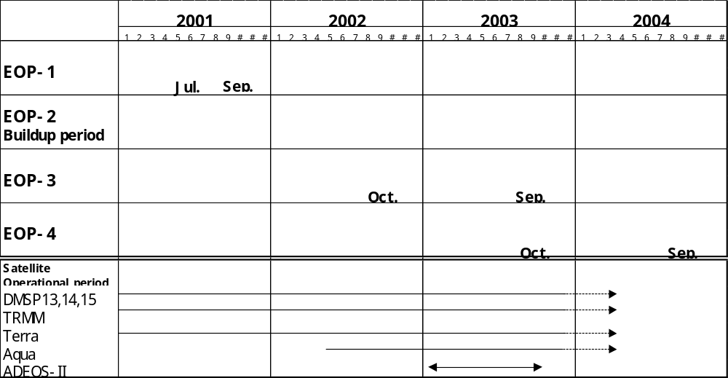

Figure 4: Satellite Dataset Collection Schedule

The current status of the actual processing of the datasets was presented as shown in the Figure below (Figure 5):

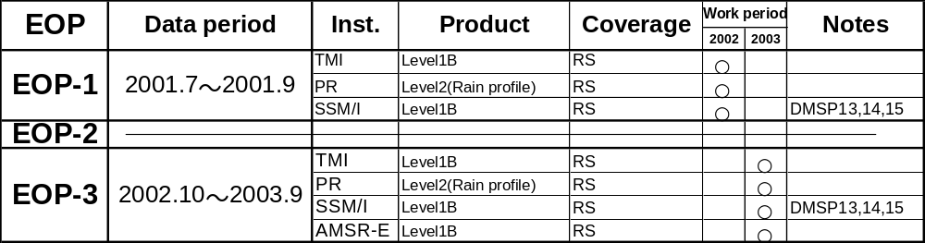

Figure 5: Current Status of Dataset Production

Figure 6 is an example of the types of products being readied by JAXA for CEOP EOP-3. It is a scene for a specific CEOP reference site with, date time stamp of 3 October 2002 at 7:56 UT. Figures 7 and 8 show the processed satellite instrument datasets for CEOP EOP-3 and the satellite instrument data production plan.
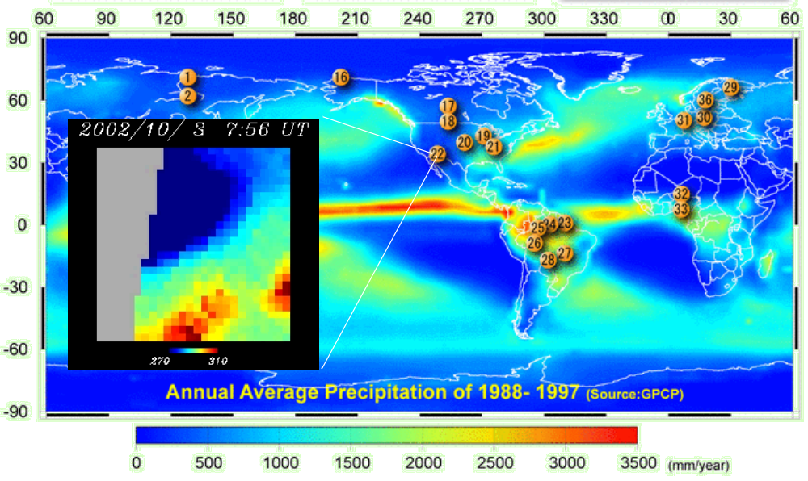
Figure 6: Example of CEOP EOP-3 Processed Datasets
Instrument | Product | Amount (Scenes)
TRMM/PR | Level-2 Rain | 4,516
TRMM/TMI | Level-1B | 15,756
DMSP13 SSM/I | Level-1B | 19,370
DMSP14 SSM/I | Level-1B | 18,364
DMSP15 SSM/I | Level-1B | 19,268
Aqua/AMSR-E | Level-1B | 19,966
Figure 7: Processed Satellite Instrument Datasets for CEOP EOP-3
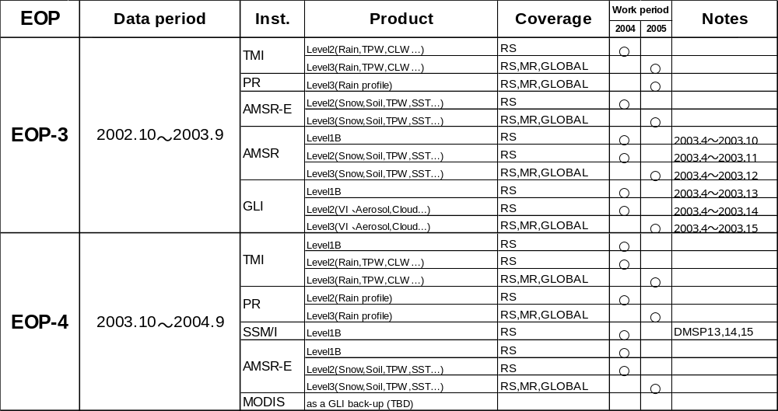

Figure 8: Satellite Instrument Dataset Production Plan

Drs Koike and Matsuura have accepted the action (A7) to continue to lead this component of CEOP and to resolve any remaining issues associated with its successful implementation for the EOP-3 and EOP-4 time periods including the pursuit of a strategy for compensation of loss of ADEOS-II satellite data (See item 2.6.1 above).

5.2 CEOS Working Group on Information Systems and Services Test Facility (WTF)

Of special significance, in the CEOP satellite integration implementation, is the continued development of the JAXA promoted, CEOS/WGISS CEOP Test Facility that will provide the means to integrate specific in situ, satellite and model data in 250Km x 250Km grid squares centered at each CEOP reference site and to make the data available by means of an Internet server scheme. This system was initially demonstrated at the end of 2003.

Drs McDonald, Enloe and Burford reported at the meeting that their had been a discussion of a CEOP WGISS Test Facility (WTF) in December 2003 following the CEOP Session at the American Geophysical Union (AGU) Meeting in San Francisco and as a result, the first in a possible series of international conference calls related to the development of the CEOP WTF was organized by Dr Osamu Ochiai on 11 February 2004. An initial document outlining guidelines for the implementation of the WTF was distributed in advance of the call. At that time it was agreed to accept the definition of data integration that was noted in the document to be the need to access multiple types of data such as in situ data, satellite data and modeling output data from many sources. The CEOP community understands that data Integration requires services that support the inter-comparison of data and that multiple tools and services are needed to perform data integration.

The document as presented at the Irvine meetings further notes that an “integrated dataset” will be composed of multiple files, at least one file for each individual member dataset in the integrated dataset. The individual datasets that compose the integrated dataset can be located at one physical location or can be located at distributed sites referenced by links. The individual datasets that compose the integrated dataset will be at least one of each type: model output data, in situ data, and satellite data. The integrated dataset will be subsetted for the area of interest and time range of interest.

Following discussion of the document at the meetings Drs Enloe and McDonald accepted the action (A8) to revise the document and re-distribute it in due course for further comment and further revision, while at the same time moving forward with the basic design outlined in the current version of the document for the WTF.

6. CEOP MODEL OUTPUT DATA DEVELOPMENT STATUS

As an on-going element of CEOP regular telecons are held to promote discussions with the spokespersons of the NWP Centers that are contributing to CEOP. As a result of these calls and the level of maturity reached in the implementation of this component of CEOP it was agreed to organize a CEOP Model Output and Analysis workshop at the University of California at Irvine (UCI) on 8-9 March 2004 in conjunction with the CEOP Third International Implementation Planning Meeting that was held at the same venue from 10-12 March 2004. The CEOP International Coordination function had followed up on an action to produce an agenda for the March 2004 CEOP Model Workshop and to distribute it for comment with a letter of invitation to all the members of the CEOP Model Output implementation team. The final version of the agenda/timeline is included in Appendix F. Representatives from all the participating Centers participated in the CEOP Modeling Workshop including Drs P. Viterbo (ECMWF), K. Mitchell (NCEP), J. Marengo/S. Chou (CPTEC), L. Rikus (BMRC), M. Bosilovich (GMAO; formerly DAO), M. Rodell (GLDAS), S.Milton (UK Met), Roads/Ruane (ECPC), G. Iyengar (NCMRWF), and T. Matsumura (JMA), and S. Belair (Environment Canada). Dr F. Toussaint participated in the meeting representing the Model and Data Group that is handling the archiving of CEOP model output products under the administration of the Max Planck Institute (MPI) at Hamburg. Drs Williams and Isemer participated in the Workshop on behalf of the CEOP Data Management Working Group and Dr B. Rockel participated as a representative of GKSS and as a “user” community representative.

The “Model Output and Information” link at: http://www.joss.ucar.edu/ghp/ceopdm/model/model.html continues to be updated with new information. The site is also linked through the CEOP Data Management Web Page: http://www.joss.ucar.edu/ghp/ceopdm/, which also continues to be updated with new information about CEOP. Each CEOP Model Output Center Spokesperson is expected to routinely review the material at CEOP Model Output Web page noted above to ensure that it is current for their specific Center.

Since application of the CEOP dataset(s) to model validation has become a critical element of the CEOP science framework a web page has been established by the Tokyo CEOP Secretariat Office where results of CEOP model inter-validation efforts can be staged. Several of the presentations made at the Workshop have been seen in earlier forms on the web page. Therefore, as another on-going action all of the participants agreed to place their own findings and to check the results of others at the CEOP Model Validation Studies Results Internet Page: http://monsoon.t.u-tokyo.ac.jp/ceop/model/telecon/. It is expected that all the participants will compare the results of the various activities that have been accomplished or which are still underway.

6.1 Administration of the CEOP Model Output Archive by the Max Planck Institute (MPI)

In the initial discussion, it was noted that it was necessary to establish a formal description of the CEOP data archive that is being compiled in Hamburg. A written input had been provided by Prof. Hartmut Grassl head of the Max-Planck Institute for Meteorology (MPIM) at Hamburg resulted in the following clarifying statement which all the participants at the workshop were urged to familiarize themselves with so that there is a clear understanding and agreement on how to cite the work being carried out for CEOP at the facility at Hamburg.

The CEOP NWP Model Output Archive is part of the ICSU World Data Center for Climate that is housed at the German Climate Computing Center (DKRZ) at Hamburg, Germany. The Model and Data Group, a service provider for the German Climate Research Community, is in charge of handling, archiving and disseminating the data. This group is administered by the Max-Planck Institute for Meteorology (MPIM) at Hamburg and supervised by a national steering group, responsible for both the Model and Data Group and the Computing Center.

6.2 Priority Actions and Recommendations Highlighted at CEOP Model Workshop

All of the participants at the Workshop agreed that the priority activities necessary for the Model Output Component of CEOP to succeed fell under two major headings related to production and handling of data (i.e. production, transfer, archiving, accessing) or to utilization of data in analyses. These two main topics are related to three specific action items that were acknowledged by the contributing centers at the meeting(s) and accepted as generalized action A9:

(i) For all contributing centers to achieve routine transfer of data (push or pull) by electronic means (FTP) to/from MPI for placement in the CEOP Database,

(ii) For all contributing centers to access CEOP Model Output Database at MPI through their web-page at: http://www.mad.zmaw.de/CEOP or through the CEOP Data Management Page Model Output and Information section.

(iii) For all contributing centers to access CEOP dataset(s) including in situ, model and satellite and use it in model intercomparison/validation exercises to improve model parameterizations and predictability.

6.3 Data Handling: Sample Data Transfer

Reports provided during the meetings made it clear that the transfer aspect of the data handling effort has been progressing well and data from at least five Centers (NCEP, JMA, UKMO, ECMWF, and ECPC) have been received and put into the database at the Hamburg facility, nearly completing this action for all the participants. The status was provided during the Meetings at Irvine, by Dr F. Toussaint, and Table 3 below is the chart of the status of the receipt of data and placement in the CERA database at that time.

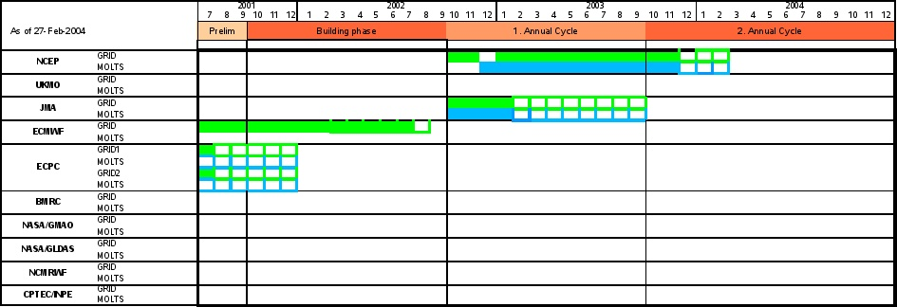

Table 3: Status of CEOP Model Data Archived in the CERA Database at Hamburg. (The boxes that are not filled in on the chart represent data received at the database facility but not yet placed on the database itself.)

Toussaint agreed to ensure that this status chart would be kept current and would remain available on the Model and Data Group CEOP Model Output Internet Page to reflect the latest contributions from all the Centers.

Model output data is arriving at a modest pace. All data providers have already received an account for data upload on the file server (schauer.dkrz.de) set up by the Model and Data Group at Hamburg. However, it is still necessary to remind all the representatives from all the contributing Centers who participated in the CEOP Modeling Workshop including Drs P. Viterbo (ECMWF), K. Mitchell (NCEP), J. Marengo/S. Chou (CPTEC), L. Rikus (BMRC), M. Bosilovich (GMAO; formerly DAO), M. Rodell (GLDAS), S.Milton (UK Met), Roads/Ruane (ECPC), G. Iyengar (NCMRWF), and T. Matsumura (JMA), and S. Belair (Environment Canada) to take the action (A9a) to access CEOP Model Output Database at MPI through their web-page at: http://www.mad.zmaw.de/CEOP or through the CEOP Data Management Page Model Output and Information section. If there is still any doubt about the procedure for putting data out to the server they should not hesitate to contact Dr Hans Luthardt (Luthardt@dkrz.de).

6.4 MOLTS Vertical Profile Data: Transferred in ASCII - distributed with a Conversion Utility

It was decided at the Workshop that there would be an effort to standardize the format of the MOLTS output that are being generated at the Centers and sent to the CERA database for archiving. There has been an on going effort to look into what, if any, impediments there are to transferring and using MOLTS profile data in American Standard Code for Information Interchange (ASCII) format.

It was argued that there are advantages to handling the MOLTS in a different format, such as network Common Data Form (netCDF). It was noted that other groups such as the GCM development community use netCDF and that the netCDF structure is one that is more “user friendly” when it comes to accessing and handling of MOLTS type data. Another benefit is that MPI would not have to process MOLTS data prior to its storage in the CERA database. In addition monthly files in netCDF would be more reasonable in size for downloading purposes. Using netCDF would mean, however, that retrieval could be only by site and only by all days for a specific month. It would also mean that either the MPI administered Model and Data Group, at Hamburg, or the Centers that have been sending their MOLTS output to the database in ASCII would have to convert the data already sent/received and for the Centers it would mean converting over to a new file structure from a given point onward.

These drawbacks were determined to outweigh the benefits to a change to netCDF as the CEOP MOLTS standard format. The recommendation was rather to settle on the ASCII structure where there is one column per parameter and one line per event in time (one line per level per event in case of atmospheric data) would be settled on as the CEOP quasi standard MOLTS format. This structure is used by ECMWF and NCEP and is now being recommended for use by all the other contributing Centers for formatting and transferring their MOLTS output to the CERA CEOP database. Representatives from all the contributing Centers who participated in the CEOP Modeling Workshop including Drs P. Viterbo (ECMWF), K. Mitchell (NCEP), J. Marengo/S. Chou (CPTEC), L. Rikus (BMRC), M. Bosilovich (GMAO; formerly DAO), M. Rodell (GLDAS), S.Milton (UK Met), Roads/Ruane (ECPC), G. Iyengar (NCMRWF), and T. Matsumura (JMA), and S. Belair (Environment Canada) have the action (A9b) to undertake to ensure their MOLTS output is provided to the CERA database in ASCII format.

In an effort to acknowledge the value of netCDF, particularly to the user community, work going on at ECMWF, as reported by Dr P. Viterbo, during a remote presentation, which he made during the Workshop was recognized and encouraged to be continued. In specific, Dr Viterbo has agreed to undertake action A9c, to follow through, as soon as possible, with the plan to provide:

- A tool to convert ASCII MOLTS into netcdf is under preparation and will be offered for trial by interested groups

The end result would then be a utility program that would be made available to everyone who prefers to have the MOLTS in netCDF. The converter is driven by a table to get the necessary information for the netCDF header.

6.5 CEOP Model Data Accessible to the Science Community at Large

The issue of open access to the model data was addressed by the CEOP SSC/AOC joint meeting participants (See Section 3.2.8). The statement by the SSC/AOC that data at the three CEOP Data Archive Centers was to be made freely available to all scientific users was fully welcomed by the CEOP Model Output Working Group members and all the contributors to the CEOP model output development process. To ensure that this concept is accepted by all the contributing Centers Dr F. Toussaint accepted the action (A9d) to get in touch with all the main points of contact of all data contributors to the model output element of CEOP to be sure they are aware of and agreed to policy.

6.6 Codes and Metadata

With the GRIB formatted data and with much of the MOLTS model output, as well, each parameter is identified by its “Code Number”; users of the data need to know the projection, between each parameter and its code identifier. It was agreed at the meeting(s) that the Model and Data Group (M&D) at Hamburg must offer these code tables together with the data at the time a request is made.

To meet this requirement is necessary for every contributing Center to provide M&D with a code table applicable to the data they transfer to the database. Therefore, representatives from all the contributing Centers who participated in the CEOP Modeling Workshop including Drs P. Viterbo (ECMWF), K. Mitchell (NCEP), J. Marengo/S. Chou (CPTEC), L. Rikus (BMRC), M. Bosilovich (GMAO; formerly DAO), M. Rodell (GLDAS), S.Milton (UK Met), Roads/Ruane (ECPC), G. Iyengar (NCMRWF), T. Matsumura (JMA), and S. Belair (Environment Canada) have the action (A9e) TO PROVIDE M&D WITH THE LOCAL CODE TABLE or to designate someone to perform this task and to be ready to answer questions of the data end users on parameters and their units, or to have someone they designate be ready to answer these questions. This requires consent to have their or their designates full name and related coordinates, with an email box posted on the M&D CEOP web site.

As a way of noting the extent to which this action requires the attention of the CEOP contributing centers M&D provided the code tables received so far are posted at the M&D CEOP Internet page: http://mad-web.dkrz.de/CEOP/ceop_overview.html.

In an attempt to make the status more clear, Toussaint has provide a status table of the CEOP Data and Code information (See Table 4 below). As can be seen from the cross reference of CEOP time/data periods by institute specific codes, the incoming data does not fully cover the CEOP required codes.

Center MOLTS data GRIB data Code Tables

NCEP 12/01/2002-03/29/2004 10/01/2002-03/29/2004 x
UKMO 10/01/2002-10/31/2002 10/01/2002-10/31/2002 x
NASA-GMAO - (07/01/2001-09/30/2001) -
NASA-GLDAS - - -
JMA 10/01/2002-09/30/2003 10/01/2002-09/30/2003 x
BMRC - - -
ECMWF - 07/01/2001-08/31/2002 x
NCMRWF - - x
ECPC - SFM:07/01/2001-07/31/2001 -
RII:07/01/2001-07/31/2001 -
CPTEC/INPE - - -

Table 4: Data and Code Tables sent to M&D up to the Current Time.

6.7 Status at Contributing Centers

In addition to the documentation on the Internet serving as a focus for the discussions in this element of CEOP, each Center Representative at the meeting gave a brief status of their progress with regard to implementing the baseline set of CEOP model output requirements. More detailed information including some results from analyses are provided in Appendix G.

6.7.1 M&D and MPI

Dr F. Toussaint reported that work is continuing at M&D/MPI to accommodate the CEOP requirements. He noted that data transfers had been accomplished between MPI and seven of the contributing Centers. The formal status has been presented in Table 3 above

Details of the main issues under consideration by the CEOP Team at M&D in Hamburg were highlighted during the meeting. The main technical issues still facing M&D were addressed in Items 7.1-7.6 above that included knowing the correct administrative structure associated with M&D and its relationship to MPI in the handling of CEOP Model Output Data; having all contributors understand and review the data transfer process; reaching agreement on a quasi standard format for CEOP MOLTS data; ensure free access to the database for all scientific users; the provision of applicable codes and metadata tables to M&D by the CEOP model output data contributors.

6.7.2 BMRC

Dr Rikus reported that BMRC was still readying the first 3 months of MOLTS output for transmission to MPI, but that this action and generation and transfer of gridded data were still being delayed by a minor processing issue. The first six weeks of data are being repackaged for transmission in the near future. Rickus is continuing to work on the validation of the data and the establishment procedures for CEOP production runs on a routine basis.

6.7.3 JMA

Dr Matsumura reported that JMA had produced MOLTS and GRIB data up to the end of CEOP EOP-3. These have been successfully sent to the CERA database. Work was progressing on subsequent months (1 October 2003 onward).

6.7.4 ECPC

Dr Roads noted that ECPC successfully transferred six months of data starting with 1 July 2001. The data are being generated continuously from the start of EOP-1 and are being sent to the CEOP Database as they are completed and packaged for transfer.

6.7.5 GMAO

Dr Bosilovich reported that he had an immediate proposal that had been funded that would extend work currently underway as well as provide the basis for new studies that would contribute to CEOP data and science related goals. A special application effort related to seabloom was one of the newer initiatives that may result in a new proposal and hopefully new funding. This work was being undertaken in concert with other groups at GSFC including the Earth Science Data and Information System (ESDIS) Project under the direction of Dr Ken McDonald.

Dr Bosilovich identified a potentially important tool for CEOP Model Data Output activities that he and others were going to begin exploring. The new capability has been identified at the “Lambda” optical network that has been funded by the NSF in the USA. The network is limited to only a short distance near Washington DC but there are plans to extend it to Scripps, GSFC and the University of Maryland. This would possibly allow extremely fast data transfers between these facilities and would provide evidence of a proof of concept that could give support to extending the network further and perhaps even internationally. Dr Bosilovich agreed to provide more information on this and a related “Starlight” network to the CEOP model output contributors as it becomes available.

6.7.6 NCEP

Dr Mitchell reported that production of CEOP model output products at NCEP is continuing and that routine connections with M&D/MPI are being maintained. There is a high level of confidence at NCEP in their CEOP model output strategy and in the significance of the progress NCEP has made toward the Model Output component of CEOP up to the current period. In addition, NCEP's model validation and assessment against CEOP reference site data has been progressing in positive ways and the results are having an impact on the overall NCEP forecasting process.

6.7.7 Met Office

Dr Milton reported that the UK Met Office had demonstrated their ability to access the data at M&D/MPI and to successfully transfer data to the CERA database. However, the three months of data that had been entered on to the database and was shown to be in the system at an earlier time had been recalled and taken off the database at the Met Office’s request. This explains the difference in the status at the time of the meeting as shown in Table 3 above and in earlier reports presented prior to the time of the meeting. The data had been found to have some inconsistencies, which require reprocessing. The CEOP data processing scheme at the Met Office has therefore been restarted.

6.7.8 ECMWF

In a presentation given remotely by conference call to the meeting from ECMWF, Dr Viterbo reported that all era40 fields should be available now on the M&D/MPI server. This was verified by the status shown in Table 3 above. As noted earlier the era40 covers only up to August 2002, however, a rerun of more recent years is planned to start later this year, covering 1990-present, to be continued in near-real time. For the MOLTS, the list of variables has been defined and data for era40 to be produced in April, and delivered in ASCII, then data for operations will follow, with updates at the end of each month. As noted in Section 6.4 above, a tool to convert ASCII MOLTS into netcdf is under preparation and will be offered for trial by interested groups. The ECMWF data could be available in both formats (ASCII and netcdf).

6.7.9 GLDAS

The Global Land Data Assimilation System (GLDAS) was represented at the meeting by Dr M. Rodell, who reiterated the work by GLDAS to produce products of importance to CEOP. The details of the long-term runs underway and planned included the following points:

GLDAS now has a LIS/Noah run going at 1 degree resolution that will cover the period 1January 2000 to present. The year 2000 GDAS forcing is now complete, enabling this run to be undertaken. Other CEOP researchers are interested in 2000, even if it's not a CEOP year. Debugging of a version of LIS, which can be forced by the Berg bias corrected ECMWF and NCEP/NCAR reanalysis forcing, is underway. When that's done a 1/2 degree run from 1/1/1979 to 1/1/2000, will be undertaken and then resolution will be increased to a 1/4 degree from that point to the present. Further discussions will lead to new MOLTS, etc. to be produced by GLDAS for CEOP.

The first of the GLDAS simulations mentioned above has the following characteristics:

Model: Noah

Resolution: 1 degree, 15 minute timesteps, 3-hourly output Subgrid variability: Each vegetation class (UMD definition) that encompasses at least 10% of a grid square is modeled as a subgrid tile. However, at this point the 3-hourly output is averaged over the grid squares and the results for individual tiles are only kept for the state variables in the daily restart files. Initial states: Quasi-climatological average for 21Z 1 January calculated based on a 15 year (1979-93) GLDAS/Noah simulation at 2 x 2.5 degree.

Forcing:
1 Jan 2000 - 31 Dec 2000: GDAS only
1 Jan 2001 - 28 Feb 2001: GDAS + disaggregated CMAP precip
1 Mar 2001 - present: GDAS + CMAP + AGRMET radiation

As soon as the LIS/GLDAS driver is set up to input the Berg et al. (2003) bias-corrected reanalysis ECMWF (1979-93) and NCEP/NCAR (1985-99) forcing, another Noah simulation will be run to replace that described above, which will be continuous from 1979 to present. The new simulation will be 1/2 degree resolution through 1999 and 1/4 degree from 2000 forward. The reasons for running at 1/2 degree for the first part are that the forcing data are 1/2 degree and that the savings in run time and disk space for output are significant. GLDAS also plans to do similar runs with the VIC, Mosaic, and CLM2 LSMs, but the pace at which those will be completed will be limited by CPU time and possibly disk space. It was agreed that GLDAS would maintain close communication with NCEP as far as the use of the Noah model was concerned, to ensure there were no issues with GLDAS starting with that LSM versus others that might be available.

6.7.10 NCMRWF

Dr Iyengar reported that NCMRWF will provide the model output data for the EOP4 period 2003-2004 from the current operational version of the T80/L18 analysis-forecast system and that the interface between NCMRWF and MPIM has been activated. The analysis fields provided will be valid for 00, 06, 12 and 18UTC. These fields will contain only the 3D atmospheric variables on 15 pressure levels and Surface Pressure. The forecast fields provided will also be valid for 00, 06, 12 and 18UTC. The forecast fields will have the 2D surface fields in addition to the 3D fields. The details of the forecast fields were given at the meeting and are provided in the following table (Table 5). The gridded data will be in the GRIB format that ECMWF uses (NCMRWF acknowledged the support of ECMWF in their provision of the GRIB software. The MOLTS data will be provided in ASCII format as agreed in Item 7.6 above.

Table 5: The details of the data that is to be provided by NCMRWF to M&D/MPI.

CEOP Code number | Variables requested by CEOP |  | NCMRWF  Code number
 | Top of Atmosphere Processes | Units
1 | shortwave downward flux (positive) | W/m^2 | 212
2 | shortwave upward flux (positive) | W/m^2 | 178
3 | longwave upward flux (positive) | W/m^2 | 179
 | Atmosphere Variables
4 | temperature | K | 130
6 | moisture | kg/kg | 133
7 | zonal wind | m/s | 131
8 | meridional wind | m/s | 132
10 | geopotential height | gpm | 156
11 | pressure velocity | Pa/s | 135
 | Atmosphere Processes 3D
 | large scale heating | K | 217
15 | convective latent heating rate | K | 216
 | diffusive heating | K | 215
21 | short-wave heating rate | K | 153
22 | long-wave heating rate | K | 154
 | Vertically Integrated Atmos. Variables
42 | surface pressure | Pa | 152
 | Vertically Integrated Processes
48 | precipitation (total) | kg/(m^2s) | 228
 | convective precipitation | kg/(m^2s) | 143
 | Surface Variables
59 | 2-meter temperature | K | 167
60 | 2-meter specific humidity | kg/kg | 168
61 | u-component at 10 m | m/s | 165
62 | v_component at 10 m | m/s | 166
65 | Soil moisture | m | 140
67 | snow depth | m | 141
69 | planetary boundary layer height | m | 159
 | Surface Processes
72 | longwave downward flux (positive number) | W/m^2 | 175
73 | longwave upward flux (postive number) | W/m^2 | 177
74 | sensible heating (positive upward) | W/m^2 | 146
75 | latent heating(positive upward) | W/m^2 | 147
 | Net Short Wave Flux at surface | W/m^2 | 149
 | Miscellaneous
95 | surface albedo | % | 174
98 | total cloud cover | % | 162

6.7.11 CPTEC

Dr. Sin Chan Chou reported that an initial formal contact with Hamburg Model and Data Group is planned to take place soon, and an initial transfer of data will take place in the near future as well primarily based on the information that was obtained through face to face discussions at the CEOP Model Output Development and Implementation Workshop. A detailed plan for the CPTEC contribution to CEOP will be provided soon after the first data transfer is successfully achieved.

7. CEOP WATER AND ENERGY SIMULATION AND PREDICTION (WESP) ISSUES

Dr J. Roads, Chair of the CEOP WESP Working Group noted that the current in situ and model output production within CEOP looks promising for various individual science investigations. WESP has undertaken to have each of its sub-project activities, namely the Water and Energy Budget Studies that began in GEWEX; the Transferability Experiments Working Group and the Land Data Assimilation (LDAS) effort sharpen their scientific objectives and strategies.

Roads highlighted the work in the model output component of CEOP as being critical to WESP meeting its main objectives, especially the GDAS and GLDAS evaluations are that are getting underway at various Centers that are contributing to CEOP (See Section 6.7.9 above). This work can not be fully taken advantage of without further development of the remotely sensed data component of CEOP. The tools and plans for the delivery of such data as reflected in Section 5 above are necessary for the WESP activities to proceed in an efficient manner.

WESP is also seeking to link activities beginning at individual centers into coordinated exercises within CEOP. As an example the LDAS and Transferability projects/experiments should act to bring together a number of land surface and regional model studies respectively. WESP is, therefore, strongly supportive of a framework for coordinating projects that involve global analyses contributions to CEOP. This would be a type of “independent” evaluation using a commonly accepted protocol for testing model performance such as the Atmospheric Model Intercomparison Project (AMIP) and related initiatives.

In this context, Dr J. Potter gave the participants an updated status of the latest aspect of AMIP, which is evolving into a new model evaluation framework known as the CCPP-ARM Parameterization Testbed or CAPT. The work is being carried out at the Lawrence Livermore National Laboratory (LLNL) with the National Center for Atmospheric Research (NCAR). CAPT combines the strengths of two Department of Energy (DOE) programs with complementary missions, namely CCPP (Climate Change Prediction Program) with a focus on GCM climate performance and ARM (Atmospheric Radiation Measurement) with a focus on column observations of radiation & cloud processes and their parameterization in GCMs. Because CAPT is fostering collaborations between GCM developers (e.g. in CCPP) and parameterization specialists (e.g. in ARM) it is synergistic with CEOP. The basic philosophy of CAPT includes: studying progression of the model’s drift away from initialization; short simulations; errors are most likely to be found in the parameterization of physics (not large scale motions) and it directly compares results to intensive observations, providing another direct connection to CEOP. Figure 9, below shows how CEOP WESP and CIMS (See Item 8. below) may connect. Drs Roads and Lau agreed to coordinate with Dr Potter on the links between CEOP and CAPT (action A10).

Climate model validation using NWP approach
CCPP-ARM Parameterization Testbed (CAPT)
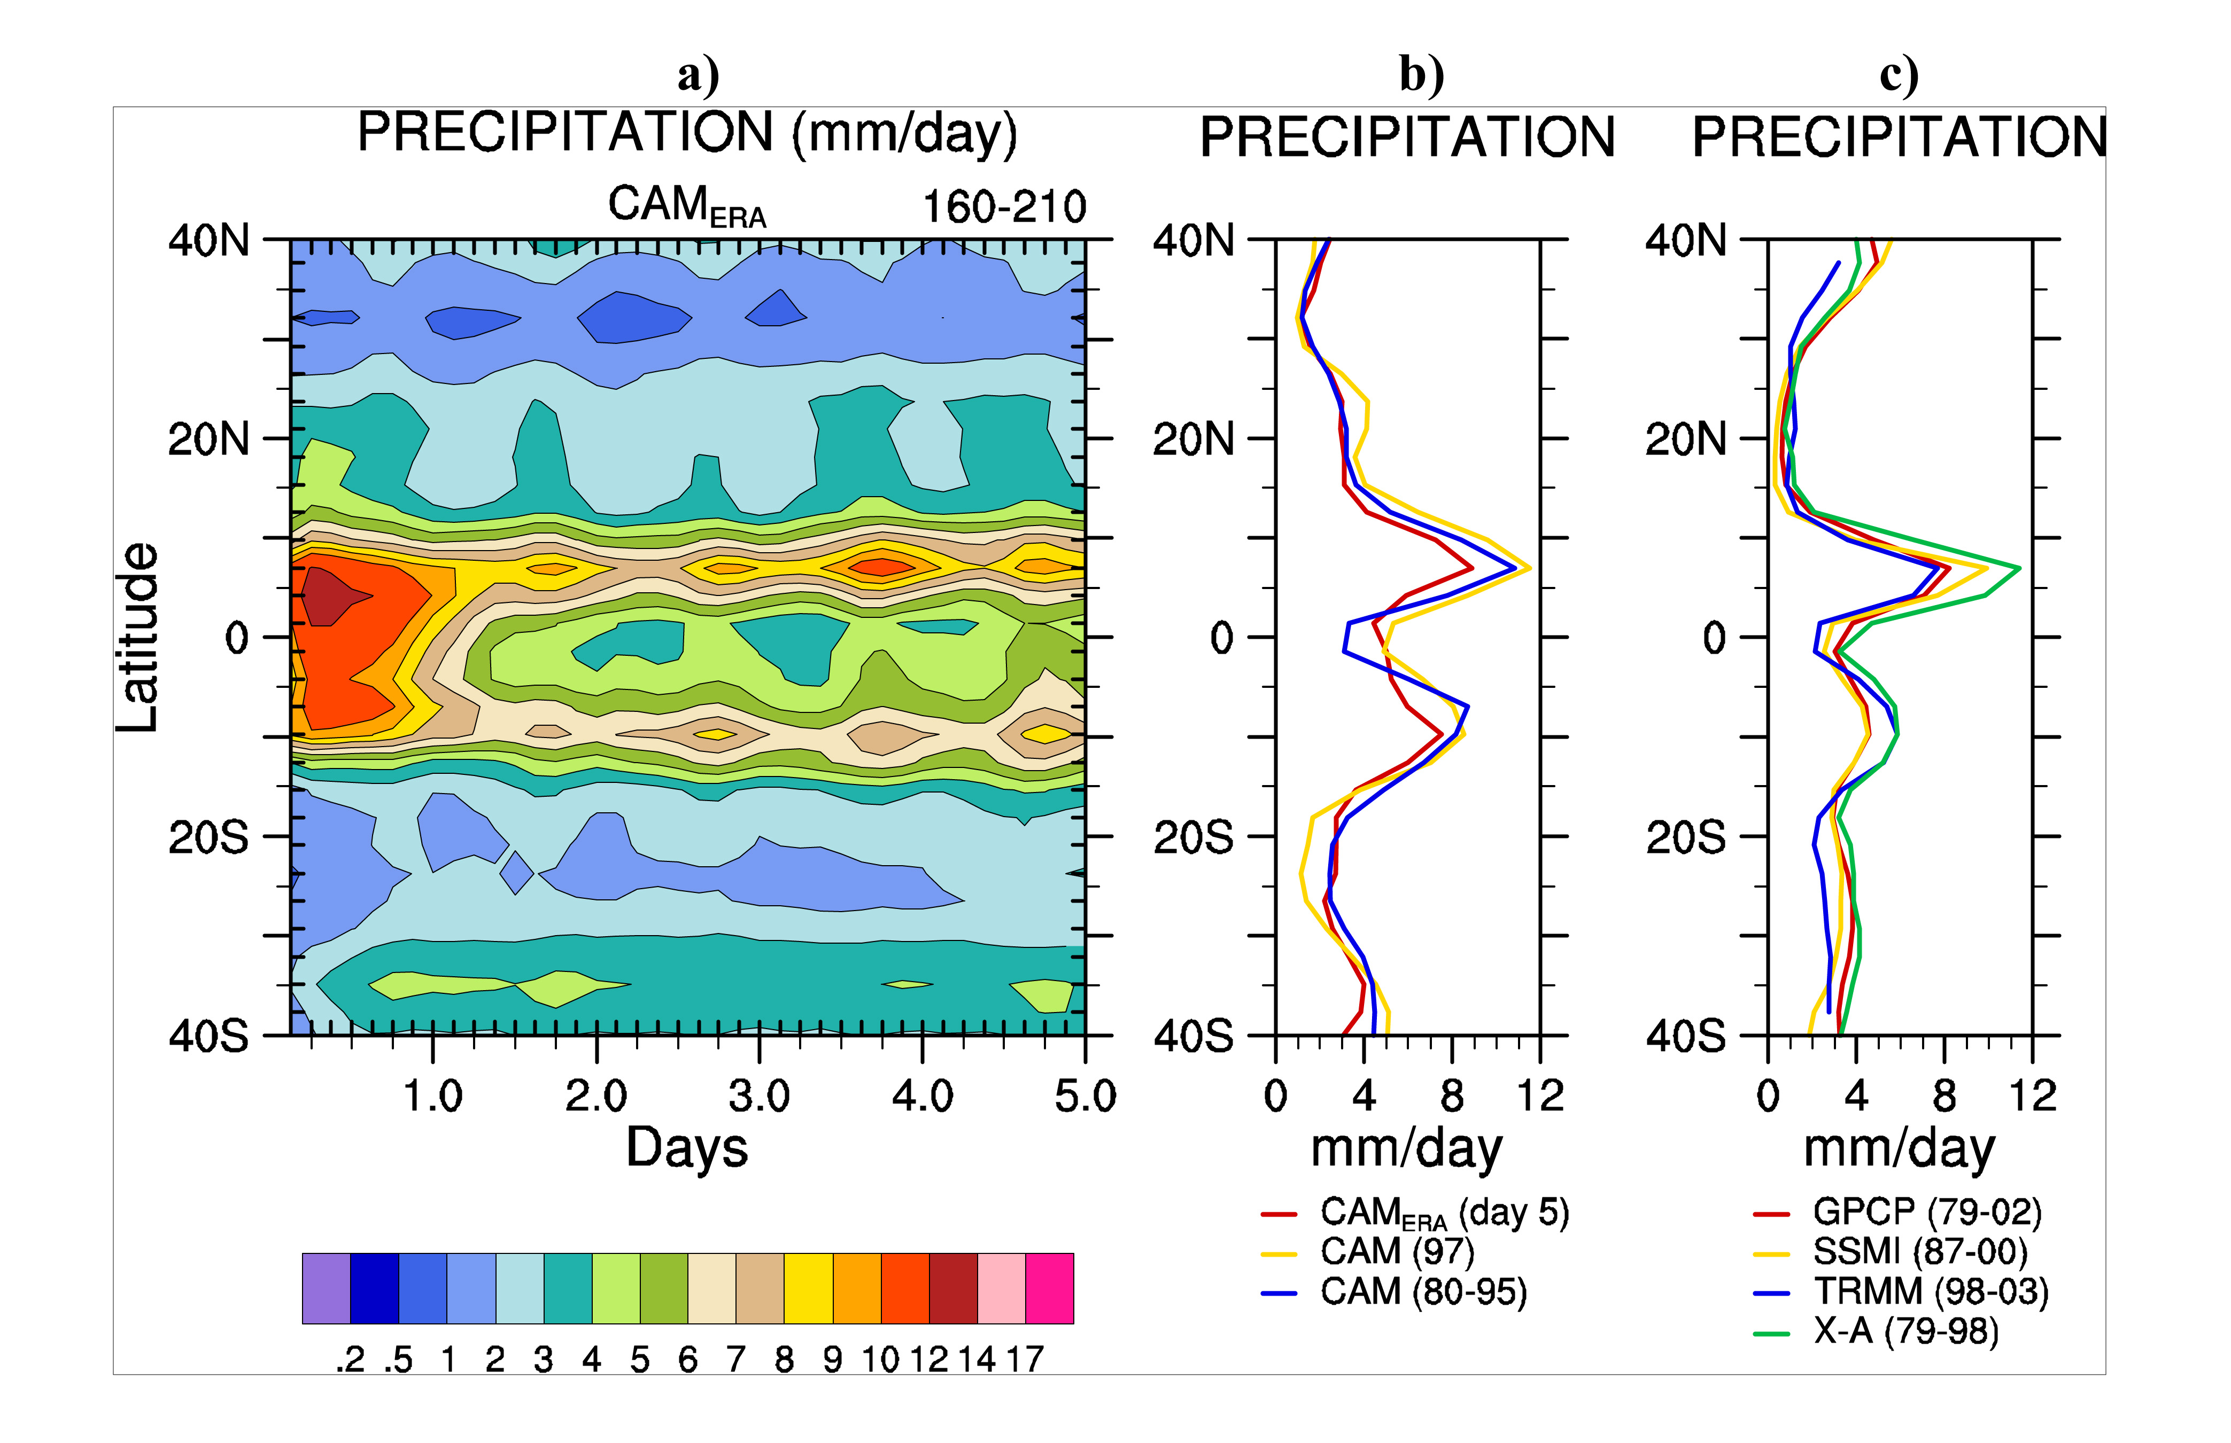
- Model physics bias occurs early
in model integration
- Model physics need to be tested
under controlled, unbiased large scale
climate conditions
- Improved physical parameterization
that reduced initial forecast errors is
likely to lead to improved climate
simulation and predictions

Figure 9: CEOP/WESP/CIMS Connections

7.1 WESP Scientific Objective and Main Questions Raised the WESP Activities Plan

The latest version of the WESP Major Activities Plan (MAP) can be accessed on the Internet through the CEOP Data Management site at: http://www.joss.ucar.edu/ghp/ceopdm/. The plan describes in detail the main elements of WESP, which has as its key scientific objective: to use enhanced observations to diagnose, simulate and predict water and energy fluxes and reservoirs over land on diurnal to annual temporal scales as well as apply these predictions for water resource applications. WESP is making progress in characterizing the water and energy budgets associated with the CSE CEOP reference site regions and in doing so is beginning to answer questions related to the comparison between the in-situ and satellite hydrometeorological values. Particularly, what are the problems in simulating the observed hydrometeorological values? More time is needed to develop the prediction aspect of WESP, which wants to show that WESP comparisons and simulations lead to improved models and increased predictability.

7.2 Continued WESP Analyses Using CEOP Coordinated Datasets

Early comparisons indicate model difficulties in depicting water and energy budget characteristics that additional CEOP Reference Site data and Model (MOLTS) output may help resolve. Figure 10 shows results which expand on findings that were published in CEOP Newsletter No. 3, March 2003. In this case the models versus the observations show for that for the energy convergence (HC) the main component is the atmospheric radiative cooling (QR), but that there is also a contribution from the latent heat of precipitation (net condensation), LP, that must be taken into account. For QR itself, there is a substantial diurnal cycle in atmospheric cooling (approximately 0) during early afternoon, as well as surface heating and for surface ground heating, G, ground heating by subsurface flux during night and cooling during day drive the need to look again carefully at the observations.

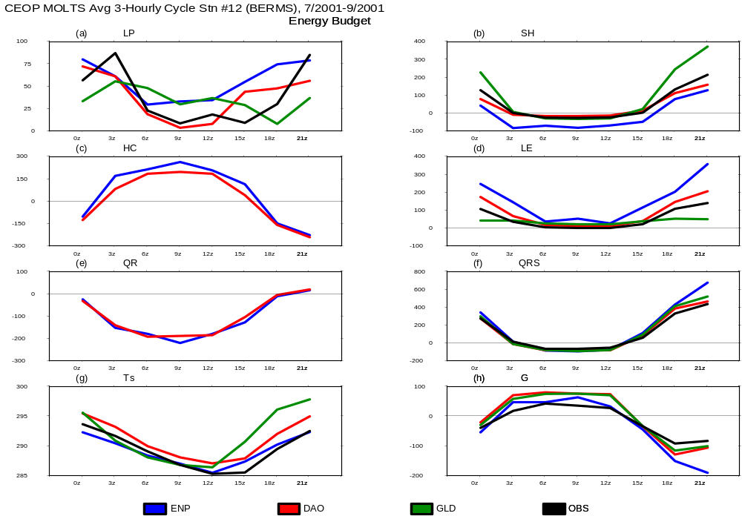

Figure 10: Pilot Data (Energy Cycle) Comparisons (CEOP Newsletter No. 3, March 2003)

7.3 WESP Breakout Session Recommendations

The special breakout session covering WESP issues focused on a number of topics related to the connection between the CEOP modeling and reference site data communities. Part of the decision centered on the delivery of CEOP EOP-1 dataset and its application in model intercomparisons. Other topics covered included the need for new/other datasets to compliment the CEOP Reference Site Database and the need to begin a CEOP model evaluation exercise.

7.3.1 CEOP Data in Model Evaluations

The breakout session brought out the necessity for communication between the data providers and data “users” so both groups fully understand the limitations of the data on the one hand and the model evaluation process on the other. Limits on the attributes assigned to the data from the reference sites, especially surface flux measurements, must be considered. These details are best known to the reference site managers.

There are also potential problems in comparing models with formulations that assign values for parameters such as vegetation, soils, and elevation for a specific site/region that may be (or inevitably are) different than the actual reference site vegetation, soils and elevation descriptives. The breakout group also highlighted the need that arises to combine multiple observations at some sites where data are flagged in the database as missing or corrupted in one way or another or where it is discovered or known that there is a difference between model/site vegetation, soils and elevation that must be compensated for or “fixed” in the model runs.

These points led to the conclusion that there was a need for an action (A10a) to be undertaken by the Representatives at the CEOP model output contributing Centers to make known the characteristics of the CEOP reference sites (i.e. vegetation type, soils, and elevation) as defined in their models. The out come of this exercise should result, at least, in the development of an objective analysis of some type that allows the best possible evaluation of model output at the reference sites.

Besides endorsing the action for other applicable datasets (i.e. BSRN, ISCCP, etc.) to be added or formally linked with the CEOP Reference Site Database (See Item 3.2.2) the breakout participants noted that another problematic issue related to the CEOP reference site data in model evaluations is the time and space sampling of precipitation that require averaging over wider areas to match model output. The group registered the need for gridded basin data from each CSE, and for other independent precipitation datasets including possibly globally gridded data from the Global Precipitation Climatology Center at Offenbach, Germany or a related product.

7.3.2 CEOP Model Evaluation Exercise at 2005 International Meeting

The recommendation of the participants was that CEOP must undertake a model evaluation exercise that would culminate at the time of the 2005 CEOP Fourth International Implementation Planning Meeting (28 February to 4 March 2005, Tokyo, Japan). Drs M. Bosilovich with M. Lautenschlager (Co-Chairs of the CEOP Model Output Development and Implementation Working Group) and J. Roads (Chair of CEOP WESP) agreed to action A10b, to form a steering committee to define guidelines for such an exercise including issues related to radiation components, especially shortwave and surface fluxes, which balance the radiation fluxes, both of which are likely to have noticeable biases; definition of state variables (meteorology); how to correct for elevation, etc. differences; cloudiness (BSRN and ISSCP); cloud base; analysis of precipitation intercomparisons from other groups to understand what the observation uncertainties at the CEOP sites; and how to communicate with other international groups are working on this type of initiative. Dr P. Arkin agreed to assist in this activity.

8. CEOP MONSOON SYSTEM WORKING GROUP STATUS

Drs Lau and Matsumoto, Co-Chairs of the CEOP Monsoon Systems Working Group, provided a status report of this work in CEOP. The main milestones that were achieved since the inception of this Working Group include: an initial CEOP Monsoon Systems Workshop, at IRI, in Palisade, NY, September 2002, that resulted in the definition of the CEOP Inter-monsoon Model Study (CIMS); a CEOP/GEWEX workshop on role of Himalayas and Tibetan Plateau on the Asian monsoon System, Milan, Italy, April 2003; a CEOP Special Session in AGU, December 2003; a CEOP newsletter no.5 article “ Diurnal Variability in monsoon regions: preliminary results from CIMS”; CEOP representation at the 3rd Workshop on Regional Climate Modeling, February, 2004 with CLIVAR AAMP, Bangalore, India. CEOP discussions are also being planned at a CEOP workshop on American monsoon, September, 2005 (See Item 3.2.5, above) and at a joint CAPT (CCSP- Arm Parameterization Testbed) CEOP session in the annual AMS meeting, January 2005 (See Item 7., above).

8.1 CIMS Diurnal Cycle Theme

The diurnal cycle is now being focused on as a unifying theme in the CIMS implementation plans. The main principals of this focus include that the: diurnal cycles of atmosphere, land surfaces and oceanic processes are fundamental components of the global climate system; diurnal cycles of clouds and precipitation affects the partitioning of precipitation between convective and stratiform, and between the land and ocean; an accurate representation of the amplitude and phase of the diurnal cycle provides a key test of many aspects of the physical parameterizations in an atmospheric model and that current AGCMs have major deficiencies in simulating the diurnal cycle of clouds and precipitation. It is also felt that the work will advance at a reasonable pace due to the fact that there are large data samples of diurnal cycles with high temporal resolution available for detailed analysis from short-term climate simulations. Figure 11 provides a graphic framework for studying the diurnal cycle in CIMS.
H
H
Tibetan Plateau
Himalayas
Equator
SSW:QuickSCAT, SeaWinds,
ASAR, PALSAR, AMSR/AMSRE
SST:MODIS,GLI,AMSR,AMSRE
Atmos. Profile::
AIRS,AMSU,MHS
Precipitation Profile: PR
Land Surf. Hydrol.
Soil Moist. Snow,
Surf. Temp, VWC.
AMSR/AMSRE
Atmos. Profile:
AIRS
Atmos. Column Values(WV, CWC, Rain):
AMSR/AMSRE
Cloud Properties:MODIS,GLI
Ocean
Land
Land Cover: ETM, ASTER, MODIS, GLI
Atmos. Column Values(Precip.):
AMSR/AMSRE
Radiation:CERES, MODIS, GLI
Diurnal Cycle: TRMM, ADEOSII,Terra+Aqua
Land Surf. Heterogeneity: ETM,ASTER+MODIS,GLI
ASAR,PALSAR+AMSR,AMSRE
Figure 11: CIMS Diurnal Cycle Framework.

CEOP and CIMS are interested in connections to other projects that are doing research over the oceans and in particular CEOP has a requirement for ocean flux data, as noted in Item 3.2.5 above. For CIMS the issue of the diurnal cycle over the ocean is of special importance. CIMS will aim to study diurnal variability over the ocean as it relates to: radiation-convection interactions; radiation-dynamics interactions; diurnal cycle of SST; atmospheric thermodynamics; remote control from continents and large-scale thermally driven atmospheric tides.

8.2 A Proposal for a Regional Atmospheric Inter-Model Evaluation Project (RAIMEP)

Dr Lau described the start-up framework for RAIMEP that is evolving in parallel with monsoon studies in CEOP and, which can be a contribution to CEOP as an initial step in CIMS. RAIMEP, was proposed at the 3rd Workshop on Regional Climate Modeling 17-20 February 2004, at the International Pacific Research Center (IPRC), at Honolulu, Hawaii with Dr Y. Wang of IPRC defined as an initial coordinator. As the name implies, this project will use Regional Climate Models (RCM) as a conduit for evaluating physics in global climate models. The Initial focus of RAIMEP is on (but not limited in) the East Asian monsoon region during summer seasons

The performance of current RCMs in simulating the diurnal variability of water cycle (clouds, precipitation, surface fluxes, soil moisture…), will be examined in order to identify the common discrepancies and key factors that cause model bias in model results and work will be done to use these findings as pathways to improve model physics. The RCMs will be used to provide boundary conditions to drive Cloud System Models (CSM) in a smaller embedded domain of active convection. Twelve RCMs and one CSM are expected to participate.

RAIMEP will address the following science issues associated with the summer monsoon over East Asia:

- What are the dominant mechanisms responsible for the diurnal cycle of clouds and precipitation ?

- What are the relative roles of convective vs. stratiform precipitation, w.r.t. the LLJ in the diurnal variability of the Mei-yu rainfall regime?

- What are the role of coupled land surface and oceanic processes ?

- What causes discrepancies in simulating the diurnal cycle in atmosphere-LSM models?

- How to improve simulation of diurnal cycle in atmosphere-land models?

- How important is the diurnal cycle of clouds and precipitation in better simulation of the mean water cycle, and floods and drought prediction?,

and there are expected to be three phases of RAIMEP:

- Phase I: To examine the performance of the participating RCMs in simulating the diurnal cycle of clouds and precipitation for summer seasons of 1998 (SCSMEX, HUBEX) and 2003 (CEOP dataset), with realistic initial conditions, and controlled large scale conditions

- Phase II: To identify the discrepancies and sensitivity of the simulated diurnal cycle to model parameterizations, and to study the physical mechanisms that control the diurnal cycle of clouds and precipitation.

- Phase III: To improve the simulation of diurnal cycle of clouds and precipitation by improving and/or developing new parameterization schemes, including the use of CRM for better understanding of microphysical processes and validation.

Drs Lau and Matsumoto are expected to maintain close ties between the development of CEOP and RAIMEP. The action (A11) is to specifically map RAIMEP Into the CIMS implementation process as an initial step in the work that CIMS wishes to accomplish.

8.3 Monsoon Working Group Breakout Session Results

The breakout session covering CEOP Monsoon studies issues expanded on the CIMS strategy as developed and published in a CIMS whitepaper resulting from the initial CIMS workshop in September 2002 and further developed and documented through a second CIMS workshop at Milan in April 2003 (Results Published in BAMS June 2004) and finally as described in a CIMS article in CEOP Newsletter No. 5, March 2004.

Considering recommendations from the CEOP-GEWEX CIMS workshop that took place at Milan, Italy in April 2003 (See Appendix H), the CEOP Monsoon System Studies Working group had already identified the main processes and mechanisms to be studied. The breakout session to refine the main topics which was held at the meeting with the focus on the implementation process for the CEOP Inter-Monsoon Model Study (CIMS) took the Working Group’s efforts to the next level of planning by noting the resources to be used. This in turn, established the basis for accomplishing the tasks concerning data collection, analysis, model set up, and data intercomparison. A CIMS article published in CEOP-Newsletter 5 and a submission of an article on the South American Low Level Jet (SALLJ) for CEOP Newsletter 6 are the first steps towards meeting all of these goals.

8.3.1 CIMS Implementation Concept

The concept outlined by the breakout group participants included the following main points:

(i) Develop and assess simulations of monsoon components using global or regional models by the CEOP model output contributor community, to improve knowledge on the physics of the monsoon.

(ii) Study the impact of past and current local and remote forcings on the characteristics of the monsoon (e.g. onset, intensity..) using the models of the CEOP model output community in hindcast simulations mode.

(iii) Document the diurnal, intraseasonal and seasonal variability of the monsoon components (precipitation, convection, LLJ, upper level anticyclone, mid tropospheric trough, etc.) based on the CEOP observations (EOP-1, -3) and appropriate reanalyses to get a climatology of these features for a 2-year time span. Other data may be applied in this step but would, at a minimum, include include the CEOP coordinated reference site, satellite and reanalysis datasets plus any other radiosonde, automatic weather station, hydrological and radiative (i.e. BSRN) products that are available and consistent with the CEOP datasets form and function.

(iv) Compare results of (iii) with MOLTS output for each of the CEOP MOLTS locations covering EOP-1 and -3).

8.3.2 CIMS Implementation Plan

The steps outlined in 8.3.1 above, related to (i) developing and assessing simulations of monsoon components using global or regional models and (ii) studying the impact of past and current local and remote forcings on the characteristics of the monsoon (e.g. onset, intensity, etc.); can begin immediately in concert with the CEOP model output contributor community and should reach a significant point of progress by the end of 2004 (some simulations have already been done). Drs Lau and Matsumoto with the CEOP International Coordination Function have the task (action A11a) to work with the NWP Centers contributing to CEOP and other appropriate modeling groups to get them to undertake this work and have a significant result readied for publication by the end of 2004.

The steps outlined in 8.3.1 above related to (iii) documenting the diurnal, intraseasonal and seasonal variability of the monsoon components (precipitation, convection, LLJ, upper level anticyclone, mid tropospheric trough, etc.) based on the CEOP observations (EOP-1, -3) and appropriate reanalyses to get a climatology of these features for a 2-year time span; and (ii) comparing results of (iv) with MOLTS output for each of the CEOP MOLTS locations covering EOP-1 and -3). can start in parallel with items (i) and (ii) and can be completed by March 2005.

Drs Lau and Matsumoto with the CEOP International Coordination Function have the task (action A11b) to work with the NWP Centers contributing to CEOP and other appropriate modeling groups to get them to undertake this work and have it completed by the time of the next CEOP International Implementation Planning Meeting (March 2005). The core group identified at the meeting to begin this effort included NCMRWF/Cochin University (Gopal), CEM, CPTEC (Chou), UCLA (Mechoso), NASA/GSFC (Bosilovich) , University of Maryland (Barbery), University of Tokyo (Tamagawa), and others.

Other elements of the CIMS plan that were strongly recommended by the breakout session participants included (v) Interaction with the WESP WG for studies on processes (e.g. land surface feedbacks, water and energy balances), (vi) Preparation of a journal paper (BAMS?) about CIMS strategy and data analysis for the monsoon regions and (vii) Organization of a CEOP-CLIVAR-GEWEX American Monsoon Workshop in 2005 (after the CEOP or the GHP meeting; See Item 3.2.5).

